INDOOR AIR QUALITY ASSESSMENT

Massachusetts Registry of Motor Vehicles
6 Larochelle Way
Southbridge, MA

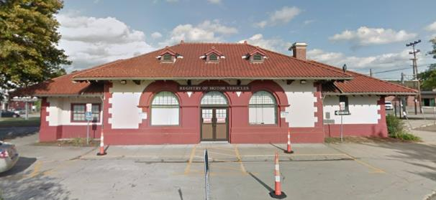

Prepared by:
Massachusetts Department of Public Health
Bureau of Environmental Health
Indoor Air Quality Program
July 2022

BACKGROUND
Building: | Massachusetts Registry of Motor Vehicles (RMV)
Address: | 6 Larochelle Way, Southbridge, MA
Assessment Requested by: | Robert Northrup, Operations Manager, MA Department of Transportation
Reason for Request: | Ventilation issues after repairs
Date of Assessment: | May 27, 2022
Massachusetts Department of Public Health/Bureau of Environmental Health (MDPH/BEH) Staff Conducting Assessment: | Michael Feeney, Director, Indoor Air Quality  (IAQ) Program and Stefanie Santora,  Environmental Analyst, IAQ Program
Building Description: | The RMV was originally built prior to 1940 as a train station. The RMV is a brick/stucco single-story building with a tile roof. Attached to the back of the building is a railroad caboose connected to the main building by a short hallway, which also serves as the main entrance. A mechanical room containing the furnace and HVAC system is located in a below-grade room that is accessible via a door in a restroom.
Building Population: | Approximately 10+ staff work in the building, with various RMV officers during shifts.
Windows: | Not openable

METHODS
Please refer to the IAQ Manual for methods, sampling procedures, and interpretation of results (MDPH, 2015).

IAQ TESTING RESULTS
The following is a summary of indoor air testing results (Table 1).
- Carbon dioxide (CO2) levels were above the MDPH guideline of 800 parts per million (ppm) in most of the occupied areas assessed, indicating a need for increased air exchange. Please note discussion regarding furnace exhaust vent.
- Temperature was within the recommended range of 70°F to 78°F in all areas assessed.
- Relative humidity was within the recommended range of 40 to 60% in all areas assessed.
- Carbon monoxide (CO) were non-detectable (ND) in all areas tested.
- Fine Particulate Matter (PM2.5) concentrations measured were below the National
Ambient Air Quality (NAAQS) limit of 35 μg/m³ in all areas tested.

Ventilation
A heating, ventilating and air conditioning (HVAC) system has several functions. First it provides heating and, if equipped, cooling. Second, it is a source of fresh air. Finally, an HVAC system will dilute and remove normally occurring indoor environmental pollutants by not only introducing fresh air, but by filtering the airstream and ejecting stale air to the outdoors via exhaust ventilation. Even if an HVAC system is operating as designed, point sources of respiratory irritation may exist and cause symptoms in sensitive individuals.
The RMV has a centralized HVAC system that has a fresh air supply and return installed in the main hallway ceiling. The air handling unit (AHU) is installed in a mechanical room that is shared by the building furnace. Fresh air is supplied by ceiling-mounted supply vents mounted in the suspended ceiling connected to the AHU via ductwork. Air mixes in the main room and is drawn to a return vent (Picture 1) located in the wall shared by the main room and mechanical room.
One exhaust vent was noted in the exterior wall (Picture 2). IAQ staff could not identify whether this vent was connected to the AHU or is utilized to provide exhaust ventilation for restrooms. This configuration may create two separate issues:
- If not connected to the AHU, the HVAC system recirculates air with fresh air supply, but only has exhaust ventilation when restroom vents are operating. If restroom vents are not operating, carbon dioxide levels would increase depending on occupancy. Lack of exhaust ventilation reduces air exchange and limits the reductions of normally occurring building pollutants, such as CO₂.
- If connected to the AHU, then the building does not have mechanical exhaust ventilation for restrooms. Without restroom exhaust operating, odors and water vapor can accumulate and be drawn to the HVAC system return vent, to then be distributed around the building.
- In the experience of IAQ staff, buildings retrofitted with an HVAC system will have restroom exhaust vents used as the sole means of venting from the building for both energy savings and reduction in installation cost.
Some areas are equipped with wall-mounted units, ductless minisplits (DMS), that provide heating and cooling. Each DMS has a fan to draw air into its coils to either heat or cool and expel the conditioned air though a vent at the top of each unit. DMS have no means to draw fresh outdoor air.

Microbial/Moisture Concerns

This visit included a visual inspection for signs of water damage and microbial growth on ceiling tiles and other building material. Ceiling tiles in the suspended ceiling grid were bowed (Picture 3), which is likely the result of moisture exposure from a combination of hot, humid weather and a lack of mechanical exhaust ventilation as described.
It is important to note that Massachusetts has experienced extended periods of relative humidity during the summer of 2021. This July was the wettest ever recorded in Massachusetts, and the three-month period from June through August, known as the meteorological summer, was the fourth wettest on record, according to the National Oceanic and Atmospheric Administration’s Centers for Environmental Information. The three-month period also was the third warmest ever in the state and was tied for the warmest on record across the United States. (HG, 2021, NOAA, 2021).
According to American Society of Heating, Refrigerating and Air-Conditioning Engineers (ASHRAE), if relative humidity exceeds 70%, mold growth may occur due to wetting of building materials (ASHRAE, 1989). In this condition, porous materials such as gypsum wallboard, cardboard and other materials may become prone to developing mold colonization. It is recommended that porous material be dried with fans and heating within 24 to 48 hours of becoming wet (US EPA, 2008, ACGIH, 1989). If porous materials are not dried within this time frame, mold growth may occur. Water-damaged porous materials cannot be adequately cleaned to remove mold growth. If porous materials are not dried within this time frame, they should be removed and discarded.

Other IAQ Evaluations
Of significant note were conditions in the mechanical room. The combustion of fuel oil produces a number of products including, but not limited to, CO₂, carbon monoxide, particulate (soot), and water vapor. Dependent on a number of conditions/factors, oil combustion may also produce nitrogen oxides (NOx), which, at certain concentrations, can be harmful to health if inhaled.
If the furnace and its flue/chimney are not airtight, products of combustion may be drawn into the HVAC return system through seams/openings that may exist in return ductwork, particularly at the AHU/duct junction, when the furnace is operating. A number of conditions noted in the mechanical room may contribute to elevated CO₂ levels that are independent of number of occupants in the building.
- It appears that the flue was not solidly connected directly to the furnace.
- Seams in the flue duct did not appear to have sealant on every connection to render it airtight.
- The flue had an open hole (Picture 4).
- Return ductwork did not appear to have any sealant on its joints (Note: the connection between the AHU and the return ductwork could not be observed during this assessment).
- While a single vent was noted in an exterior wall, no combustion air vent for the furnace could be readily identified. In order for a furnace to combust fuel efficiently and to minimize products of combustion, it is recommended that a direct pathway to the outdoors for combustion air be provided. If no outdoor source of combustion air is present, combustion air is drawn from the interior of the building, which can lead to incomplete combustion products entering the mechanical room.
Also of note is the location of the oil tank vent, which is in close proximity to the building’s fresh air intake (Picture 5). When an oil tank is filled, air pressure created by the fuel entering the tank is released by a vent which will contain oil vapors. If the AHU fresh intake is operating during an oil delivery, oil vapors may be captured by the HVAC system and distributed indoors, particularly under certain wind conditions.

CONCLUSIONS/RECOMMENDATIONS
The RMV has a number of issues likely related to the configuration of the mechanical room and possible interaction between the HVAC system and the furnace. Separation of the HVAC system from the furnace system must occur if both systems exist in the same room. It is recommended that the conditions related to furnace exhaust vent be remediated prior to use, if not already completed. The capacity of mechanical ventilation equipment to provide exhaust air from the building is limited due to the design and operation of the building.
To remedy building problems, the following recommendations are made:

Ventilation Recommendations
- If the system is configured to use restroom exhaust vents to provide general building exhaust, operate restroom exhaust vents during all hours of occupancy.
- Have the furnace exhaust duct examined by an experienced furnace servicing contractor to determine if repair or replacement should be done and to render the chimney, the flue, and all connections airtight.
- Seal all seams and holes around pipes and conduit in shared wall of mechanical room and garage.
- It is highly recommended to install a combustion air vent connected directly to the furnace air intake to limit incomplete combustion products. Consult with a heating
system/HVAC engineer to determine if this can be accomplished with existing equipment.

Water Damage Recommendations
- During extended periods of hot, humid weather, consider using a dehumidifier to reduce indoor humidity. Please note that dehumidifiers should be configured to drain condensation from the unit to the building interior or be emptied manually every day. If dehumidifiers are used, ensure they are properly maintained, including cleaning and drainage.
- Management of buildings in extreme relative humidity and rain can be challenging. The following documents can provide guidance that can be used to reduce the impact of hot, humid weather in buildings:
  - Mold growth Prevention during Hot, Humid Weather https://www.mass.gov/service-details/preventing-mold-growth-in-massachusetts-schools-during-hot-humid-weather and
  - Remediation and Prevention of Mold Growth and Water Damage in Public Schools https://www.mass.gov/service-details/remediation-and-prevention-of-mold-growth-and-water-damage-in-public-schools-and

Other Recommendations
- Consider installing carbon monoxide detectors inside occupied space near the mechanical room.
- Schedule oil deliveries when the building is unoccupied. It is recommended that either the HVAC fresh air supply be deactivated during deliveries or to have the oil tank vent relocated away from the HVAC system fresh air intake.
- Refer to resource manual and other related IAQ documents located on the MDPH’s website for further building-wide evaluations and advice on maintaining public buildings. These documents are available at: http://mass.gov/dph/iaq.

REFERENCES
ACGIH. 1989. Guidelines for the Assessment of Bioaerosols in the Indoor Environment. American Conference of Governmental Industrial Hygienists, Cincinnati, OH.
ASHRAE. 1989. ASHRAE Standard: Ventilation for Acceptable Indoor Air Quality. Sections 5.11, 5.12. American Society of Heating, Refrigerating and Air-Conditioning Engineers, Inc. Atlanta, GA.
HG. 2021. Mold keeps South Hadley High School shuttered. Hampshire Gazette. https://www.gazettenet.com/South-Hadley-High-School-still-closed-amid-mold-remediation-42413519.
MDPH. 2015. Massachusetts Department of Public Health. Indoor Air Quality Manual: Chapters I-III. Available at: https://www.mass.gov/lists/indoor-air-quality-manual-and-appendices
NOAA. 2021. Summer 2021 neck and neck with Dust Bowl summer for hottest on record. National Oceanic and Atmospheric Administration, 1401 Constitution Avenue NW, Room 5128, Washington, DC 20230 https://www.noaa.gov/news/summer-2021-neck-and-neck-with-dust-bowl-summer-for-hottest-on-record

US EPA. 2008. “Mold Remediation in Schools and Commercial Buildings”. Office of Air and Radiation, Indoor Environments Division, Washington, DC. EPA 402-K-01-001. September 2008. Available at: http://www.epa.gov/mold/mold-remediation-schools-and-commercial-buildings-guide

Picture 1
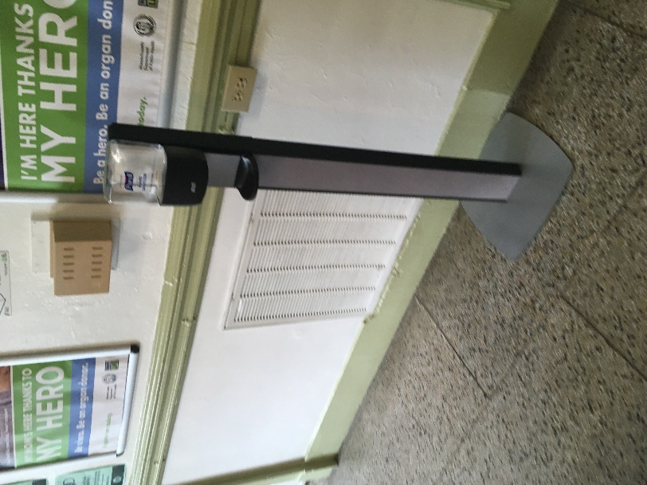
Return vent in main room

Picture 2
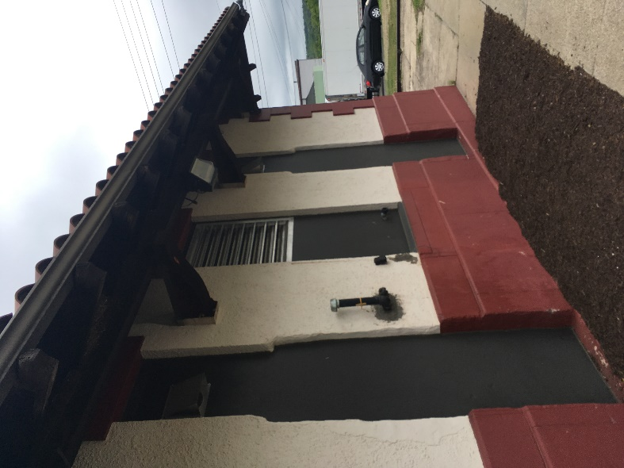
Exterior wall vents

Picture 3
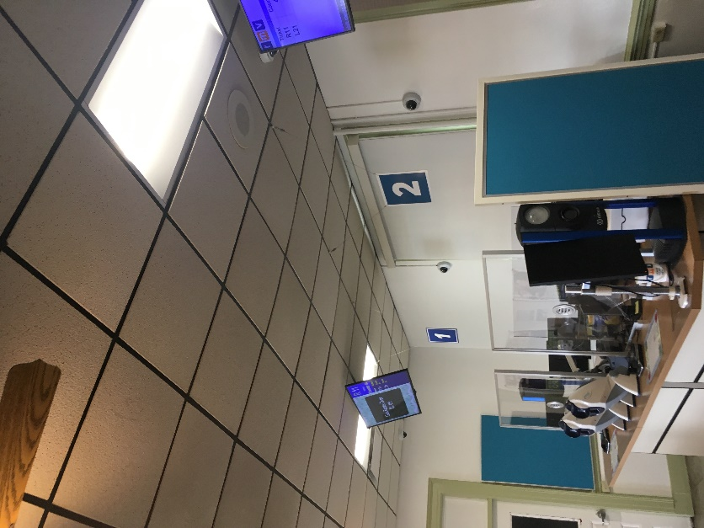
Bowed ceiling tiles

\
Picture 4
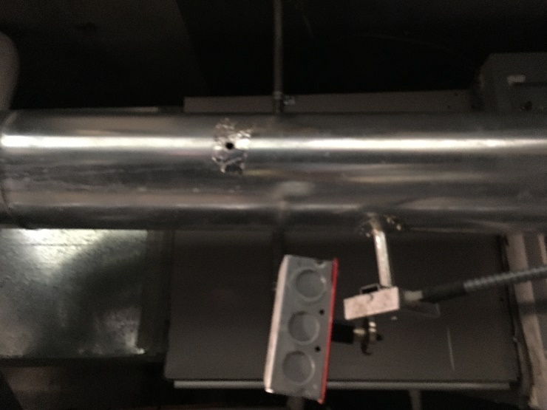
Hole in furnace flue vent
Picture 5

Oil Tank Vent Fresh Air Intake

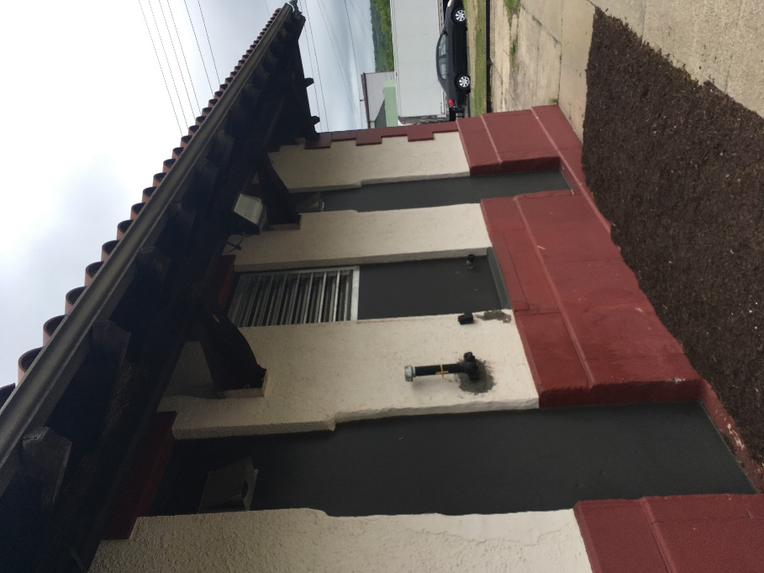
Oil tank vent near fresh air intake
Location | Carbon  Dioxide  (ppm) | Carbon Monoxide  (ppm) | Temp  (°F) | Relative  Humidity  (%) | PM2.5  (µg/m3) | Occupants  in Room | Windows  Openable | Ventilation |  | Remarks
 |  |  |  |  |  |  |  | Supply | Exhaust
Background | 365 | ND | 74 | 76 | 3
Permit Rm Testing | 998 | ND | 76 | 41 | ND | 0 | Y | N/A | N/A | Minisplit, no air intake, HEPA running
Caboose/Store Rm | 590 | ND | 72 | 40 | ND | 0 | N | N/A | N/A | Minisplit, potential of hallway tile asbestos
Caboose/Manager Office | 586 | ND | 71 | 54 | ND | 0 | Y | N/A | N/A | One window open, HEPA off, old carpet
Main Office | 806 | ND | 71 | 55 | ND | 2 | Y | Y | Y | Bowed ceiling tiles, HEPA running
Kitchenette | 950 | ND | 71 | 57 | 2 | 0 | Y | Y | Y
Equipment/Boiler Rm | 680 | ND | 71 | 61 | 1 | 22 | N/A | N/A | N/A | CO₂ 858 ppm by furnace exhaust
Main Lobby Left | 980 | ND | 73 | 54 | ND | 22 | Y | Y | Y
Main Lobby Right | 954 | ND | 72 | 56 | ND | 22 | Y | Y | Y
Main Lobby Center | 955 | ND | 71 | 56 | ND | 22 | Y | Y | Y

