Background

INDOOR AIR QUALITY
POST-OCCUPANCY ASSESSMENT

Massachusetts Department of Transportation
Registry of Motor Vehicles
1794 N Main Street
Fall River, Massachusetts

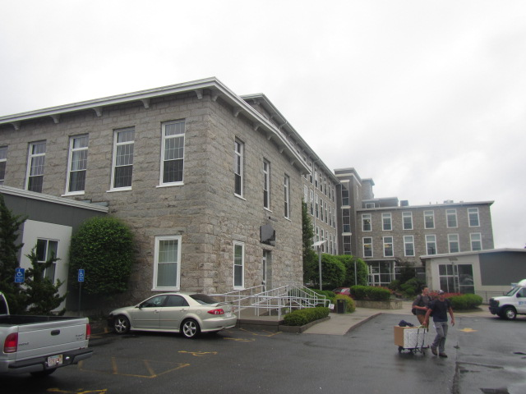

Prepared by:
Massachusetts Department of Public Health
Bureau of Environmental Health
Indoor Air Quality Program
June 2019
Building: | Massachusetts Registry of Motor Vehicles (RMV)
Address: | 1794 N Main Street, Fall River, MA
Assessment requested by: | Aric Warren, Transportation Program Planner, MassDOT
Reason for Request: | General indoor air quality (IAQ) symptoms/concerns.
Date of Assessment: | June 13, 2019
Massachusetts Department of Public Health/Bureau of Environmental Health (MDPH/BEH) Staff Conducting Assessment: | Cory Holmes, Environmental Analyst/Inspector, Indoor Air Quality (IAQ) Program
Date of Building Construction | The Sagamore Mill Complex was built in 1890.
Building Description: | The RMV has occupied space on the ground floor of the renovated mill complex for approximately 3 years. The space consists of large, open waiting/service areas, offices, testing and storage rooms.
Windows: | Windows are openable, however several of them are currently in disrepair/reportedly leak/do not shut properly.

Methods
Please refer to the IAQ Manual for methods, sampling procedures, and interpretation of results (MDPH, 2015).

IAQ Testing Results
The following is a summary of indoor air testing results (Table 1).
- Carbon dioxide levels were above the MDPH guideline of 800 parts per million (ppm) in 7 of 16 areas tested, indicating a lack of fresh air introduction/air exchange in these areas. This is discussed further in the Ventilation section of this report.
- Temperature was within the MDPH recommended range of 70°F to 78°F.
- Relative humidity was within or close to the MDPH recommended range of 40% to 60%.
- Carbon monoxide levels were non-detectable (ND) in all areas assessed.
- Fine particulate matter (PM2.5) concentrations measured were below the National Ambient Air Quality Standard (NAAQS) level of 35 micrograms per cubic meter (μg/m³) in all areas assessed.

Ventilation
A heating, ventilating and air-conditioning (HVAC) system has several functions. First it provides heating and, if equipped, cooling. Second, it is a source of fresh air. Finally, an HVAC system will dilute and remove normally-occurring indoor environmental pollutants by not only introducing fresh air, but also filtering the airstream and ejecting stale air to the outdoors via exhaust ventilation. Even if an HVAC system is operating as designed, point sources of respiratory irritants may be present and produce symptoms in sensitive individuals. The following analysis examines and identifies components of the HVAC system and likely sources of respiratory irritants found in the indoor environment.
At the time of assessment, the digital thermostats appeared to be set to “auto” which deactivates the HVAC system once the temperature set point is met (Picture 1). While the system is deactivated, no outside air is being introduced or circulated. Given the dense population of clients at times, this can contribute to thermal comfort/IAQ complaints.
The HVAC system consists of a combination of ceiling units in offices/smaller areas that provide both supply/return (Picture 2) and rooftop air handling units (AHUs) for large/common areas (Picture 3). Supply and return air is provided by ceiling vents (Pictures 4 and 5).
HVAC units are reportedly outfitted with pleated filters of a Minimum Efficiency Reporting Value (MERV) of 8, which are adequate in filtering out pollen and mold spores (ASHRAE, 2012). In addition, filters should be changed 2-4 times a year or in accordance with the manufacture’s recommendations.

Microbial/Moisture Concerns
Water-damaged ceiling tiles were seen in a few areas (Table 1, Pictures 2 and 4). Water-damaged ceiling tiles indicate leaks from either the roof or plumbing system and can provide a source for mold growth. These tiles should be replaced after a water leak is discovered and repaired.
In the Customer Service area an active leak was reported from the window. In the main waiting area several windows were in disrepair and do not close properly (Picture 6). Windows should be repaired/leaks investigated to avoid chronic wetting of porous building materials (e.g., gypsum wallboard, carpeting) that can become colonized by mold growth.
Indoor plants were observed in a few areas (Table 1). Plants, soil, and drip pans can serve as sources of mold/bacterial growth. Plants should be properly maintained, over-watering of plants should be avoided, and drip pans should be inspected periodically for mold growth.

Other Conditions
Several occupants reported issues with cleaning/dust control. Items should be relocated and/or be cleaned periodically to avoid excessive dust build up. In addition, dusty materials can accumulate on flat surfaces (e.g., desktops, windowsills and carpets) in occupied areas and subsequently be re-aerosolized causing further irritation.
Finally, some areas have carpeting. Carpets should be cleaned annually (or semi-annually in soiled/high traffic areas) in accordance with Institute of Inspection, Cleaning and Restoration Certification (IICRC) recommendations, (IICRC, 2012). Regular cleaning with a high efficiency particulate air (HEPA) filtered vacuum in combination with an annual cleaning will help to reduce accumulation and potential aerosolization of materials from carpeting.

Recommendations
The following recommendations are made to improve general IAQ:
- Consider operating HVAC system in fan “on” mode during occupied hours to provide continuous circulation/filtration.
- Contact HVAC engineer to determine if fresh air to RMV space can be adjusted/increased.
- Work with building management/RMV staff/HVAC vendor to document/map out areas of temperature/comfort issues for adjustment/reprogramming of HVAC system.
- Consider creating a log book for staff to submit specific cleaning/maintenance requests. Make log book available for staff/management in a central location. Cleaning/Maintenance requests should include date, requester, a detailed description of where and what the issue is as well as a section for cleaning/maintenance personnel to sign off or document progress of request.
- Consider adopting a balancing schedule of every 5 years for all mechanical ventilation systems, as recommended by ventilation industrial standards (SMACNA, 1994).
- Change HVAC filters (using MERV 8 or higher filters) quarterly or as per the manufacturer’s instructions.
- Clean supply, return/exhaust vents regularly to remove accumulated dust/debris.
- Make repairs to windows to prevent drafts and water damage/mold growth to porous building materials.
- Ensure all leaks are repaired and replace water-damaged ceiling tiles. Inspect above them to clean/disinfect any additional moistened/damaged materials.
- For buildings in New England, periods of low relative humidity during the winter are often unavoidable. Therefore, scrupulous cleaning practices should be adopted to minimize common indoor air contaminants whose irritant effects can be enhanced when the relative humidity is low. To control for dusts, a high efficiency particulate arrestance (HEPA) filter equipped vacuum cleaner in conjunction with wet wiping of all surfaces is recommended. Avoid the use of feather dusters. Drinking water during the day can help ease some symptoms associated with a dry environment (throat and sinus irritations).
- Clean carpeting annually or semi-annually in soiled high traffic areas as per the recommendations of the Institute of Inspection, Cleaning and Restoration Certification (IICRC, 2012).
- Keep plants in good condition, avoid overwatering, and avoid placing them on porous items such as carpets or paper.
- Refer to resource manual and other related indoor air quality documents located on the MDPH’s website for further building-wide evaluations and advice on maintaining public buildings. These documents are available at http://www.mass.gov/dph/iaq.

References
ASHRAE. 2012. American Society of Heating, Refrigeration and Air Conditioning Engineers (ASHRAE) Standard 52.2-2012 -- Method of Testing General Ventilation Air-Cleaning Devices for Removal Efficiency by Particle Size (ANSI Approved).
IICRC. 2012. Institute of Inspection, Cleaning and Restoration Certification. Carpet Cleaning: FAQ.
MDPH. 2015. Massachusetts Department of Public Health. Indoor Air Quality Manual: Chapters I-III. Available at: http://www.mass.gov/eohhs/gov/departments/dph/programs/environmental-health/exposure-topics/iaq/iaq-manual/.
SMACNA. 1994. HVAC Systems Commissioning Manual. 1st ed. Sheet Metal and Air Conditioning Contractors’ National Association, Inc., Chantilly, VA.
Picture 1
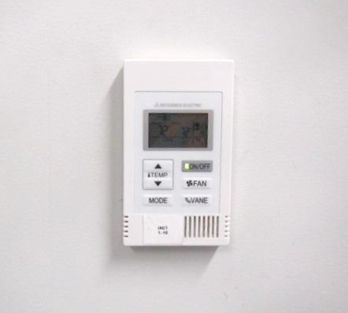
Digital thermostat for HVAC system
Picture 2
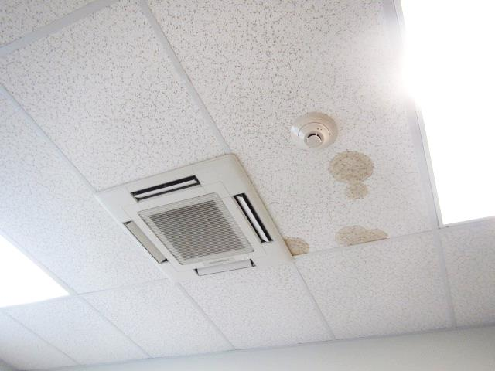
Ceiling-mounted HVAC unit, note water-damaged ceiling tiles
Picture 3
Rooftop air handling units (light colored boxes on roof)
Picture 4
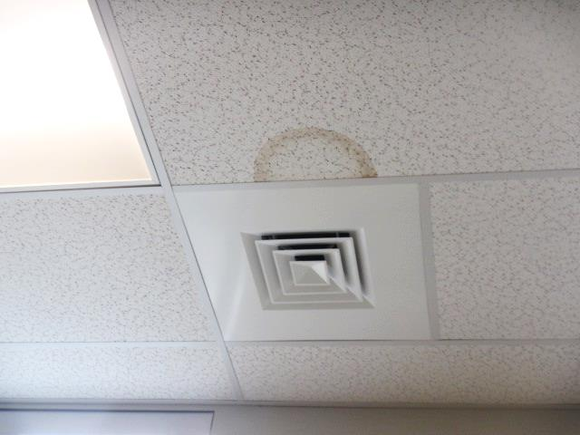
Ceiling-mounted supply diffuser, note water-damaged ceiling tile
Picture 5
Ceiling-mounted return vent
Picture 6
Space at top of window in main waiting area (arrow)
Location | Carbon  Dioxide  (ppm) | Carbon Monoxide  (ppm) | Temp  (°F) | Relative  Humidity  (%) | PM2.5  (µg/m³) | Occupants  in Room | Windows  Openable | Ventilation |  |  | Remarks
 |  |  |  |  |  |  |  | Intake | Exhaust
Background (outside) | 396 | ND | 52 | 100 | 10 |  | - | - |  | - | Rain moderate to heavy, unseasonably cool
Branch Manager Office | 789 | ND | 72 | 61 | 2 | 3 | N | Y |  | Y | Carpet
Road Test | 639 | ND | 73 | 62 | 2 | 0 | N | Y |  | Y | DEM, carpet
Road Test Waiting Area | 740 | ND | 73 | 60 | 3 | 10 | N | Y |  | Y | Tile floor
Customer Service | 915 | ND | 73 | 61 | 3 | 4 | Y | Y |  | Y | Tile floor, leaking window reported
Self Service | 892 | ND | 73 | 62 | 4 | 3 | Y | Y |  | Y | Tile floor
Stations 3-7 | 900 | ND | 73 | 62 | 3 | 14 | N | Y |  | Y | Tile floor
Stations 8-10 | 993 | ND | 73 | 60 | 2 | 6 | N | Y |  | Y | Tile floor
Stations 11-14 | 1000 | ND | 73 | 60 | 3 | 6 | N | Y |  | Y | Tile floor
Hearing Waiting Room | 1010 | ND | 73 | 61 | 2 | 13 | Y | Y |  | Y | WD CT
Hearing Room 16 | 740 | ND | 74 | 56 | 1 | 0 | Y | Y |  | N
Hearing Room 17 | 735 | ND | 74 | 56 | 1 | 0 | Y | Y |  | N
Hearing Room 18 | 743 | ND | 73 | 57 | 1 | 2 | Y | Y |  | Y | Chronic cold complaints, DEM, WD CT, plant
Hearing Back Hallway Room | 813 | ND | 74 | 55 | 3 | 0 | Y | Y |  | Y
Break Room | 765 | ND | 74 | 55 | 3 | 0 | Y | Y |  | Y
Storage Room | 611 | ND | 73 | 55 | 2 | 0 | N | Y |  | Y
Permit Testing | 760 | ND | 72 | 51 | 2 | 4 | N | Y |  | Y

