INDOOR AIR QUALITY ASSESSMENT

Registry of Motor Vehicles
175 Cabot Street
Beverly, Massachusetts

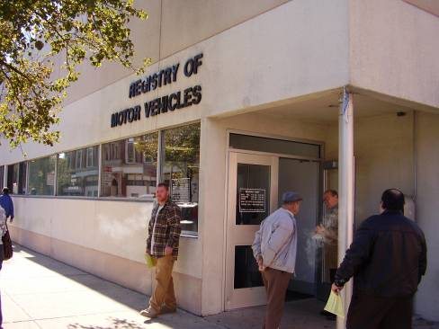

Prepared by:
Massachusetts Department of Public Health
Center for Environmental Health
Emergency Response/Indoor Air Quality Program
March 2007

Background/Introduction
In response to a request from Aric Warren, Director of Administrative Services, Massachusetts Registry of Motor Vehicles (MRMV), the Massachusetts Department of Public Health (MDPH), Center for Environmental Health (CEH), provided assistance and consultation regarding indoor air quality concerns at the Beverly RMV Branch office located at 175 Cabot Street, Massachusetts. The request was prompted by occupant complaints of odors and poor air quality in the building.
On February 27, 2007, a visit to conduct an indoor air quality assessment was made to the RMV by Cory Holmes, an Environmental Analyst in CEH’s Emergency Response/Indoor Air Quality (ER/IAQ) Program. Mr. Holmes was accompanied for portions of the assessment by Mr. Warren and Ms. Sue McNeil, Branch Manager.
The RMV occupies office space on the first floor of a two story brick and cinder block building. The RMV is made up of a large open service area/waiting room, offices, testing rooms, a break room and storage space.
Due to previous IAQ concerns among RMV staff, the Massachusetts Department of Labor and Workforce Development (MDLWD), Division of Occupational Safety (DOS) conducted an IAQ inspection in July of 2005. The DOS report made several recommendations including: (1) operate ventilation fans in the “on” mode to provide continuous supply of outside air; (2) identify and repair the source of water leaks at the front and rear entrances and replace affected floor tiles; (3) replace water damaged carpet at the rear of the office affected by the upstairs bathroom flooding; (4) inspect space above the ceiling tiles for water damage and make repairs as needed; (5) contact an HVAC engineer to adjust the system to provide at least 20 cfm of fresh air per occupant and 6 air changes per hour; (6) prohibit vehicles from running/idling near the outside air intakes; and (7) develop an IAQ management plan to address IAQ issues (MDLWD, 2005).

Methods
Air tests for carbon dioxide, carbon monoxide, temperature and relative humidity were taken by CEH with a TSI, Q-Trak, IAQ Monitor Model 8551. CEH staff also performed visual inspection of building materials for water damage and/or microbial growth. Moisture content of porous building materials was measured with a Delmhorst, BD-2000 Model, Moisture Detector equipped with a Delmhorst Standard Probe.

Results
The RMV has a daily employee population 13 and is visited by up to several hundred individuals daily. The tests were taken during normal operations. Test results appear in Table 1.

Discussion
Ventilation
It can be seen from Table 1 that carbon dioxide levels were above 800 parts per million (ppm) in all areas, indicating inadequate air exchange at the time of the assessment. It is important to note that a number of areas were sparsely populated or unoccupied at the time the tests were taken, which typically results in reduced carbon dioxide levels. Carbon dioxide levels would be expected to be higher with increased occupancy, therefore carbon dioxide levels measured in these areas and in particular, the RMV service area/waiting room, (which is a large open area), further illustrates a lack of adequate air exchange.
Mechanical ventilation is provided by air-handling units (AHUs) located in the ceiling plenum. Fresh air is drawn into the AHUs through air intakes on the exterior wall and delivered to occupied areas via ceiling-mounted air diffusers (Pictures 1 and 2). Return air is drawn into ceiling-mounted vents and ducted back to the AHUs (Pictures 3 and 4). Digital wall-mounted thermostats control the heating, ventilating and air-conditioning (HVAC) system and have fan settings of “on” and “automatic”. Despite the 2005 recommendations by DOS, the thermostats were observed to be set to the “automatic” setting (Picture 5) at the time of the MDPH assessment. The automatic setting on the thermostat activates the HVAC system at a preset temperature. Once the preset temperature is reached, the HVAC system is deactivated. Therefore, no mechanical ventilation is provided until the thermostat re-activates the system. Without a continuous source of fresh outside air and removal via the exhaust/return system, indoor environmental pollutants can build-up and lead to indoor air quality/comfort complaints.
To maximize air exchange, the MDPH recommends that both supply and exhaust ventilation operate continuously during periods of occupancy. In order to have proper ventilation with a mechanical supply and exhaust system, the systems must be balanced to provide an adequate amount of fresh air to the interior of a room while removing stale air from the room. It is recommended that HVAC systems be re-balanced every five years to ensure adequate air systems function (SMACNA, 1994). The date of the last balancing of these systems was not available at the time of the assessment.
The Massachusetts Building Code requires a minimum ventilation rate of 20 cubic feet per minute (cfm) per occupant of fresh outside air or have openable windows in each room (SBBRS, 1997; BOCA, 1993). The ventilation must be on at all times that the room is occupied. Providing adequate fresh air ventilation with open windows and maintaining the temperature in the comfort range during the cold weather season is impractical. Mechanical ventilation is usually required to provide adequate fresh air ventilation.
Carbon dioxide is not a problem in and of itself. It is used as an indicator of the adequacy of the fresh air ventilation. As carbon dioxide levels rise, it indicates that the ventilating system is malfunctioning or the design occupancy of the room is being exceeded. When this happens, a buildup of common indoor air pollutants can occur, leading to discomfort or health complaints. The Occupational Safety and Health Administration (OSHA) standard for carbon dioxide is 5,000 parts per million parts of air (ppm). Workers may be exposed to this level for 40 hours/week, based on a time-weighted average (OSHA, 1997).
The MDPH uses a guideline of 800 ppm for publicly occupied buildings. (A guideline of 600 ppm or less is preferred in schools due to the fact that the majority of occupants are young and considered to be a more sensitive population in the evaluation of environmental health status). Inadequate ventilation and/or elevated temperatures are major causes of complaints such as respiratory, eye, nose and throat irritation, lethargy and headaches. For more information concerning carbon dioxide, please see Appendix A.
Temperature readings ranged from 69º F to 71 º F, which were within or very close to the lower end of the MDPH recommended comfort guidelines in all areas surveyed during the assessment. The MDPH recommends that indoor air temperatures be maintained in a range of 70 º F to 78 º F in order to provide for the comfort of building occupants. Although temperatures measured were close to or within MDPH guidelines, complaints of poor airflow and thermal discomfort were expressed by several occupants. Portable electric space heaters were observed in a number of areas to supplement heating provided via the HVAC system. In many cases concerning indoor air quality, fluctuations of temperature in occupied spaces are typically experienced, even in a building with an adequate fresh air supply.
The relative humidity measurements ranged from 27 to 32 percent, which were below the MDPH recommended comfort range in all areas surveyed on the day of the assessment. The MDPH recommends a comfort range of 40 to 60 percent for indoor air relative humidity. Relative humidity levels in the building would be expected to drop during the winter months due to heating. The sensation of dryness and irritation is common in a low relative humidity environment. Low relative humidity is common during the heating season in the northeast part of the United States.

Odors
As discussed, the assessment was prompted in part by concerns of odors in RMV space. Building staff have reported concerns about odors periodically over the past several years. These odors reportedly occur at irregular intervals with no particular pattern. Most recently an RMV employee reported respiratory symptoms attributed to odors that occurred on February 15, 2007. According to an incident response report provided by the Beverly Fire Department (BFD), a slight odor was detected at the RMV, which was attributed to the use of portable electric space heaters at employee workstations. No measurable levels of either carbon monoxide or hydrocarbons were reportedly detected by the BFD (BFD, 2007; Appendix B).
As indicated in the DOS report (MDLWD, 2005), another potential source of odors are the fresh air intakes, which are located on exterior walls in the parking lot (Picture 1). Due to the close proximity of these air intakes to the parking lot, there is a potential for entrainment of vehicle exhaust and/or other odors that may be present outside of the building in this vicinity.
Indoor air quality can be negatively influenced by the presence of respiratory irritants, such as products of combustion. The process of combustion produces a number of pollutants. Common combustion emissions include carbon monoxide, carbon dioxide, water vapor and smoke (fine airborne particle material). Carbon monoxide is a by-product of incomplete combustion of organic matter (e.g., gasoline, wood and tobacco). Exposure to carbon monoxide can produce immediate and acute health affects.
Carbon monoxide is a by-product of incomplete combustion of organic matter (e.g., gasoline, wood and tobacco). Exposure to carbon monoxide can produce immediate and acute health affects. Several air quality standards have been established to address carbon monoxide and prevent symptoms from exposure to these substances. The MDPH established a corrective action level concerning carbon monoxide in ice skating rinks that use fossil-fueled ice resurfacing equipment. If an operator of an indoor ice rink measures a carbon monoxide level over 30 ppm, taken 20 minutes after resurfacing within a rink, that operator must take actions to reduce carbon monoxide levels (MDPH, 1997).
The American Society of Heating Refrigeration and Air-Conditioning Engineers (ASHRAE) has adopted the National Ambient Air Quality Standards (NAAQS) as one set of criteria for assessing indoor air quality and monitoring of fresh air introduced by HVAC systems (ASHRAE, 1989). The NAAQS are standards established by the US EPA to protect the public health from six criteria pollutants, including carbon monoxide and particulate matter (US EPA, 2006). As recommended by ASHRAE, pollutant levels of fresh air introduced to a building should not exceed the NAAQS levels (ASHRAE, 1989). The NAAQS were adopted by reference in the Building Officials & Code Administrators (BOCA) National Mechanical Code of 1993 (BOCA, 1993), which is now an HVAC standard included in the Massachusetts State Building Code (SBBRS, 1997). According to the NAAQS, carbon monoxide levels in outdoor air should not exceed 9 ppm in an eight-hour average (US EPA, 2006).
Carbon monoxide should not be present in a typical, indoor environment. If it is present, indoor carbon monoxide levels should be less than or equal to outdoor levels. CEH staff conducted air sampling for carbon monoxide. At the time of the assessment outdoor carbon monoxide concentrations were ND (Table 1). Carbon monoxide levels measured inside were also ND (Table 1). However it is important to note that while no odors were detected, no odor complaints were reported during the assessment.

Microbial/Moisture Concerns
A few areas had water-damaged ceiling tiles (Picture 6). Water-damaged ceiling tiles can provide a source of mold and should be replaced after a water leak is discovered and repaired. Occupants expressed concern regarding past plumbing leaks that occurred above work station 1 in the licensing area. CEH staff observed a large metal drip pan located below plumbing fixtures on top of ceiling tiles in this area (Picture 7). The drip pan was empty at the time of the assessment and no evidence of current water damage or visible mold growth was observed in the ceiling plenum. If this leak has been repaired the drip pan should be removed.
In addition, CEH staff conducted moisture testing of gypsum wallboard (GW) and carpeting in this area. In order for building materials to support mold growth, a source of water exposure is necessary. Identification and elimination of water moistening building materials is necessary to control mold growth (in this case a plumbing leak). Materials with increased moisture content over normal concentrations may indicate the possible presence of mold growth. At the time of the assessment all materials in this area were found to have low (i.e., normal) moisture content at the time of the assessment.
Evidence of water penetration through the building envelope was observed however along the front wall/Cabot Street side of the building [in the form of peeling paint and efflorescence (Pictures 8 and 9)]. Efflorescence is a characteristic sign of water damage to brick and mortar, but it is not mold growth. As moisture penetrates and works its way through mortar and brick, water-soluble compounds in mortar and brick dissolve, creating a solution. As the solution moves to the surface of the mortar or brick, the water evaporates, leaving behind white, powdery mineral deposits. At the time of the assessment water damaged wall materials along the front wall were found to have moderate to elevated moisture content indicating a moisture source (Table 1). During a perimeter inspection of the building, missing/damaged caulking was observed around windows along the front of the building (Pictures 10 and 11). In addition, the stucco exterior of the building had been damaged and exposed insulation material was observed (Picture 12), which may indicate a potential source of water penetration through the building envelope.
Repeated water damage to porous building materials (e.g., GW, plaster, ceiling tiles and carpeting) can result in microbial growth. The US Environmental Protection Agency (US EPA) and the American Conference of Governmental Industrial Hygienists (ACGIH) recommend that porous materials be dried with fans and heating within 24 to 48 hours of becoming wet (US EPA, 2001; ACGIH, 1989). If not dried within this time frame, mold growth may occur. Once mold has colonized porous materials, they are difficult to clean and should be removed.
Water coolers and containers were observed directly on carpeting (Picture 13). Leakage of containers and/or overflow of cooler catch basins can result in the wetting of the carpet. In addition, some coolers had residue/build-up in the reservoir. These reservoirs are designed to catch excess water during operation and should be emptied/cleaned regularly to prevent microbial and/or bacterial growth.
Plants were also observed in several areas. Plants should be properly maintained and equipped with drip pans. Plants should be located away from ventilation sources to prevent aerosolization of dirt, pollen or mold. Plants should not be placed on porous materials, since water damage to porous materials may lead to microbial growth.

Other IAQ Evaluations
Several other conditions that can affect indoor air quality were observed during the assessment. VOC-containing cleaning materials were observed in work areas presumably to clean personal work space (Picture 14). This particular cleaning agent contains several VOCs (e.g., isopropyl alcohol and monoethanolamine) that can be irritating to the eyes, nose and throat (3M, 2000) (Picture 15).
The HVAC filters installed at the RMV are of a type that provides minimal filtration (Picture 16). In order to decrease aerosolized particulates, higher efficiency filters can be installed. The dust spot efficiency is the ability of a filter to remove particulates of a certain diameter from air passing through the filter. Filters that have been determined by ASHRAE to meet its standard for a dust spot efficiency of a minimum of 40 percent (Minimum Efficiency Reporting Value equal to 9) would be sufficient to reduce many airborne particulates (Thornburg, 2000; MEHRC, 1997; ASHRAE, 1992). Note that increasing filtration can reduce airflow, a condition known as pressure drop. A drop in pressure can subsequently reduce efficiency due to increased resistance. Prior to any increase of filtration, each AHU should be evaluated by a ventilation engineer to ascertain whether it can maintain function with more efficient filters.
Also of note was the amount of materials stored inside offices and common areas. In areas throughout the RMV, items were observed on windowsills, tabletops, counters, bookcases and desks. The large number of items stored provides a source for dusts to accumulate (Pictures 17 and 18). These items, (e.g., papers, folders, boxes) make it difficult for custodial staff to clean. Dust can be irritating to eyes, nose and respiratory tract. Items should be relocated and/or be cleaned periodically to avoid excessive dust build up.
Missing/damaged ceiling tiles were observed in several areas (Pictures 19). Missing or damaged ceiling tiles can provide a pathway for the movement of odors, fumes and particulates from the ceiling plenum into occupied areas.
Finally, personal fans, return and exhaust vents in offices and restrooms had accumulated dust (Picture 20). If exhaust vents are not functioning, backdrafting can occur, which can re-aerosolize dust particles. Dust can also become aerosolized from the blades of fans when activated.

Conclusions/Recommendations
In view of the findings at the time of the visit, the following recommendations are made:
- Implement previous recommendations made by MDLWD (MDLWD, 2005). Most notably the setting of thermostat controls to the fan “on” position to provide constant supply and exhaust ventilation during periods of occupancy.
- Have building management consult with an HVAC consultant to determine whether the existing fresh air intake system has the capability to provide a sufficient supply of outside air. Increased fresh air supply is recommended given the elevated levels of carbon dioxide measured during both the previous DOS and current MDPH assessments.
- Consider balancing mechanical ventilation systems every 5 years, as recommended by ventilation industrial standards (SMACNA, 1994).
- Supplement airflow by using openable windows to control for comfort (with the exception of during the cooling season when AC is activated). Care should be taken to ensure windows are properly closed at night and weekends to avoid the freezing of pipes and potential flooding.
- Contact a masonry firm or building envelope specialist to examine the front exterior of the building and to repair any breaches in exterior walls to prevent water penetration.
- Once leaks are repaired replace water-damaged wall board/building materials along the front of the building. Examine the wall cavity behind this area for mold growth. Disinfect areas of water leaks with an appropriate antimicrobial as needed.
- Any mold remediation should be conducted in a manner consistent with recommendations in “Mold Remediation in Schools and Commercial Buildings” published by the US Environmental Protection Agency (US EPA, 2001). This document can be downloaded from the US EPA website at: http://www.epa.gov/iaq/molds/mold_remediation.html.
- If plumbing leak above licensing station 1 is repaired, remove drip pan to prevent a falling/safety hazard.
- Replace/repair any remaining water-stained ceiling tiles. Examine the area above and around these areas for mold growth. Disinfect areas of water leaks with an appropriate antimicrobial.
- For buildings in New England, periods of low relative humidity during the winter are often unavoidable. Therefore, scrupulous cleaning practices should be adopted to minimize common indoor air contaminants whose irritant effects can be enhanced when the relative humidity is low. To control for dusts, a high efficiency particulate arrestance (HEPA) filter equipped vacuum cleaner in conjunction with wet wiping of all surfaces is recommended. Drinking water during the day can help ease some symptoms associated with a dry environment (throat and sinus irritations).
- Ensure all plants are equipped with drip pans. Examine drip pans for mold growth and disinfect areas of water leaks with an appropriate antimicrobial where necessary.
- Relocate or place tile or rubber matting underneath water coolers and containers in carpeted areas. Clean and disinfect reservoirs as needed to prevent microbial growth.
- Clean personal fans, supply, return and restroom exhaust vents periodically of accumulated dust.
- Change filters for air-handling equipment as per the manufacturer’s instructions or more frequently if needed. Consider upgrading to higher efficiency pleated filters.
- Relocate or consider reducing the amount of materials stored in offices and common areas to allow for more thorough cleaning. Clean items regularly with a wet cloth or sponge to prevent excessive dust build-up.
- Refrain from or reduce the use of VOC-containing cleaning materials.
- Clean carpeting annually or semi-annually in high traffic areas as per the recommendations of the Institute of Inspection, Cleaning and Restoration Certification (IICRC). Copies of the IICRC fact sheet can be downloaded at: http://www.cleancareseminars.com/carpet_cleaning_faq4.htm (IICRC, 2005).
- Refer to resource manuals and other related indoor air quality documents for further building-wide evaluations and advice on maintaining public buildings. Copies of these materials are located on the MDPH’s website: http://mass.gov/dph/indoor_air.
References
ACGIH. 1989. Guidelines for the Assessment of Bioaerosols in the Indoor Environment. American Conference of Governmental Industrial Hygienists, Cincinnati, OH.

ASHRAE. 1992. Gravimetric and Dust-Spot Procedures for Testing Air-Cleaning Devices Used in General Ventilation for Removing Particulate Matter. American Society of Heating, Refrigeration and Air Conditioning Engineers. ANSI/ASHRAE 52.1-1992.

BFD. 2007. Beverly Fire Department, RMV Response Report. February 17, 2007.

BOCA. 1993. The BOCA National Mechanical Code/1993. 8th ed. Building Officials and Code Administrators International, Inc., Country Club Hill, IL. Section M-308.1.1.

IICRC. 2005. Carpet Cleaning FAQ 4 Institute of Inspection, Cleaning and Restoration Certification. Institute of Inspection Cleaning and Restoration, Vancouver, WA.

MDLWD. 2005. Indoor Air Quality (IAQ) Survey File #06S0014, Massachusetts Department of Motor Vehicles, Beverly, MA, August 24, 2005. Massachusetts Department of Labor and Workforce Development, Division of Occupational Safety, Occupational Hygiene/Indoor Air Quality Program. West Newton, MA.
MEHRC. 1997. Indoor Air Quality for HVAC Operators & Contractors Workbook. MidAtlantic Environmental Hygiene Resource Center, Philadelphia, PA.

OSHA. 1997. Limits for Air Contaminants. Occupational Safety and Health Administration. Code of Federal Regulations. 29 C.F.R 1910.1000 Table Z-1-A.

SBBRS. 1997. Mechanical Ventilation. State Board of Building Regulations and Standards. Code of Massachusetts Regulations. 780 CMR 1209.0

SMACNA. 1994. HVAC Systems Commissioning Manual. 1st ed. Sheet Metal and Air Conditioning Contractors’ National Association, Inc., Chantilly, VA.

Thornburg, D. 2000. Filter Selection: a Standard Solution. Engineering Systems 17:6 pp. 74-80.

US EPA. 2001. Mold Remediation in Schools and Commercial Buildings. US Environmental Protection Agency, Office of Air and Radiation, Indoor Environments Division, Washington, DC. EPA 402-K-01-001. March 2001.

US EPA. 2006. National Ambient Air Quality Standards (NAAQS). . US Environmental Protection Agency, Office of Air Quality Planning and Standards, Washington, DC. http://www.epa.gov/air/criteria.html.
Picture 1

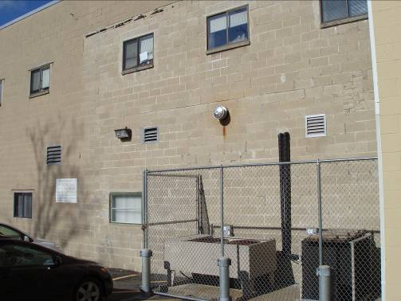

Fresh Air Intakes on Exterior Wall near Parking Lot

Picture 2

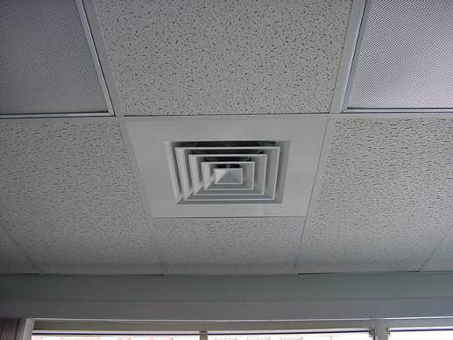

Ceiling-Mounted Air Diffuser

Picture 3

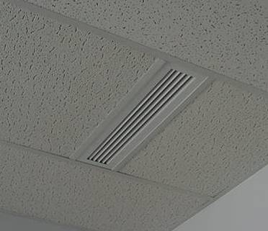

Ceiling-Mounted Return Vent in Office

Picture 4
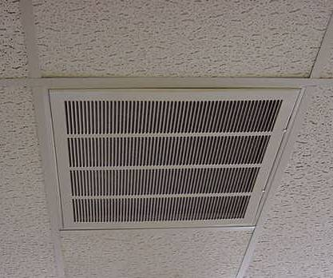

Ceiling-Mounted Return Vent in Common Work Area
Picture 5

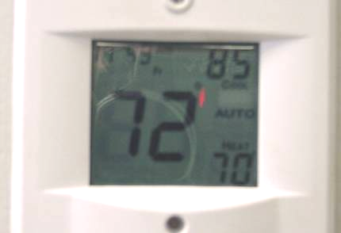

Thermostat with Fan in “Auto” Mode

Picture 6

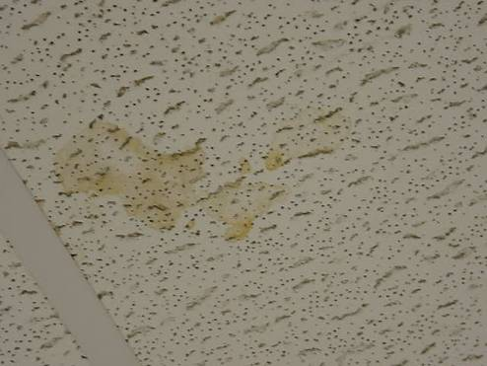

Water Stained Ceiling Tile
Picture 7

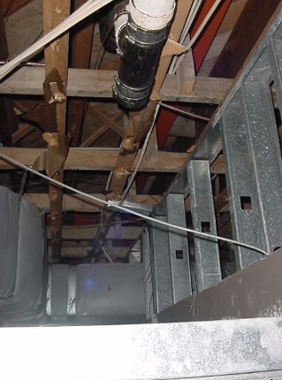

Plumbing (Top) and Metal Drip Pan (Bottom) above Ceiling Tiles in License Station 1

Picture 8

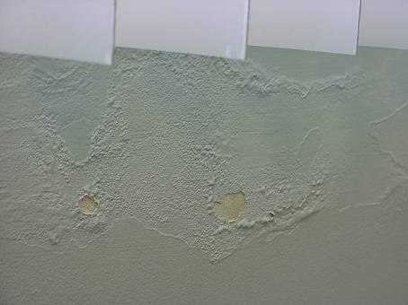

Peeling Paint and Efflorescence along Front Wall below Windows
Picture 9

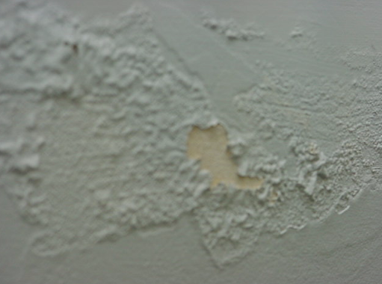

Peeling Paint and Efflorescence along Front Wall below Windows

Picture 10

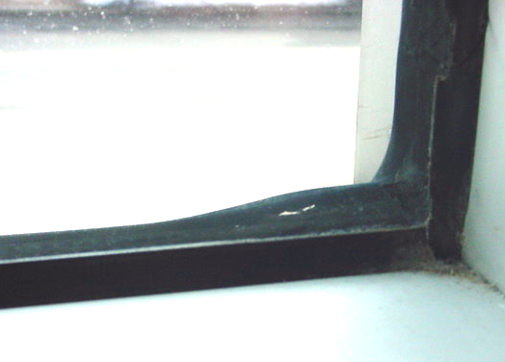

Loose/Damaged Caulking along Front Windows
Picture 11

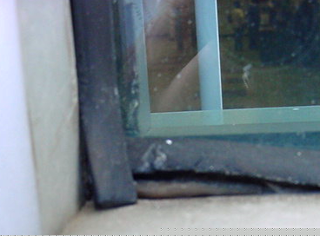

Loose/Damaged Caulking along Front Windows

Picture 12

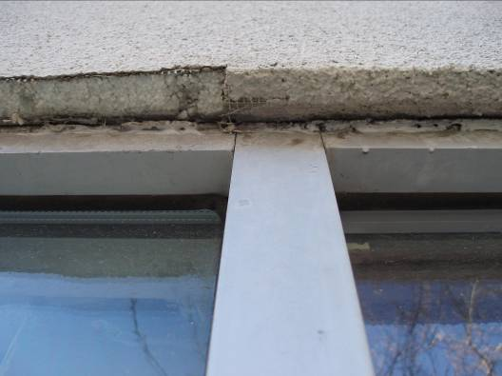

Damaged Exterior Exposing Styrofoam Insulation Material
Picture 13

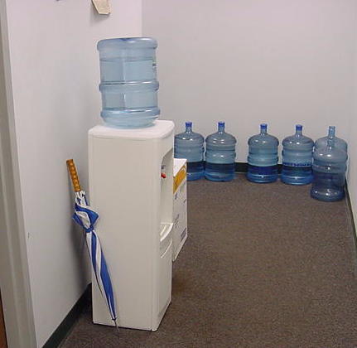

Water Cooler and Bottles on Carpet

Picture 14

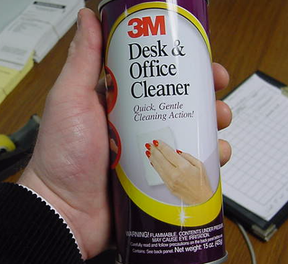

VOC-Containing Cleaning Agent, Note Label Warning: May Cause Eye Irritation
Picture 15

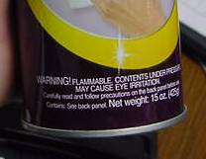

Close Up of Label Warning: May Cause Eye Irritation

Picture 16

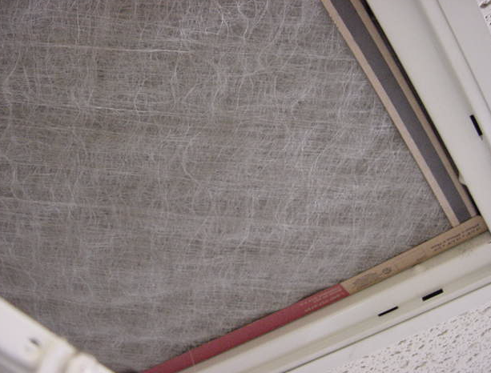

Fibrous Mesh Filter Installed in Return Vents
Picture 17

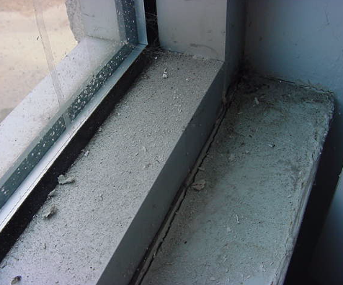

Dust/Debris Accumulation on Flat Surfaces in Office

Picture 18

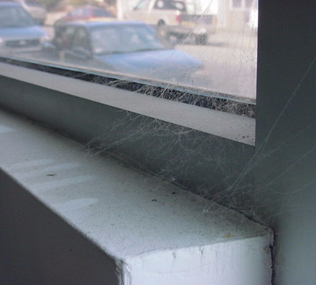

Cobwebs, Dust/Debris Accumulation on Flat Surfaces in Office
Picture 19

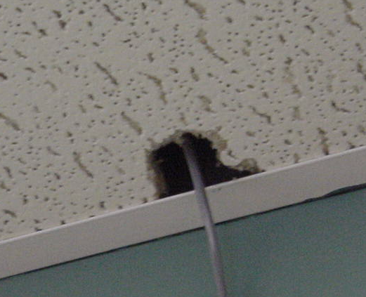

Hole in Ceiling Tile

Picture 20

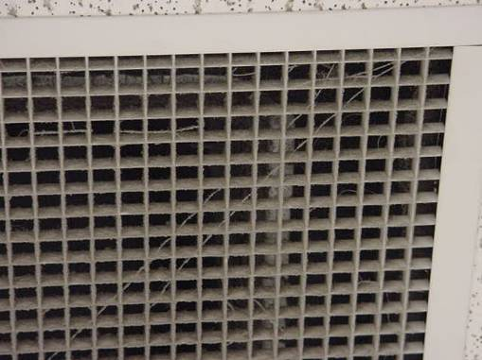

Cobwebs, Dust and Debris on Return Vent
Location | Carbon  Dioxide  (*ppm) | Temp  (°F) | Relative  Humidity  (%) | Carbon  Monoxide  (*ppm) | Occupants  in Room | Windows  Openable | Ventilation |  | Remarks
Background | 406 | 45 | 28 | ND |  |  |  |  | Mostly cloudy, winds: calm
Troopers Office/Hearing Room | 1123 | 69 | 30 | ND | 0 | Y | Y | Y | Dust/debris, cobwebs-flat surfaces, window sills
Foyer |  |  |  |  |  |  |  |  | Occupant reports of leaks
Customer Service Desk | 1100 | 69 | 30 | ND | 6 | N | Y | Y | 2 MT: corner and along wall
Waiting Room Station 13 | 1136 | 70 | 30 | ND | 6 | N | Y | Y
Custodial Closet |  |  |  |  |  | N | N | N
Ladies Room |  |  |  |  |  | N | Y | Y
Men’s Room |  |  |  |  |  | N | Y | Y
Waiting Room Stations 7-9 | 1174 | 69 | 32 | ND | 6 | Y | Y | Y | 2 CT
Waiting Room Stations1 and 2 | 1083 | 69 | 30 | ND | 8 | Y | Y | Y
Branch Manager Office | 1074 | 70 | 29 | ND | 0 | Y | Y | Y | Vent activated by light switch, cobwebs/dust
Work Stations 12/13 | 1073 | 70 | 29 | ND | 0 | N | Y | Y
Work Stations 9/10 | 1139 | 71 | 29 | ND | 3 | N | Y | Y
Work Stations 7/8 | 1123 | 71 | 29 | ND | 3 | N | Y | Y
Stock Room | 1162 | 71 | 29 | ND | 0 | Y | Y | Y | Dust/cobwebs flat surfaces/window sills
Work Stations 5/6 | 1100 | 71 | 28 | ND | 1 | N | Y | Y
Work Stations 3/4 | 1131 | 71 | 28 | ND | 3 | N | Y | Y
Conference/Break Room | 1046 | 71 | 27 | ND | 0 | Y | Y | Y | Clutter, plants, dust control
Work Stations 1/2 | 1101 | 71 | 29 | ND | 2 | N | Y | Y | Drip pan above CTs-dry, GW/carpet: low (normal) moisture
Auditor/Net Work Room | 1120 | 71 | 29 | ND | 0 | Y | Y | Y | Dust/cobwebs flat surfaces/window sills
Cash Counting | 1100 | 71 | 27 | ND | 0 | N | Y | Y | Dust/cobwebs flat surfaces
Cashier | 1090 | 71 | 27 | ND | 0 | Y | Y | Y | Fan-dust/cobwebs flat surfaces/window sills
Break Room | 1157 | 71 | 28 | ND | 2 | N | Y | Y | 1 CT, DEM
Rear Storage Room | 1104 | 71 | 27 | ND | 0 | N | Y | Y
Ladies Room |  |  |  |  |  | N | Y | Y
Men’s Room |  |  |  |  |  | N | Y | Y
Clerk 5 | 957 | 69 | 27 | ND | 0 | Y | Y | Y

