INDOOR AIR QUALITY ASSESSMENT

Registry of Motor Vehicles
4 Summer Street
Haverhill, Massachusetts

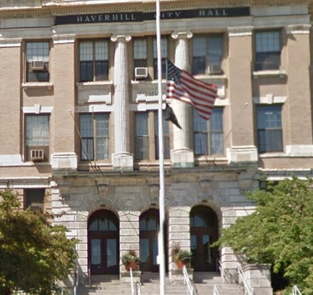

Prepared by:
Massachusetts Department of Public Health
Bureau of Environmental Health
Indoor Air Quality Program
March 2017

BACKGROUND
Building: | Registry of Motor Vehicles (RMV)
Address: | 4 Summer Street Haverhill, MA
Assessment Requested by: | Aric Warren, Transportation Program Planner, Massachusetts Department of Transportation
Reason for Request: | Water damage concerns following a steam pipe burst
Date of Assessment: | 2/16/2017
Massachusetts Department of Public Health/Bureau of Environmental Health (MDPH/BEH) Staff Conducting Assessment: | Jason Dustin, Environmental Analyst, Indoor Air Quality (IAQ) Program
Date of Building Construction: | 1906
Building Description: | Three-story brick office building. RMV is located in the basement area and contains open work areas (cubicles), office, and common areas. Most areas have tile but there is one area with wall-to-wall carpet.
Windows: | Non-openable; window air conditioners (ACs) are mounted in several windows.

Methods
Please refer to the IAQ Manual and appendices for methods, sampling procedures, and interpretation of results (MDPH, 2015).

IAQ Testing Results
The following is a summary of indoor air testing results (Table 1).
- Carbon dioxide levels were slightly above 800 parts per million (ppm) in over half of the basement RMV areas tested.
- Temperature was within the recommended range of 70°F to 78°F in all RMV areas tested.
- Relative humidity was below the recommended range of 40 to 60% in all areas tested as is typical during the heating season.
- Carbon monoxide levels were non-detectable (ND) in all indoor areas tested.
- Particulate matter (PM2.5) concentrations measured were below the National Ambient Air Quality (NAAQS) level of 35 μg/m³ in all areas tested.
- Total Volatile Organic Compounds (TVOCs) were ND in all areas tested.

Ventilation
It can be seen from Table 1 that carbon dioxide levels were slightly above 800 parts per million (ppm) in over half of the basement RMV areas tested, indicating that air exchange could be improved. The carbon dioxide levels measured likely reflect the limited introduction of outside air due to the lack of mechanical ventilation in the space. The RMV is heated with steam pipes and does not have an air handling unit (AHU) to introduce additional conditioned fresh air to the basement location.
As previously mentioned, the RMV does have window AC units (Picture 1), which may be used to introduce fresh air when operated during the “fan only” mode during temperate weather. One AC unit was operating during this assessment; the other two units were taped over to prevent winter drafts. Without adequate fresh air exchange, normally occurring pollutants cannot be diluted or removed, causing them to build up and lead to IAQ/comfort complaints.

Microbial/Moisture Concerns
As mentioned, the assessment was prompted by concerns related to a steam pipe rupture that occurred on Friday, February 12th, 2017. According to reports, approximately two-inches of water had accumulated in the space. Occupants reported that Haverhill City officials began extracting accumulated water soon after the pipe burst Friday evening. The RMV contracted with flood remediation contractor, Belfor Property Restoration, who arrived on Saturday and began remediation actions. Belfor deployed fans, dehumidifiers, and air scrubbers in their remediation efforts. They also removed stored items, removed base coving and drilled holes in walls/floor boards (Picture 2) where access was restricted. It should be noted that the majority of building materials at the RMV consist of concrete, tile, and brick all of which are not conducive to mold growth.
The United States Environmental Protection Agency (US EPA) and the American Conference of Governmental Industrial Hygienists (ACGIH) recommend that porous materials be dried with fans and heating within 24 to 48 hours of becoming wet (US EPA, 2008; ACGIH, 1989). If porous materials are not dried within this time frame, they should be removed and discarded. According to reports by RMV staff, Belfor dried remaining porous materials within this time frame.
BEH/IAQ staff noted a box of learner’s permits (Picture 3) that remained moist and brought this to the attention of the RMV manager. Using a moisture meter, BEH/IAQ staff noted that all carpeting and other porous items tested were found to be dry at the time of the assessment. In general, boxes and stored papers should be stored on shelving and not directly on the ground especially in a basement location where condensation can damage these porous items.

Volatile Organic Compounds
Indoor air concentrations can be greatly impacted by the use of products containing volatile organic compounds (VOCs). VOCs are carbon-containing substances that have the ability to evaporate at room temperature. Total volatile organic compounds (TVOCs) can result in eye and respiratory irritation if exposure occurs. For example, chemicals evaporating from a paint can stored at room temperature would most likely contain VOCs. In an effort to identify materials that can potentially increase indoor VOC concentrations, BEH/IAQ staff examined rooms for products containing these respiratory irritants. BEH/IAQ staff also measured TVOC levels in the space. TVOC levels were ND at the time of the assessment.
Hand sanitizers, air deodorizers, and cleaning products were observed in several areas (Picture 4). Hand sanitizer products may contain ethyl alcohol and/or isopropyl alcohol, which are highly volatile and may be irritating to the eyes and nose. Deodorizers contain chemicals/fragrances to which some people may be sensitive.
Belfor deployed a high efficiency particulate air filter (HEPA) air scrubber (Picture 5) that apparently also contained a deodorizing agent to help with complaints from occupants regarding a “chemical” odor. The odor reportedly was due to the repair of the steam pipe that had burst. Pipe repair sealant (Picture 6) was the likely source of this initial odor since it may contain solvents that evaporate at room temperature. BEH/IAQ staff did not detect any solvent odor at the time of the assessment but did detect a strong cherry deodorizer odor. BEH/IAQ staff received several complaints regarding the strong deodorizing odor during the assessment. Typically, a HEPA scrubber is useful in filtering out small particulate matter but unless it also contains an activated carbon filter it will only mask any solvents with an added fragrance. It was not known at the time of the assessment if the air scrubber was also fitted with a carbon filter to absorb TVOCs rather than just mask them.

Other IAQ Evaluations
Other conditions that can affect IAQ were observed during the assessment. A small area in the office is carpeted; the Institute of Inspection, Cleaning, and Restoration Certification (IICRC), recommends that carpeting be cleaned annually (or semi-annually in soiled high traffic areas) (IICRC, 2012). As mentioned this carpeting was tested and found to be dry at the time of the assessment but it also appeared to be worn and past it’s useful life (Picture 7). In general, carpeting is not recommended in basement areas especially if exposed to chronic moisture. Since the average lifespan of carpeting is approximately eleven years (Bishop, 2002), consideration should be given to planning for the installation of new flooring.
In some areas, a large number of items were on flat surfaces (e.g., floors, windowsills, tabletops), which provide a source for dusts to accumulate. These items (e.g., papers, folders, boxes) make it difficult for areas to be cleaned. Items should be relocated and/or be cleaned periodically to avoid excessive dust build up. In addition, dust and debris can accumulate on flat surfaces (e.g., desktops, shelving and carpets) in occupied areas and subsequently be re-aerosolized causing further irritation.
BEH/IAQ staff noted the presence of loose and peeling paint in the area of the steam pipe burst (Picture 6). Some occupants expressed concerns about this condition. Given the age of the building, any repairs made to this paint should be performed during unoccupied hours and utilize lead safe remediation practices.

Conclusions/Recommendations
Based on observations at the time of assessment, the following is recommended:
- Remove the box of 2016 learner’s permits that was found to be still moist during the assessment. Remove and discard any other porous materials that are found to be moist beyond the EPA recommended 24-48 hour drying period. These records may be scanned or copied prior to discarding.
- Remove deodorizing agent from air scrubber or entire scrubber from the space due to the complaints received from the strong fragrance which can have irritant effects.
- Inspect area of loose/peeling paint in area of pipe burst. Any repairs made to this paint should be performed during unoccupied hours and utilize lead safe remediation practices.
- Consider consulting with an HVAC contractor to improve fresh air exchange in the space. In the meanwhile, window AC units can be utilized in “fan only” mode to bring in more fresh air during temperate weather.
- For buildings in New England, periods of low relative humidity during the winter are often unavoidable. Therefore, scrupulous cleaning practices should be adopted to minimize common indoor air contaminants whose irritant effects can be enhanced when the relative humidity is low. To control for dusts, a high efficiency particulate arrestance (HEPA) filter equipped vacuum cleaner in conjunction with wet wiping of all surfaces is recommended. Avoid the use of feather dusters. Drinking water during the day can help ease some symptoms associated with a dry environment (throat and sinus irritations).
- Ensure that procedures are in place for occupants to report leaks, wet tiles, and other maintenance conditions so that issues can be resolved promptly.
- Do not store cardboard boxes directly on floors; store on shelving/off the ground to prevent moistening/mold growth.
- Relocate or consider reducing the amount of stored materials in offices to allow for more thorough cleaning. Move items from floors when possible. Clean items regularly with a wet cloth or sponge to prevent excessive dust build-up. Consider coordinating between staff and maintenance personnel to conduct quarterly clean-up activities.
- Reduce the use of products containing VOCs/fragrances (e.g., hand sanitizers, air deodorizers, and harsh cleaning products).
- Clean carpeting annually or semi-annually in soiled high traffic areas as per the recommendations of the Institute of Inspection, Cleaning, and Restoration Certification (IICRC, 2012). Consider replacing carpeting that is past its useful service life. When choosing a new flooring material, remember that in general, carpeting is not recommended for below grade spaces.
- Refer to resource manuals and other related indoor air quality documents for further building-wide evaluations and advice on maintaining public buildings. Copies of these materials are located on the MDPH’s website: http://mass.gov/dph/iaq.

References
ACGIH. 1989. Guidelines for the Assessment of Bioaerosols in the Indoor Environment. American Conference of Governmental Industrial Hygienists, Cincinnati, OH.
Bishop. 2002. Bishop, J. & Institute of Inspection, Cleaning and Restoration Certification. A Life Cycle Cost Analysis for Floor Coverings in School Facilities.
IICRC. 2012. Institute of Inspection Cleaning and Restoration Certification. Institute of Inspection, Cleaning and Restoration Certification. Carpet Cleaning: FAQ. Retrieved from http://www.iicrc.org/consumers/care/carpet-cleaning.
MDPH. 2015. Massachusetts Department of Public Health. Massachusetts Department of Public Health Indoor Air Quality Manual: Chapters I-III. Available at: http://www.mass.gov/eohhs/gov/departments/dph/programs/environmental-health/exposure-topics/iaq/iaq-manual/.
US EPA. 2008. “Mold Remediation in Schools and Commercial Buildings”. Office of Air and Radiation, Indoor Environments Division, Washington, DC. EPA 402-K-01-001. September 2008. Available at: http://www.epa.gov/mold/mold-remediation-schools-and-commercial-buildings-guide.
Picture 1
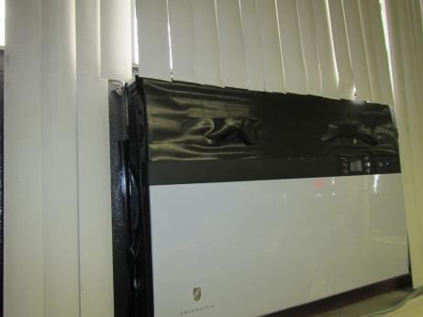
Window-mounted air conditioning unit (note tape over air vents)
Picture 2
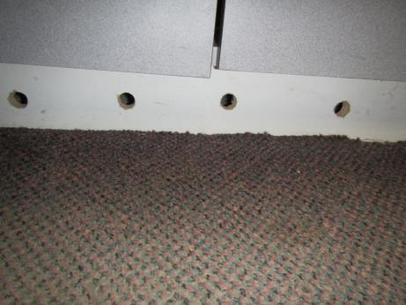
Holes drilled in desk floor board to accelerate drying
Picture 3
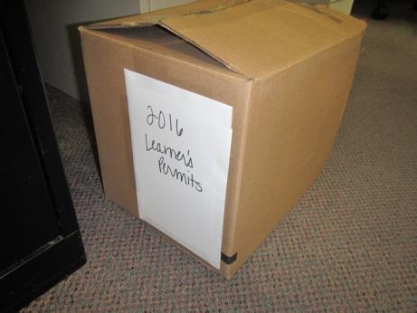
Box of permits found to be moist during assessment
Picture 4
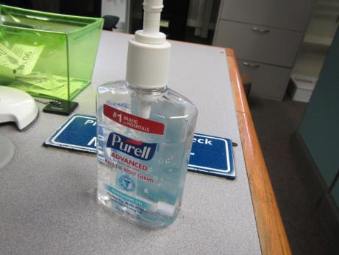
Hand sanitizer containing fragrances
Picture 5
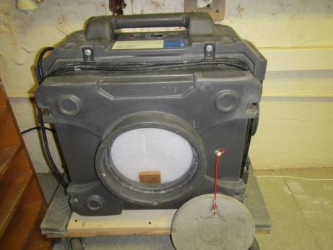
HEPA air scrubber located in area of pipe burst
Picture 6
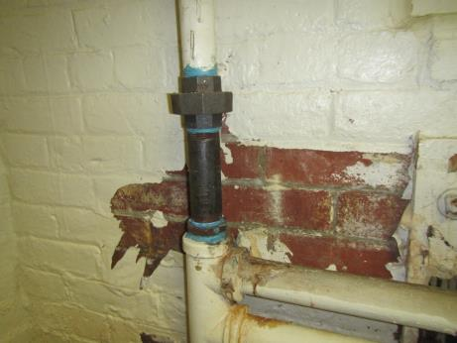
Steam pipe repair (new black pipe); note blue pipe dope
Picture 7
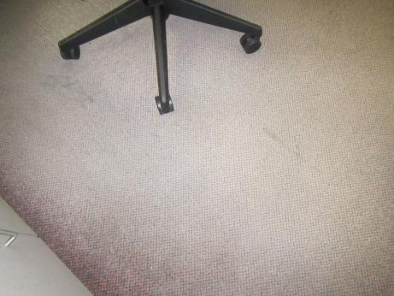
Area of worn carpeting

Location | Carbon  Dioxide  (ppm) | Carbon Monoxide  (ppm) | Temp  (°F) | Relative  Humidity  (%) | PM2.5  (µg/m³) | TVOCs  (ppm) | Occupants  in Room | Windows  Openable | Ventilation |  | Remarks
 |  |  |  |  |  |  |  |  | Supply | Exhaust
Background | 387 | 0.5 | 33 | 54 | 9 | ND | - | - | - | - | Busy Road, light snow
1st floor Foyer | 798 | ND | 65 | 38 | 18 | ND | 1 | N | N | N | Slight odor (old varnish?)
Storage room/gas adjacent to RMV |  |  |  |  |  |  |  |  |  |  | No water, cardboard dry, storage files dry
Left corner near pipe burst | 883 | ND | 72 | 31 | 8 | ND | 9 | N | N | N | Air scrubber with strong fragrance scent, peeling paint, carpet & items dry
Counter 4 & 5 | 774 | ND | 72 | 27 | 7 | ND | 5 | N | N | N | Window AC on, carpet & items dry, HS
Corner cube (Carol) | 815 | ND | 72 | 27 | 7 | ND | 1 | N | N | N | Window AC taped shut, carpet & items dry

