INDOOR AIR QUALITY ASSESSMENT

Registry of Motor Vehicles
278 Union Street
New Bedford, Massachusetts 02740

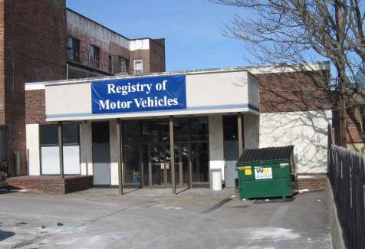

Prepared by:
Massachusetts Department of Public Health
Bureau of Environmental Health
Indoor Air Quality Program
May 2009

Background/Introduction
In response to a request from the National Association of Government Employees (NAGE) on behalf of the Massachusetts Registry of Motor Vehicles (RMV) staff, the Massachusetts Department of Public Health (DPH), Bureau of Environmental Health (BEH) provided assistance and consultation regarding indoor air quality concerns at the RMV branch office located at 278 Union Street, New Bedford, Massachusetts. The visit was coordinated through Michael Fleming, Massachusetts Executive Office of Transportation (EOT) and Aric Warren, RMV.
On February 5, 2009, Cory Holmes, Environmental Analyst/Inspector for BEH’s Indoor Air Quality (IAQ) Program, made a visit to this building to conduct an assessment. The assessment was prompted by concerns of possible mold growth and water-damaged building materials due to a roof leak in rooms 6 & 7. Mr. Holmes was accompanied during the assessment by Mike Spatafore, RMV Program Coordinator and Mr. Warren.
The branch office occupies a one-story, red brick building reportedly built in the early 1900’s. The RMV has occupied the building since August 2008. Prior to RMV occupancy, the building formerly was a bank. The space is made up of a large open service area/waiting room, offices, testing rooms, a break room and storage space. Occupied areas have wall-to-wall carpet and a dropped-ceiling tile system. The basement is unfinished/unoccupied, and contains heating and ventilation equipment.
Methods
Air tests for carbon monoxide, carbon dioxide, temperature and relative humidity were conducted with the TSI, Q-Trak, IAQ Monitor, Model 8554. Air tests for airborne particle matter with a diameter less than 2.5 micrometers were taken with the TSI, DUSTTRAK™ Aerosol Monitor Model 8520. MDPH staff also performed visual inspection of building materials for water damage and/or microbial growth.
Results
The branch office has a daily employee population of 15 and is visited by up to several hundred individuals daily. The tests were taken during normal operations and results appear in Table 1.

Discussion
Ventilation
It can be seen from Table 1 that carbon dioxide levels were above 800 parts per million (ppm) in all areas, indicating a lack of air exchange at the time of the assessment. It is important to note that a number of areas were sparsely populated or unoccupied, which typically results in reduced carbon dioxide levels. Carbon dioxide levels would be expected to be higher with increased occupancy; therefore, carbon dioxide levels measured in these areas and in particular, the service area/waiting room, (which is a large open area), further illustrates a lack of air exchange.
The heating, ventilating and air-conditioning (HVAC) system consists of four air-handling units (AHUs) or heat pumps, located in the basement. Fresh air is drawn into the AHUs through air intakes on the exterior wall and delivered to occupied areas via ceiling-mounted air diffusers (Picture 1). Return air is drawn into ceiling-mounted vents and ducted back to the AHUs (Picture 2). A digital wall-mounted thermostat controls the HVAC system and has fan settings of “on” and “automatic”.
Mr. Warren reported that previous to the BEH assessment occupants complained of a lack of airflow/discomfort and that the fan setting was typically set to the “auto” setting. The automatic setting on the thermostat activates the HVAC system at a preset temperature. Once the preset temperature is reached, the HVAC system is deactivated. Therefore, no mechanical ventilation is provided until the thermostat re-activates the system. Without a continuous source of fresh outside air and removal via the exhaust/return system, indoor environmental pollutants can build-up and lead to indoor air quality/comfort complaints. At Mr. Warren’s direction, the thermostat was set to the fan” on” setting at the time of the assessment (Picture 3). BEH staff also recommended that the RMV work with their building’s HVAC vendor to increase outside air intake.
The “IM Room” is an interior office that had several supply vents but no exhaust or return vents. In order to provide air exchange, it is recommended that either the door be undercut or a passive vent be installed.
To maximize air exchange, the MDPH recommends that both supply and exhaust ventilation operate continuously during periods of occupancy. In order to have proper ventilation with a mechanical supply and exhaust system, the systems must be balanced to provide an adequate amount of fresh air to the interior of a room while removing stale air from the room. It is recommended that HVAC systems be re-balanced every five years to ensure adequate air systems function (SMACNA, 1994).
The Massachusetts Building Code requires a minimum ventilation rate of 20 cubic feet per minute (cfm) per occupant of fresh outside air or have openable windows in each room (SBBRS, 1997; BOCA, 1993). The ventilation must be on at all times that the room is occupied. Providing adequate fresh air ventilation with open windows and maintaining the temperature in the comfort range during the cold weather season is impractical. Mechanical ventilation is usually required to provide adequate fresh air ventilation.
Carbon dioxide is not a problem in and of itself. It is used as an indicator of the adequacy of the fresh air ventilation. As carbon dioxide levels rise, it indicates that the ventilating system is malfunctioning or the design occupancy of the room is being exceeded. When this happens, a buildup of common indoor air pollutants can occur, leading to discomfort or health complaints. The Occupational Safety and Health Administration (OSHA) standard for carbon dioxide is 5,000 parts per million parts of air (ppm). Workers may be exposed to this level for 40 hours/week, based on a time-weighted average (OSHA, 1997).
The MDPH uses a guideline of 800 ppm for publicly occupied buildings. A guideline of 600 ppm or less is preferred in schools due to the fact that the majority of occupants are young and considered to be a more sensitive population in the evaluation of environmental health status. Inadequate ventilation and/or elevated temperatures are major causes of complaints such as respiratory, eye, nose and throat irritation, lethargy and headaches. For more information concerning carbon dioxide, please see Appendix A.
Indoor temperature readings ranged from 65º F to 70 º F, which were below or at the lower end of the MDPH recommended comfort guidelines at the time of the assessment. The MDPH recommends that indoor air temperatures be maintained in a range of 70 º F to 78 º F in order to provide for the comfort of building occupants. In many cases concerning indoor air quality, fluctuations of temperature in occupied spaces are typically experienced, even in a building with an adequate fresh air supply. As previously mentioned, complaints of poor airflow and thermal discomfort have been expressed by occupants. Mr. Warren reported that the RMV is currently working with building management and their HVAC vendor to have thermostats replaced for better temperature control. Replacement of thermostatic controls, operating the system in the fan “on” setting for continuous air exchange, along with BEH’s suggestion to increase outside air intake should greatly improve comfort levels for occupants of the building.
The relative humidity measurements in the building ranged from 25 to 35 percent, which were below the MDPH recommended comfort range in all areas surveyed on the day of the assessment. The MDPH recommends a comfort range of 40 to 60 percent for indoor air relative humidity. Relative humidity levels in the building would be expected to drop during the winter months due to heating. The sensation of dryness and irritation is common in a low relative humidity environment. Low relative humidity is common during the heating season in the northeast part of the United States.

Microbial/Moisture Concerns
Mr. Warren reported that the building has had chronic roof leaks and prior to the RMV occupancy, the roof was reportedly repaired. In addition a contract with a flooding restoration firm, ServiceMaster, was secured to conduct remediation and removal of water damaged materials. At the time of the assessment, a roof leak had occurred in rooms 6 & 7, in a centrally located area. Prompt investigation and repair of the leak was hampered due to heavy snow and ice on the roof. To mitigate these effects, water damaged-ceiling tiles were removed, and a bucket was placed in the area to collect water (Picture 4). No obvious mold growth was noted as a result of the current leak; however, white staining on wooden beams in the ceiling plenum was observed, which may indicate either historic mold growth or efflorescence due to water penetration through the building envelope (Picture 5).
Efflorescence is a characteristic sign of water damage but it is not mold growth. As moisture penetrates and works its way through building materials, water-soluble compounds dissolve, creating a solution. As the solution moves to the surface the water evaporates, leaving behind white, powdery mineral deposits. At the time of the assessment, BEH staff recommended that the material be cleaned. In subsequent correspondence with Mr. Warren, he reported that the beams had been cleaned by ServiceMaster.
Repeated water damage to porous building materials (e.g., GW, plaster, ceiling tiles and carpeting) can result in microbial growth. The US Environmental Protection Agency (US EPA) and the American Conference of Governmental Industrial Hygienists (ACGIH) recommend that porous materials be dried with fans and heating within 24 to 48 hours of becoming wet (US EPA, 2001; ACGIH, 1989). If not dried within this time frame, mold growth may occur. Once mold has colonized porous materials, they are difficult to clean and should be removed.
Standing water was observed in the basement in close proximity to the AHUs for the HVAC system (Picture 6). Although the area was equipped with a sump pump and floor drain, it filled with water and appeared to have not worked for some time (Pictures 7 and 8). Standing water can become stagnant and be a source for mold, bacteria and associated odors, which can be entrained into the ventilation system. In addition, exposure of metal components of the AHUs to water can compromise the integrity of the units (Picture 6). At the time of the assessment, BEH staff strongly recommended to Mr. Warren that the sump pump be repaired/replaced and that the drain be unclogged. In subsequent correspondence with Mr. Warren, he reported that both issues were corrected.
Other IAQ Evaluations
Indoor air quality can be negatively influenced by the presence of respiratory irritants, such as products of combustion. The process of combustion produces a number of pollutants. Common combustion emissions include carbon monoxide, carbon dioxide, water vapor and smoke (fine airborne particle material). Of these materials, exposure to carbon monoxide and particulate matter with a diameter of 2.5 micrometers (μm) or less (PM2.5) can produce immediate, acute health effects upon exposure. To determine whether combustion products were present in the building, BEH staff obtained measurements for carbon monoxide and PM2.5.
Carbon Monoxide
Carbon monoxide is a by-product of incomplete combustion of organic matter (e.g., gasoline, wood and tobacco). Exposure to carbon monoxide can produce immediate and acute health affects. Several air quality standards have been established to address carbon monoxide and prevent symptoms from exposure to these substances. The MDPH established a corrective action level concerning carbon monoxide in ice skating rinks that use fossil-fueled ice resurfacing equipment. If an operator of an indoor ice rink measures a carbon monoxide level over 30 ppm, taken 20 minutes after resurfacing within a rink, that operator must take actions to reduce carbon monoxide levels (MDPH, 1997).
The American Society of Heating Refrigeration and Air-Conditioning Engineers (ASHRAE) has adopted the National Ambient Air Quality Standards (NAAQS) as one set of criteria for assessing indoor air quality and monitoring of fresh air introduced by HVAC systems (ASHRAE, 1989). The NAAQS are standards established by the US EPA to protect the public health from six criteria pollutants, including carbon monoxide and particulate matter (US EPA, 2006). As recommended by ASHRAE, pollutant levels of fresh air introduced to a building should not exceed the NAAQS levels (ASHRAE, 1989). The NAAQS were adopted by reference in the Building Officials & Code Administrators (BOCA) National Mechanical Code of 1993 (BOCA, 1993), which is now an HVAC standard included in the Massachusetts State Building Code (SBBRS, 1997). According to the NAAQS, carbon monoxide levels in outdoor air should not exceed 9 ppm in an eight-hour average (US EPA, 2006).
Carbon monoxide should not be present in a typical, indoor environment. If it is present, indoor carbon monoxide levels should be less than or equal to outdoor levels. On the day of assessment, outdoor carbon monoxide concentrations were non-detect (ND) (Table 1). No levels of carbon monoxide were detected in the building at the time of the assessment (Table 1).
Particulate Matter (PM2.5)
The US EPA has established NAAQS limits for exposure to particulate matter. Particulate matter is airborne solids that can be irritating to the eyes, nose and throat. The NAAQS originally established exposure limits to particulate matter with a diameter of 10 μm or less (PM10). According to the NAAQS, PM10 levels should not exceed 150 microgram per cubic meter (μg/m³) in a 24-hour average (US EPA, 2006). These standards were adopted by both ASHRAE and BOCA. Since the issuance of the ASHRAE standard and BOCA Code, US EPA established a more protective standard for fine airborne particles. This more stringent PM2.5 standard requires outdoor air particle levels be maintained below 35 μg/m³ over a 24-hour average (US EPA, 2006). Although both the ASHRAE standard and BOCA Code adopted the PM10 standard for evaluating air quality, MDPH uses the more protective PM2.5 standard for evaluating airborne particulate matter concentrations in the indoor environment.
Outdoor PM2.5 concentrations were measured at 11 μg/m³ (Table 1). PM2.5 levels measured indoors ranged from 5 to 9 μg/m³ (Table 1). Both indoor and outdoor PM2.5 levels were below the NAAQS PM2.5 level of 35 μg/m³. Frequently, indoor air levels of particulates (including PM2.5) can be at higher levels than those measured outdoors. A number of mechanical devices and/or activities that occur in buildings can generate particulate during normal operations. Sources of indoor airborne particulates may include but are not limited to particles generated during the operation of fan belts in the HVAC system, cooking in stoves and microwave ovens; use of photocopiers, fax machines and computer printing devices; operation of an ordinary vacuum cleaner and heavy foot traffic indoors.
Other Conditions
Other conditions that can affect indoor air quality were observed during the assessment. The HVAC filters installed at the RMV are high efficiency-pleated filters (Picture 9) that are changed six times a year under a preventative maintenance plan by a private HVAC engineering firm. Although filters were clean and appeared to have been recently changed, the filters did not fit properly. Filters were observed extending out of their filter slots and had spaces on either side (Pictures 10 and 11). In addition, the units did not have filter access panels installed. The lack of access panels will render the AHU casing non-airtight and draw air from the basement space into the unit. As air bypasses filters, the opportunity exists for airborne dirt, dust, odors and particulates to be drawn into the HVAC system and be distributed to occupied areas. Aerosolized dust, particulates and odors can provide a source of eye, skin and respiratory irritation to certain individuals. In addition, these materials can accumulate on flat surfaces in occupied areas and subsequently be re-aerosolized causing further irritation.

Conclusions/Recommendations
In view of the findings at the time of the assessment, the following recommendations are made:
- If not completed, continue with plans to make roof repairs. Monitor rooms 6 & 7 for further leaks. Report to building management for prompt action.
- Replace any remaining water-stained ceiling tiles.
- Periodically inspect basement sump pump and floor drain for proper function, particulary after heavy rains. Make repairs as needed.
- Have building management consult with an HVAC engineer to determine whether the existing fresh air intake system has the capability to provide a sufficient supply of outside air. Increased fresh air supply is recommended given the elevated levels of carbon dioxide measured during the assessment.
- To facilitate air exchange in the IM Room, undercut the door approximately 1 to 2 inches or install a passive door vent.
- Continue with plans to evaluate and replace thermostatic controls (if necessary) for better temperature/comfort control.
- Consider balancing mechanical ventilation systems every 5 years, as recommended by ventilation industrial standards (SMACNA, 1994).
- Ensure filters for all AHUs and heat pumps fit flush in their racks with no spaces to prevent bypass of unfiltered air.
- Install filter access panels on basement AHUs, see Picture 12 for an example.
- For buildings in New England, periods of low relative humidity during the winter are often unavoidable. Therefore, scrupulous cleaning practices should be adopted to minimize common indoor air contaminants whose irritant effects can be enhanced when the relative humidity is low. To control for dusts, a high efficiency particulate arrestance (HEPA) filter equipped vacuum cleaner in conjunction with wet wiping of all surfaces is recommended. Drinking water during the day can help ease some symptoms associated with a dry environment (throat and sinus irritations).
- Clean personal fans, supply, return and restroom exhaust vents periodically of accumulated dust.
- Clean carpeting annually or semi-annually in high traffic areas as per the recommendations of the Institute of Inspection, Cleaning and Restoration Certification (IICRC). Copies of the IICRC fact sheet can be downloaded at: http://www.cleancareseminars.com/carpet_cleaning_faq4.htm (IICRC, 2005).
- Refer to resource manuals and other related indoor air quality documents for further building-wide evaluations and advice on maintaining public buildings. Copies of these materials are located on the MDPH’s website: http://mass.gov/dph/indoor_air.
References
ACGIH. 1989. Guidelines for the Assessment of Bioaerosols in the Indoor Environment. American Conference of Governmental Industrial Hygienists, Cincinnati, OH.

ASHRAE. 1989. Ventilation for Acceptable Indoor Air Quality. American Society of Heating, Refrigeration and Air Conditioning Engineers. ANSI/ASHRAE 62-1989
BOCA. 1993. The BOCA National Mechanical Code/1993. 8th ed. Building Officials and Code Administrators International, Inc., Country Club Hill, IL. Section M-308.1.1.

IICRC. 2005. Carpet Cleaning FAQ 4 Institute of Inspection, Cleaning and Restoration Certification. Institute of Inspection Cleaning and Restoration, Vancouver, WA.

MDPH. 1997. Requirements to Maintain Air Quality in Indoor Skating Rinks (State Sanitary Code, Chapter XI). 105 CMR 675.000. Massachusetts Department of Public Health, Boston, MA.
OSHA. 1997. Limits for Air Contaminants. Occupational Safety and Health Administration. Code of Federal Regulations. 29 C.F.R 1910.1000 Table Z-1-A.

SBBRS. 1997. Mechanical Ventilation. State Board of Building Regulations and Standards. Code of Massachusetts Regulations. 780 CMR 1209.0

SMACNA. 1994. HVAC Systems Commissioning Manual. 1st ed. Sheet Metal and Air Conditioning Contractors’ National Association, Inc., Chantilly, VA.

US EPA. 2001. Mold Remediation in Schools and Commercial Buildings. US Environmental Protection Agency, Office of Air and Radiation, Indoor Environments Division, Washington, DC. EPA 402-K-01-001. March 2001.

US EPA. 2006. National Ambient Air Quality Standards (NAAQS). . US Environmental Protection Agency, Office of Air Quality Planning and Standards, Washington, DC. http://www.epa.gov/air/criteria.html.

Picture 1

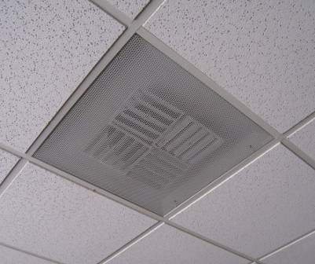

Ceiling-Mounted Supply Diffuser

Picture 2

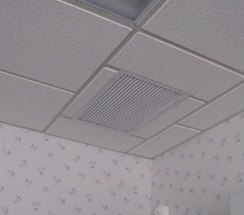

Ceiling-Mounted Return Vent

Picture 3

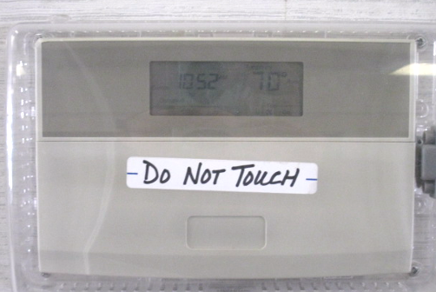

Digital Thermostat for HVAC System

Picture 4

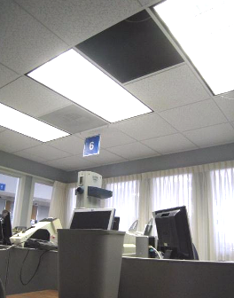

Roof Leak in Rooms 6 & 7, Note Tile Removed to Catch Water in Bucket (below)

Picture 5

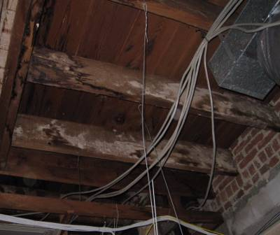

White Staining on Wooden Beams above Rooms 6 & 7

Picture 6

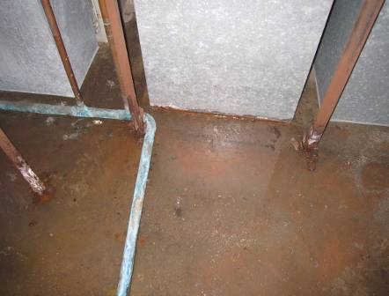

Standing Water near Air Handling Units in Basement, Note Base of Units Starting to Rust

Picture 7

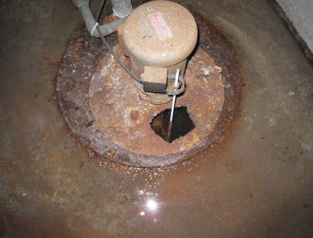

Inoperable Sump Pump Filled with Standing Water

Picture 8

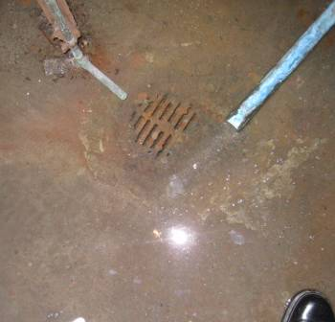

Inoperable Floor Drain Filled with Standing Water

Picture 9

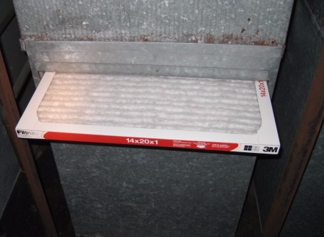

Pleated Air Filters in Basement AHU/Heat Pump

Picture 10

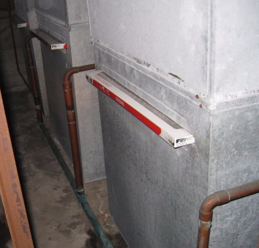

Filters Protruding from Basement AHUs/Heat Pumps,
Note no Filter Access Panels are Installed

Picture 11

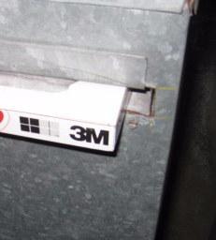

Close-Up of Spaces around Filter in Basement AHU/Heat Pump Indicating Filter Bypass

Picture 12

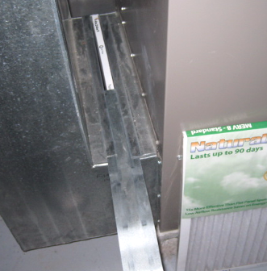

Example of Filter Access Panel on Residential AHU, Panel Slid Back to
Reveal Interior Filter
Location/ Room | Occupants  in Room | Temp  (°F) | Relative  Humidity  (%) | Carbon  Dioxide  (ppm) | Carbon Monoxide  (ppm) | PM2.5  (µg/m3) | Windows  Openable | Ventilation |  | Remarks
 |  |  |  |  |  |  |  | Supply | Exhaust
background |  | <32 | 49 | 359 | ND | 10 |  |  |  | Cold, clear, wind chill <32
Kitchen/  Break Room | 3 | 69 | 35 | 805 | ND | 2 | N | Y | Y | Dust/debris on windowsill
Employees Restroom |  |  |  |  |  |  | N | Y | Y
Public Restroom |  |  |  |  |  |  |  | Y | Y
Basement |  |  |  |  |  |  |  |  |  | 4 AHUs/heat pumps, standing water-inoperable sump pump and floor drain, filters clean: no panels/filter bypass
Waiting Area Rear Entrance | 4 | 65 | 30 | 819 | ND | 6 | N | Y | Y
Testing Room | 2 | 67 | 30 | 874 | ND | 5 | N | Y | N
6 & 7 | 7 | 68 | 29 | 986 | ND | 5 | N | Y | N | Roof leak into bucket, white staining on wooden beams above ceiling tiles-recommend cleaning
Main Lobby | 30 | 68 | 25 | 841 | ND | 6 | N | Y | Y
Registration Counter | 8 | 68 | 25 | 900 | ND | 11 | N | Y | N
Manager’s Office | 4 | 65 | 27 | 972 | ND | 8 | N | Y | Y
Plate Storage | 3 | 66 | 28 | 977 | ND | 8 | N | Y | N
IM Room | 4 | 70 | 27 | 1070 | ND | 7 | N | Y | N | No return/exhaust vent, recommend undercut door or passive vent

