INDOOR AIR QUALITY ASSESSMENT

Massachusetts Registry of Motor Vehicles
165 Liberty Street
Springfield, Massachusetts

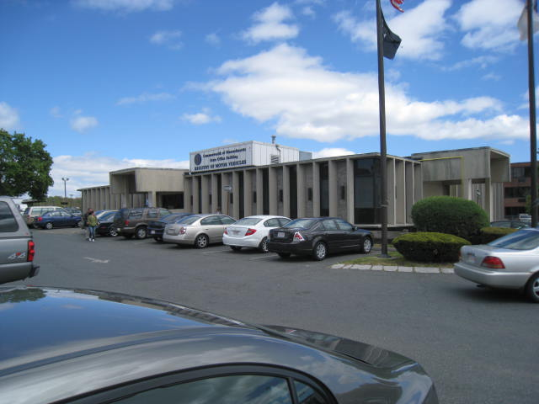

Prepared by:
Massachusetts Department of Public Health
Bureau of Environmental Health
Indoor Air Quality Program
May 2016

Background
Building: | Massachusetts Registry of Motor Vehicles
Address: | 165 Liberty Street Springfield, Massachusetts
Assessment Requested by: | Aric Warren
Reason for Request: | General indoor air quality (IAQ) concerns
Date of Assessment: | March 25, 2016
Massachusetts Department of Public Health/Bureau of Environmental Health (MDPH/BEH) Staff Conducting Assessment: | Mike Feeney, Director and Jason Dustin, Environmental Analyst/Inspector, IAQ Program
Building Description: | Two-story, concrete building with flat, membrane roof
Building Population: | Approximately 30 and up to several hundred visitors daily
Year of Construction: | Early 1970’s
Windows: | Not openable

METHODS
Please refer to the IAQ Manual for methods, sampling procedures, and interpretation of results (MDPH, 2015).

IAQ Testing Results
The following is a summary of indoor air testing results (Table 1).
- Carbon dioxide levels were above 800 parts per million (ppm) in 5 out of 8 areas tested, indicating inadequate fresh air in more than half of the areas tested. The RMV was extremely crowded during the assessment, which generally increases carbon dioxide levels.
- Temperature was within the recommended range of 70°F to 78°F in all areas tested.
- Relative humidity was within or close to the lower end of the recommended range of 40% to 60% in all areas tested.
- Carbon monoxide levels were non-detectable in all indoor areas tested.
- Fine particulate matter (PM2.5) concentrations measured were below the National Ambient Air Quality Standard (NAAQS) level of 35 μg/m³ in all areas tested.
- Total volatile organic compounds (TVOCs) levels were non-detectable in all areas assessed.

Ventilation

It can be seen from Table 1 that carbon dioxide levels were above 800 parts per million (ppm) in 5 of 8 areas, indicating less than optimal air exchange at the time of the assessment. It is important to note that most areas were extremely populated at the time measurements were taken, which generally results in increased carbon dioxide levels. Without adequate air exchange, ordinary indoor pollutants can build up over the course of the business day and lead to IAQ/comfort complaints.

Mechanical ventilation on the upper floor is provided by rooftop air-handling units (AHUs). Fresh air is drawn into the AHUs and delivered to occupied areas via ductwork. Recirculated air is directed into the office space by ceiling-mounted fresh air diffusers. Return air is ducted back to the rooftop AHUs. To maximize air exchange, the MDPH recommends that both supply and exhaust ventilation operate continuously during periods of occupancy. In order to have proper ventilation with a mechanical supply and exhaust system, the systems must be balanced to provide an adequate amount of fresh air to the interior of a room while removing stale air from the room.

Microbial/Moisture Concerns
It was reported that the roof is original to the building and has leaked in the past. RMV staff reported that a new roof would be installed shortly and that the occupants are being permanently relocated to another building within 6 months of this visit.
Water-damaged ceiling tiles were observed in several areas. Water-damaged ceiling tiles can provide a source of mold and should be replaced after a water leak is discovered and repaired.
The US Environmental Protection Agency (US EPA) and the American Conference of Governmental Industrial Hygienists (ACGIH) recommend that porous materials be dried with fans and heating within 24 to 48 hours of becoming wet (US EPA, 2008; ACGIH, 1989). If not dried within this time frame, mold growth may occur. Once mold has colonized porous materials, they are difficult to clean and should be removed.

Other IAQ Evaluations

Particulate Matter

Outdoor PM2.5 concentration was measured at 12 μg/m3 (Table 1). PM2.5 levels measured indoors ranged from 7 to 10 μg/m3 (Table 1), which were below the NAAQS PM2.5 level of 35 μg/m3. Frequently, indoor air levels of particulates (including PM2.5) can be at higher levels than those measured outdoors. A number of activities that occur indoors and/or mechanical devices can generate particulates during normal operations. Sources of indoor airborne particulates may include but are not limited to particles generated during the operation of fan belts in the HVAC system, use of stoves and/or microwave ovens in kitchen areas; use of photocopiers, fax machines and computer printing devices; operation of an ordinary vacuum cleaner and heavy foot traffic indoors.

Volatile organic compounds
Exposure to low levels of total volatile organic compounds (TVOCs) may produce eye, nose, throat, and/or respiratory irritation in some sensitive individuals. Although all areas measured non-detect for TVOCs, BEH/IAQ staff noted air fresheners, hand sanitizers, cleaners, and dry erase materials in use within the building. All of these products have the potential to be irritants to the eyes, nose, throat, and respiratory system of sensitive individuals.

Other conditions
RMV staff reported that the building has been undergoing some renovations. Any work being performed which will involve regulated materials (e.g., lead and asbestos) shall be performed according to regulations governing those materials.
In addition, the MDPH guideline “Methods Used to Reduce/Prevent Exposure to Construction/Renovation Generated Pollutants in Occupied Buildings” should be consulted to ensure proper isolation and pressurization techniques between occupied and construction areas.

Conclusions/Recommendations
In view of the findings at the time of the visit, the following recommendations are made:

- Follow proper regulations concerning the disturbance of any regulated materials encountered during renovations (e.g., lead, asbestos).
- Continue with plans to install new roof.
- Replace water-damaged ceiling tiles and porous building materials.
- To maximize air exchange, the MDPH recommends that both supply and exhaust ventilation operate continuously during periods of occupancy.
- Investigate methods of increasing fresh air supply due to the high visitor population regularly encountered.
- Consult the MDPH guideline “Methods Used to Reduce/Prevent Exposure to Construction/Renovation Generated Pollutants in Occupied Buildings”.
http://www.mass.gov/eohhs/gov/departments/dph/programs/environmental-health/exposure-topics/iaq/pollution/renovate/constructionrenovation-pollutants-prevention.html
- Eliminate or reduce the use of air fresheners, hand sanitizers, harsh cleaners (e.g., containing bleach, ammonia, or fragrances) and dry erase materials in use within the building. All of these products have the potential to be irritants to the eyes, nose, throat, and respiratory system of sensitive individuals.
- For buildings in New England, periods of low relative humidity during the winter are often unavoidable. Therefore, scrupulous cleaning practices should be adopted to minimize common indoor air contaminants whose irritant effects can be enhanced when the relative humidity is low. To control for dusts, a high efficiency particulate arrestance (HEPA) filter equipped vacuum cleaner in conjunction with wet wiping of all surfaces is recommended. Drinking water during the day can help ease some symptoms associated with a dry environment (throat and sinus irritations).
- Refer to resource manuals and other related indoor air quality documents for further building-wide evaluations and advice on maintaining public buildings. Copies of these materials are located on the MDPH’s website: http://mass.gov/dph/iaq.
- Continue with plans to relocate employees within time frame proposed.

References
ASHRAE. 1989. ASHRAE Standard: Ventilation for Acceptable Indoor Air Quality. Sections 5.11, 5.12. American Society of Heating, Refrigerating and Air-Conditioning Engineers, Inc. Atlanta, GA.
Massachusetts Department of Public Health (MDPH). 2015. Indoor Air Quality Manual: Chapters I-III. Available at: http://www.mass.gov/eohhs/gov/departments/dph/programs/environmental-health/exposure-topics/iaq/iaq-manual/.
US EPA. 2008. “Mold Remediation in Schools and Commercial Buildings”. Office of Air and Radiation, Indoor Environments Division, Washington, DC. EPA 402-K-01-001. September 2008. Available at: http://www.epa.gov/mold/mold-remediation-schools-and-commercial-buildings-guide.

Location | Carbon  Dioxide  (ppm) | Carbon Monoxide  (ppm) | Temp  (°F) | Relative  Humidity  (%) | TVOCs  (ppm) | PM2.5  (µg/m³) | Occupants  in Room | Windows  Openable | Ventilation |  |  | Remarks
 |  |  |  |  |  |  |  |  | Intake | Exhaust
Background (outside) | 384 | ND | 40 | 97 | ND | 12 | - | - | - |  | - | Overcast
Break Room | 789 | ND | 71 | 42 | ND | 9 | 3 | N | Y |  | Y | WD CTs and walls, active leaks
Main waiting area near break room | 849 | ND | 73 | 39 | ND | 7 | 15 | N | Y |  | Y
Waiting area-Center/right | 914 | ND | 73 | 39 | ND | 8 | 30 | N | Y |  | Y
Waiting area- Center/left | 960 | ND | 74 | 40 | ND | 9 | 40+ | N | Y |  | Y
Licensing waiting | 972 | ND | 74 | 40 | ND | 10 | 35+ | N | Y |  | Y
Hearings/Race room | 789 | ND | 73 | 37 | ND | 7 | 2 | N | Y |  | Y
Road Test (training room) | 771 | ND | 72 | 37 | ND | 8 | 3 | N | Y |  | Y
Licensing room | 895 | ND | 72 | 39 | ND | 8 | 0 | N | Y |  | Y

