**INDOOR AIR QUALITY ASSESSMENT**

**Department of Motor Vehicles**

**Danvers Service Center**

**8 Newbury Street**

**Danvers, Massachusetts**

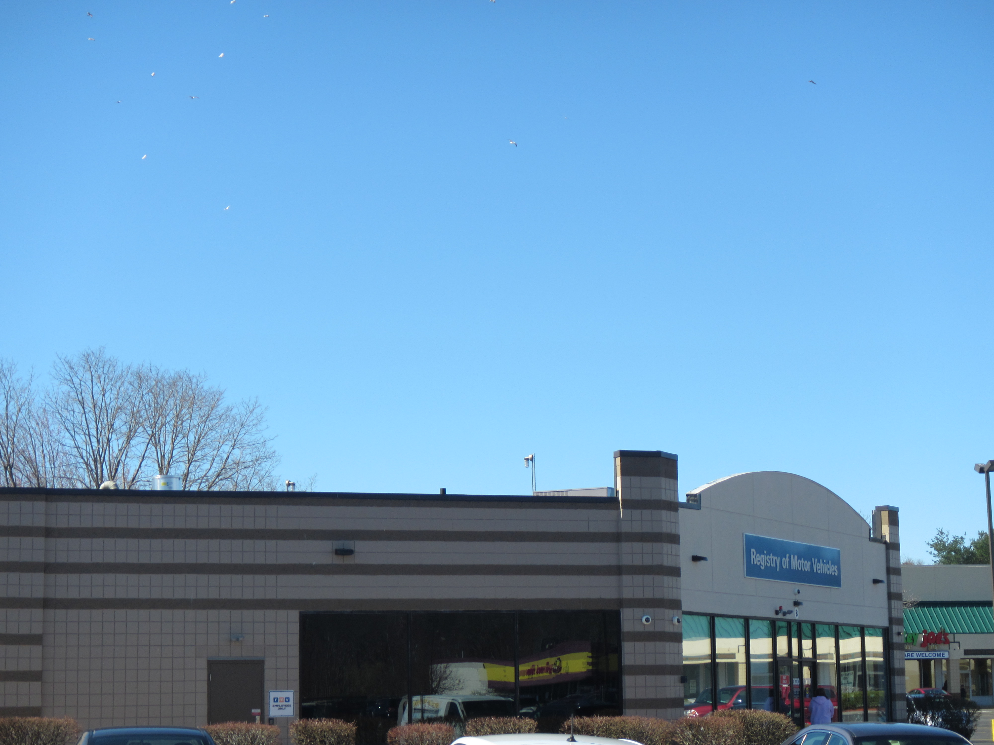

Prepared by:

Massachusetts Department of Public Health

Bureau of Environmental Health

Indoor Air Quality Program

May 2019

# Background

|  |  |
| --- | --- |
| Building: | Registry of Motor Vehicles (RMV)  Danvers Service Center |
| Address: | 8 Newbury Street, Danvers, MA |
| DCAMM Project Manager: | Robert Northrup, Facilities, Department of Transportation (DOT) |
| Reason for Request: | Indoor air quality(IAQ) concerns |
| Date of Assessment: | April 17, 2019 |
| Massachusetts Department of Public Health/Bureau of Environmental Health (MDPH/BEH) Staff Conducting Assessment: | Jason Dustin, Environmental Analyst/Inspector, IAQ Program |
| Building Description: | The RMV space is a detached building located in the Danvers Crossing Shopping Plaza off of Route 1. The space has private offices, open work areas, a large waiting room and conference rooms. Most areas have carpet tiles and dropped ceilings. |
| Windows: | Windows are not openable. |

# Methods

Please refer to the IAQ Manual for methods, sampling procedures, and interpretation of results (MDPH, 2015).

# Results

The following is a summary of indoor air testing results (Table 1).

* ***Carbon dioxide levels*** were slightly above the MDPH guideline of 800 parts per million (ppm) in nearly half of areas assessed. This is likely due to thermostats being set to fan “auto” rather than recommended fan “on” as explained further below.
* ***Temperature*** was within the MDPH recommended range of 70°F to 78°F in all areas.
* ***Relative humidity*** was below the MDPH recommended range of 40% to 60% in all areas as is typical during the heating season in the Northeast. Some occupants expressed sinus and respiratory irritation during the winter season when humidity can be extremely low.
* ***Carbon monoxide*** levels were non-detectable (ND) in all indoor areas assessed.
* ***Fine particulate matter (PM2.5)*** concentrations measured were below the National Ambient Air Quality Standard (NAAQS) level of 35 micrograms per cubic meter (μg/m3) in all occupied areas.
* ***TVOC (total volatile organic compound)*** levels were ND in all indoor areas assessed.

# Discussion

## Ventilation

A heating, ventilating, and air conditioning (HVAC) system has several functions. First it provides heating and, if equipped, cooling. Second, it is a source of fresh air. Finally, an HVAC system will dilute and remove normally occurring indoor environmental pollutants by not only introducing fresh air, but by filtering the airstream and ejecting stale air to the outdoors via exhaust ventilation. Even if an HVAC system is operating as designed, point sources of respiratory irritation may exist and cause symptoms in sensitive individuals.

The HVAC system in this space consists of large rooftop air handling units (AHUs) that draw in fresh air from intakes on the roof. Supply air is ducted to ceiling-mounted supply diffusers throughout the space (Picture 1). Return air is brought back to the AHUs through ducted return vents (Picture 2).

To maximize air exchange, the MDPH recommends that both supply and exhaust ventilation operate continuously during periods of occupancy. In order to have proper ventilation with a mechanical supply and exhaust system, the systems must be balanced to provide an adequate amount of fresh air to the interior of a room while removing stale air from the room. It is recommended that HVAC systems be re-balanced every five years to ensure adequate air systems function (SMACNA, 1994).

Some thermostats were set to “Fan Auto” (Picture 3). The thermostat fan settings for the AHUs should be inspected to ensure they are set to “Fan On” rather than “Auto”. This is especially important during temperate weather in spring and fall where heating or cooling may not be called for frequently. Intermittent fresh air supply will likely increase IAQ complaints.

## Microbial/Moisture Concerns

The RMV building had a hole in the exterior concrete wall (Picture 4) and it is reported that small birds nest in the wall cavity. DOT facilities staff reported that the exterior wall extends to the roof decking and that it is sealed at the corrugated metal roof interface. BEH staff could not access this area to determine if there were pathways between the hollow exterior concrete wall and the DMV occupied space. Birds and bird wastes can be sources of allergens and microbial contamination. The hole may also allow moisture to penetrate into occupied space. The birds/nesting materials should be removed from the wall cavity and the wall should be properly sealed to prevent further nesting.

The Danvers RMV is in close proximity to the Danvers transfer station and the Danvers landfill (Picture 5). As a result, numerous seagulls were observed flying in close proximity to the Danvers RMV building (Picture 6). Since access to the roof was not available on the day of the assessment, facilities personnel took pictures of the roof and air handler and forwarded them to IAQ staff. These pictures show bird waste and roosting areas near the air handling units. Some of the bird screens appeared to be frayed at the bottom corners possibly due to bird damage (Pictures 7 to 9). The filter efficiency was not identified at the time. Since bird waste can harbor allergens and microbial contaminants, efforts to deter roosting should be made and MERV 8 or higher filters should be fitted in the air handlers and changed quarterly.

Water-damaged ceiling tiles were noted in the counting room and break room (Pictures 10 and 11). The plenum above the ceiling tiles in both of these areas was inspected and no visible mold or musty odors were found. Roof penetrations were present directly above the water stains, and are the likely sources of the leaks (Picture 12). The ceiling tiles are considered porous and should be replaced if not dried within 24-48 hours of becoming wet.

## Other Conditions

Hand sanitizers, scented cleaning products, and air fresheners were noted in some areas of the office space. These products can cause irritation of the eyes, nose, and respiratory system of some people.

Most flooring is covered with carpet tile. The Institute of Inspection, Cleaning and Restoration Certification (IICRC), recommends that carpeting be cleaned annually (or semi-annually in soiled high traffic areas) (IICRC, 2012).

Some areas had accumulated items on surfaces and floors (Table 1). This interferes with the ability to thoroughly vacuum and wet-wipe surfaces allowing dust to accumulate in these areas.

# Conclusions/Recommendations

Based on the observations made during the visit, the following is recommended:

1. Operate the HVAC system to provide for continuous fresh air ventilation during occupied hours. Inspect all thermostats to ensure that they are set for “Fan On” instead of the “Auto” setting.
2. Remove birds and nesting materials from hole in exterior concrete block wall. Seal this hole to avoid future nesting and moisture intrusion.
3. Take measures to deter seagull roosting in the areas of the AHUs on the roof (e.g., spike strips, etc.). Regularly inspect/repair bird screens and AHUs to ensure protections are in place to avoid entrainment of bird waste, feathers, and nesting materials.
4. Given the seagull activity in the area, change filters for HVAC equipment 4 times a year. Use pleated filters of MERV 8 (or higher), which are adequate in filtering out pollen and mold spores (ASHRAE, 2012). MERV 15 are rated to filter bacteria but the AHU manufacturer should be consulted to verify if these can be used with the current equipment since pressure drop may affect AHU performance.
5. Consider adopting a balancing schedule of every 5 years for all mechanical ventilation systems, as recommended by ventilation industrial standards (SMACNA, 1994).
6. Repair leaks from roof penetrations and replace water-damaged ceiling tiles.
7. Reduce or eliminate the use of scented cleaners, hand sanitizers, and personal air fresheners.
8. Reduce the amount of accumulated items on surfaces or floors to ensure regular wet-wiping of surfaces and access for custodial staff to HEPA vacuum daily.
9. Regularly vacuum carpeting with a HEPA-filtered vacuum cleaner. Clean carpeting at least once per year according to IICRC recommendations (IICRC, 2012).
10. For buildings in New England, periods of low relative humidity during the winter are often unavoidable. Therefore, scrupulous cleaning practices should be adopted to minimize common indoor air contaminants whose irritant effects can be enhanced when the relative humidity is low. To control dusts, a high efficiency particulate arrestance (HEPA) filter equipped vacuum cleaner in conjunction with wet wiping of all surfaces is recommended. Avoid the use of feather dusters. Drinking water during the day can help ease some symptoms associated with a dry environment (throat and sinus irritations).
11. Refer to resource manuals and other related IAQ documents for further building-wide evaluations and advice on maintaining public buildings. Copies of these materials are located on the MDPH’s website: <http://mass.gov/dph/iaq>.

# References

ASHRAE. 2012. American Society of Heating, Refrigeration and Air Conditioning Engineers (ASHRAE) Standard 52.2-2012 -- Method of Testing General Ventilation Air-Cleaning Devices for Removal Efficiency by Particle Size (ANSI Approved).

IICRC. 2012. Institute of Inspection Cleaning and Restoration Certification. Institute of Inspection, Cleaning and Restoration Certification. Carpet Cleaning: FAQ. Retrieved from <https://www.iicrc.org/general/custom.asp?page=SANSIIICRCS100>.

MDPH. 2015. Massachusetts Department of Public Health. “Indoor Air Quality Manual: Chapters I-III”. Available at: <http://www.mass.gov/eohhs/gov/departments/dph/programs/environmental-health/exposure-topics/iaq/iaq-manual/>.

SMACNA. 1994. HVAC Systems Commissioning Manual. 1st ed. Sheet Metal and Air Conditioning Contractors’ National Association, Inc., Chantilly, VA.

**Picture 1**

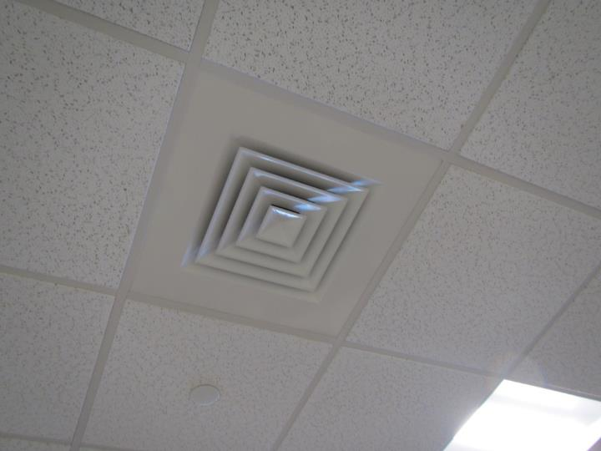

**Supply air diffuser**

**Picture 2**

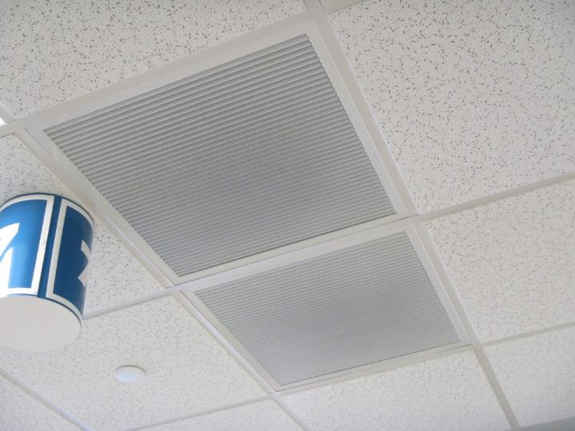

**Return air vents**

**Picture 3**

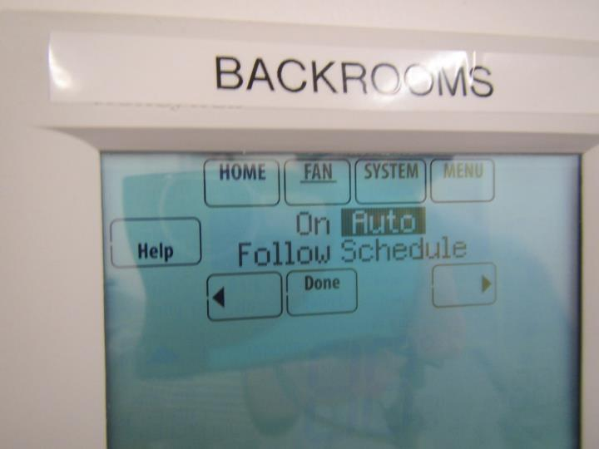

**Thermostat set to fan “auto”**

**Picture 4**

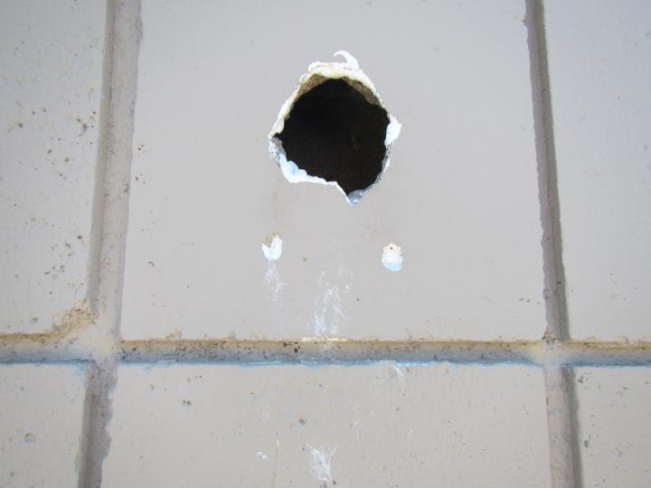

**Hole in exterior concrete wall (note bird droppings below)**

**Picture 5**

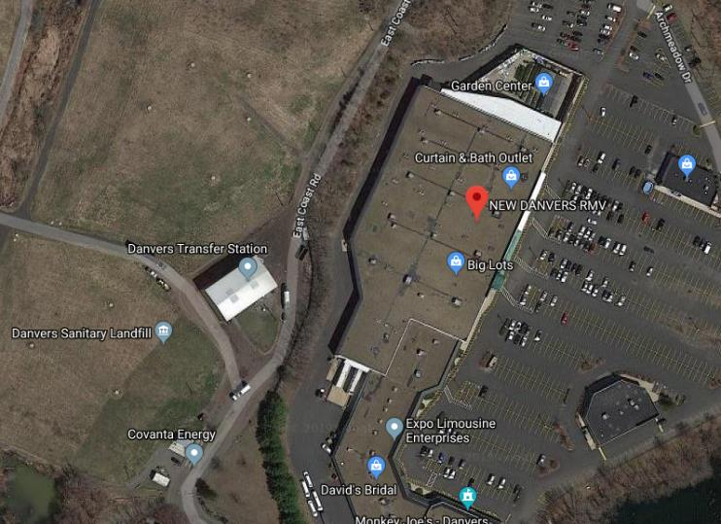

Danvers Transfer Station/Landfill

Danvers RMV

**Danvers RMV in close proximity to landfill/transfer station (photo: Google Maps)**

**Picture 6**

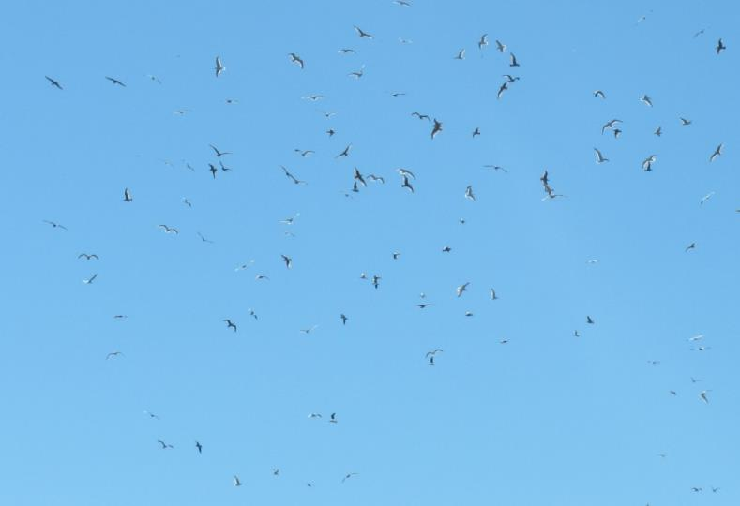

**Hundreds of seagulls noted flying above/near the RMV building**

**Picture 7**

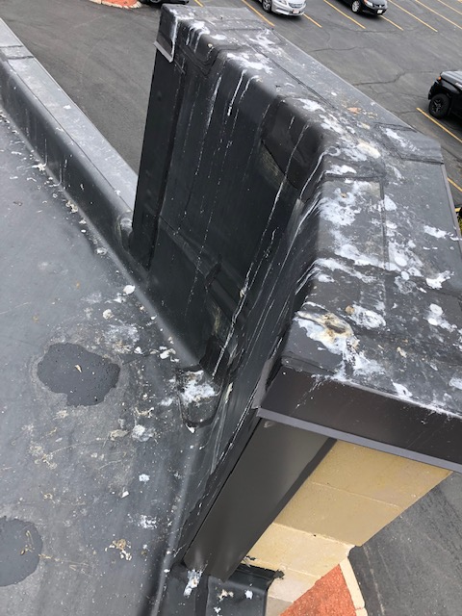

**Bird waste on roof of Danvers RMV (photo taken by Jehu Andrade MDOT)**

**Picture 8**

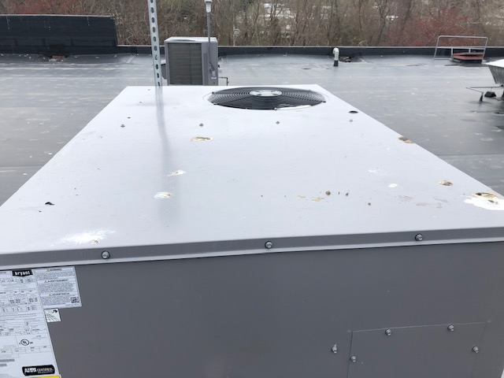

**Bird waste on top of AHU (photo taken by Jehu Andrade MDOT)**

**Picture 9**

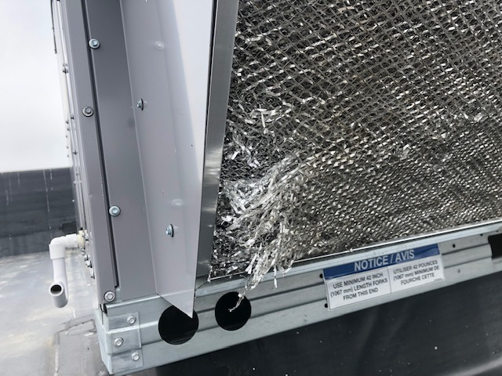

**Bird screen frayed/damaged at bottom corner (photo taken by Jehu Andrade MDOT)**

**Picture 10**

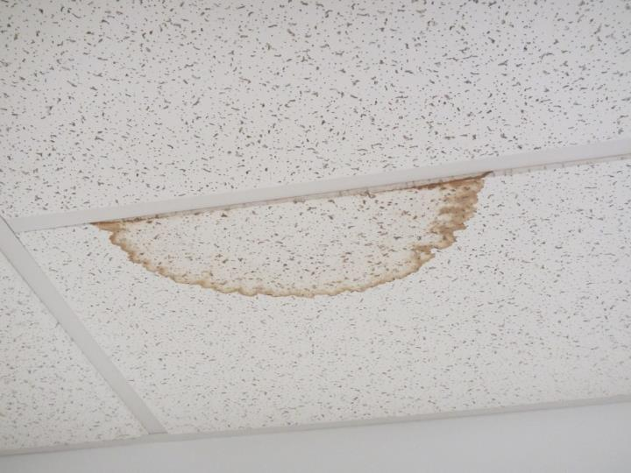

**Water-damaged ceiling tile in counting room**

**Picture 11**

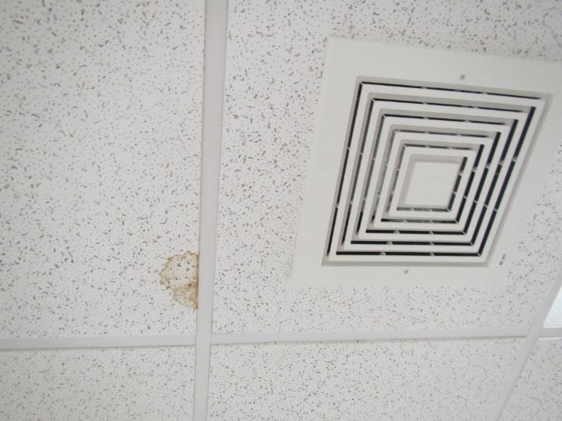

**Water-damaged ceiling tile in break room**

**Picture 12**

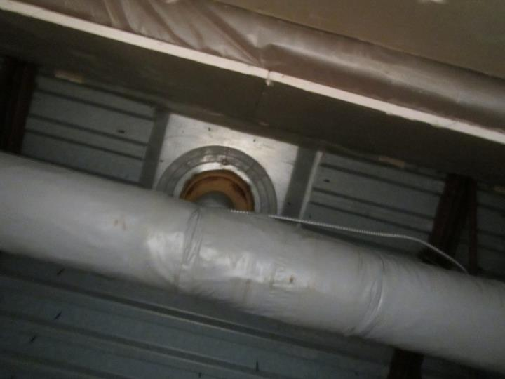

**Roof penetration above water-damaged ceiling tile**

| **Location** | **Carbon**  **Dioxide**  **(ppm)** | **Carbon Monoxide**  **(ppm)** | **Temp**  **(°F)** | **Relative**  **Humidity**  **(%)** | **PM2.5**  **(µg/m3)** | **TVOCs**  **(ppm)** | **Occupants**  **in Room** | **Windows**  **Openable** | **Ventilation** | | **Remarks** |
| --- | --- | --- | --- | --- | --- | --- | --- | --- | --- | --- | --- |
| **Supply** | **Exhaust** |
| Background | 404 | ND | 58 | 26 | 14 | ND | - | - | - | - | Windy, clear, hundreds of seagulls in area |
| Manager office | 845 | ND | 72 | 26 | 4 | ND | 4 | N | Y | Y | Ducted returns, HS, CPs, carpet tile |
| Counting room | 794 | ND | 73 | 26 | 5 | ND | 2 | N | Y | Y | WD CT, HS |
| Cash room | 891 | ND | 73 | 26 | 4 | ND | 3 | N | Y | Y | CP, HS, carpet tile |
| Break | 781 | ND | 73 | 25 | 7 | ND | 4 | N | Y | Y | WD CT, local exhaust |
| Wellness | 731 | ND | 73 | 23 | 8 | ND | 1 | N | Y | Y | Vinyl tile flooring |
| Counters 3&4 | 727 | ND | 73 | 23 | 7 | ND | 2 | N | Y | Y | HS |
| Greeter area | 780 | ND | 72 | 24 | 7 | ND | 4 | N | Y | Y | AI, PC, carpet tiles |
| Counter 11 | 806 | ND | 70 | 26 | 9 | ND | 5 | N | Y | Y | HS, tile |
| Main Waiting –left | 804 | ND | 71 | 24 | 9 | ND | 40+ | N | Y | Y | Tile |
| Road test | 751 | ND | 70 | 23 | 8 | ND | 1 | N | Y | Y | Carpet tile |
| Main waiting room- middle | 846 | ND | 71 | 26 | 8 | ND | 40+ | N | Y | Y |  |
| Permit room | 816 | ND | 72 | 23 | 10 | ND | 1 | N | Y | Y |  |
| Pod 5-9 | 842 | ND | 73 | 23 | 10 | ND | 6 | N | Y | Y | Carpet tile, CP, HS |
| Pod 10-14 | 798 | ND | 73 | 23 | 11 | ND | 7 | N | Y | Y | HS, CPs |
| Plate storage | 735 | ND | 72 | 24 | 8 | ND | 1 | N | Y | N | Vinyl tile, AI on slab |