INDOOR AIR QUALITY ASSESSMENT

Massachusetts Registry of Motor Vehicles
1084 MA-Route 28
South Yarmouth, Massachusetts

Prepared by:
Massachusetts Department of Public Health
Bureau of Environmental Health
Indoor Air Quality Program
November 2016

Background
Building: | Massachusetts Registry of Motor Vehicles (RMV)
Address: | 1084 Route 28, South Yarmouth, MA
Assessment Requested by: | Aric Warren, Transportation Program Planner, MassDOT
Reason for Request: | General indoor air quality (IAQ) assessment.
Date of Assessment: | November 3, 2016
Massachusetts Department of Public Health/Bureau of Environmental Health (MDPH/BEH) Staff Conducting Assessment: | Cory Holmes, Environmental Analyst/Inspector, IAQ Program
Date of Building Construction: | 1960
Building Description: | The RMV office is in a shopping center and is flanked by Ocean State Job Lot and a jewelry store.
Building Population: | The RMV has a staff population of 10-15 and can be visited by hundreds of people daily.
Windows: | There are no openable windows in the space.

Methods
Please refer to the IAQ Manual and appendices for methods, sampling procedures, and interpretation of results (MDPH, 2015).

Results and Discussion
The following is a summary of indoor air testing results (Table 1).
- Carbon dioxide measurements were above the MDPH recommended level of 800 parts per million (ppm) in all areas surveyed.
- Temperature was within or very close to the MDPH recommended range of 70°F to 78°F at the time of assessment.
- Relative humidity was within or very close to the MDPH recommended range of 40 to 60% in all areas tested.
- Carbon monoxide levels were non-detectable in all areas tested.
- Particulate matter (PM2.5) concentrations measured were below the National Ambient Air Quality (NAAQS) level of 35 μg/m³ in all areas tested.

Ventilation
A heating, ventilating, and air conditioning (HVAC) system has several functions. First it provides heating and, if equipped, cooling. Second, it is a source of fresh air. Finally, an HVAC system will dilute and remove normally occurring indoor environmental pollutants by not only introducing fresh air, but also filtering the airstream and ejecting stale air to the outdoors via exhaust ventilation. At the time of assessment, several digital thermostats were completely deactivated (Picture 1), therefore no outside air was being introduced nor was any air being circulated in those portions of the space. Coupled with the highly dense population of clients at times, this could likely contribute to thermal comfort and IAQ complaints experienced by RMV staff.
The rooftop air handling units (AHUs) were not accessible at the time of assessment. It is recommended that AHUs should be outfitted with pleated filters of a Minimum Efficiency Reporting Value (MERV) of 8, which are adequate in filtering out pollen and mold spores. In addition, filters should be changed 2-4 times a year or in accordance with the manufacture’s recommendations.

Microbial/Moisture Concerns
It was reported that the space had experienced roof leaks in the past, primarily in the plate/storage room. BEH/IAQ staff examined the area, including the ceiling plenum (above the ceiling tiles) and found no evidence of current leaks/mold or damage to building materials.
Light could be seen penetrating below the exterior doors in the storage room (Picture 2). These spaces can allow uncontrolled drafts, moisture and/or pests into the building.

Other Conditions
Several supply, exhaust, and return vents were observed to have accumulated dust/debris, (Pictures 3 and 4). If exhaust vents are not functioning, backdrafting can occur, which can re-aerosolize accumulated dust particles. Supply vents can aerosolize accumulated dust once activated. One vent was noticed loose/hanging in the Manager’s office and one was completely missing in the men’s restroom (Pictures 5 and 6).
The presence of fruit flies was reported by staff. Fruit flies typically proliferate when there is a source of food for them, which may include overwatered potting soil, improperly maintained indoor plants, or food such as fruits or vegetables that are exposed to the air for too long. Removal of the infested materials and regular, thorough cleaning of places where food is stored and prepared can reduce or eliminate fruit fly infestations.

Conclusions and Recommendations
In view of the findings at the time of the visit, the following recommendations are made:
- Operate the system in fan “on” mode to provide continuous air exchange and filtration during occupied hours.
- Consider adopting a balancing schedule of every 5 years for all mechanical ventilation systems, as recommended by ventilation industrial standards (SMACNA, 1994).
- Restore restroom exhaust vents. Examine all rooftop exhaust vents/motors/belts for proper function, make repairs as needed. Ensure restroom exhausts are direct to outdoors and not part of general/return ventilation system.
- Replace missing vents and make repairs to loose/hanging vents.
- For buildings in New England, periods of low relative humidity during the winter are often unavoidable. Therefore, scrupulous cleaning practices should be adopted to minimize common indoor air contaminants whose irritant effects can be enhanced when the relative humidity is low. To control for dusts, a high efficiency particulate arrestance (HEPA) filter equipped vacuum cleaner in conjunction with wet wiping of all surfaces is recommended. Avoid the use of feather dusters. Drinking water during the day can help ease some symptoms associated with a dry environment (throat and sinus irritation).
- Ensure filters for rooftop AHUs are of a pleated variety, Minimum Efficiency Reporting Value (MERV) dust-spot efficiency 8 or higher and change twice a year or more frequently if needed.
- Seal spaces beneath exterior doors (where space/light can be seen) with weather-stripping.
- Clean supply, exhaust and return vents periodically of accumulated dust, debris and cobwebs.
- Eliminate attractants for pests (e.g., fruit flies), such as plants, food, fruits and/or vegetables. It is also important for prompt removal of trash and proper washing of recyclables. If problems persist, consider contacting a licensed pest company to implement an Integrated Pest Management (IPM) plan.
- Refer to resource manual and other related indoor air quality documents located on the MDPH’s website for further building-wide evaluations and advice on maintaining public buildings. These documents are available at http://mass.gov/dph/iaq.

REFERENCES
Massachusetts Department of Public Health (MDPH). 2015. Indoor Air Quality Manual: Chapters I-III. Available at: http://www.mass.gov/eohhs/gov/departments/dph/programs/environmental-health/exposure-topics/iaq/iaq-manual/.
Sheet Metal and Air Conditioning Contractors’ National Association, Inc. (SMACNA). 1994. HVAC Systems Commissioning Manual. 1st ed. Sheet Metal and Air Conditioning Contractors’ National Association, Inc., Chantilly, VA.
Picture 1
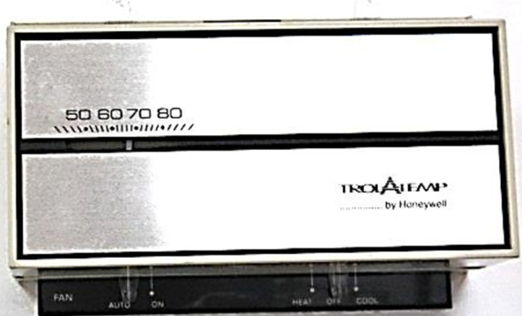
Thermostat shut off (right bottom control switch)
Picture 2
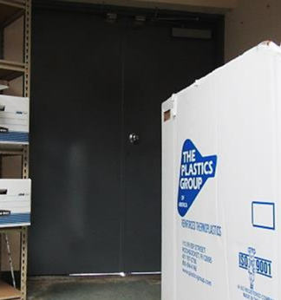
Light penetrating below exterior door in storage room
Picture 3
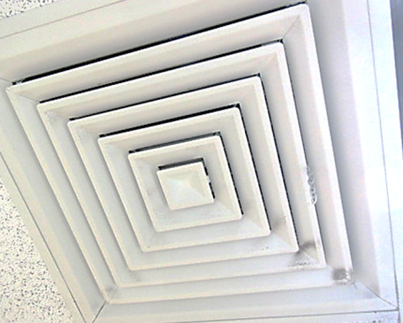
Supply vent, note dust/debris accumulation on louvers
Picture 4
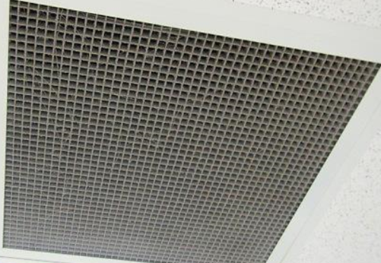
Dust, debris and cobwebs on return vent
Picture 5
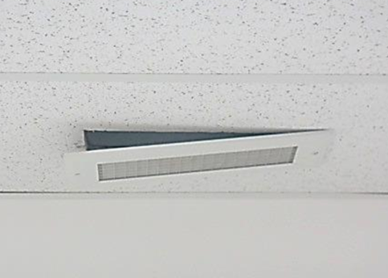
Loose/hanging vent in Manager’s office
Picture 6
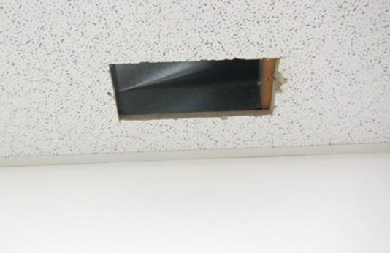
Missing vent in men's restroom
Location | Carbon  Dioxide  (ppm) | Carbon  Monoxide  (ppm) | Relative  Humidity(%) | Temp  (°F) | PM2.5  (µg/m³) | Occupants  in Room | Windows  Openable | Ventilation |  | Remarks
 |  |  |  |  |  |  |  | Supply | Exhaust
Background | 401 | ND | 80 | 64 | 9 |  |  |  |  | Grey, foggy, misty
Breakroom | 976 | ND | 52 | 69 | 7 | 0 | N | Y | Y
Manager Office | 974 | ND | 58 | 71 | 6 | 0 | N | Y | Y | Loose vent, thermostat “OFF”
Testing Room | 852 | ND | 59 | 72 | 6 | 0 | N | Y | N | Weak airflow
Lobby (3-8) | 1052 | ND | 58 | 72 | 6 | 15 | N | Y |  | Dust and debris on vents, cobwebs
Work Stations 3-8 | 1048 | ND | 58 | 72 | 6 | 4 | N | Y | Y
Work Stations 8-9 | 1027 | ND | 56 | 71 | 5 | 2 | N | Y | Y
Customer Service | 1021 | ND | 57 | 71 | 10 | 5 | N | Y | Y
Lobby 10-13 | 1028 | ND | 57 | 70 | 6 | 13 | N | Y | Y | Dust and debris on vents
Work Stations 10-13 | 1022 | ND | 57 | 70 | 5 | 9 | N | Y | Y
Hearings | 959 | ND | 58 | 70 | 5 | 0 | N | Y | Y | DO
Center Main Work Area | 1074 | ND | 61 | 71 | 5 | 11 | N | Y | Y | 2 Thermostats; 1-fan “on”: 1 fan “auto”
Counting Room | 950 | ND | 58 | 72 | 7 | 1 | N | Y | Y
Cash Office | 981 | ND | 58 | 72 | 7 | 1 | N | Y | Y | Thermostat “OFF”
Men’s Restroom |  |  |  |  |  |  | N | Y | Y | No exhaust function, missing vent
Women’s Restroom |  |  |  |  |  |  | N | Y | Y | No exhaust function
Storage | 994 | ND | 58 | 72 | 6 | 0 | N | Y | Y | Light penetration beneath exterior door, area of previous roof leaks, no current signs of water damage/mold above CT system

