Background

INDOOR AIR QUALITY ASSESSMENT

Registry of Motor Vehicles
278 Union Street
New Bedford, Massachusetts

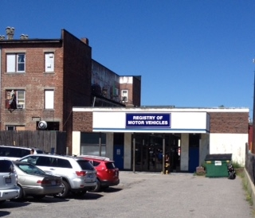

Prepared by:
Massachusetts Department of Public Health
Bureau of Environmental Health
Indoor Air Quality Program
October 2015

Building: | Registry of Motor Vehicles (RMV)
Address: | 278 Union Street, New Bedford, MA
Assessment Requested by: | Aric Warren, Director of Administrative Services, Massachusetts Department of Transportation (DOT)
Date of Assessment: | September 15, 2015
BEH/IAQ Staff Conducting Assessment: | Cory Holmes, Environmental Analyst/Inspector
Date of Building Construction: | 1925
Reason for Request: | Reports of poor air quality/temperature control

Building Description
The RMV is located on the ground floor of a two-story red brick building in downtown New Bedford that formerly served as a bank.

Results
The space assessed houses approximately 15 employees with several hundred members of the public visiting the space daily. Test results are presented in Table 1.

Discussion

Ventilation
It can be seen from Table 1 that carbon dioxide levels were above 800 parts per million (ppm) in all areas tested, indicating a lack of air exchange. Mechanical ventilation is provided by a number of air handling units (AHUs) located in a basement mechanical room (Picture 1). Air is ducted to wall or ceiling-mounted supply diffusers (Picture 2). Return air is drawn into wall or ceiling-mounted return vents, however, these were few in number compared to supply vents. The basement and AHUs have the following problems that can adversely affect indoor air quality.
- AHUs had filters that were not properly installed and were of minimal efficiency.
- AHUs were missing filter access panels (Picture 4) that would enclose each filter within the ductwork. This condition allows air to bypass the filter and can draw in odors, debris, and water vapor into the AHU from the basement to be transported throughout the occupied space.
- AHUs have poor drainage of condensation from the cooling coil drip pan. This condition causes pooling water on the floor which has caused severe corrosion of the AHU housing and duct support structures (Pictures 5 through 10).
- Electrical components were corroded due to condensation dripping from poorly insulated chilled water pipes (Pictures 11 and 12).
Not only do these issues compromise the integrity of the units, they can also serve as electrical/safety hazards. The holes from corrosion of the AHU housing can result in the draw of combustion gasses from the adjacent water heater (Picture 6).
To maximize air exchange, the MDPH recommends that both supply and exhaust ventilation operate continuously during periods of occupancy. At the time of the assessment thermostats were set to the fan “auto” position (Picture 13), which deactivates the HVAC system once the preset temperature is reached. Therefore, no mechanical ventilation is provided until the thermostat re-activates the system. The MDPH recommends that thermostats be set to the fan “on” setting during occupied hours to provide a continuous source of fresh air and filtration.

Temperature and Relative Humidity
Indoor temperature measurements ranged from 70°F to 72°F (Table 1), which were within the MDPH recommended comfort range of 70°F to 78°F. Indoor relative humidity measurements ranged from 44 to 50 percent (Table 1), which were within the MDPH recommended comfort range. The MDPH recommends a comfort range of 40 to 60 percent for indoor air relative humidity.

Microbial/Moisture Concerns
In order for building materials to support mold growth, a source of water exposure is necessary. Water-damaged ceiling tiles were observed in several areas, which could be historic damage from previous roof leaks or current damage from condensation/plumbing leaks (Picture 14). Water-damaged ceiling tiles and walls around the window in the breakroom (Pictures 15 and 16), are indicative of window leaks (Picture 17). The breakroom also had a leaking faucet that was wetting the cabinet underneath, which can lead to damage of the wood cabinet and mold growth.
Although the roof was reported to have been replaced recently, pooling water and plant growth were noted in several areas (Pictures 18 and 19) and over the entrance/awning (Pictures 20 through 22). The weight of the water/debris and freezing/thawing action over the winter can cause damage to the roof membrane and lead to structural damage, leaks and mold growth. In addition, stagnant water can serve as a breeding ground for mosquitoes.
The former bank vault in the basement was being used for storage. This area is prone to moisture/condensation and is not equipped with mechanical ventilation/dehumidification, therefore is not suited for storage of porous materials (e.g., cardboard, paper/Picture 23), which can get wet and grow mold.
The poor condensation drainage system and resulting standing water in the basement mechanical room may provide the opportunity for microbial growth and associated odors. These odors and moisture may be drawn into the gaps around the filter assembly of the AHUs and be distributed throughout occupied areas of the space.

Other IAQ Evaluations
Indoor air quality can be negatively influenced by the presence of respiratory irritants, such as products of combustion. The process of combustion produces a number of pollutants. Common combustion emissions include carbon monoxide, carbon dioxide, water vapor, and smoke (fine airborne particle material). Of these materials, exposure to carbon monoxide and particulate matter with a diameter of 2.5 micrometers (μm) or less (PM2.5) can produce immediate, acute health effects upon exposure. To determine whether combustion products were present in the indoor environment, BEH/IAQ staff obtained measurements for carbon monoxide and PM2.5.

Carbon Monoxide
Carbon monoxide should not be present in a typical, indoor environment. If it is present, indoor carbon monoxide levels should be less than or equal to outdoor levels. On the day of assessment, outdoor carbon monoxide concentrations were non-detect (ND) (Table 1). No measurable levels of carbon monoxide were detected inside the building (Table 1).

Particulate Matter
Outdoor PM2.5 was measured at 10 to 38 μg/m³ (Table 1), which was above the NAAQS PM2.5 level of 35 μg/ m³ due to nearby road construction. PM2.5 levels measured indoors ranged from 4 to 5 μg/m³ (Table 1), which were below the NAAQS PM2.5 level of 35 μg/m³.

Other Conditions
Several other conditions that can potentially affect IAQ were identified. Ceiling-mounted supply vents were noted to have dust/debris build up/corrosion (Picture 2).
Most areas of the RMV are carpeted. The Institute of Inspection, Cleaning and Restoration Certification (IICRC) recommends that carpeting be cleaned annually (or semi-annually in soiled high traffic areas) (IICRC, 2012). Regular cleaning with a high efficiency particulate air (HEPA) filtered vacuum in combination with an annual cleaning will help to reduce accumulation and potential aerosolization of materials from carpeting.
Finally, the basement sump pump was severely corroded, resulting in the development of a large hole in the cover (Picture 24). Breaches in the cover can further increase the relative humidity and allow soil gases, moisture and odors to infiltrate the mechanical room where they can be drawn into and distributed to occupied areas via the HVAC system.

Conclusions/Recommendations
In view of the findings at the time of the visit, the following recommendations are made:
- Due to the compromised integrity/condition of AHUs, they should either be rebuilt or replaced. Units should also be elevated and not directly on the basement floor.
- Work with HVAC engineer to evaluate system with a focus on introducing additional fresh air to the space. The system should also be evaluated to ensure proper exhaust/return capabilities.
- Install filter panels to prevent filter bypass on AHUs.
- Install properly-fitted, higher efficiency (i.e., pleated filters) in AHUs; change 2 to 4 times a year or per the manufacturer’s instructions.
- Extend condensation drains away from units and to a properly installed drain to prevent water pooling/further damage to units.
- Rebuild/replace metal ductwork supports.
- Ensure chilled water pipes are fully insulated to prevent dripping on electrical components (Picture 11).
- Replace corroded electrical components in basement mechanical room.
- Completely seal any breaches/holes in and around the sump pump to avoid soil gases, pests and added moisture from entering the mechanical room; replace if necessary.
- Ensure leaks (plumbing, condensation, windows, etc.) are repaired and replace any water-damaged ceiling tiles and building materials, particular attention should be paid to evaluate/repair leaks around breakroom window.
- Consider adopting a balancing schedule of every 5 years for all mechanical ventilation systems, as recommended by ventilation industrial standards (SMACNA, 1994).
- For buildings in New England, periods of low relative humidity during the winter are often unavoidable. Therefore, scrupulous cleaning practices should be adopted to minimize common indoor air contaminants whose irritant effects can be enhanced when the relative humidity is low. To control for dusts, a high efficiency particulate arrestance (HEPA) filter equipped vacuum cleaner in conjunction with wet wiping of all surfaces is recommended. Avoid the use of feather dusters. Drinking water during the day can help ease some symptoms associated with a dry environment (throat and sinus irritations).
- Refrain from storing porous materials (e.g., books, papers) in the basement due to moisture concerns such as high humidity and flooding.
- Clean carpeting annually or semi-annually in soiled high traffic areas as per the recommendations of the Institute of Inspection, Cleaning and Restoration Certification (IICRC, 2012).
- Periodically clean supply diffusers and return grates to avoid re-aerosolizing particulates. Consider replacing damaged/corroded components.
- Refer to resource manual and other related indoor air quality documents located on the MDPH’s website for further building-wide evaluations and advice on maintaining public buildings. These documents are available at http://mass.gov/dph/iaq.

References
IICRC. 2012. Institute of Inspection, Cleaning and Restoration Certification. Carpet Cleaning: FAQ. Retrieved from http://www.iicrc.org/consumers/care/carpet-cleaning/#faq.
SMACNA. 1994. HVAC Systems Commissioning Manual. 1st ed. Sheet Metal and Air Conditioning Contractors’ National Association, Inc., Chantilly, VA.
Picture 1

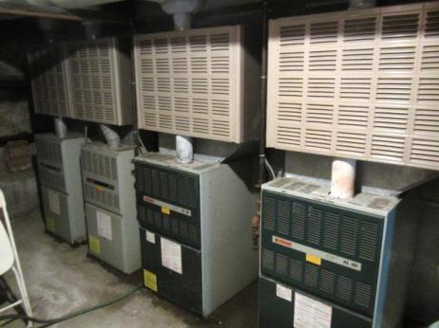

Air handling units (AHUs) in basement mechanical room

Picture 2

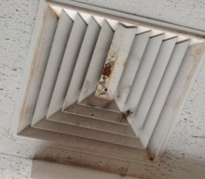

Ceiling-mounted supply diffuser, note corrosion and debris (dark stains)
Picture 3

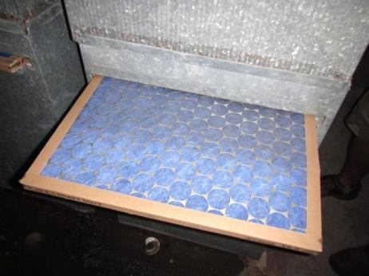

Improperly sized fibrous mesh filters installed in AHUs

Picture 4

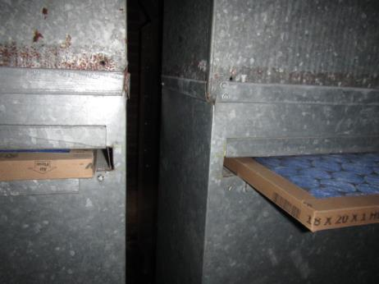

Improperly sized filters, note spaces around filters (arrows) and lack of access panels
Picture 5

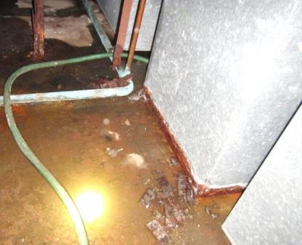

Standing water on floor of mechanical room, note severe corrosion of bottom of AHUs and ductwork supports (arrows)

Picture 6

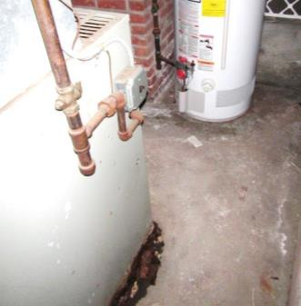

Severe corrosion of bottom of AHU, note proximity to gas-fired hot water heater
Picture 7

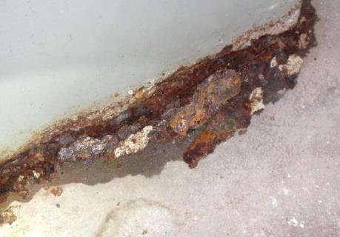

Close-up of severe corrosion to bottom of AHU

Picture 8

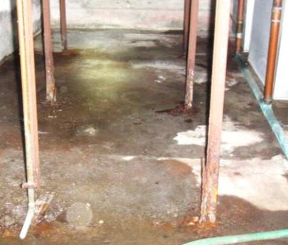

Pooling water on mechanical room floor resulting in severe corrosion compromising the integrity of metal ductwork supports
Picture 9

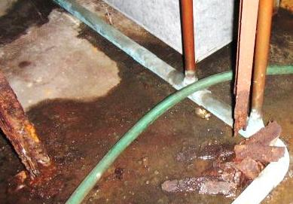

Severely corroded/compromised integrity of ductwork support structures

Picture 10

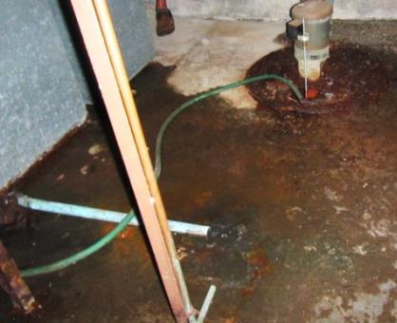

Condensation pipes (arrows) emptying on floor of mechanical room causing corrosion of AHUs and ductwork support beams, note sump pump in background
Picture 11

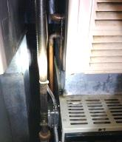

Uninsulated copper elbow dripping condensation on electrical box (arrows)

Picture 12

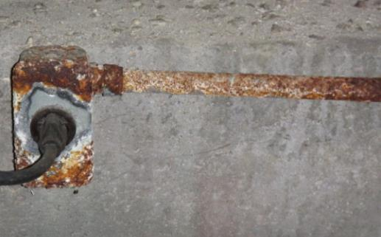

Severely corroded electrical box/conduit

Picture 13

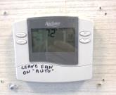

Digital thermostat

Picture 14

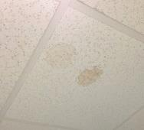

Water-damaged ceiling tiles
Picture 15

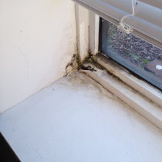

Water damage around window frame in breakroom
Picture 16

Water-damaged ceiling tile above breakroom window

Picture 17

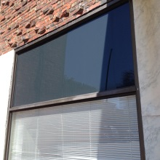

Breakroom window

Picture 18

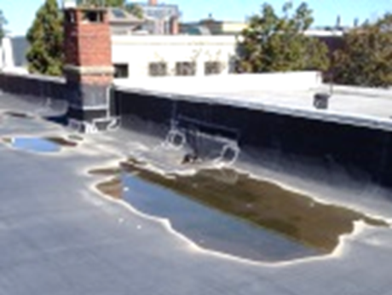

Pooling water on roof
Picture 19

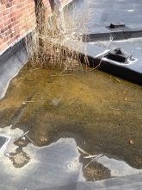

Pooling water, debris and plant growth on roof

Picture 20

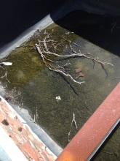

Pooling water, debris and plant growth on entrance/roof
Picture 21

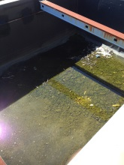

Pooling water, debris and plant growth on entrance/roof

Picture 22

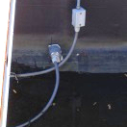

Electrical box sealed with duct tape in pooling water over entrance
Picture 23

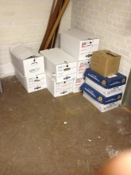

Cardboard boxes on floor of former bank vault in basement

Picture 24

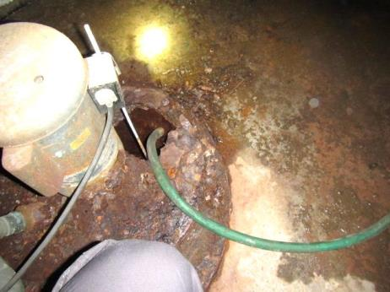

Hole in sump pump cover, note severe corrosion
Location | Carbon  Dioxide  (ppm) | Carbon Monoxide  (ppm) | Temp  (°F) | Relative  Humidity  (%) | PM2.5  (µg/m³) | Occupants  in Room | Windows  Openable | Ventilation |  |  | Remarks
 |  |  |  |  |  |  |  | Intake | Exhaust
Background | 437 | ND | 80 | 53 | 10-38 |  |  |  |  |  | Breezy, sunny, warm
Reception/rear entrance | 1694 | ND | 72 | 50 | 5 | 13 | N | Y |  | Y | Dust/debris/corrosion on supply vent, thermostat fan “auto”
Testing Room | 1588 | ND | 72 | 47 | 4 | 0 | N | Y |  | Y | WD CT
6 & 7 | 1710 | ND | 72 | 48 | 4 | 2 | N | Y |  | N
Main Waiting Area | 1690 | ND | 71 | 48 | 4 | 35 | N | Y |  | Y | 4 WD CT
Counting Room | 1602 | ND | 70 | 44 | 4 | 0 | N | Y |  | N
Branch Manager Office | 1592 | ND | 71 | 49 | 5 | 0 | N | Y |  | Y | 2 WD CT
Inspection/  Maintenance Office | 1587 | ND | 70 | 49 | 4 | 1 | N | Y |  | N
Break Room | 1625 | ND | 70 | 49 | 5 | 1 | N | Y |  | Y | WD CT/window sill/leaks, leaking sink (wet under cabinet)

