INDOOR AIR QUALITY ASSESSMENT

Department of Motor Vehicles
Lawrence Service Center
73 Winthrop Avenue
Lawrence, Massachusetts

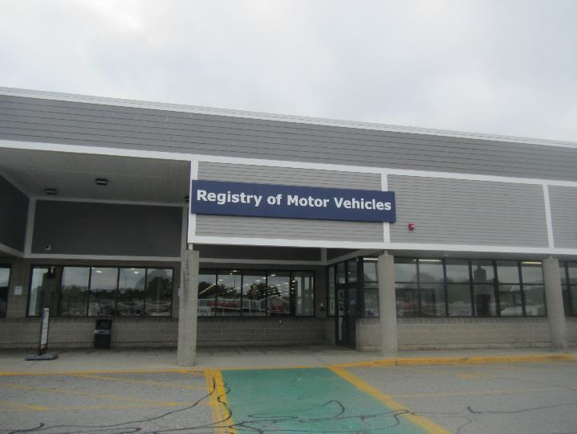

Prepared by:
Massachusetts Department of Public Health
Bureau of Environmental Health
Indoor Air Quality Program
October 2019

Background

Building: | Registry of Motor Vehicles (RMV)  Lawrence Service Center
Address: | 73 Winthrop Ave. Lawrence, MA
DCAMM Project Manager: | Robert Northrup, Facilities, Department of Transportation (DOT)
Reason for Request: | Indoor air quality(IAQ) concerns
Date of Assessment: | September 4, 2019
Massachusetts Department of Public Health/Bureau of Environmental Health (MDPH/BEH) Staff Conducting Assessment: | Jason Dustin, Environmental Analyst/Inspector, IAQ Program
Building Description: | The RMV space is located in a strip mall at the site of a former super market. The space has private offices, open work areas, a large waiting room and conference rooms. Most areas have carpet tiles and dropped ceilings.
Windows: | Windows are not openable.

Methods
Please refer to the IAQ Manual for methods, sampling procedures, and interpretation of results (MDPH, 2015).

Results
The following is a summary of indoor air testing results (Table 1).
- Carbon dioxide levels were below the MDPH guideline of 800 parts per million (ppm) in most areas assessed. A few areas were slightly above 800 ppm, mainly in or near the highly populated work spaces.
- Temperature was within the MDPH recommended range of 70°F to 78°F in all areas.
- Relative humidity was within the MDPH recommended range of 40% to 60% in most areas. A few areas were just above this level which is reflective of the outside humidity level.
- Carbon monoxide levels were non-detectable (ND) in all indoor areas assessed.
- Fine particulate matter (PM2.5) concentrations measured were below the National Ambient Air Quality Standard (NAAQS) level of 35 micrograms per cubic meter (μg/m³) in all occupied areas.
- TVOC (total volatile organic compound) levels were ND in all indoor areas assessed.

Discussion

Ventilation
A heating, ventilating, and air conditioning (HVAC) system has several functions. First it provides heating and, if equipped, cooling. Second, it is a source of fresh air. Finally, an HVAC system will dilute and remove normally occurring indoor environmental pollutants by not only introducing fresh air, but by filtering the airstream and ejecting stale air to the outdoors via exhaust ventilation. Even if an HVAC system is operating as designed, point sources of respiratory irritation may exist and cause symptoms in sensitive individuals.
The HVAC system in this space consists of large rooftop air handling units (AHUs) that draw in fresh air from intakes on the roof (Picture 1). Note that the dark staining near the condensate line may indicate pooling of water near the AHU. Efforts should be made to minimize pooling to prevent microbial growth near the AHU intake. Supply air is ducted to ceiling-mounted supply diffusers throughout the space (Picture 2). Return air is brought back to the AHUs through ducted return vents (Picture 3).
The RMV space utilizes an Energy Recovery Ventilator (ERV) to capture the heat/cooling of exhaust air and temper the incoming fresh air. This device was noted to have an indicator light for the need for service. Maintenance records reviewed by IAQ staff revealed that the ERV has had function problems.
To maximize air exchange, the MDPH recommends that both supply and exhaust ventilation operate continuously during periods of occupancy. In order to have proper ventilation with a mechanical supply and exhaust system, the systems must be balanced to provide an adequate amount of fresh air to the interior of a room while removing stale air from the room. It is recommended that HVAC systems be re-balanced every five years to ensure adequate air systems function (SMACNA, 1994).
Some thermostats were set to “Fan Auto” (Picture 4) which will only activate air circulation when heating or cooling is called for by the system. The thermostat fan settings for the AHUs should be inspected to ensure they are set to “Fan On” rather than “Auto”. This is especially important during temperate weather in spring and fall where heating or cooling may not be called for frequently. Intermittent fresh air supply will likely increase IAQ complaints. RMV facilities staff spoke to the property manager who reported that all of the fans are set to run continuously and that some of the thermostats act solely as temperature sensors rather than fan controls.

Microbial/Moisture Concerns
Some ceiling tiles were water-damaged. The server room had one water-damaged ceiling tile that may have been moistened due to a leak or condensation from the ductless air conditioning unit (Picture 5). Other damaged tiles were reported to be inactive/historic leaks. Water-damaged ceiling tiles should be replaced and the areas should be monitored for any active leaks. Any necessary roof or plumbing repairs should be made to address active leaks to avoid further water damage.
BEH/IAQ staff noted large gaps around a loading dock door as well as between the rear exit doors of the space (Pictures 6 and 7). This loading dock is open to the RMV occupied space for restroom access; therefore it is possible that warm, moist air entering through the door gaps can cause condensation on cooler surfaces that have been chilled below the dew point temperature. The loading dock area floor was covered with carpet tile. No musty odors or visible mold was noted during this assessment.
RMV staff reported that there was a leak in an adjacent unit in the building that moistened a wall and carpet in the RMV space. The water source was reported to be from a possible cracked toilet supply tank. RMV staff stated that the property manager responded quickly to extract water and used fans to accelerate drying. BEH staff noted that the vinyl coving on the gypsum wallboard (GW) remained in place (Picture 8). This water impermeable surface may have prevented the GW from drying. The US Environmental Protection Agency (US EPA) and the American Conference of Governmental Industrial Hygienists (ACGIH) recommends that porous materials (e.g., wallboard, carpeting) be dried with fans and heating within 24 to 48 hours of becoming wet (US EPA, 2008; ACGIH, 1989). If porous materials are not dried within this time frame, mold growth may occur. The area was dry and free of any musty odors or visible mold at the time of the assessment.
Boxes of paper were on the floor in some areas of the RMV (Picture 9). The BEH IAQ program recommends that porous materials be stored on shelving and up off of concrete slabs or floors in below grade spaces. This will allow for air circulation under the materials and avoid any chronic moisture/microbial growth associated with condensation.

Carpet Tile
Note that the RMV space was completely renovated within the last three years. All new furniture, lighting, ceiling tiles, gypsum wallboard and carpeting were installed at the time of the remodel.
RMV staff have reported that the carpet tiles in the space have had some dark staining that disappears when cleaned but returns within several days. Some of the stains observed appeared to be from beverage spills while others appeared to be grease stains that are likely tracked into the building from motorized chair use (Picture 10). However, small dark/blotchy stains observed in some areas are likely the result of the failure of the carpet installation and failure to follow manufacturer recommended maintenance techniques (Picture 11).
BEH staff inspected beneath several areas of carpet and noted that in some areas, the carpet mastic beneath was clean and tacky but in others there was a dark, gummy substance with the consistency of tar, which is most likely old mastic not removed from the cement floor (Pictures 12 and 13). The backing of carpet tiles was a porous felt-like material, as opposed to the hard resin, impermeable backing typically seen in commercial use. The manufacturer states that this tile is designed to allow water vapor/moisture to pass through the carpet tile from the concrete slab beneath. This permeable tile may be necessary in floor slabs lacking a vapor barrier but it may also allow moisture on the carpet surface (e.g., from cleaning or condensation) to penetrate to the mastic beneath the carpet tile. This may reactivate the mastic and allow it to bleed through the carpet causing surface staining. The manufacturer also states that the mastic used in installation and the maintenance required are specific for this type of product. RMV staff reported that cleaning methods used prior to this assessment have not conformed to manufacturer recommendations. It is unclear if the mastic used in the installation of these tiles was manufacturer recommended.
Since this assessment, RMV facilities staff has contacted a carpet specialist who will be following the manufacturer cleaning/maintenance guidelines and will be updating BEH staff on the outcome of these efforts. Some techniques to be implemented are using a non-toxic “dry” cleaning mixture as well as using fans to accelerate the complete drying of the carpet after cleaning.

Other Conditions
Exposure to low levels of total volatile organic compounds (TVOCs) may produce eye, nose, throat, and/or respiratory irritation in some sensitive individuals. To determine if VOCs were present, BEH/IAQ staff took measurements for TVOCs, and none was detected (Table 1). Hand sanitizers, scented cleaning products, and air fresheners were noted in some areas of the office space. These products can cause irritation of the eyes, nose, and respiratory system of some people.
The Institute of Inspection, Cleaning and Restoration Certification (IICRC), recommends that carpeting be cleaned annually (or semi-annually in soiled high traffic areas) (IICRC, 2012). As mentioned above, the manufacturer recommendations regarding maintenance specific to this carpet tile should also be consulted.
Some areas had accumulated items on surfaces and floors (Table 1). This interferes with the ability to thoroughly vacuum and wet-wipe surfaces allowing dust to accumulate in these areas.

Conclusions/Recommendations
Based on the observations made during the visit, the following is recommended:
- Operate the HVAC system to provide for continuous fresh air ventilation during occupied hours. Inspect all thermostats/controls to ensure that they are set for “Fan On” instead of the “Auto” setting.
- Make efforts to minimize any pooling on the roof especially in the vicinity of AHU fresh air intakes.
- Institute a protocol to respond to extended periods of weather with high humidity; which should include the dehumidification of the RMV space during weekends/holidays in summer to avoid any condensation on the floor slab/carpet. Dehumidification should reduce the chance of further carpet moistening and problems with carpet mastic.
- Regularly vacuum carpeting with a HEPA-filtered vacuum cleaner. Clean carpeting at least once per year according to IICRC recommendations (IICRC, 2012). Continue with plans to follow specific manufacturer maintenance recommendations to avoid any unwanted interactions with carpet mastic from occurring (e.g., using “dry” cleaning products, drying with fans after cleaning or condensation events). These recommendations can be found at: https://floors.milliken.com/floors/en-us/technical/.
- Replace any heavily soiled or water-damaged carpet tiles.
- If efforts to maintain carpet fail, consider replacing existing porous carpet tiles with commercial carpet tiles having an impermeable backing as well as complete removal of old mastic on the cement floor.
- Confirm with the property owner that the leak which penetrated the RMV space was not black water (i.e., water from toilet or sewer drains). If it was black water, all porous materials (e.g., carpet, GW) should be discarded to one foot above the high water line. If the spill was clean water as reported, the coving should be lifted in that area to ensure that no microbial growth has taken place behind the rubber coving. Any areas of microbial growth on GW should be discarded and replaced.
- Replace water-damaged ceiling tiles and monitor for any active leaks. Make any roof/plumbing repairs as necessary.
- Inspect AC unit in ceiling of server room and make repairs necessary to stop any condensation or leaks from this unit or condensation pump.
- Service the ERV unit as recommended by the manufacturer. If problems persist, consult an HVAC specialist to properly abandon this appliance. Considerations regarding exhaust, supply air, and HVAC balancing should be examined closely before making any changes to existing design.
- Add tight fitting door gaskets/weather stripping to loading dock door and rear exit door to eliminate any unconditioned/humid air from entering the RMV space and condensing on cooler surfaces.
- Reduce or eliminate the use of scented cleaners, hand sanitizers, and personal air fresheners.
- Reduce the amount of accumulated items on surfaces or floors to ensure regular wet-wiping of surfaces and access for custodial staff to HEPA vacuum daily.
- Refrain from storing porous items directly on the floor to reduce the risk of condensation moistening the materials.
- Consider adopting a balancing schedule of every 5 years for all mechanical ventilation systems, as recommended by ventilation industrial standards (SMACNA, 1994).
- For buildings in New England, periods of low relative humidity during the winter are often unavoidable. Therefore, scrupulous cleaning practices should be adopted to minimize common indoor air contaminants whose irritant effects can be enhanced when the relative humidity is low. To control dusts, a high efficiency particulate arrestance (HEPA) filter equipped vacuum cleaner in conjunction with wet wiping of all surfaces is recommended. Avoid the use of feather dusters. Drinking water during the day can help ease some symptoms associated with a dry environment (throat and sinus irritations).
- Refer to resource manuals and other related IAQ documents for further building-wide evaluations and advice on maintaining public buildings. Copies of these materials are located on the MDPH’s website: http://mass.gov/dph/iaq.

References
ACGIH. 1989. Guidelines for the Assessment of Bioaerosols in the Indoor Environment. American Conference of Governmental Industrial Hygienists, Cincinnati, OH.
IICRC. 2012. Institute of Inspection Cleaning and Restoration Certification. Institute of Inspection, Cleaning and Restoration Certification. Carpet Cleaning: FAQ. Retrieved from https://www.iicrc.org/general/custom.asp?page=SANSIIICRCS100.
MDPH. 2015. Massachusetts Department of Public Health. “Indoor Air Quality Manual: Chapters I-III”. Available at: http://www.mass.gov/eohhs/gov/departments/dph/programs/environmental-health/exposure-topics/iaq/iaq-manual/.
SMACNA. 1994. HVAC Systems Commissioning Manual. 1st ed. Sheet Metal and Air Conditioning Contractors’ National Association, Inc., Chantilly, VA.
US EPA. 2008. “Mold Remediation in Schools and Commercial Buildings”. Office of Air and Radiation, Indoor Environments Division, Washington, DC. EPA 402-K-01-001. September 2008. Available at: http://www.epa.gov/mold/mold-remediation-schools-and-commercial-buildings-guide.
Picture 1
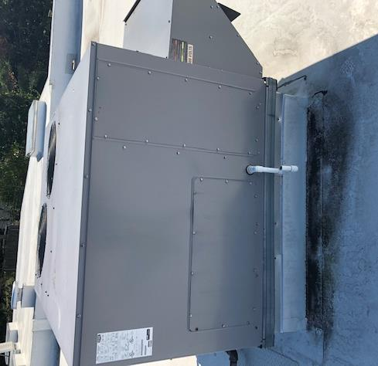
Roof-mounted AHU (note staining near condensate drain)
Picture 2
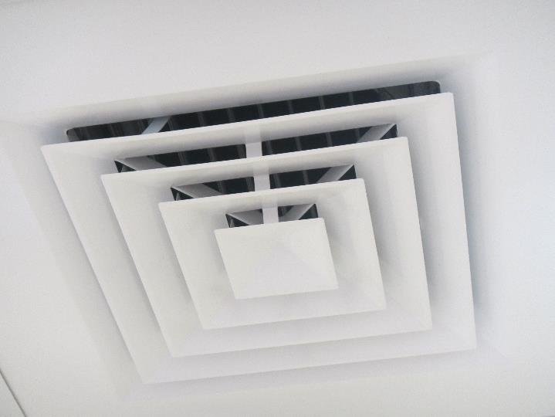
Ceiling-mounted supply air diffuser
Picture 3
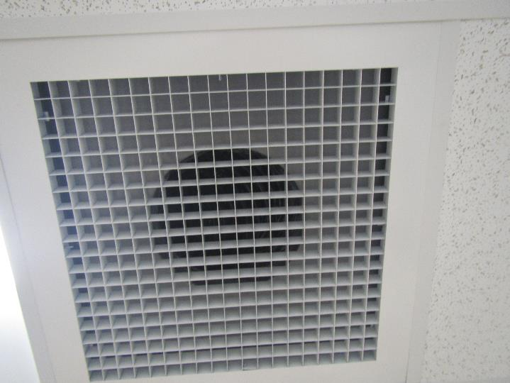
Ducted return air grate
Picture 4
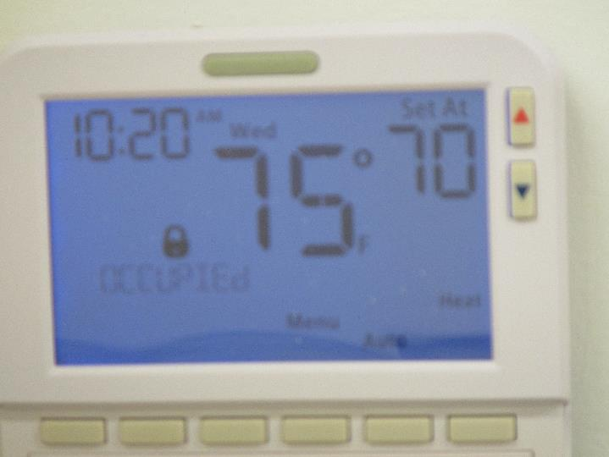
Thermostat showing “auto” setting
Picture 5
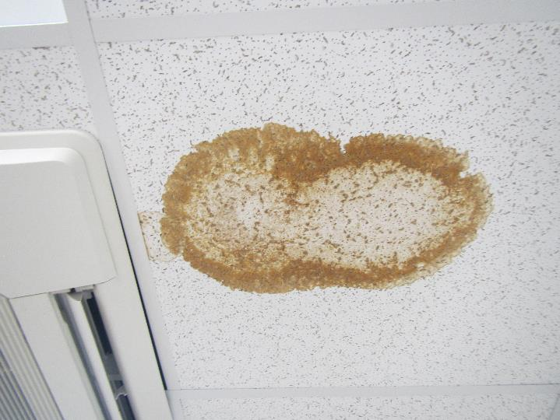
Water-damaged ceiling tile near AC unit in server room
Picture 6
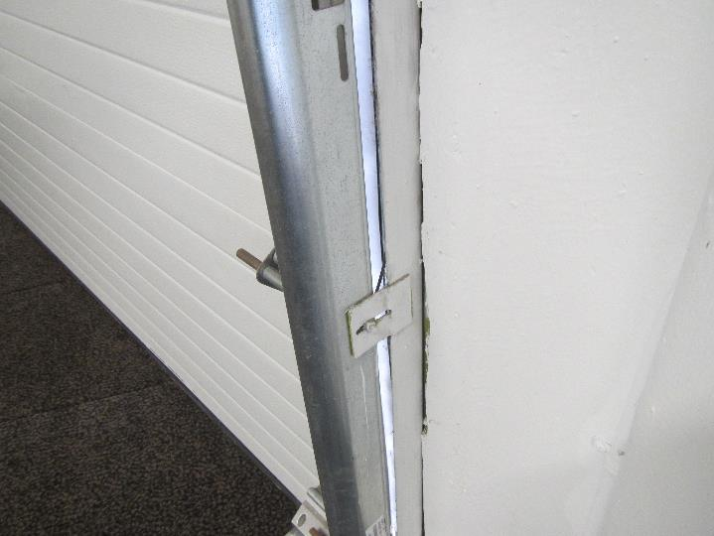
Loading dock door with large gaps to the outdoors
Picture 7
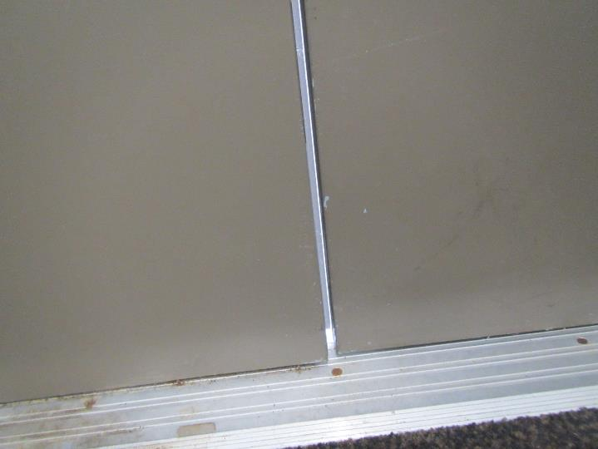
Rear exit door showing large gaps between doors
Picture 8
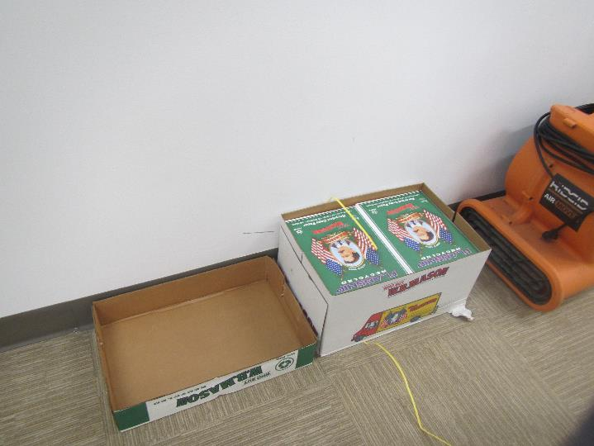
Area of reported water leak from adjacent tenant (note vinyl coving in place)
Picture 9
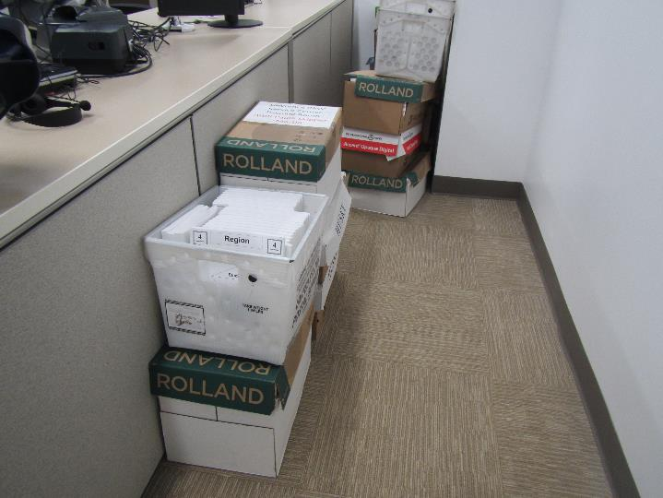
Boxes stored directly on the slab floor
Picture 10
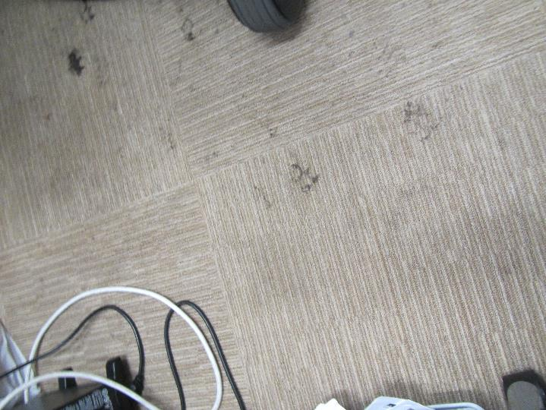
Apparent grease stains with tracks made by motorized chair
Picture 11
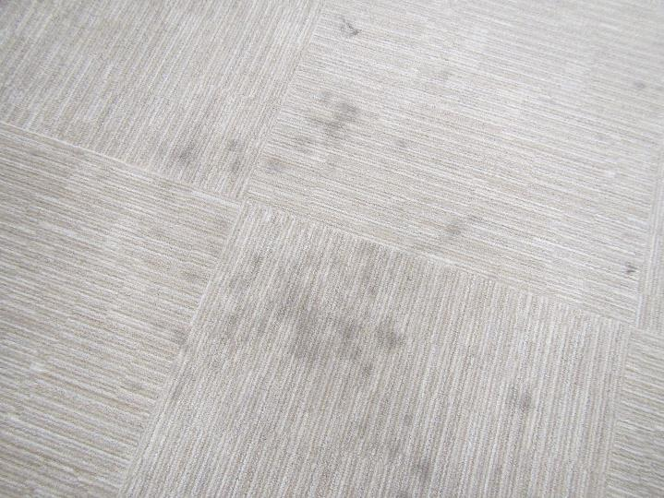
Dark, blotchy stains noted in several areas of the RMV
Picture 12
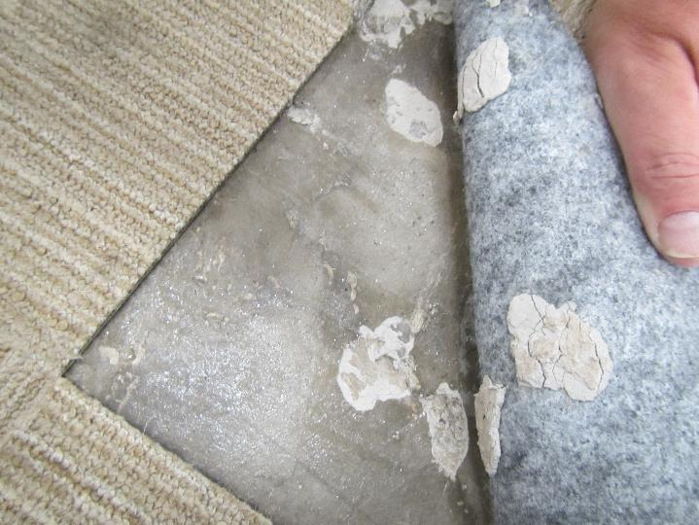
Concrete showing clear, tacky mastic (white is floor leveler)
Picture 13
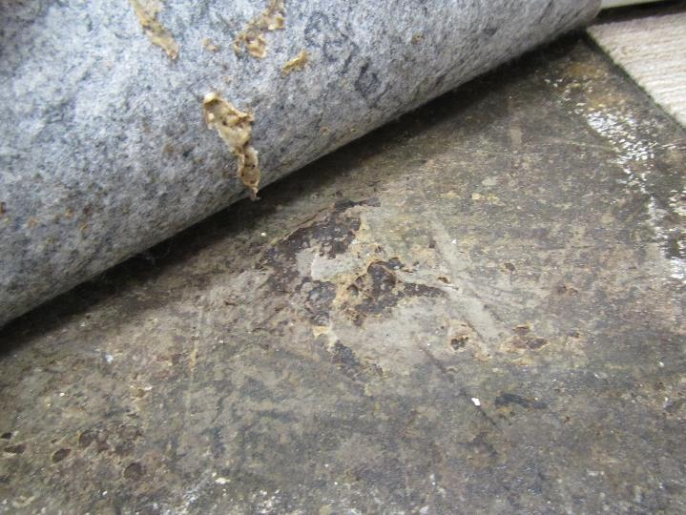
Concrete showing dark, tar like consistency of mastic

Location | Carbon  Dioxide  (ppm) | Carbon Monoxide  (ppm) | Temp  (°F) | Relative  Humidity  (%) | PM2.5  (µg/m³) | TVOCs  (ppm) | Occupants  in Room | Windows  Openable | Ventilation |  | Remarks
 |  |  |  |  |  |  |  |  | Supply | Exhaust
Background | 335 | ND | 76 | 73 | 29 | ND | - | - | - | - | People smoking near building
B2B area | 819 | ND | 72 | 57 | 14 | ND | 4 | N | Y | Y | Report of flood from adjacent tenant, dried with fans within hours, vinyl coving left in place on GW base
Main lobby-center | 790 | ND | 73 | 56 | 13 | ND | 20 | N | Y | Y
Main lobby-right | 728 | ND | 73 | 56 | 12 | ND | 23 | N | Y | Y
Main lobby-left | 828 | ND | 73 | 57 | 11 | ND | 27 | N | Y | Y
17 | 842 | ND | 73 | 57 | 7 | ND | 2 | N | Y | Y | WD CT, Fan “auto”, HS
18 | 811 | ND | 74 | 57 | 6 | ND | 2 | N | Y | Y | HS
19 | 762 | ND | 74 | 57 | 2 | ND | 3 | N | Y | Y | DEM, HS
Staff support | 661 | ND | 73 | 59 | 4 | ND | 2 | N | Y | Y | Tile floor
Loading dock area | - | - | - | - | - | - | - | - | - | - | Door left open to occupied area, carpet tile on floor, large gaps in loading dock door and rear exit door
Training room | 630 | ND | 73 | 59 | 9 | ND | 2 | N | Y | Y | WD CT, DEM, boxes on floor
Counting room-left | 634 | ND | 73 | 61 | 11 | ND | 2 | N | Y | Y | HS, AF
Counting room-right | 671 | ND | 74 | 60 | 12 | ND | 2 | N | Y | Y | HS, AF
Cash room | 602 | ND | 73 | 62 | 10 | ND | 2 | N | Y | Y | HS, WD CT, CPs
Counter 15 | 705 | ND | 74 | 60 | 13 | ND | 5 | N | Y | Y | WD CT
Counter 12 | 650 | ND | 74 | 61 | 12 | ND | 4 | N | Y | Y | HS
District Manager | 621 | ND | 73 | 60 | 11 | ND | 2 | N | Y | Y
Manager | 612 | ND | 73 | 60 | 11 | ND | 2 | N | Y | Y | HS, DEM, stained carpet tiles
Server room | - | - | - | - | - | - | - | - | - | - | WD CT near ceiling AC unit (condensation/leak?)
Counter 6 | 645 | ND | 72 | 61 | 14 | ND | 3 | N | Y | Y | Carpet stains
Road Test | 637 | ND | 74 | 55 | 14 | ND | 3 | N | Y | Y | Carpet stains, DEM, HS
Don’s office | 622 | ND | 72 | 59 | 11 | ND | 2 | N | Y | Y | Accumulated items, stained carpet tiles (grease?)
Greeter (inside) | 724 | ND | 72 | 59 | 14 | ND | 2 | N | Y | Y | HS, stained carpet, fragrances, boxes on floor
Tax collector | 702 | ND | 73 | 62 | 13 | ND | 2 | N | Y | Y | HS, small dark stain on 1 carpet tile
Vehicle Inspection | 610 | ND | 73 | 60 | 11 | ND | 1 | N | Y | Y

