INDOOR AIR QUALITY ASSESSMENT

Registry of Motor Vehicles
1 Washington Street
Taunton, Massachusetts

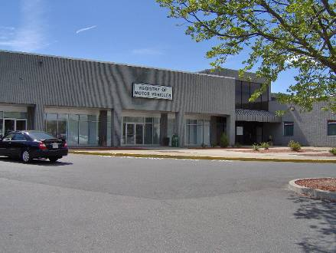

Prepared by:
Massachusetts Department of Public Health
Bureau of Environmental Health
Indoor Air Quality Program
June 2010

Background/Introduction
In response to a request from Aric Warren, Director of Administrative Services, Massachusetts Registry of Vehicles (RMV), the Massachusetts Department of Public Health (MDPH), Bureau of Environmental Health (BEH), provided assistance and consultation regarding indoor air quality concerns at the Taunton RMV office located at 1 Washington Street, Taunton, Massachusetts. The request was prompted by occupant complaints/concerns of musty odors reported in the building. On April 30, 2010, a visit to conduct an indoor air quality assessment was made by Michael Feeney, Director of BEH’s Indoor Air Quality (IAQ) Program. Mr. Feeney was accompanied by Robert Rafail, Manager of Real Property Management, Department of Transportation.
The RMV occupies space in a strip mall. The RMV is physically separated from adjacent businesses by floor to ceiling walls constructed on gypsum wallboard and narrow corridors approximately 6 to 8 feet in width. The RMV is made up of a large open service area/waiting room (Map 1), offices and storage space. The RMV space has no openable windows.

Methods
Air tests for carbon dioxide, temperature and relative humidity were taken with the TSI, Q-Trak, IAQ Monitor. Air tests for airborne particle matter with a diameter less than 2.5 micrometers were taken with the TSI, DUSTTRAK™ Aerosol Monitor Model 8520. BEH staff also performed visual inspection of building materials for water damage and/or microbial growth.

Results
The RMV has an employee population of approximately 30 and is visited by up to several hundred individuals daily. The tests were taken during normal operations. Test results appear in Table 1 and are numbered to correspond with numbered locations in Map 1.

Discussion

Ventilation
It can be seen from Table 1 that carbon dioxide levels were above 800 parts per million (ppm) in but one area, indicating less than optimal air exchange at the time of the assessment. It is important to note that a number of areas were sparsely populated or unoccupied at the time carbon dioxide measurements were taken, which generally results in reduced carbon dioxide levels. Carbon dioxide levels would be expected to be higher with full occupancy. The fact that the RMV service area/waiting room is a large open area with high ceilings, further illustrates a lack of adequate air exchange.
Mechanical ventilation is provided by rooftop air-handling units (AHUs) (Picture 1). Fresh air is drawn into the AHUs and delivered to occupied areas via ductwork. Recirculated air is directed into the office space by ceiling-mounted fresh air diffusers. Return air is drawn into an open ceiling plenum (Picture 2), which is returned to the rooftop AHU by a duct in the ceiling plenum. No means to exhaust stale air exists (Picture 1). In this configuration, ordinary indoor pollutants can build up over the course of the business day and lead to IAQ/comfort complaints. The only form of exhaust ventilation for the office space appears to be the exhaust vents in the restrooms. In order to maximize exhaust ventilation, exhaust fans in commercial settings are usually located at the roof level. The restroom exhaust vent fans for the RMV space (Picture 3) are located in the suspended ceiling and are connected to the roof via flexible ducts (Picture 4). The placement of exhaust in this manner will reduce air velocity to decrease draw of air, which in turn serves to increase carbon dioxide levels. Unfortunately, these vents are also activated by restroom light switches. The fans were deactivated at the time of the assessment because the lights were not on.
Digital wall-mounted thermostats control the heating, ventilating and air-conditioning (HVAC) system and have fan settings of “on” and “automatic”. Thermostats were set to the “automatic” setting during the assessment. The automatic setting on the thermostat activates the HVAC system at a preset temperature. Once the preset temperature is reached, the HVAC system is deactivated. Therefore, no mechanical ventilation is provided until the thermostat re-activates the system. Without a continuous source of fresh outside air and removal via the exhaust/return system, indoor environmental pollutants can built-up and lead to indoor air quality/comfort complaints.
To maximize air exchange, the MDPH recommends that both supply and exhaust ventilation operate continuously during periods of occupancy. In order to have proper ventilation with a mechanical supply and exhaust system, the systems must be balanced to provide an adequate amount of fresh air to the interior of a room while removing stale air from the room. It is recommended that HVAC systems be re-balanced every five years to ensure adequate air systems function (SMACNA, 1994). The date of the last balancing of these systems was not available at the time of the assessment.
The Massachusetts Building Code requires a minimum ventilation rate of 20 cubic feet per minute (cfm) per occupant of fresh outside air or have openable windows in each room (SBBRS, 1997; BOCA, 1993). The ventilation must be on at all times that the room is occupied. Providing adequate fresh air ventilation with open windows and maintaining the temperature in the comfort range during the cold weather season is impractical. Mechanical ventilation is usually required to provide adequate fresh air ventilation.
Carbon dioxide is not a problem in and of itself. It is used as an indicator of the adequacy of the fresh air ventilation. As carbon dioxide levels rise, it indicates that the ventilating system is malfunctioning or the design occupancy of the room is being exceeded. When this happens, a buildup of common indoor air pollutants can occur, leading to discomfort or health complaints. The Occupational Safety and Health Administration (OSHA) standard for carbon dioxide is 5,000 parts per million parts of air (ppm). Workers may be exposed to this level for 40 hours/week, based on a time-weighted average (OSHA, 1997).
The MDPH uses a guideline of 800 ppm for publicly occupied buildings. A guideline of 600 ppm or less is preferred in schools due to the fact that the majority of occupants are young and considered to be a more sensitive population in the evaluation of environmental health status. Inadequate ventilation and/or elevated temperatures are major causes of complaints such as respiratory, eye, nose and throat irritation, lethargy and headaches. For more information concerning carbon dioxide, please see Appendix A.
Temperature readings ranged from 65° F to 73° F during the assessment, some of which were below the MDPH recommended comfort guidelines in some areas surveyed. The MDPH recommends that indoor air temperatures be maintained in a range of 70 º F to 78 º F in order to provide for the comfort of building occupants. In many cases concerning indoor air quality, fluctuations of temperature in occupied spaces are typically experienced, even in a building with an adequate fresh air supply.
The relative humidity measured during the assessment ranged from 22 to 32 percent, which was below the MDPH recommended comfort range in all areas surveyed the day of the assessment. The MDPH recommends a comfort range of 40 to 60 percent for indoor air relative humidity. Relative humidity levels in the building would be expected to drop during the winter months due to heating. Relative humidity levels in the building would be expected to drop during the heating season. It is important to note however, that relative humidity measured indoors exceeded outdoor measurements (range +9 to 19 percent). This increase in relative humidity can indicate that the exhaust system is insufficient to remove normal indoor pollutants (e.g., water vapor from respiration).
Moisture removal is important since the sensation of heat conditions increases as relative humidity increases (the relationship between temperature and relative humidity is called the heat index). As indoor temperature rises, the addition of more relative humidity will make occupants feel hotter. If moisture is removed, the comfort of the individuals is increased. Removal of moisture from the air, however, can have some negative effects. The sensation of dryness and irritation is common in a low relative humidity environment. Low relative humidity is a common problem during the heating season in the northeast part of the United States.

Microbial/Moisture Concerns
A few areas had water-damaged ceiling tiles. Water-damaged ceiling tiles can provide a source of mold and should be replaced after a water leak is discovered and repaired. The US Environmental Protection Agency (US EPA) and the American Conference of Governmental Industrial Hygienists (ACGIH) recommend that porous materials be dried with fans and heating within 24 to 48 hours of becoming wet (US EPA, 2001; ACGIH, 1989). If not dried within this time frame, mold growth may occur. Once mold has colonized porous materials, they are difficult to clean and should be removed.

Particulate Matter
The US EPA has established NAAQS limits for exposure to particulate matter. Particulate matter is airborne solids that can be irritating to the eyes, nose and throat. The NAAQS originally established exposure limits to particulate matter with a diameter of 10 μm or less (PM10). According to the NAAQS, PM10 levels should not exceed 150 microgram per cubic meter (μg/m3) in a 24-hour average (US EPA, 2006). These standards were adopted by both ASHRAE and BOCA. Since the issuance of the ASHRAE standard and BOCA Code, US EPA established a more protective standard for fine airborne particles. This more stringent PM2.5 standard requires outdoor air particle levels be maintained below 35 μg/m3 over a 24-hour average (US EPA, 2006). Although both the ASHRAE standard and BOCA Code adopted the PM10 standard for evaluating air quality, MDPH uses the more protective PM2.5 standard for evaluating airborne particulate matter concentrations in the indoor environment.
Outdoor PM2.5 concentration was measured at 5 μg/m3 (Table 1). PM2.5 levels measured indoors ranged from 1 to 3 μg/m3 (Table 1), which were below the NAAQS PM2.5 level of 35 μg/m3. Frequently, indoor air levels of particulates (including PM2.5) can be at higher levels than those measured outdoors. A number of mechanical devices and/or activities that occur indoors can generate particulate during normal operations. Sources of indoor airborne particulates may include but are not limited to particles generated during the operation of fan belts in the HVAC system; use of photocopiers, fax machines and computer printing devices; operation of an ordinary vacuum cleaner and heavy foot traffic indoors.

Conclusions/Recommendations
In view of the findings at the time of the visit, the following recommendations are made:
- Examine methods to improve exhaust ventilation. Adding exhaust vents to the rooftop AHUs should be considered.
- Set the thermostat to the fan “on” position to operate the ventilation system continuously during business hours.
- In order to increase air circulation, consideration should be given to replacing six ceiling tiles with “egg crates” in the public waiting area (Area 23) to allow for waste heat to vent into the ceiling plenum.
- Consideration should be give to installing restroom exhaust motors in place of the cane-shape vents on the roof.
- Install timer to operate restroom exhaust vents continuously during business hours.
- For buildings in New England, periods of low relative humidity during the winter are often unavoidable. Therefore, scrupulous cleaning practices should be adopted to minimize common indoor air contaminants whose irritant effects can be enhanced when the relative humidity is low. To control for dusts, a high efficiency particulate arrestance (HEPA) filter equipped vacuum cleaner in conjunction with wet wiping of all surfaces is recommended. Drinking water during the day can help ease some symptoms associated with a dry environment (throat and sinus irritations).
- Ensure leaks are repaired and replace water-damaged ceiling tiles. Examine the area above and around these areas for mold growth. Disinfect areas of water leaks with an appropriate antimicrobial as needed.
- Refer to resource manuals and other related indoor air quality documents for further building-wide evaluations and advice on maintaining public buildings. Copies of these materials are located on the MDPH’s website: http://mass.gov/dph/iaq.

References
ACGIH. 1989. Guidelines for the Assessment of Bioaerosols in the Indoor Environment. American Conference of Governmental Industrial Hygienists, Cincinnati, OH.

BOCA. 1993. The BOCA National Mechanical Code/1993. 8th ed. Building Officials and Code Administrators International, Inc., Country Club Hill, IL. Section M-308.1.1.

OSHA. 1997. Limits for Air Contaminants. Occupational Safety and Health Administration. Code of Federal Regulations. 29 C.F.R 1910.1000 Table Z-1-A.

SBBRS. 1997. Mechanical Ventilation. State Board of Building Regulations and Standards. Code of Massachusetts Regulations. 780 CMR 1209.0.

SMACNA. 1994. HVAC Systems Commissioning Manual. 1st ed. Sheet Metal and Air Conditioning Contractors’ National Association, Inc., Chantilly, VA.

US EPA. 2001. Mold Remediation in Schools and Commercial Buildings. US Environmental Protection Agency, Office of Air and Radiation, Indoor Environments Division, Washington, DC. EPA 402-K-01-001. March 2001.
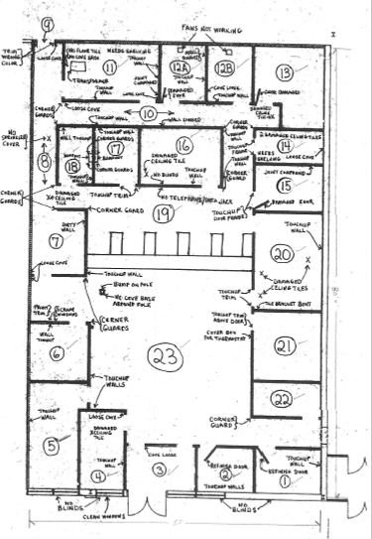
Picture 1

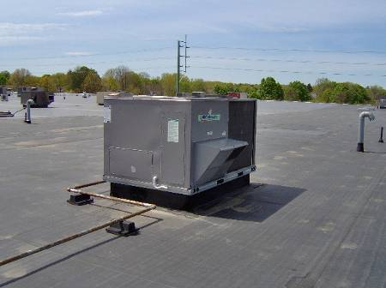

Rooftop AHU, Note Sheet Metal over Exhaust Vent (Arrow)

Picture 2

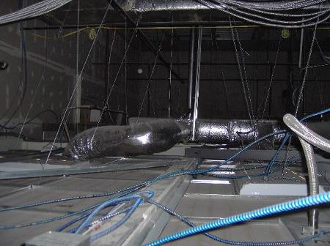

Ceiling Plenum Above Office Space, Note Large Volume (+8 Feet)

Picture 3

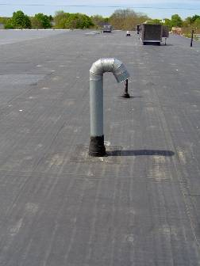

Restroom Exhaust Vents on Roof

Picture 4

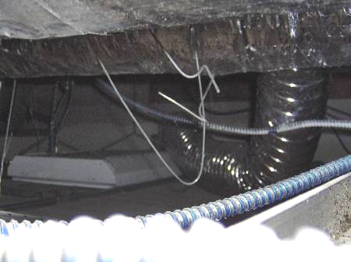

Flexible Duct Connected to Restroom Vent
Location | Occupants  in Room | Temp  (°F) | Relative  Humidity  (%) | Carbon  Dioxide  (ppm) | PM2.5 (ug/m3) | Windows  Openable | Ventilation |  | Remarks
 |  |  |  |  |  |  | Supply | Exhaust | Remarks
Outside  (Background) |  | 75 | 13 | 392 | 5
16 | 0 | 69 | 27 | 1102 | 1 | N | Y | Y
19 | 10 | 68 | 27 | 1022 | 1 | N | Y | Y
18 | 0 | 68 | 26 | 975 | 1 | N | Y | Y
8 | 0 | 68 | 26 | 978 | 1 | N | Y | Y
15 | 1 | 69 | 26 | 991 | 1 | N | Y | Y
14 | 0 | 69 | 26 | 971 | 1 | N | Y | N
17 | 0 | 69 | 26 | 965 | 1 | N | Y | N
20 | 2 | 70 | 26 | 1059 | 1 | N | Y | Y
23 | 30+ | 71 | 26 | 1090 | 1 | N | Y | Y | 3 water damaged ceiling tiles
21 | 2 | 71 | 26 | 1078 | 1 | N | Y | N
7 | 1 | 71 | 26 | 1080 | 1 | N | Y | Y
4 | 1 | 72 | 23 | 1039 | 1 | N | Y | Y
2 | 1 | 72 | 24 | 1198 | 1 | N | Y | Y
Waiting corridor | 15+ | 73 | 24 | 918 | 3 | N | N | N
22 | 0 | 65 | 32 | 1298 | 3 | N | Y | N
1 | 2 | 69 | 26 | 1035 | 2 | N | Y | N
5 | 0 | 71 | 22 | 720 | 1 | N | Y | Y
3 | 0 | 72 | 24 | 1021 | 3 | N | N | N
13 | 1 | 71 | 23 | 965 | 1 | N | Y | Y
12B restroom | 0 | 71 | 23 | 976 | 2 | N | Y | Y
12A rest room | 0 | 70 | 24 | 949 | 1 | N | Y | Y

