INDOOR AIR QUALITY REASSESSMENT

Registry of Motor Vehicles
1 Washington Street
Taunton, Massachusetts

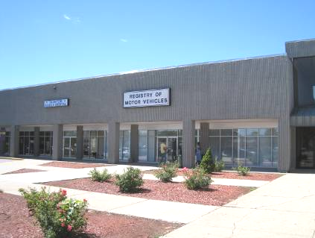

Prepared by:
Massachusetts Department of Public Health
Bureau of Environmental Health
Indoor Air Quality Program
November 2010

Background/Introduction
In response to a request from Aric Warren, Director of Administrative Services, Massachusetts Registry of Motor Vehicles (RMV), the Massachusetts Department of Public Health (MDPH), Bureau of Environmental Health (BEH) provided assistance and consultation regarding indoor air quality concerns at the Taunton RMV office. The office is located at 1 Washington Street, Taunton, Massachusetts.
The building was originally evaluated by BEH staff in April 2010. A report was issued detailing conditions observed at the time and provided recommendations to improve IAQ (MDPH, 2010). On August 27, 2010, Cory Holmes, Environmental Analyst/Regional Inspector for BEH’s Indoor Air Quality (IAQ) Program conducted a reassessment of the RMV.

Actions on MDPH Recommendations
As mentioned, BEH staff had previously visited the building and issued a report with recommendations to improve indoor air quality based upon an IAQ assessment in April 2010 (MDPH, 2010). A summary of actions taken on previous recommendations is included as Appendix A.

Methods
Air tests for carbon dioxide, carbon monoxide, temperature and relative humidity were taken with the TSI, Q-Trak, IAQ Monitor. Air tests for airborne particle matter with a diameter less than 2.5 micrometers were taken with the TSI, DUSTTRAK™ Aerosol Monitor Model 8520. BEH staff also performed visual inspection of building materials for water damage and/or microbial growth.

Results
The RMV has an employee population of approximately 30 and is reportedly visited by hundreds of individuals daily. The tests were taken during normal operations and are presented in Table 1. Results are numbered to correspond with locations in Map 1.

Discussion

Ventilation
It can be seen from Table 1 that carbon dioxide levels were below 800 parts per million (ppm) in all areas, indicating adequate air exchange at the time of the assessment. Mechanical ventilation is provided by rooftop air-handling units (AHUs) (Picture 1). Fresh air is drawn into the AHU through a bank of pleated air filters (Picture 2); and is heated/cooled; and delivered to occupied areas via ducted supply diffusers. Return air is drawn into the ceiling plenum and ducted back to rooftop AHUs. Rooftop AHU filters were clean at the time of the assessment (Picture 2). Restroom exhaust vents provide general exhaust for the RMV space. As recommended in the previous MDPH report, they were on a timer to provide continuous exhaust during business hours (Appendix A), as recommended previously.
Digital wall-mounted thermostats control the heating, ventilating and air-conditioning (HVAC) system and have fan settings of “on” and “automatic”. The automatic setting on the thermostat activates the HVAC system at a preset temperature. Once the preset temperature is reached, the HVAC system is deactivated. Therefore, no mechanical ventilation is provided until the thermostat re-activates the system. Thermostats at the RMV were set to the “on” setting at the time of the assessment, providing a continuous source of fresh air and filtration.
To maximize air exchange, the MDPH recommends that both supply and exhaust ventilation operate continuously during periods of occupancy. In order to have proper ventilation with a mechanical supply and exhaust system, the systems must be balanced to provide an adequate amount of fresh air to the interior of a room while removing stale air from the room. It is recommended that HVAC systems be re-balanced every five years to ensure adequate air systems function (SMACNA, 1994).
The Massachusetts Building Code requires a minimum ventilation rate of 20 cubic feet per minute (cfm) per occupant of fresh outside air or have openable windows in each room (SBBRS, 1997; BOCA, 1993). The ventilation must be on at all times that the room is occupied. Providing adequate fresh air ventilation with open windows and maintaining the temperature in the comfort range during the cold weather season is impractical. Mechanical ventilation is usually required to provide adequate fresh air ventilation.
Carbon dioxide is not a problem in and of itself. It is used as an indicator of the adequacy of the fresh air ventilation. As carbon dioxide levels rise, it indicates that the ventilating system is malfunctioning or the design occupancy of the room is being exceeded. When this happens, a buildup of common indoor air pollutants can occur, leading to discomfort or health complaints. The Occupational Safety and Health Administration (OSHA) standard for carbon dioxide is 5,000 parts per million parts of air (ppm). Workers may be exposed to this level for 40 hours/week, based on a time-weighted average (OSHA, 1997).
The MDPH uses a guideline of 800 ppm for publicly occupied buildings. A guideline of 600 ppm or less is preferred in schools due to the fact that the majority of occupants are young and considered to be a more sensitive population in the evaluation of environmental health status. Inadequate ventilation and/or elevated temperatures are major causes of complaints such as respiratory, eye, nose and throat irritation, lethargy and headaches. For more information concerning carbon dioxide, please see Appendix B.
Temperature readings taken during the assessment ranged from 68º F to 72 º F, which were within or close to the lower end of the MDPH recommended comfort guidelines. The MDPH recommends that indoor air temperatures be maintained in a range of 70 º F to 78 º F in order to provide for the comfort of building occupants. In many cases concerning indoor air quality, fluctuations of temperature in occupied spaces are typically experienced, even in a building with an adequate fresh air supply. It was reported by building maintenance that the exterior door to the auxiliary waiting room was periodically left open. The auxiliary waiting room is located outside of the RMV space in an unconditioned area with a high ceiling. Leaving this door open would allow heat and/or cooling to escape making it more difficult to control temperature and comfort.
The relative humidity measured during the assessment ranged from 46 to 55 percent, which was within the MDPH recommended comfort range in all areas surveyed the day of the assessment. The MDPH recommends a comfort range of 40 to 60 percent for indoor air relative humidity. Relative humidity levels in the building would be expected to drop during the winter months due to heating. Relative humidity levels in the building would be expected to drop during the heating season. The sensation of dryness and irritation is common in a low relative humidity environment. Low relative humidity is a common problem during the heating season in the northeast part of the United States.

Other Indoor Air Evaluations
Indoor air quality can be negatively influenced by the presence of respiratory irritants, such as products of combustion. The process of combustion produces a number of pollutants. Common combustion emissions include carbon monoxide, carbon dioxide, water vapor, and smoke (fine airborne particle material). Of these materials, exposure to carbon monoxide and particulate matter with a diameter of 2.5 micrometers (μm) or less (PM2.5) can produce immediate, acute health effects upon exposure. To determine whether combustion products were present in the indoor environment, BEH staff obtained measurements for carbon monoxide and PM2.5.

Carbon Monoxide
Carbon monoxide is a by-product of incomplete combustion of organic matter (e.g., gasoline, wood and tobacco). Exposure to carbon monoxide can produce immediate and acute health affects. Several air quality standards have been established to address carbon monoxide and prevent symptoms from exposure to these substances. The MDPH established a corrective action level concerning carbon monoxide in ice skating rinks that use fossil-fueled ice resurfacing equipment. If an operator of an indoor ice rink measures a carbon monoxide level over 30 ppm, taken 20 minutes after resurfacing within a rink, that operator must take actions to reduce carbon monoxide levels (MDPH, 1997).
The American Society of Heating Refrigeration and Air-Conditioning Engineers (ASHRAE) has adopted the National Ambient Air Quality Standards (NAAQS) as one set of criteria for assessing indoor air quality and monitoring of fresh air introduced by HVAC systems (ASHRAE, 1989). The NAAQS are standards established by the US EPA to protect the public health from six criteria pollutants, including carbon monoxide and particulate matter (US EPA, 2006). As recommended by ASHRAE, pollutant levels of fresh air introduced to a building should not exceed the NAAQS levels (ASHRAE, 1989). The NAAQS were adopted by reference in the Building Officials & Code Administrators (BOCA) National Mechanical Code of 1993 (BOCA, 1993), which is now an HVAC standard included in the Massachusetts State Building Code (SBBRS, 1997). According to the NAAQS, carbon monoxide levels in outdoor air should not exceed 9 ppm in an eight-hour average (US EPA, 2006).
Carbon monoxide should not be present in a typical, indoor environment. If it is present, indoor carbon monoxide levels should be less than or equal to outdoor levels. On the day of the assessment, outdoor carbon monoxide concentrations were non-detect (ND) (Table 1). No measureable levels of carbon monoxide were detected in the building during the assessment (Table 1).

Particulate Matter
The US EPA has established NAAQS limits for exposure to particulate matter. Particulate matter is airborne solids that can be irritating to the eyes, nose and throat. The NAAQS originally established exposure limits to particulate matter with a diameter of 10 μm or less (PM10). According to the NAAQS, PM10 levels should not exceed 150 micrograms per cubic meter (μg/m³) in a 24-hour average (US EPA, 2006). These standards were adopted by both ASHRAE and BOCA. Since the issuance of the ASHRAE standard and BOCA Code, US EPA established a more protective standard for fine airborne particles. This more stringent PM2.5 standard requires outdoor air particle levels be maintained below 35 μg/m³ over a 24-hour average (US EPA, 2006). Although both the ASHRAE standard and BOCA Code adopted the PM10 standard for evaluating air quality, MDPH uses the more protective PM2.5 standard for evaluating airborne particulate matter concentrations in the indoor environment.
Outdoor PM2.5 was measured at 3 μg/m³ (Table 1). PM2.5 levels measured indoors ranged from 1 to 2 μg/m³ (Table 1), which were below the NAAQS PM2.5 level of 35 μg/m³. Frequently, indoor air levels of particulates (including PM2.5) can be at higher levels than those measured outdoors. A number of mechanical devices and/or activities that occur in buildings can generate particulate during normal operations. Sources of indoor airborne particulates may include but are not limited to particles generated during the operation of fan belts in the HVAC system, use of stoves and/or microwave ovens in kitchen areas; use of photocopiers, fax machines and computer printing devices; operation of an ordinary vacuum cleaner and heavy foot traffic indoors.

Other Conditions
Other conditions that can affect indoor air quality were observed during the assessment. A wet mop and bucket with standing water was observed in the plate storage room (Picture 3). Mops should be dried and buckets should be emptied after use to prevent mold growth and associated odors.
In response to BEH previous recommendations, “egg crate” vents were installed in ceiling tiles in the waiting room to increase air circulation and remove waste heat. Occupants reported that dirt, dust and debris from the ceiling plenum had fallen into the RMV onto flat surfaces, most likely due to vibration from adjacent construction. Dirt, dust and particulates can provide a source of eye and respiratory irritation. At the time of the assessment no such dust/debris was observed; however, it was reported that building management had ordered a filter media to install above the egg crates which would let air pass through while catching dust and debris that might be present. MDPH believes this is a prudent measure.

Conclusions/Recommendations
RMV officials, working in conjunction with building management/maintenance personnel, private contractors and RMV staff, have improved indoor environmental conditions in the building by implementing a number of MDPH’s previous recommendations. At the time of the reassessment complaints mainly consisted of routine cleaning and maintenance. In view of the findings at the time of this visit, the following additional recommendations are made to further improve indoor air quality:
- Consider creating a log book for staff to submit specific cleaning/maintenance requests. Make log book available for staff/management in a central location. Cleaning/Maintenance requests should include date, requester, a detailed description of where and what the issue is as well as a section for cleaning/maintenance personnel to sign off or document progress of request.
- Continue to operate thermostats in the fan “on” position to operate the ventilation system continuously during business hours.
- In order to increase air exchange and control comfort, ensure all exterior doors are closed (e.g., auxiliary waiting room).
- To improve cleaning and dust control, a high efficiency particulate arrestance (HEPA) filter equipped vacuum cleaner in conjunction with wet wiping of flat surfaces is highly recommended.
- Clean carpeting annually or semi-annually in soiled high traffic areas as per the recommendations of the Institute of Inspection, Cleaning and Restoration Certification (IICRC). Copies of the IICRC fact sheet can be downloaded at: http://www.cleancareseminars.com/carpet_cleaning_faq4.htm (IICRC, 2005).
- Ensure mops are dried and buckets are emptied and cleaned after use.
- Continue with plans to install filter media above egg crates to prevent dust/debris from the ceiling plenum into occupied areas.
- Refer to resource manuals and other related indoor air quality documents for further building-wide evaluations and advice on maintaining public buildings. Copies of these materials are located on the MDPH’s website: http://mass.gov/dph/indoor_air.

References
ASHRAE. 1989. Ventilation for Acceptable Indoor Air Quality. American Society of Heating, Refrigeration and Air Conditioning Engineers. ANSI/ASHRAE 62-1989.

BOCA. 1993. The BOCA National Mechanical Code/1993. 8th ed. Building Officials and Code Administrators International, Inc., Country Club Hill, IL. Section M-308.1.1.

IICRC. 2005. Carpet Cleaning FAQ 4 Institute of Inspection, Cleaning and Restoration Certification. Institute of Inspection Cleaning and Restoration, Vancouver, WA.

MDPH. 1997. Requirements to Maintain Air Quality in Indoor Skating Rinks (State Sanitary Code, Chapter XI). 105 CMR 675.000. Massachusetts Department of Public Health, Boston, MA.

MDPH. 2010. Indoor Air Quality Assessment. Massachusetts Registry of Motor Vehicles, Taunton Branch. Massachusetts Department of Public Health, Bureau of Environmental Health, Boston, MA. June 2010.

OSHA. 1997. Limits for Air Contaminants. Occupational Safety and Health Administration. Code of Federal Regulations. 29 C.F.R 1910.1000 Table Z-1-A.

SBBRS. 1997. Mechanical Ventilation. State Board of Building Regulations and Standards. Code of Massachusetts Regulations. 780 CMR 1209.0.

US EPA. 2006. National Ambient Air Quality Standards (NAAQS). US Environmental Protection Agency, Office of Air Quality Planning and Standards, Washington, DC. http://www.epa.gov/air/criteria.html.
Picture 1

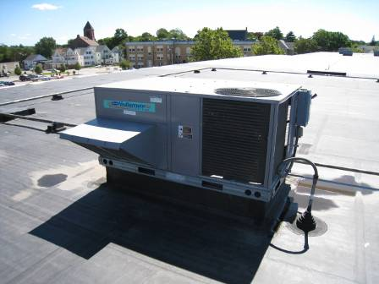

Rooftop Air Handling Unit

Picture 2

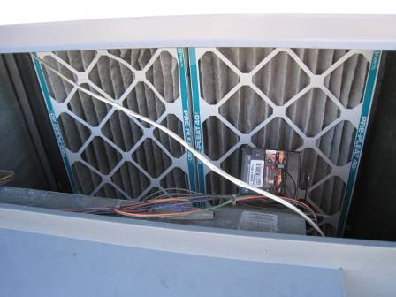

Pleated Filters Installed in Rooftop Air Handling Units

Picture 3

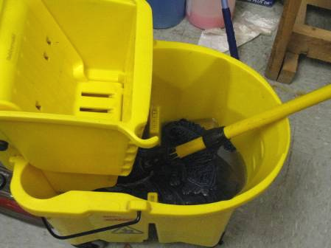

Wet Mop and Bucket with Standing Water in Storage Room
Location | Occupants  in Room | Temp  (°F) | Relative  Humidity  (%) | Carbon  Dioxide  (ppm) | Carbon  Monoxide  (ppm) | PM2.5 (ug/m3) | Windows  Openable | Ventilation |  | Remarks
Outside  (Background) |  | 82 | 47 | 351 | ND | 3 |  |  |  | Clear skies, hot, sunny busy traffic area parking lot
Director’s Office | 2 | 71 | 53 | 509 | ND | 2 | N | Y | Y
RACE Unit | 1 | 70 | 52 | 524 | ND | 2 | N | Y | Y | Cobwebs on return vent
Supervisor’s Office | 0 | 70 | 54 | 495 | ND | 2 | N | Y | Y
Break Room | 1 | 71 | 55 | 540 | ND | 2 | N | Y | Y
Men’s Restroom |  |  |  |  |  |  | N | N | Y | Exhaust vent on timer
Women’s Restroom |  |  |  |  |  |  | N | N | Y | Exhaust vent on timer
Plate Storage | 0 | 71 | 53 | 497 | ND | 2 | N | Y | Y | Mop bucket with standing water
Cash Room | 2 | 71 | 53 | 501 | ND | 2 | N | Y | N
Work Stations 1-5 | 8 | 72 | 52 | 514 | ND | 2 | N | Y | Y
Testing Room | 0 | 71 | 50 | 499 | ND | 2 | N | Y | N
Eye Test | 0 | 71 | 50 | 583 | ND | 2 | N | Y | Y
Waiting Area | ~40-45 | 70 | 50 | 572 | ND | 2 | N | Y | Y | 1 water-damaged ceiling tile, egg crates installed in ceiling
Tax Collector | 1 | 71 | 48 | 467 | ND | 1 | N | Y | Y
Road Test Examiners Room | 0 | 70 | 50 | 433 | ND | 2 | N | Y | N
Auditors Room | 0 | 71 | 49 | 424 | ND | 2 | N | Y | N
District Managers Office | 0 | 68 | 46 | 430 | ND | 1 | N | Y | Y

Actions on MDPH Recommendations
Massachusetts Registry of Motor Vehicles, Taunton, MA

The following is a status report of action(s) taken on MDPH recommendations (in bold) based on reports from RMV officials, maintenance staff, photographs and MDPH staff observations.
- Examine methods to improve exhaust ventilation. Adding exhaust vents to the rooftop AHUs should be considered.
- Action: Exhaust ventilation was reportedly improved by placing existing exhaust vents in restrooms on a timer to operate continuously during business hours.
- Set the thermostat to the fan “on” position to operate the ventilation system continuously during business hours.
- Action: Thermostats were set to the fan “on” position and were running continuously at the time of the IAQ assessment (Picture A-1).
- In order to increase air circulation, consideration should be given to replacing six ceiling tiles with “egg crates” in the public waiting area (Area 23) to allow for waste heat to vent into the ceiling plenum.
- Action: Egg crates were installed in the waiting area (Picture A-2).
- Consideration should be give to installing restroom exhaust motors in place of the cane-shape vents on the roof.
- Action: No action was taken on this recommendation, however exhaust was improved by operating existing exhaust continuously.

- Install timer to operate restroom exhaust vents continuously during business hours.
Action: Timers were installed for exhaust vents and has improved air exchange (Picture A-3).
- For buildings in New England, periods of low relative humidity during the winter are often unavoidable. Therefore, scrupulous cleaning practices should be adopted to minimize common indoor air contaminants whose irritant effects can be enhanced when the relative humidity is low. To control for dusts, a high efficiency particulate arrestance (HEPA) filter equipped vacuum cleaner in conjunction with wet wiping of all surfaces is recommended. Drinking water during the day can help ease some symptoms associated with a dry environment (throat and sinus irritations).
Action: At the time of the MDPH assessment, occupants reported concerns regarding cleaning practices. Communications between RMV staff/management and the building maintenance staff should be enhanced. Use of a HEPA-filtered vacuum cleaner is highly recommended.
- Ensure leaks are repaired and replace water-damaged ceiling tiles. Examine the area above and around these areas for mold growth. Disinfect areas of water leaks with an appropriate antimicrobial as needed.
Action: One water-damaged ceiling tile was observed in the waiting area (Picture A-4). At the time of the MDPH IAQ assessment, maintenance staff reported that their HVAC vendor was scheduled to be on-site to examine the rooftop air handling unit in this area for leakage and that the ceiling tile was left in place to identify the location of the leak.
Picture A-1
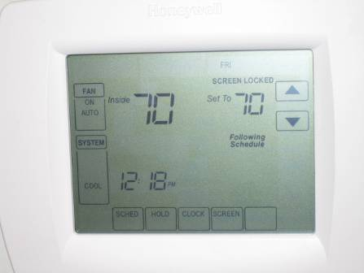
Digital Thermostat Set to Fan “On” to Provide Continuous Air Exchange
Picture A-2
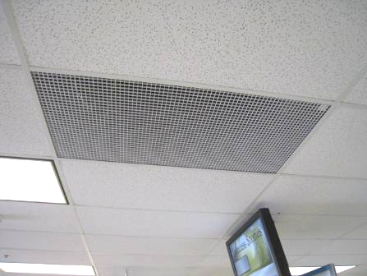
One of Several Egg Crates Installed in Ceiling of Waiting Room
Picture A-3
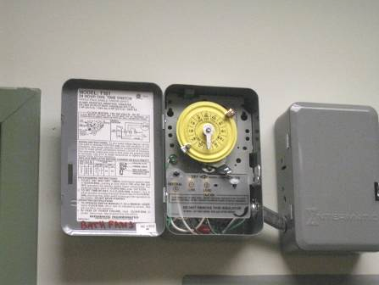
Timer Installed for Restroom Exhaust Vents
Picture A-4
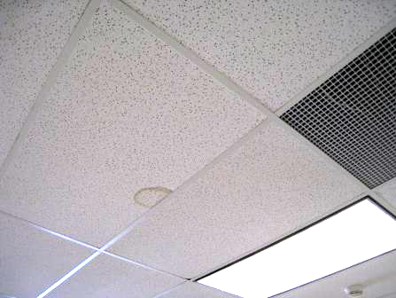
Water-Damaged Ceiling Tile in Waiting Area

