INDOOR AIR QUALITY ASSESSMENT

Massachusetts Registry of Motor Vehicles
73 Winthrop Avenue
Lawrence, Massachusetts

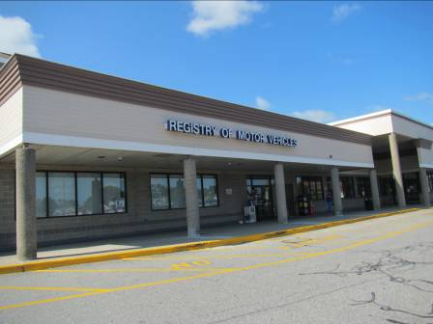

Prepared by:
Massachusetts Department of Public Health
Bureau of Environmental Health
Indoor Air Quality Program
September 2014

Background/Introduction
In response to a request from Mr. Aric Warren, Deputy Director of General Services, Massachusetts Department of Transportation (MassDOT), the Massachusetts Department of Public Health (MDPH), Bureau of Environmental Health (BEH) provided assistance and consultation regarding indoor air quality (IAQ) concerns at the Lawrence branch of the Massachusetts Registry of Motor Vehicles (RMV), located at 73 Winthrop Avenue, Lawrence, Massachusetts. Concerns were expressed regarding pest control and cleaning issues and general IAQ in the space.
On July 29, 2014, a visit to conduct an IAQ assessment was made by Ruth Alfasso, Environmental Engineer/Inspector within BEH’s IAQ Program. Ms. Alfasso was accompanied by Gerry Covino, Office of Leasing and State Office Planning, Division of Capital Asset Management and Maintenance (DCAMM) and Robert Northrup, Program Coordinator, MassDOT.
The RMV is located in a one-story building with a flat roof that is part of a strip mall. The RMV space is made up of a large open service area/waiting room, testing/classrooms, offices, an employee break room and storage space. The space has a dropped ceiling tile system, floor tile and wall-to-wall carpeting in some areas. The windows in the space are not openable. To one side of the RMV is a Marshall’s department store; to the other is a Work Out World gym.

Methods
Air tests for carbon dioxide, carbon monoxide, temperature and relative humidity were taken with the TSI, Q-Trak, IAQ Monitor 7565. Air tests for airborne particle matter with a diameter less than 2.5 micrometers were taken with the TSI, DUSTTRAK II™ Aerosol Monitor Model 8532. Screening for volatile organic compounds was conducted using a RAE Systems Mini-RAE 2000 Photo Ionization Detector. BEH/IAQ staff also performed visual inspection of building materials for water damage and/or microbial growth.

Results
The RMV has an employee population of approximately 40 and can be visited by up to 1000 members of the public on a daily basis. The tests were taken during normal operations. Test results appear in Table 1.

Discussion

Ventilation
It can be seen from Table 1 that carbon dioxide levels were above 800 parts per million (ppm) in 7 of 19 areas surveyed, indicating a lack of air exchange in these areas surveyed at the time of assessment. Most areas with carbon dioxide readings above 800 ppm were in or adjacent to waiting areas that were heavily occupied.
Fresh air for the RMV is supplied by air handling units (AHUs) located on the roof. The AHUs draw in air, heat or cool it and deliver it to spaces via supply vents (Picture 1). Ceiling-mounted exhaust vents remove stale air and return it via a plenum to the AHUs. The system is controlled by wall-mounted digital thermostats. According to Mr. Northrup, some of these thermostats had been found to be non-functional and had been replaced prior to the assessment; others had reportedly been set to the “automatic” setting but had been changed to the “on” setting prior to the assessment. The automatic setting on the thermostat activates the HVAC system at a preset temperature. Once the preset temperature is reached, the HVAC system is deactivated. Therefore, no mechanical ventilation is provided until the thermostat re-activates the system. In the fan “on” mode, air will be continuously circulated and filtered, which should improve temperature/comfort control. MDPH recommends that thermostats be set to the fan “on” setting during occupied periods to provide continuous air circulation and filtration.
As noted above, most of the carbon dioxide readings that were above 800 ppm were in or adjacent to the waiting area. This area has a large number of people continually cycling through it. Additional fresh air may need to be supplied to this area, and similarly additional exhaust ventilation. It was observed that the exhaust vents for the waiting/clerks areas were mostly located over the clerk area, which would tend to draw stale air through the breathing zone of employee work stations. Installing additional exhaust ventilation in the waiting area may facilitate the removal of stale air and help reduce carbon dioxide levels. Some offices had similar issues; in some cases the exhaust vent was located directly next to doors, which are often left open (Picture 2). This would tend to draw air from the hallway into the exhaust vent rather than exhausting air from the office.
Restrooms were equipped with exhaust vents that remove air directly to the outside. All of the restroom vents examined were operational at the time of the visit. Make-up air for the exhaust vents is via undercut doors.
To maximize air exchange, the MDPH recommends that both supply and exhaust ventilation operate continuously during periods of occupancy. In order to have proper ventilation with a mechanical supply and exhaust system, the systems must be balanced to provide an adequate amount of fresh air to the interior of a room while removing stale air from the room. It is recommended that HVAC systems be re-balanced every five years to ensure adequate air systems function (SMACNA, 1994). Balancing information for the systems was not available at the time of assessment.
Minimum design ventilation rates are mandated by the Massachusetts State Building Code (MSBC). Until 2011, the minimum ventilation rate in Massachusetts was higher for both occupied office spaces and general classrooms, with similar requirements for other occupied spaces (BOCA, 1993). The current version of the MSBC, promulgated in 2011 by the State Board of Building Regulations and Standards (SBBRS), adopted the 2009 International Mechanical Code (IMC) to set minimum ventilation rates. Please note that the MSBC is a minimum standard that is not health-based. At lower rates of cubic feet per minute (cfm) per occupant of fresh air, carbon dioxide levels would be expected to rise significantly. A ventilation rate of 20 cfm per occupant of fresh air provides optimal air exchange resulting in carbon dioxide levels at or below 800 ppm in the indoor environment in each area measured. MDPH recommends that carbon dioxide levels be maintained at 800 ppm or below. This is because most environmental and occupational health scientists involved with research on IAQ and health effects have documented significant increases in indoor air quality complaints and/or health effects when carbon dioxide levels rise above the MDPH guidelines of 800 ppm for schools, office buildings and other occupied spaces (Sundell et al., 2011). The ventilation must be on at all times that the room is occupied. Providing adequate fresh air ventilation with open windows and maintaining the temperature in the comfort range during the cold weather season is impractical. Mechanical ventilation is usually required to provide adequate fresh air ventilation.
Carbon dioxide is not a problem in and of itself. It is used as an indicator of the adequacy of the fresh air ventilation. As carbon dioxide levels rise, it indicates that the ventilating system is malfunctioning or the design occupancy of the room is being exceeded. When this happens, a buildup of common indoor air pollutants can occur, leading to discomfort or health complaints. The Occupational Safety and Health Administration (OSHA) standard for carbon dioxide is 5,000 parts per million parts of air (ppm). Workers may be exposed to this level for 40 hours/week, based on a time-weighted average (OSHA, 1997).
The MDPH uses a guideline of 800 ppm for publicly occupied buildings. A guideline of 600 ppm or less is preferred in schools due to the fact that the majority of occupants are young and considered to be a more sensitive population in the evaluation of environmental health status. Inadequate ventilation and/or elevated temperatures are major causes of complaints such as respiratory, eye, nose and throat irritation, lethargy and headaches. For more information concerning carbon dioxide, please see Appendix A.
Temperature readings during the assessment ranged from 68º F to 73º F, which were within or near the lower end of the MDPH recommended comfort guidelines. The MDPH recommends that indoor air temperatures be maintained in a range of 70º F to 78º F in order to provide for the comfort of building occupants. In many cases concerning indoor air quality, fluctuations of temperature in occupied spaces are typically experienced, even in a building with an adequate fresh air supply.
The relative humidity measured during the assessment ranged from 50 to 64 percent, which was within or slightly above the MDPH recommended comfort range. Note that the highest readings were measured in the waiting area, which is near the exterior doors; these readings may also be influenced by a lack of exhaust ventilation in this area to remove occupant-generated moisture. The MDPH recommends a comfort range of 40 to 60 percent for indoor air relative humidity. Humidity levels in the building would be expected to drop during the heating season. The sensation of dryness and irritation is common in a low relative humidity environment. Low relative humidity is a very common problem during the heating season in the northeast part of the United States.

Microbial/Moisture Concerns
A number of areas had water-damaged ceiling tiles (Table 1; Picture 3). Water-damaged ceiling tiles can indicate leaks from the roof or plumbing system and provide a source for mold growth. Water-damaged ceiling tiles should be replaced after a water leak is discovered and repaired. There were reports of past roof leaks, particularly in the kitchen/break room; reportedly, the roof has been repaired recently.
Water-damaged paint was observed in the vestibule (Picture 4) and water-damaged carpeting was observed in several areas, including outside the men’s restroom (Picture 5) There was also evidence of historic water infiltration in the data room where tile mastic could be seen around the edges of the floor tiles (Picture 6). Reportedly, there has not been water infiltration in the data room during the current tenancy by the RMV.
The US Environmental Protection Agency (US EPA) and the American Conference of Governmental Industrial Hygienists (ACGIH) recommend that porous materials be dried with fans and heating within 24 to 48 hours of becoming wet (US EPA, 2001; ACGIH, 1989). If not dried within this time frame, mold growth may occur. Once mold has colonized porous materials, they are difficult to clean and should be removed.
A ductless air conditioning unit was observed in the data room. This unit is equipped with a condensate drain which is pumped to the outside (Picture 7), reportedly to the roof. The drain piping and pump on this unit should be examined periodically to ensure that they are functioning correctly and not leaking.
Light was observed penetrating through spaces around/underneath the exterior door in the loading dock area (Picture 8), which can serve as a pathway for moisture, insects, rodents and other pests into the building. In some areas, boxes and paper were observed on the floor (Table 1; Picture 8). During humid weather, floors may be subject to condensation, which can moisten items stored on the floor and lead to damage and microbial growth. This is particularly true in areas with a connection to the outside, such as the loading dock shown in Picture 8. Porous items should be stored on shelving or in cabinets to protect them from condensation.
Water coolers and mini refrigerators were observed to be located in carpeted areas, where they can spill or leak and cause water damage to the carpet (Picture 9). These appliances should be located on non-porous flooring on or a waterproof mat.

Other IAQ Evaluations
Indoor air quality can be negatively influenced by the presence of respiratory irritants, such as products of combustion. The process of combustion produces a number of pollutants. Common combustion emissions include carbon monoxide, carbon dioxide, water vapor and smoke (fine airborne particle material). Of these materials, exposure to carbon monoxide and particulate matter with a diameter of 2.5 micrometers (μm) or less (PM2.5) can produce immediate, acute health effects upon exposure. To determine whether combustion products were present in the indoor environment, BEH/IAQ staff obtained measurements for carbon monoxide and PM2.5.

Carbon Monoxide
Carbon monoxide is a by-product of incomplete combustion of organic matter (e.g., gasoline, wood and tobacco). Exposure to carbon monoxide can produce immediate and acute health affects. Several air quality standards have been established to address carbon monoxide and prevent symptoms from exposure to these substances. The MDPH established a corrective action level concerning carbon monoxide in ice skating rinks that use fossil-fueled ice resurfacing equipment. If an operator of an indoor ice rink measures a carbon monoxide level over 30 ppm, taken 20 minutes after resurfacing within a rink, that operator must take actions to reduce carbon monoxide levels (MDPH, 1997).
The American Society of Heating Refrigeration and Air-Conditioning Engineers (ASHRAE) has adopted the National Ambient Air Quality Standards (NAAQS) as one set of criteria for assessing indoor air quality and monitoring of fresh air introduced by HVAC systems (ASHRAE, 1989). The NAAQS are standards established by the US EPA to protect the public health from six criteria pollutants, including carbon monoxide and particulate matter (US EPA, 2006). As recommended by ASHRAE, pollutant levels of fresh air introduced to a building should not exceed the NAAQS levels (ASHRAE, 1989). The NAAQS were adopted by reference in the Building Officials & Code Administrators (BOCA) National Mechanical Code of 1993 (BOCA, 1993), which is now an HVAC standard included in the Massachusetts State Building Code (SBBRS, 2011). According to the NAAQS, carbon monoxide levels in outdoor air should not exceed 9 ppm in an eight-hour average (US EPA, 2006).
Carbon monoxide should not be present in a typical, indoor environment. If it is present, indoor carbon monoxide levels should be less than or equal to outdoor levels. On the day of assessment, outdoor carbon monoxide concentrations were non-detect (ND) (Table 1). No measurable levels of carbon monoxide were detected inside the building during the assessment (Table 1).

Particulate Matter
The US EPA has established NAAQS limits for exposure to particulate matter. Particulate matter is airborne solids that can be irritating to the eyes, nose and throat. The NAAQS originally established exposure limits to particulate matter with a diameter of 10 μm or less (PM10). According to the NAAQS, PM10 levels should not exceed 150 micrograms per cubic meter (μg/m³) in a 24-hour average (US EPA, 2006). These standards were adopted by both ASHRAE and BOCA. Since the issuance of the ASHRAE standard and BOCA Code, US EPA established a more protective standard for fine airborne particles. This more stringent PM2.5 standard requires outdoor air particle levels be maintained below 35 μg/m³ over a 24-hour average (US EPA, 2006). Although both the ASHRAE standard and BOCA Code adopted the PM10 standard for evaluating air quality, MDPH uses the more protective PM2.5 standard for evaluating airborne particulate matter concentrations in the indoor environment.
Outdoor PM2.5 concentrations were measured at 5 to 13 μg/m³ (Table 1). PM2.5 levels measured indoors ranged from 1 to 30 μg/m³ (Table 1), which were below the NAAQS PM2.5 level of 35 μg/m³. Frequently, indoor air levels of particulates (including PM2.5) can be at higher levels than those measured outdoors. A number of mechanical devices and/or activities that occur indoors can generate particulate matter during normal operations. Sources of indoor airborne particulates may include but are not limited to particles generated during the operation of fan belts in the HVAC system, use of stoves and/or microwave ovens in kitchen areas; use of photocopiers, fax machines and computer printing devices; operation of an ordinary vacuum cleaner and heavy foot traffic indoors.

Volatile Organic Compounds
Indoor air concentrations can be greatly impacted by the use of products containing volatile organic compounds (VOCs). VOCs are carbon-containing substances that have the ability to evaporate at room temperature. Total volatile organic compounds (TVOCs) can result in eye and respiratory irritation if exposure occurs. For example, chemicals evaporating from a paint can stored at room temperature would most likely contain VOCs. In order to determine if VOCs were present, testing for TVOCs was conducted. Outdoor TVOC concentrations were ND on the day of assessment (Table 1). No measureable levels of TVOCs were detected in the building during the assessment (Table 1).
There are several photocopiers in the building. Photocopiers can be sources of pollutants such as VOCs, ozone, heat and odors, particularly if the equipment is older and in frequent use. Both VOCs and ozone are respiratory irritants (Schmidt Etkin, 1992). Photocopiers should be kept in well-ventilated rooms, and should be located near windows or exhaust vents.
Hand sanitizer was found in some offices and common areas (Table 1). Hand sanitizers may contain ethyl alcohol and/or isopropyl alcohol, which are highly volatile and may be irritating to the eyes and nose. Sanitizing products may also contain fragrances to which some people may be sensitive.
Air fresheners and deodorizing materials were observed in some areas (Table 1). A scented candle was observed in one area. Air deodorizers contain chemicals that can be irritating to the eyes, nose and throat of sensitive individuals. Many air fresheners contain 1,4-dichlorobenzene, a VOC which may cause reductions in lung function (NIH, 2006). Furthermore, deodorizing agents do not remove materials causing odors, but rather mask odors that may be present in the area.

Other Conditions
Other conditions that can affect indoor air quality were observed during the assessment. AHUs are equipped with air filters that should be cleaned or changed per the manufacturer’s instructions to avoid the reaerosolization of dusts and particulates. The AHUs on the roof could not be accessed and the types of filters in use were not known at the time of assessment. In order to provide for adequate removal of aerosolized particulates, especially in locations such as this one with heavy traffic, disposable filters with an appropriate dust spot efficiency should be installed. The dust spot efficiency is the ability of a filter to remove particulates of a certain diameter from air passing through the filter. Filters that have been determined by ASHRAE to meet its standard for a dust spot efficiency of a minimum of 40 percent would be sufficient to reduce many airborne particulates (Thornburg, D., 2000; MEHRC, 1997; ASHRAE, 1992). Pleated filters with a Minimum Efficiency Reporting Value dust-spot efficiency of 9 or higher are recommended. Note that increasing filtration can reduce airflow (called pressure drop), which can subsequently reduce the efficiency of the unit due to increased resistance. Prior to any increase of filtration, each AHU should be evaluated by a ventilation engineer to ascertain whether it can maintain function with more efficient filters.
Pest issues (specifically fleas) were reported to be of concern in this office. Several days prior to the assessment, a pest control contractor had reportedly visited the space and installed light/heat/pheromone-activated traps for the capture/identification of fleas in the space; no evidence of flea activity had been found by the time of the assessment. Occupant concerns about pests in the building should be brought to the attention of building management for continued coordination with a licensed pest control contractor to identify and treat pests as needed.
Occupants had also expressed concerns regarding the suboptimal level of cleaning in the space, such as lack of vacuuming, surface cleaning and the maintenance of restrooms. Reportedly, the evening prior to the assessment, a thorough cleaning of the space was conducted by a different contractor. Thorough and regular cleaning of floors, carpets, and other surfaces is crucial to the maintenance of IAQ.
A number of air diffusers, exhaust/return vents and personal fans were observed to have accumulated dust/debris. If exhaust vents are not functioning, backdrafting can occur, which can re-aerosolize accumulated dust particles. Re-activated vents/fans can also reaerosolize dust/debris accumulated on grills/louvers, fan blades and internal components.
Many areas are carpeted and some carpeting is worn and/or soiled. The Institute of Inspection, Cleaning and Restoration Certification (IICRC), recommends that carpeting be cleaned annually (or semi-annually in soiled high traffic areas) (IICRC, 2012). Consideration should be made to replacing worn/stained carpeting.
In the custodial closet, items, including plastic and cleaners, were observed on top of the water heater (Picture 10). This appliance becomes hot in use and may volatilize plastics from items placed on top, leading to odors and potentially fire. Also note that there was no exhaust vent in this closet, which can allow odors from cleaners, mop buckets, and other items to migrate to occupied areas.
In some areas, accumulation of items, including papers, boxes and personal items were found stored on desks, tables and counters (Picture 11). Large numbers of items provide a source for dusts to accumulate. These items make it difficult for custodial staff to clean. Items should be relocated and/or cleaned periodically to avoid excessive dust build up.
In the loading dock area, a collection of spent fluorescent light bulbs was observed, many of which were not properly contained (Picture 12). These bulbs contain mercury, and must be properly handled and stored in order to prevent breaks and mercury release.

Conclusions/Recommendations
In view of the findings at the time of the visit, the following recommendations are made:
- Operate HVAC systems/AHUs throughout the building continuously during occupied periods.
- Consider adding and/or modifying the location of exhaust vents in the waiting area and offices to allow for more thorough removal of stale air from these spaces.
- Examine the feasibility of installing local exhaust ventilation in custodial closets to remove excess moisture and odors.
- Consider adopting a balancing schedule of every 5 years for all mechanical ventilation systems, as recommended by ventilation industry standards (SMACNA, 1994).
- For buildings in New England, periods of low relative humidity during the winter are often unavoidable. Therefore, scrupulous cleaning practices should be adopted to minimize common indoor air contaminants whose irritant effects can be enhanced when the relative humidity is low. To control for dusts, a high efficiency particulate arrestance (HEPA) filter equipped vacuum cleaner in conjunction with wet wiping of all surfaces is recommended. Drinking water during the day can help ease some symptoms associated with a dry environment (throat and sinus irritations).
- Ensure leaks are repaired and replace water-damaged ceiling tiles. Examine the area above and around these areas for mold growth. Disinfect areas of water leaks with an appropriate antimicrobial as needed.
- Install weather stripping around exterior doors to prevent drafts, water penetration and pest entry. Check for tightness by monitoring for light and/or drafts around doors.
- Consider moving water dispensers and refrigerators to non-carpeted areas or supplying each unit with a waterproof mat.
- Store boxes and other porous materials off the floor. Consider removing or relocating papers/boxes//stored items to allow for more thorough cleaning.
- Avoid the use of air fresheners, deodorizers and scented candles.
- Continue to consult with a licensed pest contractor regarding pest control issues.
- Ensure that the space is thoroughly cleaned on a regular basis. Occupants can assist with cleaning by properly storing/reducing accumulated papers, boxes and other items.
- Clean air diffusers, and return/exhaust vents and personal fans periodically of accumulated dust/debris.
- Avoid storing anything on top of water heater in custodial closet. Keep items in closet clean and dry to avoid odors.
- Continue to clean carpeting annually or semi-annually in soiled high traffic areas as per the recommendations of the Institute of Inspection, Cleaning and Restoration Certification (IICRC, 2012). Consider replacing carpeting that is worn, stained and/or beyond its service life.
- Ensure AHUs are on a preventative maintenance (PM) program. Ensure filters are changed as per the manufacturers’ instructions or more frequently if needed. Use pleated MERV 9 (or higher) dust-spot efficiency filters. Prior to any increase of filtration, HVAC system components should be evaluated by a ventilation engineer as to whether they can maintain function with more efficient filters.
- Photocopiers should be kept in well-ventilated rooms, and should be located near windows or exhaust vents.
- Properly store and dispose of fluorescent light bulbs.
- Refer to resource manuals and other related indoor air quality documents for further building-wide evaluations and advice on maintaining public buildings. Copies of these materials are located on the MDPH’s website: http://mass.gov/dph/iaq.

References
ACGIH. 1989. Guidelines for the Assessment of Bioaerosols in the Indoor Environment. American Conference of Governmental Industrial Hygienists, Cincinnati, OH.
ASHRAE. 1989. Ventilation for Acceptable Indoor Air Quality. American Society of Heating, Refrigeration and Air Conditioning Engineers. ANSI/ASHRAE 62-1989.
ASHRAE. 1992. Gravimetric and Dust-Spot Procedures for Testing Air-Cleaning Devices Used in General Ventilation for Removing Particulate Matter. American Society of Heating, Refrigeration and Air Conditioning Engineers. ANSI/ASHRAE 52.1-1992.
BOCA. 1993. The BOCA National Mechanical Code/1993. 8th ed. Building Officials and Code Administrators International, Inc., Country Club Hill, IL. Section M-308.1.1.
IMC, 2009. 2009 International Mechanical Code. International Code Council Inc., Country Club Hills, IL.
IICRC. 2012. Institute of Inspection, Cleaning and Restoration Certification. Carpet Cleaning: FAQ. Retrieved from http://www.iicrc.org/consumers/care/carpet-cleaning/#faq.
MDPH. 1997. Requirements to Maintain Air Quality in Indoor Skating Rinks (State Sanitary Code, Chapter XI). 105 CMR 675.000. Massachusetts Department of Public Health, Boston, MA.
MEHRC. 1997. Indoor Air Quality for HVAC Operators & Contractors Workbook. MidAtlantic Environmental Hygiene Resource Center, Philadelphia, PA.
NIH. 2006. Chemical in Many Air Fresheners May Reduce Lung Function. NIH News. National Institute of Health. July 27, 2006. http://www.nih.gov/news/pr/jul2006/niehs-27.htm
OSHA. 1997. Limits for Air Contaminants. Occupational Safety and Health Administration. Code of Federal Regulations. 29 C.F.R 1910.1000 Table Z-1-A.
SBBRS. 2011. Mechanical Ventilation. State Board of Building Regulations and Standards. Code of Massachusetts Regulations, 8th edition. 780 CMR 1209.0.
Schmidt Etkin, D. 1992. Office Furnishings/Equipment & IAQ Health Impacts, Prevention & Mitigation. Cutter Information Corporation, Indoor Air Quality Update, Arlington, MA.
SMACNA. 1994. HVAC Systems Commissioning Manual. 1st ed. Sheet Metal and Air Conditioning Contractors’ National Association, Inc., Chantilly, VA.
Sundell. 2011. Sundell, J., H. Levin, W. W. Nazaroff, W. S. Cain, W. J. Fisk, D. T. Grimsrud, F. Gyntelberg, Y. Li, A. K. Persily, A. C. Pickering, J. M. Samet, J. D. Spengler, S. T. Taylor, and C. J. Weschler. Ventilation rates and health: multidisciplinary review of the scientific literature. Indoor Air, Volume 21: pp 191–204.
Thornburg, D. 2000. Filter Selection: a Standard Solution. Engineering Systems 17:6 pp. 74-80.
US EPA. 2001. Mold Remediation in Schools and Commercial Buildings. US Environmental Protection Agency, Office of Air and Radiation, Indoor Environments Division, Washington, DC. EPA 402-K-01-001. March 2001.
US EPA. 2006. National Ambient Air Quality Standards (NAAQS). US Environmental Protection Agency, Office of Air Quality Planning and Standards, Washington, DC. http://www.epa.gov/air/criteria.html.
Picture 1

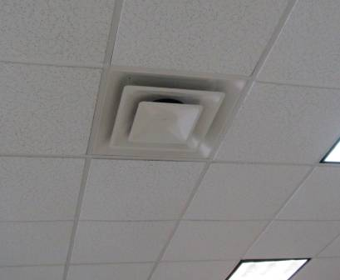

Supply vent

Picture 2

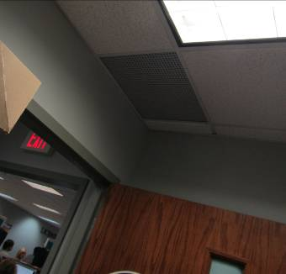

Exhaust vent in an office, note proximity to the door

Picture 3

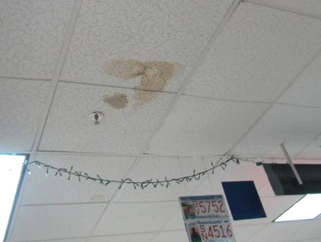

Water-damaged ceiling tile

Picture 4
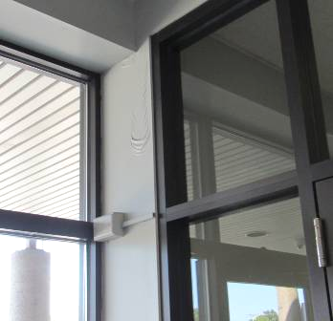

Water-damaged paint in vestibule (arrow)

Picture 5

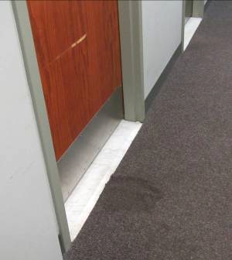

Water-damaged carpeting outside men’s room

Picture 6

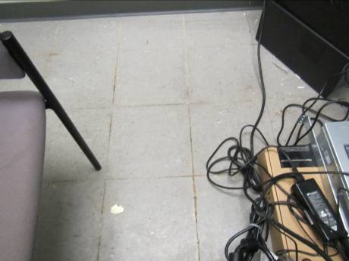

Mastic coming up between tiles, a sign of historic water infiltration
Picture 7

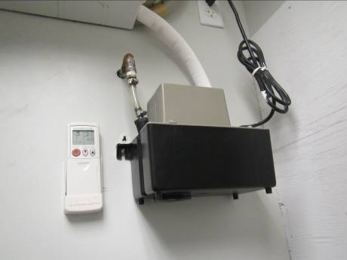

Condensate piping and pump for ductless air conditioner

Picture 8

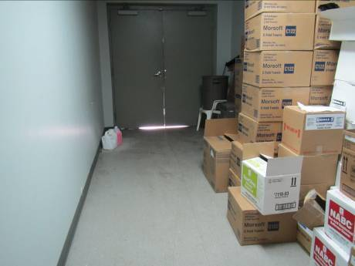

Light visible under/around door to outside; note also boxes stored on the floor
Picture 9

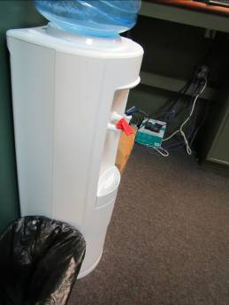

Water cooler on carpet

Picture 10

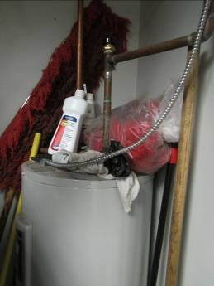

Items on top of water heater in custodial closet
Picture 11

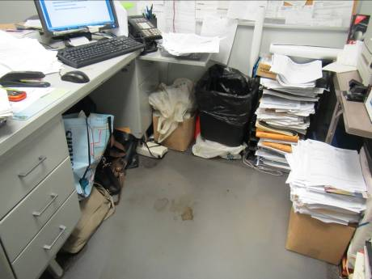

Items/papers in an office and stained floor mat

Picture 12

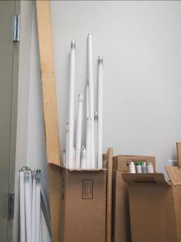

Improperly stored fluorescent bulb
Location | Carbon  Dioxide  (ppm) | Carbon Monoxide  (ppm) | Temp  (°F) | Relative  Humidity  (%) | PM2.5  (µg/m³) | TVOC  (ppm) | Occupants  in Room | Windows  Openable | Ventilation |  | Remarks
 |  |  |  |  |  |  |  |  | Supply | Exhaust | Remarks
Background | 388 | ND | 71 | 57 | 5-13 | ND |  |  |  |  | Sunny, windy
Central Clerk Area | 1164 | ND | 73 | 53 | 10 | ND | 5 | N | Y | Y | Carpeted, printers
Manager’s Office | 838 | ND | 73 | 55 | 1 | ND | 1 | N | Y | Y | Exhaust near door, DO, HS, plants, items
Right Counting Room | 758 | ND | 71 | 51 | 8 | ND | 0 | N | Y | Y | Exhaust near door, disty carpet/debris, PF
Copy Area | 668 | ND | 71 | 55 | 2 | ND | 0 | N | Y | N
Cash Room | 624 | ND | 70 | 50 | 1 | ND | 0 | N | Y | Y | Boxes on floor
Left Counting Room | 638 | ND | 68 | 51 | 1 | ND | 0 | N | Y | Y
Compliance center | 745 | ND | 69 | 60 | 1 | ND | 0 | N | Y | Y
FIDEIN office | 708 | ND | 71 | 60 | 1 | ND | 1 | N | Y | Y | Boxes and papers on floor, items
Stockroom | 631 | ND | 70 | 52 | 1 | ND | 0 | N | Y | y | NC, boxes on floor, some boxes on pallets
Training room | 849 | ND | 70 | 60 | 10 | ND | 0 | n | Y | Y | Computers
Auditor | 708 | ND | 70 | 57 | 1 | ND | 1 | N | Y | Y | Personal heater on, CP, WD40, carpet
Tax collector (adjacent to/connected to RMV) | 699 | ND | 71 | 58 | 7 | ND | 1 | N | Y | N | Fridge on carpet, water cooler on carpet, food
Women’s staff restroom |  |  |  |  |  |  |  | N | Y | Y on | CP, AF, door undercut
Men’s staff restroom |  |  |  |  |  |  |  | N | Y | Y on | Door undercut
Break room | 789 | ND | 71 | 59 | 11 | ND | 2 | N | Y | Y | WD CT, reports of previous leaks near sink.
Custodian’s closet |  |  |  |  |  |  |  | N |  |  | Water heater (electric) with items on top, cleaning products, mops, no exhaust
Conference room | 694 | ND | 71 | 57 | 1 | ND | 2 | N | Y | Y | Carpet, boxes
Vehicle safety office | 653 | ND | 72 | 58 | 13 | ND | 0 | N | Y | Y | Plants
DATA room |  |  |  |  |  |  |  | N |  |  | Ductless AC with condensate drain pump.
Hearing room | 1035 | ND | 72 | 61 | 14 | ND | 3 | N | Y | Y | Carpet is WD, PF, DO
Waiting, left | 1091 | ND | 73 | 64 | 15 | ND | ~40 | N | Y | Y | NC
Waiting, center | 1089 | ND | 73 | 64 | 7-30 | ND | ~30 | N | Y | Y | NC
Waiting, right | 1075 | ND | 73 | 63 | 23 | ND | ~40 | N | y | y | NC

