WATER DAMAGE/MOLD INVESTIGATION

Registry of Motor Vehicles
1084 Rte. 28
South Yarmouth, Massachusetts

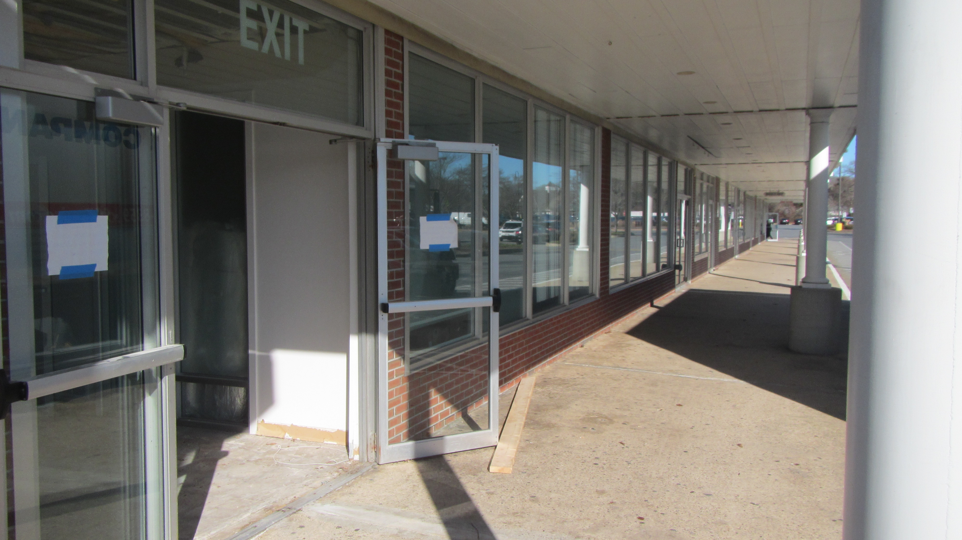

Prepared by:
Massachusetts Department of Public Health
Bureau of Climate and Environmental Health
Indoor Air Quality Program
February 2024

BACKGROUND
Building: | Registry of Motor Vehicles (RMV)
Address: | 1084 Rte. 28, South Yarmouth, MA
Assessment Requested by: | Aric Warren, Transportation Program Planner, Massachusetts Department of Transportation (Mass DOT)
Reason for Request: | Water damage concerns after flooding incident from vandalism that occurred on 12/31/2023. The space was further water-damaged on 1/7/2024.
Date of Assessment: | January 12, 2024
Massachusetts Department of Public Health/Bureau of Climate and Environmental Health (MDPH/BCEH) Staff Conducting Assessment: | Michael Feeney, Director, Indoor Air  Quality (IAQ) Program
Building Description: | The RMV occupies the corner section of a one-story building that is a multiple business mall. An alley is located behind the building that forms the exterior southwestern wall of the RMV space.
Windows: | Not openable

The BCEH/IAQ Program was asked to examine the Yarmouth RMV office for the presence of water damage/mold growth to gypsum wallboard (GW) ceilings/walls, insulation, and flooring.

METHODS
Please refer to the IAQ Manual for methods, sampling procedures, and interpretation of results (MDPH, 2015). Moisture measurements of GW were taken with a moisture meter. Exterior wall surface temperatures were measured using a laser thermometer.

RESULTS and DISCUSSION
The following is a summary of testing results.
- Moisture Measurements of walls were moistened in all areas sampled.
- Relative Humidity Measurements indoors ranged from 57% to 59%, which was significantly higher than outdoors (50%). These measurements may indicate that conditions inside this space remained wet.

At the time of this assessment, the building was undergoing renovations including remediation for water damage caused by vandalism. Flood restoration activities included:
- Use of fans and dehumidifiers to accelerate drying GW, and
- removal of GW and insulation in some areas.
It is important to note that dehumidifiers were operating while the building’s exterior doors were open reducing their ability to dry GW. Standing water was noted in a rear section of the building, despite drying efforts (Picture 1). GW was observed to have mold growth (Picture 2). In an effort to discern whether GW was dried sufficiently since the vandalism incident, moisture levels were taken in various locations. One measurement was taken near the front entrance since that was farthest from the reported water source of the vandalism incident. That measurement was 2-4%. GW is considered dry with a measurement between 0-1% (Delmhorst, unknown). All moisture measurements taken in the building were significantly above 1%, which indicates that GW was likely wet since the reported initial vandalism incident on 12/31/2023.
In general, the US Environmental Protection Agency (US EPA) and the American Conference of Governmental Industrial Hygienists (ACGIH) recommend that porous materials (e.g., wallboard, carpeting) be dried with fans and heating within 24 to 48 hours of becoming wet (US EPA, 2008; ACGIH, 1989). If porous materials are not dried within this time frame, mold growth may occur. Moisture measurements indicate the GW has been continuously moistened for over 48 hours.
As reported by RMV staff, GW walls affixed to the southwest wall (Picture 3) have experienced water damage previous to the vandalism incident. The GW and wall studs appear to have been installed directly onto the cement block exterior wall. This wall cavity did not appear to have any insulation installed prior to the vandalism incident. Without insulation materials inside, the wall cavity is likely to have a similar temperature as outdoor air. In addition, this exterior cement block wall exists in an alley where it is in continuous shade (Picture 4). Without direct exposure to sunlight, this cement block wall likely experiences temperatures that are below the dew point in winter months as well as during hot, humid weather. If the interior side of the cement block wall is below the dewpoint, the wall cavity, wall studs and attached GW can be chronically moistened.
IAQ staff measured wall temperatures using a laser thermometer to ascertain if the wall serves as a thermal bridge, which could result in the wall and attached GW and studs being prone to collecting condensation during hot, humid weather. Wall temperatures were approximately 40°F, which match the outdoor air temperature in Yarmouth the morning of this assessment despite drying activities inside the building. These measurements indicate the wall is susceptible to having a temperature significantly below indoors, likely matching outdoor temperature. These measurements also indicate that this wall may be prone to condensation in both cold and hot outdoor temperatures, especially during extended humid weather.
Where a wide temperature range exists between air and building component surfaces (floors and walls), the building materials at the colder end of the range may be prone to becoming moistened with condensation in hot, humid weather, particularly when the HVAC system is in cooling mode. This phenomenon was likely exacerbated during the weather conditions experienced in New England during the summer of 2018 and 2021 (HG, 2021; NOAA, 2021):
The New England area experienced an unprecedented period of extended hot, humid weather. According to the Washington Post, “[d]ata…show[s]…cities in the Northeast have witnessed such humidity levels for record-challenging duration...[i]ncluding Albany, Boston, Burlington Portland, and Providence” during the summer of 2018 (WP, 2018). “Boston and nearby locations… [saw]…historic numbers of those warm nights with low temperatures at or above 70 degrees…Providence and Blue Hill Observatory have already broken their annual records” (WP, 2018).
Periods of extended, humid weather may cause building materials to have a temperature below the dew point to become moistened for >24-48 hours, which can then cause mold growth. The key to managing condensation is understanding dew point. Condensation is the collection of moisture on a surface at or below the dew point. The dew point is the temperature that air must reach for saturation to occur. If a building material/component has a temperature below the dew point, condensation will accumulate on that material. Over time, condensation can collect and form water droplets.
In addition, the presence of high relative humidity (>70%) alone for a significantly long period (>48 hours) can also cause water damage to susceptible materials. If these materials are porous, carbon-containing items (e.g., GW, carpeting, cloth, paper, and cardboard), mold can grow (ASHRAE, 1989).
The exterior wall has a rusted, metal structure of indeterminable use or purpose that appears to open above the suspended ceiling. If it is a non-functional vent, hot, moist air may enter the ceiling/wall system under certain wind conditions and cause water damage to building materials. This structure may also be a light fixture, which can allow for hot- humid air to enter indoors via electrical conduit.

CONCLUSIONS and RECOMMENDATIONS
Based on the observations made during the visit, it appears that all affected water-damaged materials continue to be moistened despite drying/remediation efforts. The following additional recommendations are made:
- Replace all existing GW walls damaged by the flooding incident.
- Examine how the southwest exterior wall can be insulated between the existing cement block wall and the interior GW/wall studs/framing.
- Determine the use of the metal structure in Picture 5. If a light fixture, remove and permanently fill electrical wiring holes. If a vent no longer in use, permanently remove and seal vent opening.
- Prior to re-occupancy:
- Operate/flush out the HVAC system for 24 hours and change filters. The MDPH recommends pleated filters with a Minimum Efficiency Reporting Value (MERV) of 8, which are adequate in filtering out pollen and mold spores (ASHRAE, 2012).
- Once remediation activities are completed, clean all items and surfaces with a high efficiency particulate arrestance (HEPA) filter equipped vacuum cleaner combined with wet wiping and have carpets professionally cleaned.
- For more information on mold refer to the US EPA’s “Mold Remediation in Schools and Commercial Buildings”. Available at: http://www.epa.gov/mold/mold-remediation-schools-and-commercial-buildings-guide.
- Refer to resource manuals and other related IAQ documents for further building-wide evaluations and advice on maintaining public buildings. Copies of these materials are located on the MDPH’s website: http://mass.gov/dph/iaq.
- If desired, contact the IAQ Program for a re-occupancy assessment following the completion of remediation and reconstruction work.

REFERENCES
ACGIH. 1989. Guidelines for the Assessment of Bioaerosols in the Indoor Environment. American Conference of Governmental Industrial Hygienists, Cincinnati, OH.
ASHRAE. 1989. Ventilation for Acceptable Indoor Air Quality. American Society of Heating, Refrigeration and Air Conditioning Engineers. ANSI/ASHRAE 62-1989.
ASHRAE. 2012. American Society of Heating, Refrigeration and Air Conditioning Engineers (ASHRAE) Standard 52.2-2012 -- Method of Testing General Ventilation Air-Cleaning Devices for Removal Efficiency by Particle Size (ANSI Approved).
Delmhorst, unknown. BD-2100 Buildings Materials Moisture Meter Operation Manual. Delmhorst Europe Titianiumlann 100 NL 5221 CK ‘s-Hertogenbosch The Netherlands. http://www.moisturemetersdelmhorst.com/content/moisturemetersdelmhorst/EN/images/BD-2100-moisture-meter-manual.pdf

HG. 2021. Mold keeps South Hadley High School shuttered. Hampshire Gazette. https://www.gazettenet.com/South-Hadley-High-School-still-closed-amid-mold-remediation-42413519.

MDPH. 2015. Massachusetts Department of Public Health. “Indoor Air Quality Manual: Chapters I-III”. Available at: https://www.mass.gov/lists/indoor-air-quality-manual-and-appendices
NOAA. 2021. Summer 2021 neck and neck with Dust Bowl summer for hottest on record. National Oceanic and Atmospheric Administration, 1401 Constitution Avenue NW, Room 5128, Washington, DC 20230 https://www.noaa.gov/news/summer-2021-neck-and-neck-with-dust-bowl-summer-for-hottest-on-record

US EPA. 2008. Mold Remediation in Schools and Commercial Buildings. US Environmental Protection Agency, Office of Air and Radiation, Indoor Environments Division, Washington, D.C. EPA 402-K-01-001. http://www.epa.gov/mold/mold-remediation-schools-and-commercial-buildings-guide.
WP. 2018. ‘It’s been relentless’: Smothering summer humidity in the Northeast has crushed records. Washington Post, Washington, DC. https://www.washingtonpost.com/news/capital-weather-gang/wp/2018/08/30/its-been-relentless-smothering-summer-humidity-in-the-northeast-has-crushed-records/

Picture 1

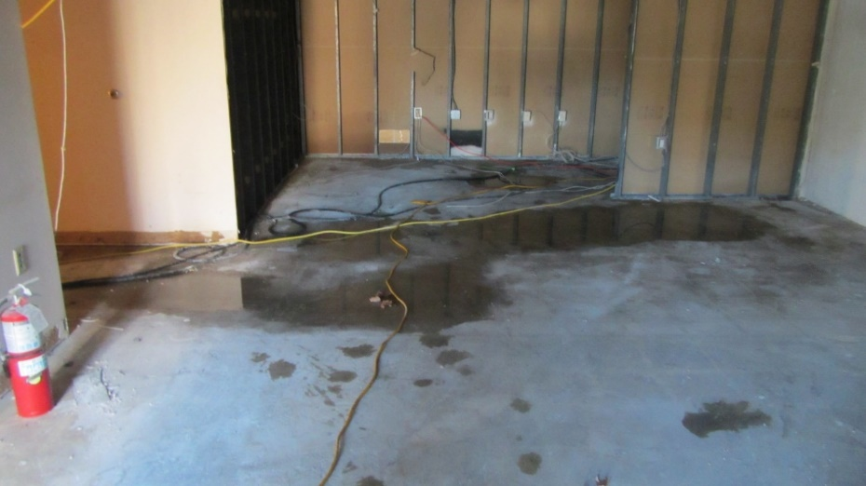
Standing water inside building

Picture 2

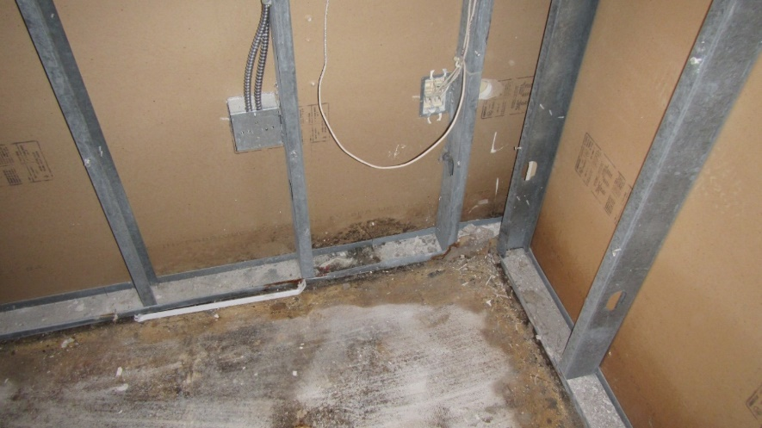
Visible mold growth on GW near standing water in Picture 1

Picture 3

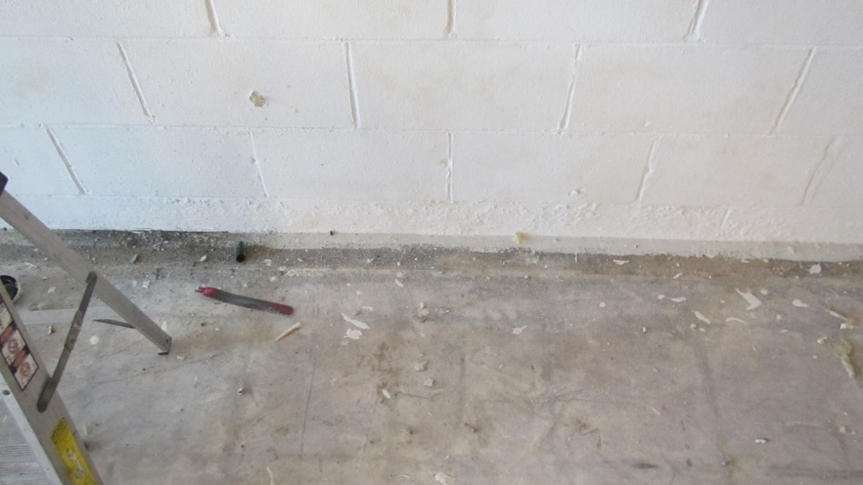
Base of interior side of uninsulated southwest-facing wall of the RMV

Picture 4
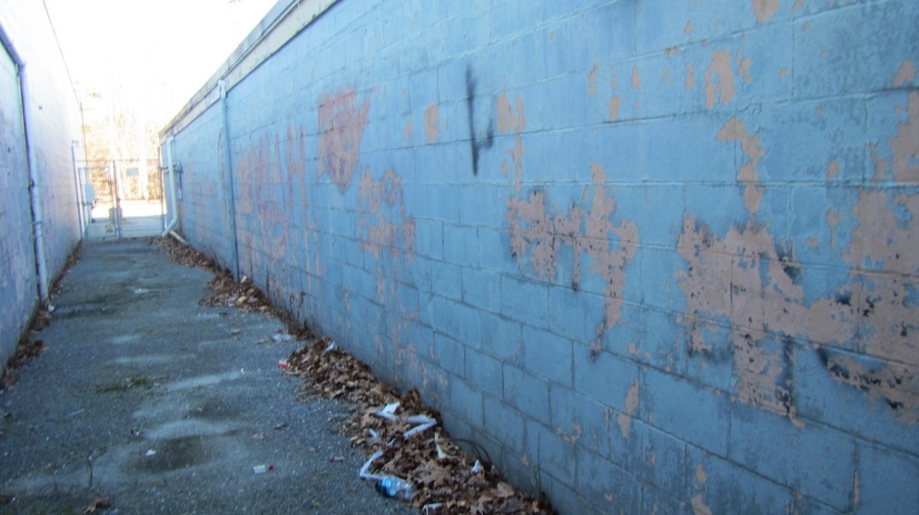
Exterior side of wall in Picture 3

Picture 5

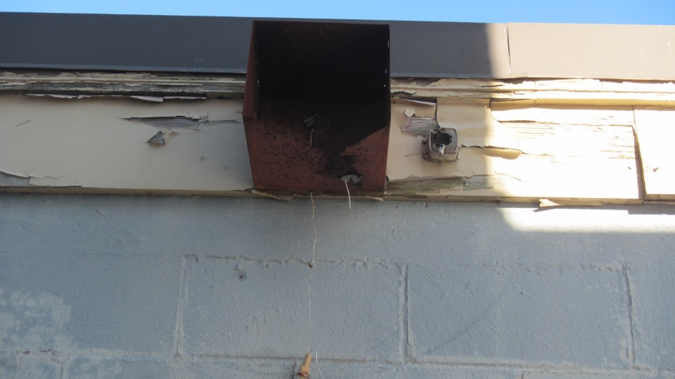
Structure of unidentified purpose/use on exterior wall

