INDOOR AIR QUALITY ASSESSMENT
Rehoboth Town Offices
148 Peck Street
Rehoboth, Massachusetts
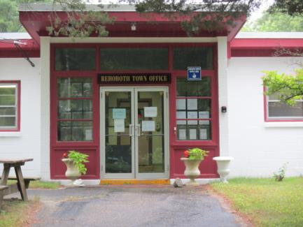
Prepared by:
Massachusetts Department of Public Health
Bureau of Environmental Health
Indoor Air Quality Program
August 2017

BACKGROUND
Building: | Rehoboth Town Offices (RTO)
Address: | 148 Peck Street, Rehoboth, MA
Assessment Requested by: | Concerned Occupants
Reason for Request: | Water damage and general air quality concerns
Date(s) of Assessment: | July 7 & 13, 2017
Massachusetts Department of Public Health/Bureau of Environmental Health (MDPH/BEH) Staff Conducting Assessment: | Mike Feeney, Director and Cory Holmes, Environmental Analyst/Inspector, Indoor Air Quality (IAQ) Program
Date of Building Construction: | 1950s
Building/Site Description: | One-story concrete block building with flat roof originally constructed as military facility
Windows: | Openable

METHODS
Please refer to the IAQ Manual for methods, sampling procedures, and interpretation of results (MDPH, 2015).

RESULTS and DISCUSSION
The following is a summary of indoor air testing results (Table 1).
- Carbon dioxide levels were above the MDPH guideline of 800 parts per million (ppm) in six of eighteen areas surveyed. It should be noted that several areas were unoccupied, which can reduce carbon dioxide levels.
- Temperature was within or close to the MDPH recommended range of 70°F to 78°F in areas tested.
- Relative humidity was above the MDPH recommended range of 40 to 60% in a number of areas.
- Carbon monoxide levels were non-detect (ND) throughout all areas surveyed.
- Particulate matter (PM2.5) concentrations were below the National Ambient Air Quality (NAAQS) guideline of 35 μg/m³.
Ventilation
The building lacks a mechanical heating, ventilation and air conditioning (HVAC) system to provide fresh air to occupied areas. Instead, the building relies solely on open windows and infiltration through the building envelope to provide air exchange. It should be noted however, that windows are original to the building and many are reportedly in disrepair/difficult to open. As mentioned above, carbon dioxide readings were below MDPH guidelines in most areas primarily due to low occupancy at the time of assessment. The use of open windows can be an effective means of ventilation however during the winter season it may prove impractical due to comfort issues (e.g., cold drafts).
Many areas are equipped with window air conditioning (AC) units. These units can also be used in “fan only” mode to increase ventilation in the space during temperate weather. This is important to remember especially in rooms where the AC unit is occupying the only window in a room. The MDPH typically recommends that buildings are equipped with HVAC systems to provide continuous filtering, fresh air and exhaust capabilities to dilute and remove common indoor air pollutants. If the building is to be used long-term, consideration should be given to consulting with an HVAC design engineer to provide for building-wide mechanical ventilation and air conditioning.

Microbial/Moisture Concerns
A distinct musty odor was detected upon entering the vault. The vault contains a significant amount of important town records that have been exposed to moisture.
Moisture is penetrating into the vault due to several related conditions. The RTO was constructed with a sloped roof with gutter installed along the roof edge at the rear of the building (Pictures 1 and 2). In 1991, a vault was added to the rear of the building (Picture 3). The roof of the vault was made flat instead of with a slope matching the original roof. According to architect plans, the vault does not have a drain listed as part of the design. Water stains along the vault exterior walls indicate that rainwater pools on the roof and runs off the roof edges. Without adequate drainage, pooling water can damage the vault roof and create leaks inside the vault, particularly around ductwork. In addition, the floor of the vault has a number of cracks (Picture 4). If the cracks are completely through the cement slab, moisture from soil can easily migrate into the vault.
A number of areas have wall-to-wall carpeting that is water-stained (Picture 5). There are several possible sources wetting carpeting. Water staining appears to be along the exterior wall of each room, which can indicate water penetration through window AC installations. The spaces around ACs are not watertight and appear enclosed using particleboard. The particleboard appears to be heavily water-stained (Picture 6) and can support mold growth if moistened for longer than 24-48 hours. Under wind-driven rain conditions, water would readily enter around ACs. Another possible source is water penetrating through the exterior wall and/or floor slab. The cement slab of the RTO was likely not designed with either insulation or a vapor barrier. Without a vapor barrier or insulation, it is likely that the floor is prone to becoming moistened by condensation in hot, humid weather and/or water penetration through the slab.
In an effort to ascertain if carpets were wet, moisture content of carpeted and tiled floors was measured in rooms throughout the building. If a source of moisture were atmospheric (e.g., increase relative humidity), moisture readings in carpet would be expected to be uniform (i.e., with a narrow variation of + 2%). Where a significant variation exists in moisture content (e.g., one section of carpet measures non-detectable for moisture, another section measures 10%), it could be concluded that another source of water is moistening the carpet.
The moisture sampling was conducted on July 13, 2017, which was a rainy day, with an outdoor temperature of 66°F and relative humidity of 69 percent. No active leaks were observed and no visible, accumulated moisture was noted on carpets, walls or ceilings. Relative humidity indoors was measured in a range of 47 to 71 percent (Table 2). Moisture readings are listed by room in Table 2 in a range from the lowest to highest moisture concentration. All but two rooms had moistened carpet.
In order to ascertain if wall materials were also moistened, moisture measurements were taken in wall materials. Measurements were taken in exterior walls around windows as well as interior walls for comparison (Table 2). Exterior walls in offices along the rear wall had significant moisture content (Figure 1). The source of moisture is likely water penetration from rainwater accumulation against the rear wall of the building. A deep soil trough exists along the rear wall (Picture 7), a likely result of water emptying from gutter/downspouts in the same location for over 50 years, which compressed the soil (Picture 8). During significant rainstorms, water accumulates against the building, which then penetrates along the slab/wall junction. This condition is exacerbated by the fact that the exterior wall and floor slab are buried. The exterior wall/floor junction should not be below soil, since water can penetrate into a building along the seam. This condition likely contributes to the rotted/damaged wood and sawdust/debris that was observed along the baseboard of the Selectmen’s Meeting Room, which also shows signs of termite damage (Picture 9).
The US Environmental Protection Agency (US EPA) and the American Conference of Governmental Industrial Hygienists (ACGIH) recommends that porous materials (e.g., wallboard, carpeting, ceiling tiles) be dried with fans and heating within 24 to 48 hours of becoming wet (US EPA, 2008; ACGIH, 1989). If porous materials are not dried within this time frame, mold growth may occur. Once mold has colonized porous materials, they are difficult to clean and should be removed. Under these conditions, it is very likely that carpeting throughout the building is water-damaged/mold-colonized, resulting in the odors detected.

Other IAQ Evaluations
Other conditions that can affect IAQ were observed during the assessment. Carpets should be cleaned annually (or semi-annually in soiled/high traffic areas) in accordance with Institute of Inspection, Cleaning and Restoration Certification (IICRC) recommendations, (IICRC, 2012). The service life of carpeting is approximately 10-11 years (IICRC, 2002). In many areas, carpeting was observed to be worn and stained. Carpeting of this age and condition becomes increasingly difficult to clean and maintain and may be a source of particulate matter to the indoor environment. Regular cleaning with a high efficiency particulate air (HEPA) filtered vacuum in combination with an annual cleaning will help to reduce accumulation and potential aerosolization of materials from carpeting.
BEH/IAQ staff noted many holes/gaps in walls, ceilings, and floors (Pictures 10 and 11). These and any other gaps or breaches in the walls and ceilings should be properly sealed to avoid the migration of particulate matter, odors, moisture and pests into occupied areas. In the kitchen area a ceiling tile was ajar, exposing fiberglass insulation (Picture 12), which can be a source of eye, skin and respiratory irritation.
Due to the age of the building, it was reported that asbestos-containing floor tiles are located throughout. In many areas the tiles have been carpeted over, however in several areas tiles were found to be damaged (Pictures 13 and 14).
Restrooms are equipped with floor drains (Picture 15). It was reported that occasionally sewer gas odors are present. Without regular input of water, drain traps can dry out allowing sewer gases to migrate into the building, which are nuisance odors and can be a source of irritation.
Finally, florescent light covers were missing in the Clerk’s Office (Picture 16). Fixtures should be equipped with access covers installed with bulbs fully secured in their sockets. Breakage of glass can cause injuries and may release mercury and/or other hazardous compounds.

CONCLUSION AND RECOMMENDATIONS
The conditions related to IAQ at the RTO raise a number of issues. The condensation issues/lack of a vapor barrier coupled with the presence of reported asbestos-containing floor tiles, present a number of problems related to water damage/mold-growth and remediation options within the building. In addition, without a mechanical ventilation system, normally occurring environmental pollutants can build up in occupied areas and lead to IAQ/comfort complaints.
A decision should be made concerning the water-damaged/mold-contaminated materials stored in the vault. These boxes, documents, books and other stored materials will continue to be a source of mold associated odors/particulates. In this case, ventilation alone cannot serve to reduce or eliminate mold growth in these materials. Since many of these materials appear to be historical records, an evaluation concerning disposition of these materials must be made. Porous materials that are judged not worthy of preservation, restoration, or transfer to another media (e.g., microfiche or computer scanning) should be discarded. Where stored materials are valuable enough to require preservation/restoration, an evaluation should be done by a professional book/records conservator. This process can be rather expensive, and should only be considered for conservation of irreplaceable items. Due to the cost of book conservation, the disposal or replacement of moldy materials may be the most economically feasible option.
In view of the findings at the time of the visit, the following additional recommendations are made:
- Remove carpeting in a manner consistent with US EPA “Mold Remediation in Schools and Commercial Buildings” (US EPA, 2008). This work should be performed when the building is unoccupied. In addition, due to the age of the building and the presence of asbestos-containing floor tiles, all work should be done in accordance with state and federal regulations.
- Replace old, worn carpeting past its useful life (> 10-11 years). If not removed, clean carpeting annually or semi-annually in soiled high traffic areas as per the recommendations of the Institute of Inspection, Cleaning, and Restoration Certification (IICRC, 2012).
- Consider opening exterior walls in offices along the rear of the building to examine the wall material for dampness/mold growth. If mold colonized, consider replacing interior walls along the rear of the building with cement board.
- Make repairs as needed to prevent chronic water infiltration, including sealing the many holes and gaps, repairing missing flashing/caulking/mortar and replacing rotted trim
- Improve roof drainage. Install and maintain missing downspouts/gutters to collect and disperse storm water away from the building’s foundation. Extend downspouts to empty at least five feet from the building walls.
- Consideration should be given to installing a roof drain in the vault ceiling. This drain must have sufficient capacity to drain both the vault roof and the adjoining roof of the RTO. Installation of a drain would like require reroofing the vault to provide a proper pitch.
- If installation of a roof drain is not feasible, installation of a roof component to redirect water away from the vault roof/HVAC system is recommended.
- Improve drainage from the rear of the building by re-grading the ground against the slab. If feasible, remove soil to a level low enough to unearth the exterior wall/floor slab junction.
- Seal the cracks in the vault floor.
- Remove or trim back trees or shrubs within 5 feet of building exterior to decrease moisture against the building envelope.
- Discontinue the use of the dehumidifier in the vault if the HVAC system is operating in AC mode.
- Refrain from storing porous items (e.g., paper, cardboard) in areas prone to chronic moisture.
- Seal open utility holes with a fire-rated sealant.
- Replace missing/ajar/damaged ceiling tiles to prevent exposure to dust/debris/fiberglass.
- Occupants should utilize open windows and AC units set to “fan only” mode during temperate weather to increase ventilation in occupied areas. Occupants should refrain from opening windows during AC cooling mode and remember to also close windows during driving rain storms to avoid further water damage.
- Ensure filters in window AC units are cleaned regularly according to manufacturer’s recommendations.
- Consider consulting with a ventilation engineer regarding the feasibility of retro-fitting the building with a mechanical HVAC system.
- For buildings in New England, periods of low relative humidity during the winter are often unavoidable. Therefore, scrupulous cleaning practices should be adopted to minimize common indoor air contaminants whose irritant effects can be enhanced when the relative humidity is low. To control for dusts, a high efficiency particulate arrestance (HEPA) filter equipped vacuum cleaner in conjunction with wet wiping of all surfaces is recommended. Avoid the use of feather dusters. Drinking water during the day can help ease some symptoms associated with a dry environment (throat and sinus irritation).
- Ensure that local exhaust vents are operating correctly (e.g., bathroom) and that exhaust is ejected outside of the building.
- Fixtures that are to be used should have water poured into drains on a regular basis to avoid dry drain traps.
- Relocate or consider reducing the amount of stored materials to allow for more thorough cleaning. Clean items regularly with a wet cloth or sponge to prevent excessive dust build-up.
- Replace all missing covers for fluorescent light fixtures.
- Contact a licensed pest exterminator treat/develop a plan for termite infestation.
- Replace termite-damaged wood.
- Refer to resource manual and other related indoor air quality documents located on the MDPH’s website for further building-wide evaluations and advice on maintaining public buildings. These documents are available at http://mass.gov/dph/iaq.

REFERENCES
ACGIH. 1989. Guidelines for the Assessment of Bioaerosols in the Indoor Environment. American Conference of Governmental Industrial Hygienists, Cincinnati, OH.
IICRC. 2002. Institute of Inspection, Cleaning and Restoration Certification. A Life-Cycle Cost Analysis for Floor Coverings in School Facilities.
IICRC. 2012. Institute of Inspection Cleaning and Restoration Certification. Institute of Inspection, Cleaning and Restoration Certification. Carpet Cleaning: FAQ. Retrieved from http://www.iicrc.org/consumers/care/carpet-cleaning.
MDPH. 2015. Massachusetts Department of Public Health. Indoor Air Quality Manual: Chapters I-III. Available at: http://www.mass.gov/eohhs/gov/departments/dph/programs/environmental-health/exposure-topics/iaq/iaq-manual/.
US EPA. 2008. “Mold Remediation in Schools and Commercial Buildings”. Office of Air and Radiation, Indoor Environments Division, Washington, DC. EPA 402-K-01-001. September 2008. Available at: http://www.epa.gov/mold/mold-remediation-schools-and-commercial-buildings-guide.

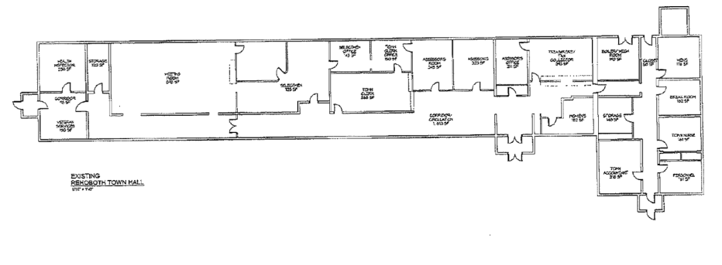

Picture 1
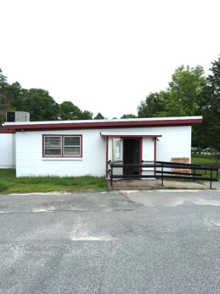
Sloped roof
Picture 2
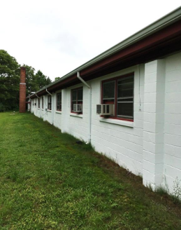
Gutter on roof edge at rear of the building
(Note slope of ground towards the base of exterior wall)
Picture 3
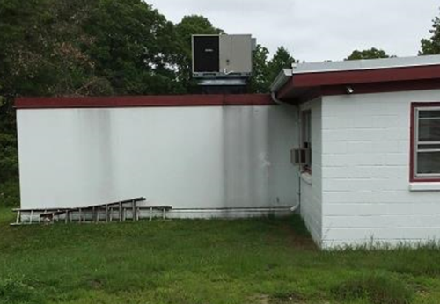
The vault with flat roof [arrows showing heavy water runoff stains]
Picture 4
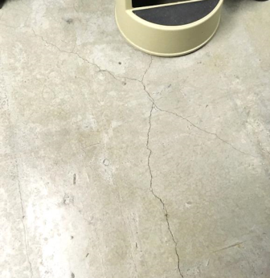
Cracks in vault floor
Picture 5
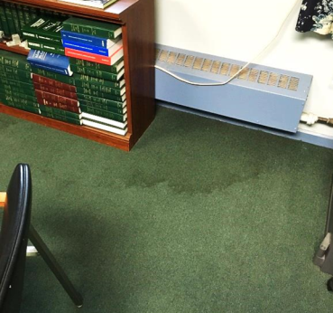
Water-damaged carpet
Picture 6
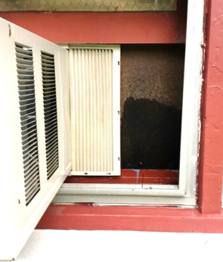
Window mounted AC with water-stained particleboard
Picture 7
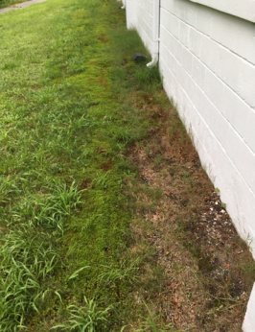
Trough in soils against the rear wall
Picture 8
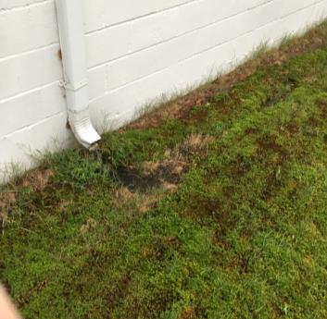
Downspout emptying at the base of the wall; note scoured grass

Picture 9
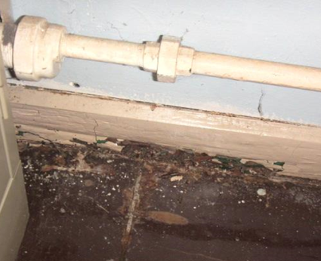
Termite damage/rotted wood in Selectmen's Meeting Room
Picture 10
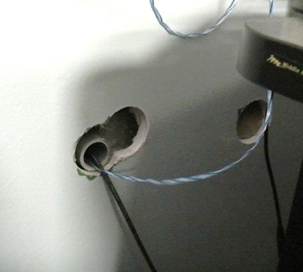
Open utility holes in wall
Picture 11
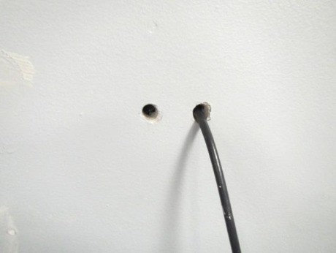
Open utility holes in wall
Picture 12
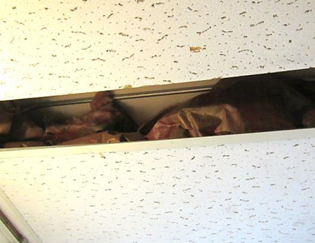
Ajar ceiling tile exposing fiberglass insulation
Picture 13
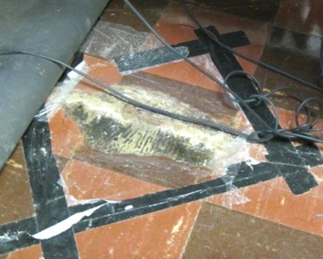
Damaged floor tiles
Picture 14
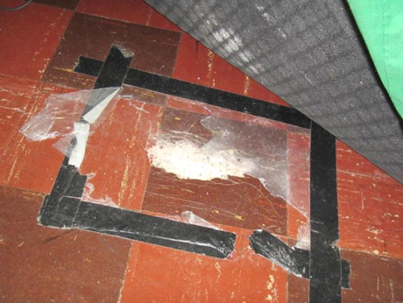
Damaged floor tiles
Picture 15
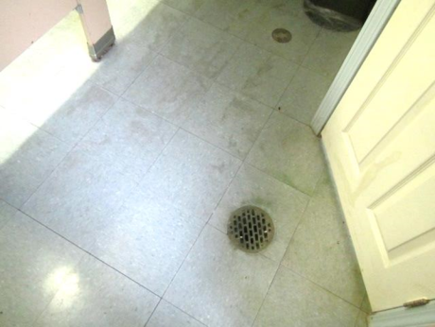
Bathroom floor drain
Picture 16
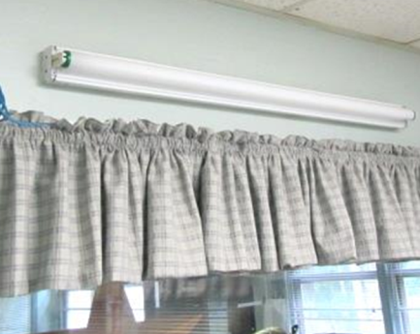
Missing florescent light cover

Location | Carbon  Dioxide  (ppm) | Carbon Monoxide  (ppm) | Temp  (°F) | Relative  Humidity  (%) | PM2.5  (µg/m³) | Occupants  in Room | Windows  Openable | Ventilation |  |  | Remarks
 |  |  |  |  |  |  |  | Intake | Exhaust
Background | 388 | ND | 70 | 100 | 16 |  |  |  |  |  | Rain
Veteran’s Services | 812 | ND | 73 | 54 | 12 | 1 | Y | N |  | N | AC, WD CT 4, DO
Board of Health | 908 | ND | 73 | 65 | 14 | 2 | Y | N |  | N | AC
Board of Selectmen Meeting Room | 621 | ND | 74 | 61 | 10 | 0 | Y | N |  | N | AC, musty odor, damaged floor tiles, termite-damaged woodwork/coving, holes in wall
Board of Selectmen Office | 606 | ND | 74 | 63 | 13 | 1 | Y | N |  | N | AC
Town Administrator | 555 | ND | 74 | 67 | 14 | 0 | Y | N |  | N | AC, stained carpet
Planning | 519 | ND | 74 | 62 | 10 | 0 | Y | N |  | N
Town Administrator | 839 | ND | 71 | 41 | 6 | 0 | Y | N |  | N | Stained carpet
Town Administrator | 828 | ND | 71 | 43 | 6 | 1 | N | N |  | N | Fan
Assessors | 708 | ND | 74 | 64 | 12 | 1 | Y | N |  | N | AC
Assessors Meeting | 721 | ND | 75 | 62 | 10 | 0 | Y | N |  | N | AC
Treasurer | 680 | ND | 76 | 58 | 10 | 0 | Y | N |  | N | AC
Collector | 736 | ND | 76 | 54 | 9 | 1 | Y | N |  | N | AC-on, carpet WD
Town Accountant | 1120 | ND | 77 | 58 | 8 | 1 | Y | N |  | N | AC, wall to wall carpet, broken CT-fiberglass insulation
Personnel Office | 616 | ND | 69 | 54 | 10 | 0 | Y | N |  | N | Portable AC, dust/debris on floor/windowsill
Town Nurse’s Office | 511 | ND | 73 | 70 | 11 | 0 | Y | N |  | N | Lab fridge-heat gain
Building Department (former lunchroom) | 848 | ND | 75 | 62 | 11 | 0 | Y | N |  | N | Holes in wall
Lunch Room | 777 | ND | 76 | 59 | 12 | 0 | Y | N |  | N | Fridge on carpet, AT-fiberglass insulation
Men’s Room |  |  |  |  |  |  | N | N |  | Y | Wall activated exhaust fan, floor drains
Storage/File Area | 659 | ND | 76 | 55 | 8 | 0 | N | N |  | N | No ventilation/climate control

Location | Temp  (°F) | Relative  Humidity  (%) | Dew Point  (°F) | Floor Temp  (°F) | Wall Temp  (°F) | Floor Moisture (%) | Exterior Wall Moisture (%) | Interior  Wall Moisture (%) | Remarks
Background | 66 | 69 | 54
Town Administrator | 75 | 54 | 59 | 67 | 67 | 7 | 34-45 | 4-7
Board of Selectmen | 77 | 58 | 59 | 70 | 70 | 38 | 33-44 | 6-7
Plans | 74 | 57 | 58 | 69 | 69 | 28 | 34-46 | 0
Town Clerk | 74 | 47 | 52 | 64 | 63 | 10-25 | -- | 0
Town Clerk Printer | 73 | 47 | 51 | 61 | 61 | 15-31 | 63-65 | 0
Assessor | 74 | 61 | 60 | 64 | 66 | 21-33 | 64-72 | 0
Assessor’s Meeting | 75 | 60 | 60 | 66 | 67 | 70-90 | 66-69 | 0 | Tile floor
Collector | 75 | 55 | 58 | 70 | 71 | 2-10 | 12-18 | 0-22
Treasurer | 76 | 57 | 59 | 69 | 70 | 18-21 | 0 | 0
Accountant | 76 | 69 | 65 | 70 | 71 | 90-97 | 0 | 0 | No extra wall
Personnel | 75 | 53 | 57 | 67 | 71 | 0 | 0 | 0
Building Dept. | 74 | 71 | 64 | 70 | 70 | 39-76 | 0 | 0
Kitchen | 74 | 64 | 64 | 71 | 71 | 5-9 | 0 | 0
Meeting Room | 75 | 60 | 60 | 68 | 69 | 71-93 | 58-74 | 0 | Tile floor
Veteran Services | 74 | 62 | 61 | 66 | 66 | 0 | 0 | --
Board of Health | 74 | 70 | 64 | 70 | 70 | 26-84 | 1-2 | 7
Hallway | 75 | 62 | 61 | 66 | 65 | 63-85 | 8-38 | 0 | Tile floor
Inner Vault | 71 | 29 | 37 | 46 | 45 | 43-56 | 65-97 | 88-89 | Floor cracks, cement floor
Outer Vault | 70 | 46 | 47 | 53 | 59 | 70-95 | 68-73 | 17 | Cement floor

