INDOOR AIR QUALITY ASSESSMENT

Reid Middle School
950 North Street
Pittsfield, MA

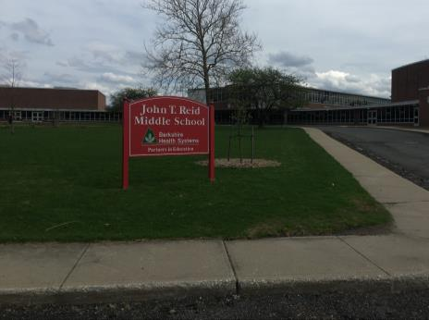

Prepared by:
Massachusetts Department of Public Health
Bureau of Environmental Health
Indoor Air Quality Program
December 2018

Background

Building: | Reid Middle School (RMS)
Address: | 950 North Street, Pittsfield, MA
Assessment Requested by: | James Esoldi, Project Supervisor  Building Maintenance, City of Pittsfield
Reason for Request: | General indoor air quality (IAQ) concerns
Date of Assessment: | November 30, 2018
Massachusetts Department of Public Health/Bureau of Environmental Health (MDPH/BEH) Staff Conducting Assessment: | Mike Feeney, Director, IAQ Program
Date of Building Construction: | Opened in 1953. Major renovations in 2001 included an addition that houses the library and classrooms, as well as a new heating system
Building Description: | Brick and concrete construction with interior courtyards
Building Population: | Approximately 650 students in grades 6 to 8 with approximately 100 staff members
Windows: | Openable

Background
Earlier this year, the IAQ Program visited the RMS on May 2 and 11, 2018, to conduct an indoor air quality assessment. During the course of these visits, concerns regarding exposure to products of combustion were raised. Air testing for products of combustion from the furnace could not be done at that time since the furnace was not activated due to the weather/season.
On November 30, 2018, the IAQ Program staff returned to the RMS to conduct air sampling for products of combustion. During this visit, IAQ staff examined the roof and classrooms that share an interior wall with the chimney (Rooms 101, 103, 205 and 207) as well as adjacent hallways and classrooms.
Details regarding heating, ventilating and air conditioning (HVAC) system configuration, water damage and odor assessment recommendations can be found in the RMS June 2018 IAQ report which can be found on-line at https://www.mass.gov/info-details/indoor-air-quality-reports-cities-and-towns-p#pittsfield-

IAQ Testing Results
Please refer to the IAQ Manual for methods, sampling procedures, and interpretation of results (MDPH, 2015). The following is a summary of indoor air testing results (Table 1). Air testing conducted by the IAQ Program reflects building conditions (e.g. furnace activated) at the time of the assessment.
- Carbon dioxide levels were above 800 parts per million (ppm) in classrooms 101, 205, and 207. All other adjacent areas were below 800 ppm. Of particular note was Room 207, which had carbon dioxide levels over 800 ppm despite being unoccupied on the day of this assessment (Table 2).
- Temperature was within or slightly below the recommended range of 70°F to 78°F on the day of assessment.
- Relative humidity was below the recommended range of 40 to 60% in all areas the day of assessment.
- Carbon monoxide levels were non-detectable in all areas tested.
- Fine particulate matter (PM2.5) concentrations measured were below the NAAQS limit of 35 μg/m³ in all areas tested.

Furnace/ Products of Combustion Concerns
As noted in the June 2018 IAQ report, the heating/boiler systems for the school run on natural gas. Natural gas odors and concerns about health were expressed during the visit. A properly functioning heating system will vent all products of combustion from the building away from indoor air and fresh air supply vents. Natural gas used in the United States is primarily methane, which is odorless. An odorous compound is added to natural gas to make leaks easily detected. When natural gas is combusted, the primary products on combustion produced are carbon dioxide (CO₂) and water. Dependent on a number of conditions/factors, natural gas combustion may also produce carbon monoxide (CO) and/or nitrogen oxides (NO_{x}), which, at certain concentrations, can be harmful to health if inhaled. CO₂ elevation can be used to ascertain if a source of combustion exists in a building. If CO₂ levels are significantly above outdoor levels in a room that is unoccupied, that measurement can be an indication that the furnace is venting into the building.
As described in the June 2018 IAQ report, two possible pathways exist for furnace products of combustion to enter occupied spaces at the RMS that could not be directly observed when the furnace was deactivated: migration through walls of classrooms and downdraft from the chimney due to configuration and weather patterns.

Migration through Interior Walls
IAQ staff examined classrooms that share a wall with the chimney and conducted air sampling for CO and CO₂. The measurement of CO₂ in close proximity to the chimney/classroom walls indicates that products of combustion are likely migrating through the chimney walls and into Rooms 101, 103, 205 and 207 (Table 2). Of note was the measurement of 2,723 ppm carbon dioxide in Room 207 despite the room being unoccupied the entire day of the visit. CO₂ levels above the suspended ceiling in room 207 were in excess of 5,000 ppm. These measurements indicate that when the furnace is activated, products of combustion are migrating through interior cement block walls of these classrooms.

Downdrafts and the Chimney
IAQ staff observed the chimney emissions on the roof. A slight westerly wind existed that directed chimney exhaust toward the library wing. At times the plume would move parallel to the ground or upwards (Picture 1). At intermittent times, the exhaust plume appears to dip downwards towards the Room 101 courtyard and the library wing (Picture 2).

Conclusions/Recommendations
As indicated in the June 2018 IAQ report, it appears that products of combustion from the furnace migrates from the chimney interior into Rooms 101, 103, 205 and 207. This condition appears to be present whenever the furnace is operating. Products of combustion drafting downwards from the chimney towards the Room 101 exterior courtyard does occur intermittently (Picture 1), dependent on weather conditions. Because of this issue, the recommendations made in this report are divided into short-term recommendations and long-term recommendations. The long-term recommendations may require altering the chimney system and/or restructuring various components of the building. The following recommendations are made to assist in improving indoor air quality.

Short-term recommendations
- Discontinue the use of Rooms 101, 103, 205 and 207 until repairs are made to the chimney.

Long-term recommendations
- Consult with a building engineer to evaluate the function of the boiler exhaust/chimney system and make recommendations to prevent the potential for entraining products of combustion into air intakes and/or directly into occupied areas. Issues that should be considered include:
  - The height of the chimney;
  - The location of the chimney;
  - Chimney materials appropriate for a gas furnace and subfreezing weather; and
  - The location of the fresh air intakes for the library wing of the building facing the chimney.

References
MDPH. 2015. Massachusetts Department of Public Health. “Indoor Air Quality Manual: Chapters I-III”. Available at: http://www.mass.gov/eohhs/gov/departments/dph/programs/environmental-health/exposure-topics/iaq/iaq-manual/.

Picture 1
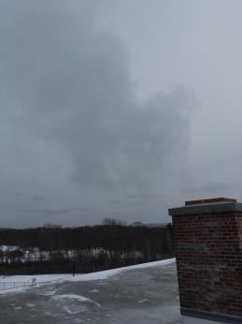
Chimney exhaust plume moving in an upward direction
Picture 2
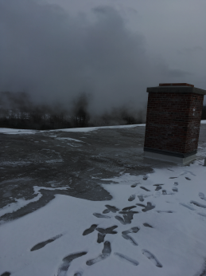
Chimney exhaust plume dipping downwards toward courtyard and library wing
Location | Carbon  Dioxide  (ppm) | Carbon Monoxide  (ppm) | Temp  (°F) | Relative  Humidity  (%) | PM2.5  (µg/m³) | Occupants  in Room | Windows  Openable | Ventilation |  | Remarks
 |  |  |  |  |  |  |  | Supply | Exhaust
Background (Outdoors) | 440 | ND | 38 | 57 | 3 |  |  |  |  | Parking lot north of RMS
Background (Outdoors) | 448 | ND | 34 | 65 | 1 |  |  |  |  | Courtyard outside Room 101/103
101 | 1564 | ND | 72 | 33 | 1 | 18 | Y | Y | Y | Shared chimney wall
103 | 720 | ND | 73 | 26 | 1 | 20 | Y | Y | Y | Shared chimney wall
203 | 1163 | ND | 72 | 26 | 1 | 0 | Y | Y | Y | Shared chimney wall
205 | 921 | ND | 76 | 22 | 1 | 16 | Y | Y | Y | Shared chimney wall
209 | 649 | ND | 70 | 23 | 2 | 9 | Y | Y | Y
Hallway outside 205 & 207 | 793 | ND | 70 | 24 | 5 | 5 | N | N | N
MDF | 540 | ND | 69 | 23 | 4 | 0 | Y | Y | Y
Hallway outside 101 & 103 | 687 | ND | 70 | 25 | 1 | 3 | N | N | N
105 | 678 | ND | 70 | 24 | 1 | 17 | Y | Y | Y

Room | Carbon Dioxide at univent  (ppm) | Carbon Dioxide below Exhaust Vent  (ppm) | Carbon Dioxide against chimney wall  (ppm) | Above suspended ceiling  (ppm) | Carbon Dioxide outdoors  (ppm)
101 | 650 | 755 | 958
103 | 722 | 783 | 980
205 | 755 | 961 | 1025
207 | 753 | 1098 | 2723 | 5000+
Courtyard at rooms 101 & 103 at univent fresh air intakes |  |  |  |  | 448
Roof top chimney exhaust plume |  |  |  |  | 5000+

