**INDOOR AIR QUALITY ASSESSMENT**

**Reid Middle School**

**950 North Street**

**Pittsfield, MA**

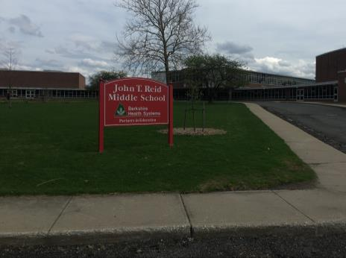

Prepared by:

Massachusetts Department of Public Health

Bureau of Environmental Health

Indoor Air Quality Program

June 2018

# Background

|  |  |
| --- | --- |
| Building: | Reid Middle School (RMS) |
| Address: | 950 North Street, Pittsfield, MA |
| Assessment Requested by: | James Esoldi, Project Supervisor  Building Maintenance, City of Pittsfield |
| Reason for Request: | General indoor air quality (IAQ) concerns |
| Date of Assessment: | May 4, 2018 and May 10, 2018 |
| Massachusetts Department of Public Health/Bureau of Environmental Health (MDPH/BEH) Staff Conducting Assessment: | Mike Feeney, Director, IAQ Program |
| Date of Building Construction: | Opened in 1953. Major renovations in 2001 included an addition that houses the library and classrooms, as well as a new heating system |
| Building Description: | Brick and concrete construction with interior courtyards |
| Building Population: | Approximately 650 students in grades 6 to 8 with approximately100 staff members |
| Windows: | Openable |

# Background

The IAQ Program was contacted on May 2, 2018, about reported IAQ concerns at the RMS. It is important to note that this assessment was conducted on May 4, 2018, on a warm day when the furnace was deactivated. During this assessment, it was revealed that building occupants were concerned about “gas” odors and mold, and building staff reported concerns consistent with sulfur/sewer gas and products of combustion from the furnace. Air testing for products of combustion from furnace could not be done on May 4, 2018, since the heating system was deactivated. The IAQ Program offered to return to the building when the furnace is operating in fall 2018 to conduct air testing during the heating season.

On May 11, 2018, the IAQ Program staff returned to the RMS to address concerns raised by staff during May 4, 2018 visit. During the second visit, IAQ staff examined the roof, the chimney, the furnace room, and tunnels to the furnace room from the gymnasium.

# IAQ Testing Results

Please refer to the IAQ Manual for methods, sampling procedures, and interpretation of results (MDPH, 2015). The following is a summary of indoor air testing results from May 4, 2018 (Table 1). Air testing conducted by the IAQ Program reflect the operation the building (e.g. furnace deactivated) at the time of the assessment.

* ***Carbon dioxide levels*** were below 800 parts per million (ppm) in all areas tested, indicating adequate air exchange throughout the building; however, some areas were empty. Low occupancy can result in reduced carbon dioxide levels.
* ***Temperature*** was within or slightly above the recommended range of 70°F to 78°F on the day of assessment.
* ***Relative humidity*** was above the recommended range of 40 to 60% in most areas the day of assessment.
* ***Carbon monoxide*** levels were non-detectable in all areas tested.
* ***Fine particulate matter (PM2.5)*** concentrations measured were below the NAAQS limit of 35 μg/m3 in all areas tested.

## Ventilation

A heating, ventilating, and air conditioning (HVAC) system has several functions. First, it provides heating and, if equipped, cooling. Second, it is a source of fresh air. Finally, an HVAC system will dilute and remove normally occurring indoor environmental pollutants by not only introducing fresh air but also by filtering the airstream and ejecting stale air to the outdoors via exhaust ventilation. Even when an HVAC system is operating as designed, point sources of respiratory irritation may exist and cause symptoms in sensitive individuals.

Fresh air is provided by a combination of unit ventilators (univents) located in individual classrooms (Picture 1) and air-handling units (AHUs) that serve central areas such as the gym, library, and office areas. A univent draw fresh air through a vent on the exterior wall (Picture 2). Air is mixed with return air from the room, filtered, heated (if needed), and delivered to the room (Figure 1). Air from the AHUs is filtered, heated, or cooled as needed, and delivered to rooms via ducted supply vents.

Many univents were obstructed by items placed on top or in front. Both the top and the vent at the bottom need to be kept clear of obstructions for the units to operate as designed.

Air is exhausted from ceiling-mounted exhaust vents on the opposite side of the room, in some cases near classroom doors. Note that when classroom doors are open, exhaust vents will tend to pull hallway air into the classroom instead of removing stale air/pollutants from the room and out the building.

To maximize air exchange, the MDPH recommends that both supply and exhaust ventilation operate *continuously* during periods of occupancy. In order to have proper ventilation with a mechanical supply and exhaust system, these systems must be balanced to provide an adequate amount of fresh air while removing stale air from a room. It is recommended that existing ventilation systems be re-balanced every five years to ensure adequate air systems function (SMACNA, 1994). The last time these systems were balanced is unknown.

There are several fume hoods located in science classrooms (Picture 3). Such equipment should be tested and calibrated on a regular schedule to ensure they are functioning properly.

## Microbial/Moisture Concerns

Science rooms have sinks that are not used during typical school activities. The drain traps in these sinks can dry out, which can lead to sewer odors in occupied areas. Since these sinks used periodically, they cannot be cut, capped, and removed. Therefore sink drains need to be moistened periodically to maintain the trap seal. Similarly, drains to safety showers (Picture 4) should be moistened periodically to prevent odors.

A number of concerns were raised in the gymnasium locker room areas. Reports of mold odor can be attributed to the lack of use of showers in the locker rooms. As with the science wing, unused drains need to be wetted at least every other day to maintain the seal on the drain trap and prevent odors from the sewer/septic system entering the locker rooms.

It appears that the original ventilation system for the gymnasium was abandoned. The wall in the gymnasium has metal covers over the original grates that provided heat (Picture 5). The covers appear to have been sealed with caulking that had split from the wall, which would allow air from the former heating system to enter to the gymnasium (Picture 6). While dirt, dust, and debris were found in this opening, no mold was identified.

In addition, several openings were found in the wall behind the bleachers. These opened into a tunnel that leads to the boiler room (Picture 7). Due to the height the gymnasium and an addition of a different ventilation system, it appears that odors can be drawn into the gymnasium via these tunnel openings.

The exterior of the RMS consists of a traditional red brick exterior wall. An examination of the exterior brick was conducted to identify the location and condition of weep holes. Of note is that many weep holes were blocked with concrete, which prevents water drainage from the exterior wall system. In order for water to drain from the exterior brick wall system, a series of weep holes is customarily installed at or near the foundation slab/exterior wall system junction (Figure 2). Weep holes allow water accumulated behind the brick to drain from a wall system (Dalzell, 1955). Failure to install weep holes in brickwork or burial of weep holes below grade will cause water to accumulate in the base of walls, resulting in seepage and possible moistening of building components (Figure 3).

Indoor plants were observed in a few areas. Plants can be a source of pollen and mold, which can be respiratory irritants to some individuals. Plants should be properly maintained and equipped with drip pans and should be located away from air diffusers to prevent the aerosolization of dirt, pollen, and mold.

Water-damaged ceiling tiles and plaster/paint observed in a few areas (Table 1) are indicative of leaks from the building envelope or plumbing system. It was reported that roof repairs had recently been conducted to prevent further leaks. Damaged ceiling tiles should be replaced after the leak is found and repaired.

## Furnace/ Products of Combustion Concerns

The heating/boiler systems for the school run on natural gas. Natural gas odors and concerns about health were expressed during the visit. Natural gas used in the United States is primarily methane, which is odorless. An odorous compound is added to natural gas to make leaks easily detected. Burning natural gas can produce combustion products, including carbon monoxide (CO) and nitrogen oxides (NOx), which at certain concentrations can be harmful to health if inhaled. A properly functioning heating system will vent all products of combustion from the building away from indoor air and fresh air supply vents. Note that while no CO was detected during this assessment, the boilers were turned off due to warm weather. However, pathways were found that could allow leaking gas or products of combustion from the heating system into occupied areas. Additionally, wind patterns and the chimney height can aid movement of combustion products into the building.

### Downdrafts and Chimneys

As wind impinges upon the building, the windward side of the building becomes pressurized. Air gathers and then moves upwards over the building. This pressurized air then passes over the roof. With the air pressurized as it passes on the roof, the leeward side of the building creates a vacuum-like depressurization that will pull air downwards from the roof edge (Figure 4). If a pollutant is emitted close to the surface of the roof, the downward draft would then draw of the pollutant towards the ground. The downward draw of air would increase with higher wind speed.

To overcome the downdraft of combustion products, several characteristics are usually incorporated to the design and installation of chimneys, particularly the chimney being of sufficient height above the roof to prevent downdraft. The chimney is usually located at the center of the roof and should be located as far away as feasible from any structures above the level of the roof to prevent disruption of freely flowing air around the entire chimney structure. Ideally, products of combustion should exit the flue within approximately 90 degree angle parallel to the roof (Figure 5).

Based on a historic review, a freestanding chimney was originally located adjacent to the 1953 building (Picture 8). This chimney was estimated to be at least 20 feet or more above the roof level. The original chimney met each of the preferred characteristics. This chimney was removed during the 2001 renovation, when a new heating system was installed

The new chimney, added to the 1953 building during the 2001 renovations, does not meet the preferred characteristics of a chimney. The new chimney has the following characteristics:

* The chimney flue is roughly 8 feet above the surface of the roof (Picture 9).
* The chimney is offset from the center of the roof (Picture 10).
* An exhaust vent penthouse exists south of the chimney (Picture 11) at a height of approximately 5 feet and a distance of roughly 30 feet. The height of the chimney is only about 3 feet higher than the exhaust vent penthouse. Under certain wind direction, combustion products may be drawn into the penthouse.

Based on these observations it appears that the location and height of the chimney may have an effect on how products of combustion travel from the flue into the building. In addition, the configuration of the building can also influence the movement of products of combustion.

The RMS consists of several buildings that are joined by a one-story curving hallway at the front of the building. The main 1953 building has a roof higher than the library addition which has a higher roof than the main hallway, creating a step effect (Figure 4). Between the original classroom wing and the library addition is a triangular courtyard (Picture 12). Two classrooms have univent fresh air supplies at the ground level of the courtyard. These classrooms may be susceptible to drawing furnace exhaust pollutants that accumulate in the courtyard via the downdraft affect noted in this report. Secondly the library wing has a raised mechanical room with fresh air intakes that face the chimney. These fresh air intakes also entrain furnace air due to the noted downdraft effect (Picture 13).

### Condensing of Products of Combustion

Natural gas combustion produces a number of different byproducts, the majority of which are carbon dioxide (CO2) and water vapor. Depending upon the efficiency of the combustion and purity of the fuel, other types of byproducts are generated including: NOx, CO, methane (CH4), nitrous oxide (N2O), volatile organic compounds (VOCs), trace amounts of sulfur dioxide (SO2), and particulate matter (PM) (US EPA, 1998). Of note is nitrogen dioxide (NO2), which has irritant effects on the respiratory system.

As the furnace operates, heat rises up the chimney to exit the flue. If the products of combustion become cooled at the top of the stack due to low chimney temperature, water vapor will condense on the brick and mix with SO2 to form sulfurous acid and NO2 to form nitric acid. For this reason, it is recommended that a chimney be lined with metal during a conversion from use of heating oil to natural gas. The metal in a chimney resists acid exposure and maintains the temperature of the combustion products, preventing condensation.

The interior of the chimney at RMS appears to be lined with ceramic tiles joined together with mortar (Picture 14). IAQ Program staff observed the inside surface of the chimney covered with a white material known as efflorescence. Classroom walls against the chimney also show signs of efflorescence (Picture 15). Efflorescence is composed of salts that are left behind when water enters brick and mortar to form a solution that travels to a wall surface. The water evaporates leaving behind a white material. Efflorescence does not pose a health hazard, but is a sign of water exposure to brick and mortar, which can cause these materials to break down. Presence of efflorescence suggests moisture is causing the chimney to degrade.

Accelerating the degradation process of the mortar is sulfurous and nitric acids that are contained in the condensed water. A sign of this process is the significant amount of mortar debris in the base of the chimney (Picture 16). This process can undermine the integrity of the chimney and may allow furnace pollutants to enter into the interior of the building through damaged/missing chimney mortar and into classrooms.

As mentioned, combustion products contain VOCs. Exposure to low levels of total VOCs (TVOCs) may produce eye, nose, throat, and/or respiratory irritation in some sensitive individuals. To determine if VOCs were present, BEH/IAQ staff examined rooms for products containing VOCs.

## Other IAQ issues

BEH/IAQ staff noted other VOC-containing products, including hand sanitizers, cleaners/spray bottles, and dry erase materials in use within the building. All of these products have the potential to be irritants to the eyes, nose, throat, and respiratory system of sensitive individuals. In addition, spray bottles/cleaning products should be kept out of reach of children.

Some areas had carpeting. Carpeting should be cleaned annually or semi-annually in soiled high traffic areas as per the recommendations of the Institute of Inspection, Cleaning and Restoration Certification (IICRC, 2012). Many classrooms had area rugs, which should also be cleaned regularly and discarded when too worn out or soiled to be cleaned.

Note that the U.S. Environmental Protection Agency (US EPA) conducted a National School Radon Survey in which it discovered nearly one in five schools had “…at least one frequently occupied ground contact room with short-term radon levels above 4 [picocuries per liter] pCi/L” (US EPA 1993). The BEH/IAQ Program recommends that every school be tested for radon, and that this testing be conducted during the heating season while school is in session in a manner consistent with USEPA radon testing guidelines. Radon measurement specialists and other information can be found at [www.nrsb.org](http://www.nrsb.org) and <http://aarst-nrpp.com/wp>, with additional information at: <http://www.mass.gov/eohhs/gov/departments/dph/programs/environmental-health/exposure-topics/iaq/radon>.

# Conclusions/Recommendations

The indoor air conditions observed at the RMS pose a number of complex problems. Primarily, it appears that products of combustion from the furnace may have two possible routes to enter the interior of the building. Because of this issue, the recommendations made in this report are divided into short-term recommendations and long-term recommendations. The long-term recommendations may require altering the chimney system and/or restructuring various components of the building. The following recommendations are made to assist in improving indoor air quality.

## Short-term recommendations

1. Discontinue the use of rooms that contain are in contact with the chimney, particularly when the heating system is activated. Install carbon monoxide detectors in each room.
2. Seal all holes behind the bleachers with an appropriate material to render each airtight.
3. Reseal the former heating openings in the gymnasium with an appropriate material to render airtight.
4. Moisten drain trap seals in unused floor drains. Alternately, cover drains with removable covers or tape to prevent infiltration of sewer gases.
5. Run water in all sinks in the science classrooms twice a week to maintain a seal on drain traps.
6. Operate all supply and exhaust ventilation equipment continuously during occupied periods.
7. Use openable windows to supplement fresh air during temperate weather. Ensure all windows are tightly closed at the end of the day.
8. Check exhaust vents for draw periodically and repair any non-operating vents.
9. Close classroom doors to facilitate exhaust function.
10. Ensure laboratory exhaust hoods are in good repair and calibrated as required.
11. Consider adopting a balancing schedule of every 5 years for all mechanical ventilation systems, as recommended by ventilation industrial standards (SMACNA, 1994).
12. For buildings in New England, periods of low relative humidity during the winter are often unavoidable. Therefore, scrupulous cleaning practices should be adopted to minimize common indoor air contaminants whose irritant effects can be enhanced when the relative humidity is low. To control dusts, a high efficiency particulate arrestance (HEPA) filter equipped vacuum cleaner in conjunction with wet wiping of all surfaces is recommended. Avoid the use of feather dusters. Drinking water during the day can help ease some symptoms associated with a dry environment (throat and sinus irritations).
13. Ensure roof and plumbing leaks are repaired and replace water-damaged ceiling tiles.
14. Properly maintain plants, including drip pans, to prevent water damage to porous materials. Plants should also be located away from air diffusers to prevent the aerosolization of dirt, pollen, and mold.
15. Remove blockages from all weep holes and clear obstructions to walls to maximize water drainage from exterior wall systems.
16. Reduce use of products and equipment that create VOCs; only use in well-ventilated areas.
17. Continue to change filters for HVAC equipment 2-4 times a year. The MDPH recommends using pleated filters of Minimum Efficiency Reporting Value (MERV) of 8, which are adequate in filtering out pollen and mold spores (ASHRAE, 2012), if these can be used with current equipment.
18. Regularly clean/vacuum univent cabinets, supply/return vents, and fans to avoid aerosolizing accumulated particulate matter. Consider using compressed air to loosen/remove accumulated dust/debris in hard to access univent grills/cabinets, and then vacuum with a HEPA vacuum cleaner.
19. Consider reducing the amount of items stored in classrooms to make cleaning easier. Periodically move items to clean flat surfaces.
20. Clean carpeting annually (or semi-annually in soiled high traffic areas) as per the recommendations of the Institute of Inspection, Cleaning and Restoration Certification (IICRC).
21. The school should be tested for radon by a certified radon measurement specialist during the heating season when school is in session. Radon measurement specialists and other information can be found at: [www.nrsb.org](http://www.nrsb.org/), and <http://aarst-nrpp.com/wp>.
22. Consider adopting the US EPA (2000) document, “Tools for Schools,” as an instrument for maintaining a good IAQ environment in the building available at: <http://www.epa.gov/iaq/schools/index.html>.
23. Refer to resource manual and other related IAQ documents located on the MDPH’s website for further building-wide evaluations and advice on maintaining public buildings. These documents are available at: <http://mass.gov/dph/iaq>.

## Long-term recommendations

1. Consult with a building engineer to evaluate the function of the boiler exhaust/chimney system and make recommendations to prevent the potential for entraining products of combustion into air intakes and/or directly into occupied areas. Issues that should be considered our:
   1. The height of the chimney;
   2. The location of the chimney;
   3. Chimney materials are appropriate for a gas furnace and subfreezing weather; and
   4. The location of the fresh air intakes for the library wing of the building facing the chimney.

# References

ASHRAE. 2012. American Society of Heating, Refrigeration and Air Conditioning Engineers (ASHRAE) Standard 52.2-2012 -- Method of Testing General Ventilation Air-Cleaning Devices for Removal Efficiency by Particle Size (ANSI Approved).

IICRC. 2012. Institute of Inspection, Cleaning and Restoration Certification. Carpet Cleaning: FAQ.

MDPH. 2015. Massachusetts Department of Public Health. “Indoor Air Quality Manual: Chapters I-III”. Available at: <http://www.mass.gov/eohhs/gov/departments/dph/programs/environmental-health/exposure-topics/iaq/iaq-manual/>.

SMACNA. 1994. HVAC Systems Commissioning Manual. 1st ed. Sheet Metal and Air Conditioning Contractors’ National Association, Inc., Chantilly, VA.

US EPA. 1993. Radon Measurement in Schools, Revised Edition. Office of Air and Radiation, Office of Radiation and Indoor Air, Indoor Environments Division (6609J). EPA 402-R-92-014. <https://www.epa.gov/sites/production/files/2014-08/documents/radon_measurement_in_schools.pdf>

US EPA. 1998. Emission Factor Documentation For Ap-42 Section 1.4 Natural Gas. Office of Air Quality Planning and Standards. U.S. Environmental Protection Agency. Research Triangle Park, NC. March 1998 <https://www3.epa.gov/ttn/chief/ap42/ch01/bgdocs/b01s04.pdf>

US EPA. 2000. Tools for Schools. Office of Air and Radiation, Office of Radiation and Indoor Air, Indoor Environments Division (6609J). EPA 402-K-95-001, Second Edition. <http://www.epa.gov/iaq/schools/index.html>.

**Figure 1**

**Unit Ventilator (Univent)**

**Figure 2**

 = Fresh air return

 = Mixed air

Fan

Mixed Air

Air Diffuser

**Outdoors**

**Indoors**

Heating/Cooling Coil

Filter

Air Mixing Plenum

Return Air

Outdoor Air

Air Flow Control Louvers

**Drainage Plane Function: Weep Holes Drain Water from the Wall System to**

**Prevent Moisture Penetration into the Interior**

Drainage Plane

Driving Rain

Water

Movement

Exterior Curtain Wall

**Figure 3**

**Blocked Weep Hole: Water Accumulates in the Drainage Plane**

Drainage Plane

Exterior Curtain Wall

Accumulated Water

Moisture Weep Hole Blocked with Wick

**Figure 4**

**Curving of Air around Building**

**The Step Effect**

General Wind Direction

Local Airflow over Building

**Figure 5**

**Products of Combustion Desired Venting Angle to Resist Downdraft**

Arc of area where product of combustion should vent

**Picture 1**

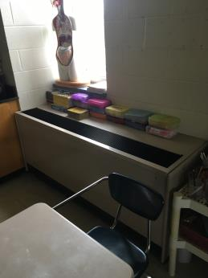

**Unit ventilator (univent)**

**Picture 2**

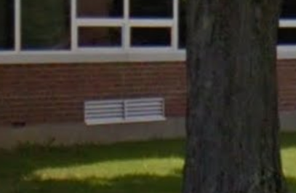

**Univent fresh air intake**

**Picture 3**

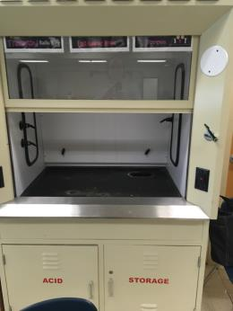

**Chemical fume hood**

**Picture 4**

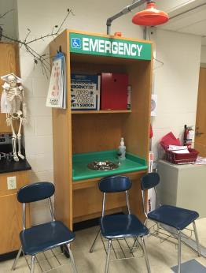

**Chemical safety shower with eye wash station and sink**

**Picture 5**

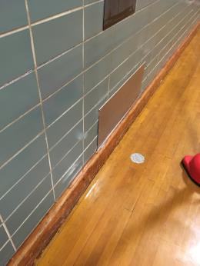

**Abandoned heating system sealed with metal sheet in gym**

**Picture 6**

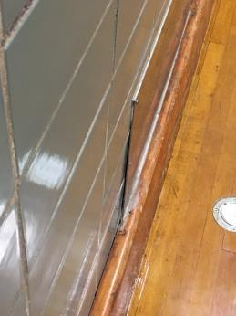

**Metal sheet with split caulking**

**Picture 7**

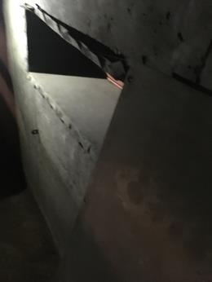

**Open former heat duct holes in tunnel beneath bleachers**

**Picture 8**

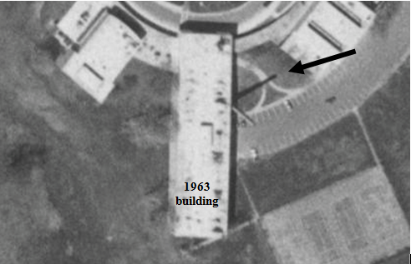

**Original chimney in 1995, prior to construction of 2001 addition, note shadow**

**(picture via mapjunction.com)**

**Picture 9**

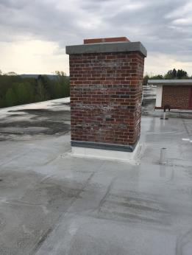

**8’ tall chimney**

**Picture 10**

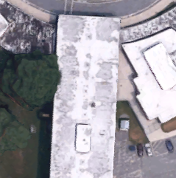

**Penthouse**

**Chimney**

**Chimney on main building, note exhaust vent penthouse south of chimney**

**Picture 11**

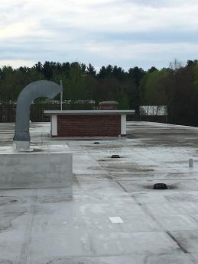

**Penthouse in relation to chimney**

**Picture 12**

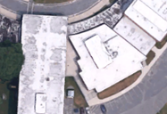

**Courtyard between original building and library wing**

**Picture 13**

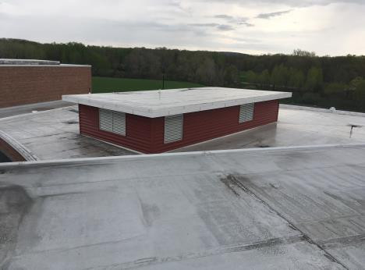

**Fresh air intakes for library wing**

**Picture 14**

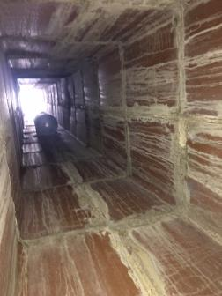

**Interior of chimney consists of ceramic tile and mortar with walls covered with efflorescence**

**Picture 15**

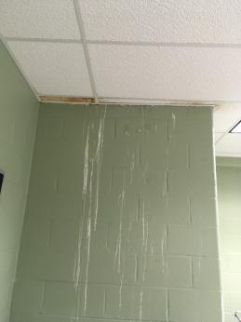

**Efflorescence on exterior wall of chimney in classroom**

**Picture 16**

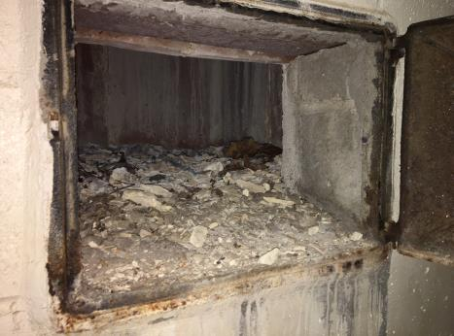

**Mortar debris at the base of chimney**

| Location | **Carbon**  **Dioxide**  **(ppm)** | **Carbon Monoxide**  **(ppm)** | **Temp**  **(°F)** | **Relative**  **Humidity**  **(%)** | **PM2.5**  **(µg/m3)** | **Occupants**  **in Room** | **Windows**  **Openable** | **Ventilation** | | **Remarks** |
| --- | --- | --- | --- | --- | --- | --- | --- | --- | --- | --- |
| Supply | Exhaust |
| Background |  |  |  |  |  |  |  |  |  |  |
| Teacher’s lounge | 442 | ND | 77 | 62 | 13 | 0 | Y open | Y | Y off |  |
| Teacher’s | 417 | ND | 80 | 57 | 11 | 0 | Y open | Y | Y off | 5 missing ceiling tiles |
| Main office | 483 | ND | 77 | 67 | 15 | 5 | N | Y | Y | 3 missing ceiling tiles |
| library | 621 | ND | 77 | 61 | 8 | 20+ | Y | Y | Y | Carpeted |
| Cafeteria B | 493 | ND | 77 | 68 | 12 | 2 | Y | Y | Y |  |
| Cafeteria A | 407 | ND | 77 | 67 | 13 | 0 | Y | Y | Y |  |
| Boys gym | 677 | ND | 77 | 66 | 13 | 20 | N | Y | Y |  |
| Girls gym | 770 | ND | 77 | 63 | 11 | 20 | N | Y | Y | Odor from floor drains |
| 1 | 392 | ND | 75 | 66 | 12 | 0 | Y open | Y | Y |  |
| 2 | 429 | ND | 76 | 67 | 12 | 1 | Y open | Y | Y |  |
| 3 | 445 | ND | 75 | 66 | 12 | 0 | Y | Y | Y |  |
| 4 | 497 | ND | 77 | 65 | 13 | 14 | Y open | Y | Y |  |
| 5 | 430 | ND | 77 | 63 | 12 | 13 | Y open | Y | Y |  |
| 6 | 398 | ND | 76 | 67 | 13 | 1 | Y | Y | Y |  |
| 7 | 443 | ND | 78 | 64 | 12 | 1 | Y open | Y | Y | 3 water damaged ceiling tiles |
| 8 | 487 | ND | 77 | 67 | 12 | 4 | Y | Y | Y |  |
| 9 | 643 | ND | 78 | 65 | 14 | 6 | Y | Y | Y |  |
| 12 | 475 | ND | 76 | 63 | 11 | 13 | Y | Y open | Y |  |
| 101 | 480 | ND | 78 | 61 | 13 | 0 | Y open | Y | Y off | 4 missing ceiling tiles |
| 102 | 422 | ND | 77 | 61 | 14 | 1 | Y open | Y | Y off |  |
| 103 | 607 | ND | 79 | 61 | 14 | 19 | Y open | Y | Y off |  |
| 104 | 453 | ND | 78 | 57 | 15 | 0 | Y open | Y | Y off |  |
| 105 | 491 | ND | 79 | 60 | 14 | 13 | Y open | Y | Y off |  |
| 106 | 617 | ND | 79 | 61 | 14 | 12 | Y open | Y | Y off |  |
| 107 | 472 | ND | 79 | 60 | 13 | 0 | Y open | Y | Y off | Plants |
| 108 | 547 | ND | 79 | 60 | 15 | 7 | Y open | Y | Y off |  |
| 109 | 486 | ND | 78 | 62 | 13 | 3 | Y open | Y | Y off | Fan |
| 110 | 640 | ND | 77 | 64 | 28 | 15 | Y open | Y | Y off | Plants on diffusers |
| 111 | 493 | ND | 77 | 63 | 13 | 6 | Y open | Y | Y off | Plants on diffusers |
| 112 | 507 | ND | 77 | 63 | 13 | 14 | Y open | Y | Y off |  |
| 113 | 533 | ND | 77 | 64 | 12 | 6 | Y open | Y | Y off |  |
| 114 | 515 | ND | 77 | 63 | 14 | 9 | Y open | Y | Y off | Plants |
| 115 | 430 | ND | 77 | 63 | 12 | 0 | Y open | Y | Y off |  |
| 116 | 402 | ND | 77 | 61 | 13 | 0 | Y open | Y | Y off |  |
| 118 | 660 | ND | 77 | 64 | 13 | 15 | Y open | Y | Y off | Emergency shower, plants, fan |
| 119 | 585 | ND | 77 | 64 | 14 | 1 | Y open | Y | Y off | Ajar ceiling tile |
| 137 | 594 | ND | 75 | 68 | 9 | 0 | Y | Y | Y |  |
| 137 | 483 | ND | 77 | 63 | 12 | 1 | Y | Y | Y |  |
| 138 | 601 | ND | 78 | 64 | 13 | 20+ | Y | Y off | Y |  |
| 201 | 561 | ND | 78 | 66 | 23 | 0 | Y open | Y | Y off | Plants |
| 202 | 416 | ND | 79 | 61 | 20 | 0 | Y open | Y | Y off | Floor fan |
| 203 | 503 | ND | 81 | 60 | 20 | 4 | Y open | Y | Y off |  |
| 204 | 491 | ND | 79 | 61 | 22 | 0 | Y open | Y | Y off | Plants |
| 206 | 690 | ND | 81 | 61 | 21 | 3 | Y open | Y | Y off |  |
| 207 | 475 | ND | 79 | 61 | 18 | 0 | Y open | Y | Y off? |  |
| 208 | 588 | ND | 79 | 61 | 21 | 17 | Y open | Y | Y off? |  |
| 209 | 739 | ND | 79 | 62 | 20 | 14 | Y open | Y | Y off? |  |
| 210 | 591 | ND | 79 | 60 | 18 | 21 | Y open | Y | Y off? |  |
| 211 | 632 | ND | 79 | 62 | 14 | 20 | Y open | Y | Y off? | Floor fan, air freshener |
| 212 | 554 | ND | 79 | 61 | 18 | 10 | Y open | Y | Y off? | Plant |
| 213 | 611 | ND | 79 | 61 | 16 | 16 | Y open | Y | Y off? | Carpeted, plants, fan |
| 214 | 680 | ND | 79 | 62 | 15 | 2 | Y open | Y | Y off? | Plants |
| 215 | 465 | ND | 79 | 60 | 15 | 1 | Y open | Y | Y off? | Books on supply vent |
| 216 | 482 | ND | 78 | 61 | 14 | 10 | Y open | Y | Y off? | Plants, air freshener |
| 217 | 704 | ND | 77 | 65 | 15 | 15 | Y open | Y | Y off | Air freshener, emergency shower, drains, lab hood |
| 218 | 462 | ND | 77 | 62 | 13 | 0 | Y open | Y | Y off | Emergency shower, drains, lab hood |
| 220 | 408 | ND | 77 | 61 | 14 | 13 | Y open | Y | Y off | Emergency shower, lab hood, drains |
| 221 | 481 | ND | 77 | 62 | 16 | 0 | Y | Y | Y off |  |