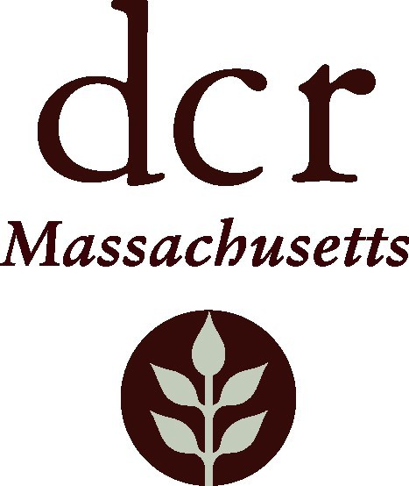

Massachusetts DCR Urban and Community Forestry
Challenge Grant Reimbursement Request Form for Non-Planting Projects

________________________________________________________ ______________________
Name of Grant Recipient/Community Date

________________________________________________________ ( ) __________________
Name of Grant Contact Telephone

Total Amount of Grant Awarded $__________________

Amount of Previous Reimbursements $__________________

Total Remaining in Account $__________________

Dates of Service for This Request (dd/mm/yy) ____-____-____ through _____-______-____

Grant - Request for Reimbursement: (Please place in the following broad categories)

Salaries $__________________

Contractual (Consultants, etc.) $__________________

Supplies (Materials & Equipment) $__________________

Administrative Expenses (Postage, etc.) $__________________

Minus Any Program Income (registrations, etc.) - $__________________

Total Request: $__________________

Total remaining in balance of account $__________________

Is this your final request for reimbursement? YES NO

Match - Verification: Match to-date must equal or exceed Total Request. Please use Expense and Match Documentation Form to calculate and document expenses for reimbursement and match. That form and supporting documentation must be submitted along with this reimbursement request.

Number of Staff Involved __________

Staff Labor Hours ________________

Hourly Rate _______________ _______

Value of Staff Labor Hours $__________________

Number of Volunteers Involved __________________

Total Volunteer Hours ____________

Volunteer Rate (see instructions) __________________

Value of Volunteer Labor Contribution $__________________

Value of In-kind Material Contribution $__________________

Additional Expenditures, 'cash match' $__________________

Total Match for this Request: $__________________

Amount of Match previously documented: $__________________

Total Value of Match to-date: $__________________

Inspected by _________________________ Date ________________ Approved/Rejected

Inspector Comments:

Return to: Julie Coop, DCR Urban & Community Forestry Program Coordinator, Julie.Coop@mass.gov

