INDOOR AIR QUALITY ASSESSMENT

Reingold Elementary School
70 Reingold Avenue
Fitchburg, Massachusetts

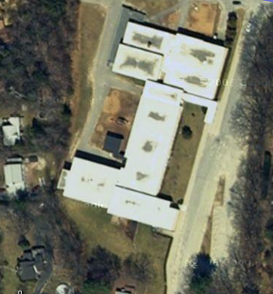

Prepared by:
Massachusetts Department of Public Health
Bureau of Environmental Health
Indoor Air Quality Program
September 2009

Background/Introduction
At the request of William Barletta, Facilities Director for Fitchburg Public Schools, the Massachusetts Department of Public Health (MDPH), Bureau of Environmental Health (BEH) provided assistance and consultation regarding indoor air quality (IAQ) at the Reingold Elementary School (RES), 70 Reingold Avenue, Fitchburg, Massachusetts. The assessment was conducted as part of an on-going effort to monitor and improve IAQ conditions in Fitchburg’s public schools. On March 13, 2009, a visit to conduct an IAQ assessment was made to the RES by Lisa Hébert, Environmental Analyst/Inspector in BEH’s IAQ Program. Ms. Hébert was accompanied by Mr. Barletta during the assessment.
The RES is a roughly rectangular, two level brick building built in 1969. The school contains regular classrooms, science classrooms, gym, cafeteria/kitchen, library, computer room, art room, specialty meeting rooms and office space. A new rubber membrane roof was installed in 1995. The RES also uses 900 square foot portable classroom. Windows are openable throughout the building. Window/wall mounted air conditioners were noted in office areas, library and in the portable classroom.

Methods
Air tests for carbon monoxide, carbon dioxide, temperature and relative humidity were conducted with the TSI, Q-Trak, IAQ Monitor, Model 8551. Air tests for airborne particle matter with a diameter less than 2.5 micrometers were taken with the TSI, DUSTTRAK™ Aerosol Monitor Model 8520. MDPH staff also performed visual inspection of building materials for water damage and/or microbial growth.

Results
The RES has an employee population of approximately 103 and serves 589 children in grades Pre-K through 4. Tests were taken under normal operating conditions and results appear in Table 1. Air sampling results are listed in the table by location that the air sample was taken. Windows were closed unless otherwise indicated.

Discussion

Ventilation
It can be seen from Table 1 that carbon dioxide levels were above 800 parts per million (ppm) in 40 of 57 areas at the time of the assessment, indicating poor air exchange in the majority of areas surveyed. It is important to note that several classrooms had open windows and/or were empty/sparsely populated, which can greatly reduce carbon dioxide levels. Carbon dioxide levels would be expected to increase with full occupancy and windows closed.
Fresh air in most classrooms is supplied by wall or ceiling mounted unit ventilator (univent) systems (Picture 1). A univent draws air from the outdoors through a fresh air intake located on the exterior wall of the building and returns air through an air intake located at the base of the unit. Fresh and return air are mixed, filtered, heated and provided to classrooms through an air diffuser located in the top of the unit (Figure 1).
Classroom exhaust ventilation is provided by unit exhaust ventilators (Picture 2). A unit exhaust ventilator appears similar to a univent, but removes air from the classroom and exhausts it out of the building. Many univents and exhausts were deactivated/not-functioning during the assessment. In addition, a number of both univent and exhaust units were obstructed by furniture, bookcases, paper and supplies (Pictures 3 & 4). Without proper supply and exhaust ventilation, environmental pollutants can build up in the indoor environment and lead to indoor air quality complaints. In order for univents and exhausts to function as designed, air diffusers, intakes/vents must remain free of obstructions. Importantly, these units must remain “on” and be allowed to operate while rooms are occupied.
Both univents and univent exhaust systems appear to have been installed at the time the building was constructed in the late 1960’s, which makes them approximately 40 years old. Mechanical ventilation units of this age can be difficult to maintain because replacement parts are often unavailable.
Fresh air is common areas (e.g., library, gym, cafeteria, kitchen and a few classrooms) is provided via ceiling mounted air handling units (AHUs). The library utilizes two window mounted air conditioners for cooling. The portable classroom lacked ventilation and exhaust capability, as did some of the administrative offices. Heat is supplied to the portable unit via electric baseboard. Two wall mounted air conditioners are used for cooling in the portable classroom as well. Air supply diffusers and exhaust vents in several rooms on the lower level did not appear to be functioning at the time of the assessment.
To maximize air exchange, the MDPH recommends that both supply and exhaust ventilation operate continuously during periods of school occupancy. In order to have proper ventilation with a mechanical supply and exhaust system, the systems must be balanced to provide an adequate amount of fresh air to the interior of a room while removing stale air from the room. It is recommended that HVAC systems be re-balanced every five years to ensure adequate air systems function (SMACNA, 1994). The date of the last balancing of these systems was not available at the time of the assessment.
The Massachusetts Building Code requires a minimum ventilation rate of 15 cubic feet per minute (cfm) per occupant of fresh outside air or have openable windows in each room (SBBRS, 1997; BOCA, 1993). The ventilation must be on at all times that the room is occupied. Providing adequate fresh air ventilation with open windows and maintaining the temperature in the comfort range during the cold weather season is impractical. Mechanical ventilation is usually required to provide adequate fresh air ventilation.
Carbon dioxide is not a problem in and of itself. It is used as an indicator of the adequacy of the fresh air ventilation. As carbon dioxide levels rise, it indicates that the ventilating system is malfunctioning or the design occupancy of the room is being exceeded. When this happens, a buildup of common indoor air pollutants can occur, leading to discomfort or health complaints. The Occupational Safety and Health Administration (OSHA) standard for carbon dioxide is 5,000 parts per million parts of air (ppm). Workers may be exposed to this level for 40 hours/week, based on a time-weighted average (OSHA, 1997).
The MDPH uses a guideline of 800 ppm for publicly occupied buildings. A guideline of 600 ppm or less is preferred in schools due to the fact that the majority of occupants are young and considered to be a more sensitive population in the evaluation of environmental health status. Inadequate ventilation and/or elevated temperatures are major causes of complaints such as respiratory, eye, nose and throat irritation, lethargy and headaches. For more information concerning carbon dioxide, consult Appendix A.
Temperature measurements in occupied areas ranged from 67° F to 76° F, which were within the MDPH recommended range in the majority of areas surveyed (Table 1). The MDPH recommends that indoor air temperatures be maintained in a range of 70º F to 78º F in order to provide for the comfort of building occupants. In many cases concerning indoor air quality, fluctuations of temperature in occupied spaces are typically experienced, even in a building with an adequate fresh air supply. In addition, it is difficult to control temperature and maintain comfort without operating the ventilation equipment as designed (e.g., univents/exhaust vents deactivated/obstructed).
The relative humidity measured in the building ranged from 12 to 26 percent at the time of the assessment, which was below the MDPH recommended comfort range (Table 1). The MDPH recommends a comfort range of 40 to 60 percent for indoor air relative humidity. Relative humidity levels in the building would be expected to drop during the winter months due to heating. The sensation of dryness and irritation is common in a low relative humidity environment. Low relative humidity is a very common problem during the heating season in the northeast part of the United States.

Microbial/Moisture Concerns
Several potential sources of water damage and/or mold growth were observed during the assessment. Water damaged ceiling tiles were observed in classrooms as well as in hallways on both levels of RES and in the portable classroom (Table 1/Picture 5). Water-damaged ceiling tiles can provide a source of mold growth and should be replaced after a water leak is discovered and repaired.
The US Environmental Protection Agency (US EPA) and the American Conference of Governmental Industrial Hygienists (ACGIH) recommend that porous materials be dried with fans and heating within 24 to 48 hours of becoming wet (US EPA, 2001; ACGIH, 1989). If not dried within this time frame, mold growth may occur. Once mold has colonized porous materials such as ceiling tiles, they are difficult to clean and should be removed/discarded.
Plant soil and drip pans can serve as a source of mold growth. A number of plants were observed without drip pans (Picture 6). Plants should be properly maintained and be equipped with drip pans. Plants should also be located away from the air stream of mechanical ventilation to prevent aerosolization of dirt, pollen or mold. Additionally, the counter surface adjacent to some of the plants exhibited soil accumulation.
BEH staff examined the exterior of the building to identify breaches in the building envelope that could provide a source of water penetration. Several potential sources were identified:
- Exterior doors near portable classroom exhibited gaps to the outdoors (Picture 7). The interior side of the door revealed buckled floor tiles, likely due to water penetration.
- Mortar was cracked and missing around exterior brick (Picture 8).
- Sealant was observed to have deteriorated (Picture 8).
- Moss was also observed at the base of the building (Picture 9). The presence of moss on exterior brick is indicative of repeated water exposure. “The two main requirements of moss are sufficient moisture and accessible nutrients. For example, the moist environment of a rooftop shaded by trees is just fine for mosses, [which] prefer to colonize shingles above the eaves, on detritus that builds up in the eaves' troughs or other depressions. Mosses will be at their best in the winter when there is plenty of water, little light, and low temperatures” (OSU, 2000).
- Warped, water damaged vertical siding was observed on the portable classroom. Moss was observed on portions of siding as well (Picture 10). Additionally, the foundation of the portable classroom was damaged.
- Trees, shrubs and plants were observed to be growing in close proximity to the building (Pictures 11 & 12). The growth of roots against exterior walls can bring moisture in contact with the foundation. Plant roots can eventually penetrate, leading to cracks and/or fissures in the sublevel foundation.
- One portion of the roof observed above the front stairway had a temporary drainage system designed out of sheet metal, which was likely installed to eliminate rainwater from pouring onto individuals as they walk up the stairway to enter the school (Picture 13). A well-designed gutter and downspout system would provide more protection and would also be likely to deposit the rainwater further away from the building.
- Of note along the exterior of the building was a lack of visible weep holes in the masonry. Exterior wall systems should be designed to prevent moisture penetration into the building interior. An exterior wall system should consist of an exterior curtain wall. Behind the curtain wall is an air space that allows for water to drain downward and for the exterior cladding system to dry. In order to allow for water to drain from the exterior brick system, a series of weep holes is customarily installed in the exterior wall, at or near the foundation slab/exterior wall system junction. Weep holes allow for accumulated water to drain from a wall system (Dalzell, 1955). Opposite the exterior wall and across the air space is a continuous, water-resistant material adhered to the back up wall that forms the drainage plane (Figure 2).
The purpose of the drainage plane is to prevent moisture that crosses the air space from penetrating the interior of the building. The plane also directs moisture downwards toward the weep holes. The drainage plane can consist of a number of water-resistant materials, such as tarpaper or, in newer buildings, plastic wraps. The drainage plane should be continuous. Where breaks exist in the drainage plane (e.g., window systems, door systems, air intakes), additional materials (e.g., flashing) are installed as transitional surfaces to direct water to weep holes. If the drainage plane is discontinuous, missing flashing or lacking air space, rainwater may accumulate inside the wall cavity and lead to moisture penetration into the building.
The aforementioned conditions represent potential water penetration sources. Over time, these conditions can undermine the integrity of the building envelope and provide a means of water entry into the building via capillary action through foundation concrete and masonry (Lstiburek & Brennan, 2001). In addition, some of these breaches may provide a means for pests/rodents to enter the building.

Other IAQ Evaluations
Indoor air quality can be negatively influenced by the presence of respiratory irritants, such as products of combustion. The process of combustion produces a number of pollutants. Common combustion emissions include carbon monoxide, carbon dioxide, water vapor and smoke (fine airborne particle material). Of these materials, exposure to carbon monoxide and particulate matter with a diameter of 2.5 micrometers (μm) or less (PM2.5) can produce immediate, acute health effects upon exposure. To determine whether combustion products were present in the school environment, BEH staff obtained measurements for carbon monoxide and PM2.5.

Carbon Monoxide
Carbon monoxide is a by-product of incomplete combustion of organic matter (e.g., gasoline, wood and tobacco). Exposure to carbon monoxide can produce immediate and acute health affects. Several air quality standards have been established to address carbon monoxide and prevent symptoms from exposure to these substances. The MDPH established a corrective action level concerning carbon monoxide in ice skating rinks that use fossil-fueled ice resurfacing equipment. If an operator of an indoor ice rink measures a carbon monoxide level over 30 ppm, taken 20 minutes after resurfacing within a rink, that operator must take actions to reduce carbon monoxide levels (MDPH, 1997).
The American Society of Heating Refrigeration and Air-Conditioning Engineers (ASHRAE) has adopted the National Ambient Air Quality Standards (NAAQS) as one set of criteria for assessing indoor air quality and monitoring of fresh air introduced by HVAC systems (ASHRAE, 1989). The NAAQS are standards established by the US EPA to protect the public health from six criteria pollutants, including carbon monoxide and particulate matter (US EPA, 2006). As recommended by ASHRAE, pollutant levels of fresh air introduced to a building should not exceed the NAAQS levels (ASHRAE, 1989). The NAAQS were adopted by reference in the Building Officials & Code Administrators (BOCA) National Mechanical Code of 1993 (BOCA, 1993), which is now an HVAC standard included in the Massachusetts State Building Code (SBBRS, 1997). According to the NAAQS, carbon monoxide levels in outdoor air should not exceed 9 ppm in an eight-hour average (US EPA, 2006).
Carbon monoxide should not be present in a typical, indoor environment. If it is present, indoor carbon monoxide levels should be less than or equal to outdoor levels. On the day of assessment, outdoor carbon monoxide concentrations ranged from 2-3 ppm (Table 1). Carbon monoxide levels measured in the school were non detect (ND) in all but one room, that measured 2 ppm, which was reflective of outside ambient conditions. A likely source of measurable levels of carbon monoxide in the area was vehicle exhaust. The RES is situated between Routes 2A and 31 to the north, Route 12 to the east and Route 2 to the south (Figure 3). Additionally, a shopping plaza and large parking area is located to the south of the building, in close proximity to the school.

Particulate Matter (PM2.5)
The US EPA has established NAAQS limits for exposure to particulate matter. Particulate matter is airborne solids that can be irritating to the eyes, nose and throat. The NAAQS originally established exposure limits to particulate matter with a diameter of 10 μm or less (PM10). According to the NAAQS, PM10 levels should not exceed 150 microgram per cubic meter (μg/m³) in a 24-hour average (US EPA, 2006). These standards were adopted by both ASHRAE and BOCA. Since the issuance of the ASHRAE standard and BOCA Code, US EPA established a more protective standard for fine airborne particles. This more stringent PM2.5 standard requires outdoor air particle levels be maintained below 35 μg/m³ over a 24-hour average (US EPA, 2006). Although both the ASHRAE standard and BOCA Code adopted the PM10 standard for evaluating air quality, MDPH uses the more protective PM2.5 standard for evaluating airborne particulate matter concentrations in the indoor environment.
Outdoor PM2.5 concentrations the day of the assessment were measured at 6 μg/m³. PM2.5 levels measured inside the school ranged from 4 to 27 μg/m³ (Table 1), which were below the NAAQS PM2.5 level of 35 μg/m³. Frequently, indoor air levels of particulates (including PM2.5) can be at higher levels than those measured outdoors. A number of mechanical devices and/or activities that occur in schools can generate particulate during normal operations. Sources of indoor airborne particulates may include but are not limited to particles generated during the operation of fan belts in the HVAC system, cooking in the cafeteria stoves and microwave ovens; use of photocopiers, fax machines and computer printing devices; operation of an ordinary vacuum cleaner and heavy foot traffic indoors.

TVOCs
Indoor air concentrations can be greatly impacted by the use of products containing volatile organic compounds (VOCs). VOCs are carbon-containing substances that have the ability to evaporate at room temperature. Frequently, exposure to low levels of total VOCs (TVOCs) may produce eye, nose, throat and/or respiratory irritation in some sensitive individuals. For example, chemicals evaporating from a paint can stored at room temperature would most likely contain VOCs. In an effort to identify materials that can potentially increase indoor VOC concentrations, BEH staff examined classrooms for products containing these respiratory irritants.
Air fresheners, reed diffusers, deodorizing materials and cleaning products were observed in several areas, some within reach of children (Picture 14). Air deodorizers contain chemicals that can be irritating to the eyes, nose and throat of sensitive individuals. Many air fresheners contain 1,4-dichlorobenzene, a VOC which may cause reductions in lung function (NIH, 2006). Furthermore, deodorizing agents do not remove materials causing odors, but rather mask odors that may be present in the area. Cleaning products and an unlabeled spray bottle containing a clear liquid was also observed during the assessment. All products should be stored in properly labeled containers and out of the reach of children. Additionally, Material Safety Data Sheets (MSDS) for all cleaning products used within RES must be stored in a central location and must be accessible to all individuals during periods of building operations in the event of an emergency as required by the Massachusetts Right-To-Know Act (MGL, 1983).
Some classrooms contained dry erase boards and dry erase markers. Materials suchas dry erase markers and dry erase board cleaners may contain volatile organic compounds (VOCs) (e.g., methyl isobutyl ketone, n-butyl acetate and butyl-cellusolve), which can be irritating to the eyes, nose and throat (Sanford, 1999).
In an effort to reduce noise from sliding chairs and tables, tennis balls were sliced open and placed on chair legs in some classrooms (Picture 15). Tennis balls are made of a number of materials that are a source of respiratory irritants. Constant wearing of tennis balls can produce fibers and off-gas VOCs. Tennis balls are made with a natural rubber latex bladder, which becomes abraded when used as a chair leg pad. Use of tennis balls in this manner may introduce latex dust into the school environment. Some individuals are highly allergic to latex (e.g. spina bifida patients) (SBAA, 2001). It is recommended that the use of materials containing latex be limited in buildings to reduce the likelihood of symptoms in sensitive individuals (NIOSH, 1997). A question and answer sheet concerning latex allergy is attached as Appendix B (NIOSH, 1998).
A snow-blower was observed stored in the front foyer of the main entrance (Picture 16). Odors and off-gassing of VOCs from gasoline can have an adverse effect on indoor air quality. In addition, storing gas-powered equipment indoors may be a fire hazard.

Other Conditions
Other conditions that can affect indoor air quality were observed during the assessment. A number of unit ventilators were opened and examined during the assessment. Dust/debris accumulation was observed on the interior of these units. Spaces around pipes were noted within all univent cabinet interiors surveyed. Additionally, a large hole was observed in the floor of one of the units. Open spaces around pipes and within these cabinets can serve as pathways for dust, dirt, odors and other pollutants to move from the floor/wall cavities into occupied areas during the operation of univents (Picture 17).
Of note was an accumulation of rodent droppings within some univents (Picture 18). To penetrate the exterior of a building, rodents require a minimal breach of ¼ inch (MDFA, 1996). As previously mentioned, spaces on exterior doors, on masonry, as well as spaces within the univent cabinets themselves were noted during the assessment, each of which would be sufficient to allow rodents to enter and travel within the building. Rodent infestation results from easy access to food and water in a building. Evidence of food sources included numerous food products stored in classrooms (Picture 19). In addition, many classrooms contain refrigerators, microwaves and numerous small appliances (Picture 20). Rodent infestation can result in indoor air quality related symptoms due to materials in their wastes. Mouse urine contains a protein that is a known sensitizer (US EPA, 1992). A three-step approach is necessary to eliminate rodent infestation:
- removal of the rodents;
- cleaning of waste products from the interior of the building; and
- reduction/elimination of pathways/food sources that are attracting rodents.
To eliminate exposure to allergens, rodents must be removed from the building. Please note that removal, even after cleaning, may not provide immediate relief since allergens can exist in the interior for several months after rodents are eliminated (Burge, 1995). A combination of cleaning, increase in ventilation and filtration should serve to reduce rodent associated allergens once the infestation is eliminated. Under current Massachusetts law that went into effect November 1, 2001, the principles of integrated pest management (IPM) must be used to remove pests in schools (Mass Act, 2000).
A bathroom exhaust fan was not operating in the Health room. Exhaust ventilation is necessary in restrooms to remove excess moisture and to prevent odors from penetrating into adjacent areas.
An upholstered sofa was observed in the lobby. Upholstered furniture is covered with fabric that comes in contact with human skin. This type of contact can leave oils, perspiration, hair and skin cells. Dust mites feed upon human skin cells and excrete waste products that contain allergens. In addition, if relative humidity levels increase above 60 percent, dust mites tend to proliferate (US EPA, 1992). In order to remove dust mites and other pollutants, frequent vacuuming of upholstered furniture is recommended (Berry, M.A., 1994). It is also recommended that upholstered furniture (if present in schools), be professionally cleaned on an annual basis. If an excessive dusty environment exists due outdoor conditions or indoor activities (e.g., renovations), cleaning frequency should be increased (every six months) (IICRC, 2000).
A kiln was observed in the art room. BEH was informed that the kiln was not currently in use. A ribbed plastic hose commonly utilized for dryer vents was being utilized as a duct for the kiln vent (Picture 21). These hoses puncture easily and may not be as temperature resistant as the duct materials frequently in use today. Prior to its use, it was recommended that the kiln be fitted with an appropriately constructed, fire resistant, dedicated exhaust system.
Accumulated chalk dust was observed in several classrooms. Chalk dust is a fine particulate, which can be easily aerosolized and serve as an eye and respiratory irritant. Several personal fans and return/exhaust vents had accumulated dust and debris. Dust can be a source for eye and respiratory irritation. If exhaust vents are not functioning, which was the case in some classrooms, back-drafting can occur and aerosolize dust particles. Personal fans with dust can serve to distribute particles once activated.
In several classrooms, items were observed on the floor, windowsills, tabletops, counters, bookcases and desks (Picture 22). Clutter was also observed in the hallways between classrooms in some areas as well. Some of these storage areas actually blocked exterior doors meant to be used as a second means of egress (Picture 23). In addition to posing a fire hazard, the large number of items stored in classrooms and hallways provides a source for dusts to accumulate. Once dusts accumulate, they can be subsequently re-aerosolized causing further irritation. These items (e.g., papers, folders, boxes) also make it difficult for custodial staff to clean. Items should be relocated and/or be cleaned periodically to avoid excessive dust build up.
As mentioned, RES staff reported a strong odor often present in one room, particularly in the morning after the building has been closed. BEH was unable to identify any sources of odors within the room. The source of the odor should be investigated and remedied if it is located. It should be noted that electrical panels were observed within the room, as a starting point for further investigations.

Conclusions/Recommendations
The conditions noted at the RES raise a number of indoor air quality issues. The general building conditions, maintenance, work hygiene practices and the age/condition of HVAC equipment, if considered individually, present conditions that could degrade indoor air quality. When combined, these conditions can serve to further degrade indoor air quality. Some of these conditions can be remedied by actions of building occupants. Other remediation efforts will require alteration to the building structure and equipment.
In view of the findings at the time of the assessment, the following recommendations are made:
- Operate all ventilation systems throughout the building (e.g., gym, cafeteria, classrooms) continuously during periods of school occupancy and independent of thermostat control.
- Set thermostat controls in portable classrooms to the “on” position to provide constant supply and exhaust ventilation during periods of occupancy.
- Remove obstructions (furniture, bookcases, posters and accumulated paper) from in front of unit ventilators and unit exhaust ventilators.
- Use openable windows in conjunction with mechanical ventilation to facilitate air exchange. Care should be taken to ensure windows are properly closed at night and weekends to avoid the freezing of pipes and potential flooding.
- Contract with a ventilation engineer to inspect AHUs, UVs as well as unit exhaust ventilators for proper function. Repair or replace components as necessary to ensure adequate air supply and exhaust capability throughout the school’s classrooms, offices and common areas.
- Consider adopting a balancing schedule of every 5 years for all mechanical ventilation systems, as recommended by ventilation industrial standards (SMACNA, 1994).
- Change filters for air-handling equipment (e.g., univents, AHUs and ACs) as per the manufacturer’s instructions or more frequently if needed. Vacuum interior of units prior to activation to prevent the aerosolization of dirt, dust and particulates. Ensure filters fit flush in their racks with no spaces in between allowing bypass of unfiltered air into the unit.
- Restore exhaust ventilation in restrooms to remove odors and moisture, make repairs as necessary.
- Ensure leaks are repaired and replace water damaged ceiling tiles. Examine the area above and around these areas for mold growth. Disinfect areas of water leaks with an appropriate antimicrobial.
- Remove rodent droppings and clean/disinfect interior of unit ventilators.
- Seal all open utility holes to eliminate rodent pathways into the building.
- Contract with a licensed pest control firm to eliminate rodents from the building. For additional advice regarding pest control contact the Massachusetts Department of Agricultural Resources, Pesticide/School IPM Program at (617) 626-1700 http://www.mass.gov/agr/
- Eliminate sources of food from within classrooms.
- Discontinue practice of storing snow blower within the building.
- Clean personal fans, air diffusers, exhaust, return vents and adjacent ceiling tiles periodically of accumulated dust. If soiled ceiling tiles cannot be cleaned, they should be replaced.
- Periodically clean chalkboards and trays of accumulated dust.
- Store cleaning products properly and out of reach of students. Ensure spray bottles are properly labeled. Obtain Material Safety Data Sheets (MSDS) for all cleaning products used within the school and keep them in an area that is accessible to all individuals during periods of building operations as required by the Massachusetts Right-To-Know Act (MGL, 1983).
- Relocate or consider reducing the amount of materials stored in classrooms to allow for more thorough cleaning of classrooms. Clean items regularly with a wet cloth or sponge to prevent excessive dust build-up.
- Consider providing plants with drip pans and avoid over-watering. Examine drip pans periodically for mold growth. Disinfect with an appropriate antimicrobial where necessary.
- Eliminate air fresheners and reed diffusers.
- Replace latex-based tennis balls with latex-free tennis balls or alternative “glides”.
- Professionally clean upholstered furniture annually or more frequently as needed.
- Investigate complaint of odor as described in Table 1.
- Seal gaps on all exterior doors.
- Repoint masonry to eliminate water from penetrating the building envelope.
- Repair or replace deteriorated sealant on the exterior of the building.
- All plants in contact with the foundation or walls of the RES should be either trimmed or removed. Cut shrubbery in a manner to maintain a space of five feet from the building.
- Consider replacing temporary drainage system with a well-designed gutter and downspout system.
- Prior to resuming use of the kiln, consider contacting an HVAC engineering firm to install an appropriately designed, dedicated exhaust system in accordance with local and state fire codes.
- For buildings in New England, periods of low relative humidity during the winter are often unavoidable. Therefore, scrupulous cleaning practices should be adopted to minimize common indoor air contaminants whose irritant effects can be enhanced when the relative humidity is low. To control for dusts, a high efficiency particulate arrestance (HEPA) filter equipped vacuum cleaner in conjunction with wet wiping of all surfaces is recommended. Avoid the use of feather dusters. Drinking water during the day can help ease some symptoms associated with a dry environment (throat and sinus irritations).
- Consider adopting the US EPA (2000) document, “Tools for Schools”, as an instrument for maintaining a good indoor air quality environment in the building. This document is available at: http://www.epa.gov/iaq/schools/index.html.
- Refer to resource manual and other related indoor air quality documents located on the MDPH’s website for further building-wide evaluations and advice on maintaining public buildings. These documents are available at: http://mass.gov/dph/iaq.

References
ACGIH. 1989. Guidelines for the Assessment of Bioaerosols in the Indoor Environment. American Conference of Governmental Industrial Hygienists, Cincinnati, OH.
Arundel et al. 1986. Indirect Health Effects of Relative humidity on Indoor Environments. Env. Health Perspectives 65:351-361.
ASHRAE. 1989. Ventilation for Acceptable Indoor Air Quality. American Society of Heating, Refrigeration and Air Conditioning Engineers. ANSI/ASHRAE 62-1989
Bayer, C. et al. 1999. Causes of Indoor air Quality Problems in Schools. US Department of Energy, Oak Ridge National Laboratory, Energy Division, Oak Ridge, TN.
Berry, M.A. 1994. Protecting the Built Environment: Cleaning for Health, Michael A. Berry, Chapel Hill, NC.
BOCA. 1993. The BOCA National Mechanical Code/1993. 8th ed. Building Officials and Code Administrators International, Inc., Country Club Hill, IL.
IICRC. 2000. IICRC S001 Reference Guideline for Professional On-Location Cleaning of Textile Floor Covering Materials Institute of Inspection, Cleaning and Restoration Certification. Institute of Inspection Cleaning and Restoration, Vancouver, WA.
IICRC. 2002. A Life-Cycle Cost Analysis for Floor Coverings in School Facilities. Institute of Inspection, Cleaning and Restoration Certification, Vancouver, WA
IICRC. 2005. Carpet Cleaning FAQ 4 Institute of Inspection, Cleaning and Restoration Certification. Institute of Inspection Cleaning and Restoration, Vancouver, WA.
MDLI. 1993. Regulation of the Removal, Containment or Encapsulation of Asbestos, Appendix 2. 453 CMR 6,92(I)(i).
MDPH. 1997. Requirements to Maintain Air Quality in Indoor Skating Rinks (State Sanitary Code, Chapter XI). 105 CMR 675.000. Massachusetts Department of Public Health, Boston, MA.
MGL. 1986. Stopped motor vehicles; Operation of Engine; Time Limit; Penalty. Massachusetts General Laws. M.G.L. c. 90:16A.
Nelson, P.E. 1999. Brick Cavity Walls and Associated Flashings. Third Annual Westford Symposium on Building Science Course Book. Building Science Corporation, Westford, MA.
OSHA. 1997. Limits for Air Contaminants. Occupational Safety and Health Administration. Code of Federal Regulations. 29 C.F.R 1910.1000 Table Z-1-A.
Sanford. 1999. Material Safety Data Sheet (MSDS No: 198-17). Expo® Dry Erase Markers Bullet, Chisel, and Ultra Fine Tip. Sanford Corporation. Bellwood, IL.
SBBRS. 1997. Mechanical Ventilation. State Board of Building Regulations and Standards. Code of Massachusetts Regulations. 780 CMR 1209.0
SMACNA. 1994. HVAC Systems Commissioning Manual. 1st ed. Sheet Metal and Air Conditioning Contractors’ National Association, Inc., Chantilly, VA.
US EPA. 1992. Indoor Biological Pollutants. US Environmental Protection Agency, Environmental Criteria and Assessment Office, Office of Health and Environmental Assessment, Research Triangle Park, NC. ECAO-R-0315. January 1992.
US EPA. 2001. “Mold Remediation in Schools and Commercial Buildings”. Office of Air and Radiation, Indoor Environments Division, Washington DC. EPA 402-K-01-001. March 2001. Available at: http://www.epa.gov/iaq/molds/mold_remediation.html
US EPA. 2000. Tools for Schools. Office of Air and Radiation, Office of Radiation and Indoor Air, Indoor Environments Division (6609J). EPA 402-K-95-001, Second Edition. http://www.epa.gov/iaq/schools/tools4s2.html.
US EPA. 2006. National Ambient Air Quality Standards (NAAQS). US Environmental Protection Agency, Office of Air Quality Planning and Standards, Washington, DC. http://www.epa.gov/air/criteria.html.
Figure 3

Overhead View of Reingold Elementary School and Surrounding Roads

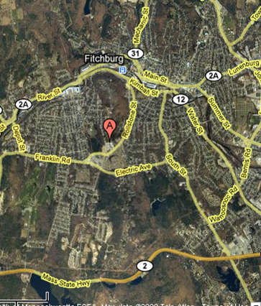

“A” – Indicates Location of Reingold Elementary School

Picture 1

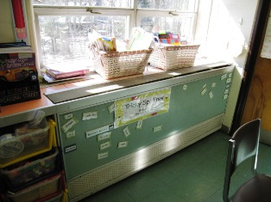

Unit Ventilator Circa Late 1960’s

Picture 2

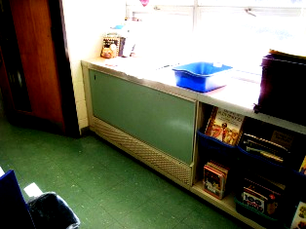

Unit Exhaust Ventilator Circa Late 1960’s

Picture 3

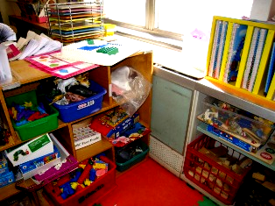

Unit Ventilator Obstructed by Bookcase and Classroom Supplies

Picture 4

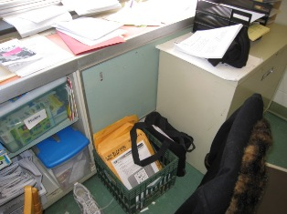

Exhaust Obstructed by Filing Cabinet and Other Items
Picture 5

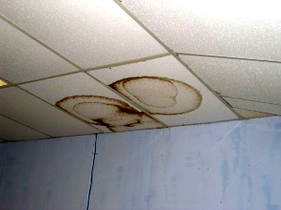

Water Damaged Ceiling Tiles

Picture 6

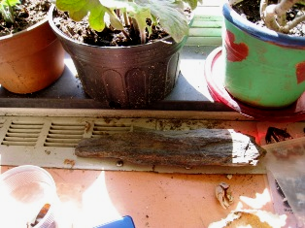

Plants on Window Sill
Note Soil Accumulation
Picture 7

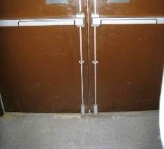

Gap in Exterior Door
Note buckled Floor Tiles

Picture 8

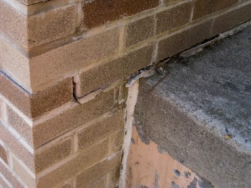

Cracked, Missing Mortar and Deteriorated Sealant
Picture 9



Moss and Plant Growth at Base of Building

Picture 10

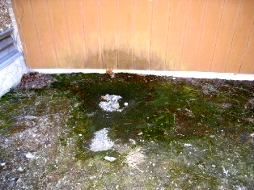

Vertical Siding Subject to Moisture/Staining/Moss Growth

Picture 11

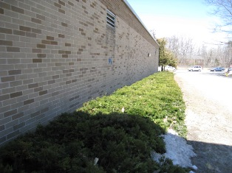

Plants Adjacent to Building

Picture 12

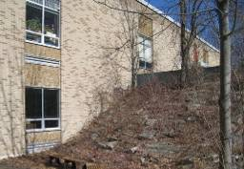

Brush Adjacent to Building

Picture 13

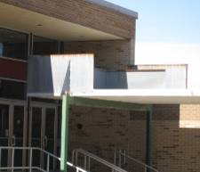

Temporary Drainage System above Stairway

Picture 14

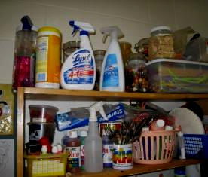

Numerous Cleaning Product Stored in Classroom
Note Unlabeled Spray Bottle

Picture 15

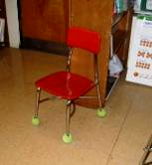

Tennis Balls on Chair Legs

Picture 16

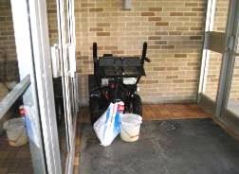

Snow-Blower Stored in Foyer

Picture 17

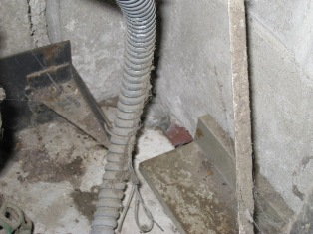

Hole at Wall/Floor Junction into Wall Cavity

Picture 18

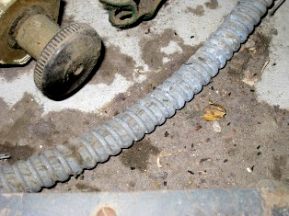
Rodent Droppings (as Indicated by Dark Spots) on Floor of Unit Ventilator

Picture 19



Food Products Stored in Classroom

Picture 20

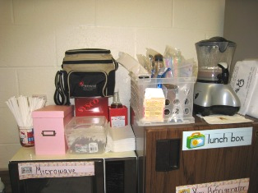

Small Appliances in Classroom

Picture 21

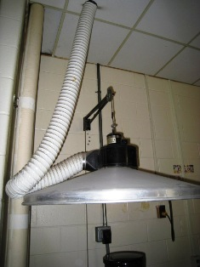

Plastic Vent Hose for Kiln

Picture 22

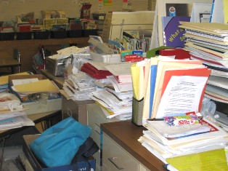

Paper and Accumulation Materials in Classroom

Picture 23

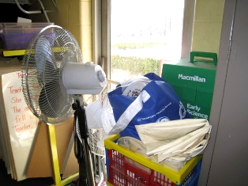

Clutter Stored in Hallway between Classrooms
Note Obstructed Exterior Door
Location/ Room | Occupants  in Room | Temp  (°F) | Relative  Humidity  (%) | Carbon  Dioxide  (ppm) | Carbon Monoxide  (ppm) | PM2.5  (µg/m3) | Windows  Openable | Ventilation |  | Remarks
 |  |  |  |  |  |  |  | Supply | Exhaust | Remarks
background | - | 64 | 6 | 363 | 2-3 | 6 | - | - | -
Room 132 | 2 | 72 | 19 | 590 | ND | 9 | N | Y | Y | DO, PF, WD CTs
Health Room | 3 | 71 | 19 | 752 | ND | 7 | N | Y  Off | Y  Off | DO, PF, AD
Women’s | 0 | 74 | 21 | 838 | ND | 8 | N | N | Y  Off | DC
Mail Room | 1 | 74 | 17 | 637 | ND | 7 | N | Y  Off | Y  Off | DO
Ms. Ford | 2 | 73 | 16 | 822 | ND | 6 | N | Y  Off | Y  Off | DO
Title I Room | 4 | 72 | 16 | 719 | ND | 6 | N | Y  Off | N | DO, WD CTs, DEM, AP, micro, fridge
Computer Rm | 0 | 69 | 14 | 521 | ND | 6 | N | Y  On | N  In hall outside rm | DO, 25 comp
Room 140 | 0 | 70 | 15 | 553 | ND | 5 | N | Y  Off | Y  Off | DO, DEM, backdraft of cold air
Conference Rm | 4 | 70 | 15 | 826 | ND | 5 | N | Y  Off | Y  Off | DC, backdraft
Room 143A | 22 | 70 | 20 | 1439 | ND | 19 | N | Y  cm univent | N | Buckled CTs
Room 143 | 1 | 70 | 12 | 451 | ND | 6 | N | Y  cm univent | N | DO, CD
Room 146 | 0 | 71 | 14 | 519 | ND | 5 | N | Y  Off | Y  On | DO, PF-on
Library | 1 | 72 | 12 | 589 | ND | 4 | Y | Y  on | Y  On | DC
Room 159 | 20 | 73 | 21 | 1644 | ND | 11 | Y | Y  UV on | Y  UV Off | DC, DEM
Room 160 | 22 | 72 | 24 | 1694 | ND | 13 | Y | Y  UV on | Y  UV off | DC, paper accum., disinfectant
Room 161 | 24 | 72 | 23 | 1257 | ND | 6 | Y | Y  UV on | Y  UE on but blocked | CD
Room 158 | 17 | 73 | 26 | 1206 | ND | 8 | Y | Y  UV on but blocked | Y  UE on but blocked | DC, CD, TB
Room 157 | 21 | 72 | 24 | 1612 | ND | 9 | Y | Y  UV on | Y  UE off | DC
Room 156 | 9 | 71 | 21 | 1178 | ND | 16 | Y | Y  UV | Y  UE off | DO
Room 153 | 9 | 72 | 18 | 1012 | ND | 8 | N | Y  UV off | N | DO, FC, CD
Portable | 0 | 70 | 16 | 1091 | ND | 6 | Y | N | N | DO, 2 ACs, DEM
Room 134 | 1 | 71 | 22 | 1350 | ND | 15 | Y | Y  UV on | Y  UE blocked | DO, paper accumulation
Room 134A | 0 | 71 | 13 | 645 | ND | 4 | Y | Y  UV on | Y  Off | DO
Room 133 | 2 | 72 | 14 | 533 | ND | 4 | Y | Y  UV on | Y  UE on | DO, accumulation of clutter
Office (front) | 4 | 73 | 17 | 822 | ND | 8 | Y | N | N | DO, window mounted AC
Assistant Principal | 1 | 74 | 17 | 991 | ND | 7 | N | N | N | DO
Principal | 0 | 74 | 17 | 834 | ND | 9 | Y | N | N | DO, plants WD CT, window mounted AC
Lobby | 25 | 74 | 15 | 759 | ND | 10 | N | N | N | Snow blower in foyer
Gym | 50 | 74 | 16 | 825 | ND | 15 | N | Y  cm on | Y  on | DO, DEM
Cafeteria | 91 | 73 | 14 | 701 | ND | 10 | Y | Y | Y | DO
Kitchen | 3 | 73 | 13 | 663 | ND | 10 | N | Y | Y
Boiler Room | 0 | 80 | 9 | 510 | ND | 10 | N | Y | N
Gym Office | 0 | 74 | 13 | 923 | 2 | 6 | N | N | N | DO
Mrs. Dion | 0 | 67 | 16 | 612 | ND | 6 | N | Y | Y | DO, WD CTs and walls, DEM
Upper Floor  Room 208 | 18 | 72 | 25 | 1735 | ND | 13 | Y | Y  UV on | Y UE off | DC, DEM
Room 213 | 16 | 73 | 25 | 1566 | ND | 15 | Y | Y  UV | Y  UE off | DC, plant
Room 215 | 8 | 72 | 23 | 1564 | ND | 10 | Y | Y  UV on | Y  UE off | DC, DEM, CD
Room 219 | 21 | 73 | 21 | 1274 | ND | 11 | Y | Y  UV on | Y  UE | DC, DEM
Room 230 | 5 | 73 | 18 | 1058 | ND | 10 | Y  ½ open | Y  UV on | N | DO, WD CTs
Mrs. Nikitas | 1 | 74 | 18 | 1084 | ND | 13 | N | Y  Above door | Y  on | DO, WD CTs, odor complaints
Staff Room | 0 | 76 | 21 | 1412 | ND | 16 | N | Y  cm UV | Y  off | DO, WD CTs, DEM
Room 245 | 0 | 76 | 21 | 2594 | ND | 27 | Y | Y  UV on | Y  UE off | DO, PF, CD, DEM, rodent droppings in univent
Room 255 | 20 | 74 | 15 | 913 | ND | 7 | Y | Y  UV on | Y  UE | DO, DEM
Room 248 | 20 | 75 | 21 | 1492 | ND | 14 | Y | Y  UV | Y  UE off | DO, DEM, WD CT
Room 251 | 21 | 74 | 23 | 1769 | ND | 23 | Y | Y  UV | Y  UE off | DEM, reed diffuser
Room 240A | 10 | 74 | 19 | 1241 | ND | 16 | Y | Y | Y | DO, PF, CD, TB
Room 240  (Art) | 20 | 74 | 18 | 1046 | ND | 10 | Y | Y  UV on | Y | DO, kiln – plastic hose exhaust, clutter
Room 239 | 20 | 75 | 19 | 1505 | ND | 19 | Y | Y  UV on | Y  UE off | DO, WD CT, plants, DEM
Room 235 | 21 | 76 | 24 | 1595 | ND | 15 | Y | Y UV on but blocked | Y  UE off | DC, CD, plants, DEM
Room 229 | 23 (30 seconds earlier) | 75 | 16 | 1248 | ND | 15 | Y  2/4 | Y UV | Y UE | DO, DEM
Room 225 | 2 | 74 | 20 | 1730 | ND | 16 | Y  ¼ | Y  UV on | Y  UE off | DO, DEM, chemicals
Room 220 | 0 | 74 | 14 | 917 | ND | 10 | Y  2/4 | Y  UV on | Y  off | DO, many WD CTs, DEM, chemicals below sink in cabinet, faucet leaks
Room 214 | 21 | 75 | 19 | 1018 | ND | 13 | Y  ¼ | Y  UV on | Y  UE off | DC, chemicals, DEM
Room 209 | 1 | 74 | 15 | 819 | ND | 10 | Y  ¼ | Y  UV on | Y  UE off | DO,
Room 204 | 21 | 74 | 15 | 749 | ND | 9 | Y  ¾ | Y  UV off | Y  UE off | DO, CD, DEM, plants, PF
Room 260 | 19 | 74 | 23 | 1586 | ND | 16 | Y | Y  UV off | Y  UE blocked | DE, DEM, WD CT
Room 259 | 19 | 74 | 20 | 1029 | ND | 9 | Y | Y  UV on | Y UE off, blocked | DC, TB DEM

