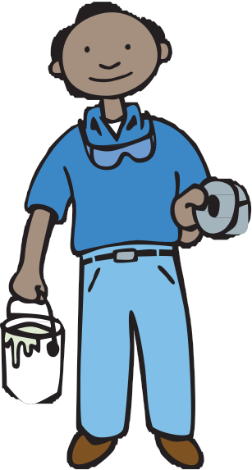

Remember:

• Keep children and pregnant women away from the work area.

• Cover all doors and windows with plastic sheeting.

• Work wet to stop lead dust.

• Clean up at the end of each day.

• Hire a certified RRP Contractor to do the work– www.mass.gov/LWD/labor-standards/lead-program
Renovate Your
Home Safely

A Do-It-Yourself Guide to Lead-Safe Home Improvement

FOR MORE INFORMATION, CONTACT:
Childhood Lead Poisoning

Prevention Program (CLPPP)
Massachusetts Department of Public Health
250 Washington St., Seventh Floor
Boston, MA 02108

Call: 1-800-532-9571
(TTY 617-624-286)
On the Web: www.mass.gov/dph/clppp
E-mail: clppp@state.ma.us
Massachusetts Department of Public Health
Bureau of Environmental Health

Childhood Lead
Poisoning Prevention

2015
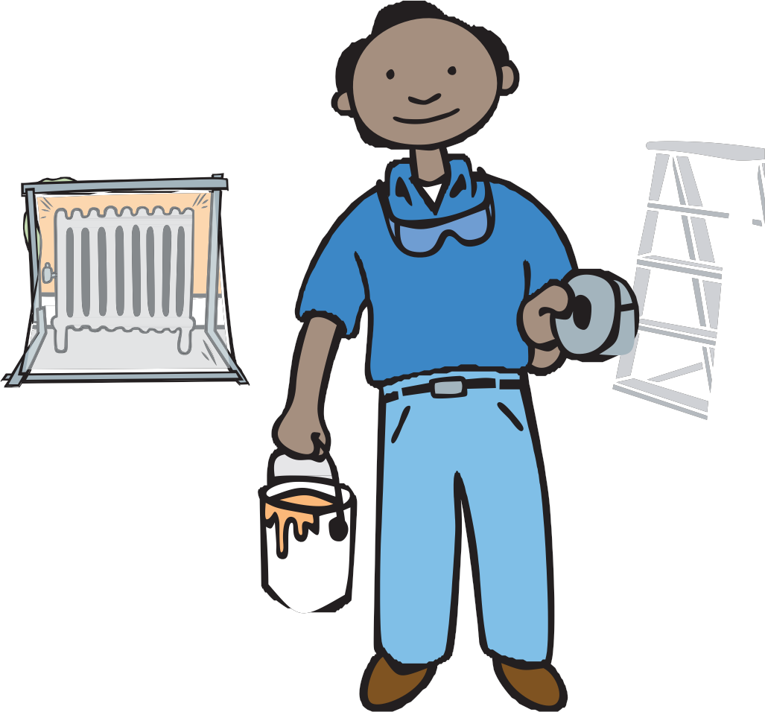

Program (CLPPP)

Call for free: 1-800-532-9571
Assistance available in other languages

Lead Paint DANGER

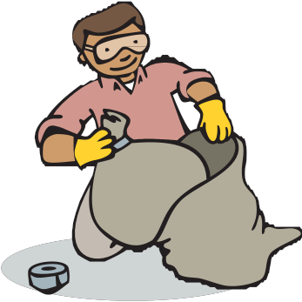

Many homes built before 1978 have lead paint on the inside and outside of the building. Repair work or renovation on older homes can create lead dust. Children and adults can breathe in or swallow lead dust. This may cause lead poisoning.

Lead is Poison

Children between the ages of 9 months and 6 years are most at risk for lead poisoning. Lead can cause long-lasting and serious harm to the brain, kidneys, and nervous system. If you are pregnant, lead can hurt your baby. Lead can also harm adults. Lead can cause high blood pressure, kidney damage, memory loss, and headaches.
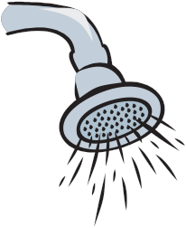

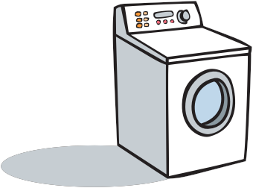

For more information on lead poisoning, call the Childhood Lead Poisoning Prevention Program (CLPPP) at 1-800-532-9571 or visit www.mass.gov/dph/CLPPP
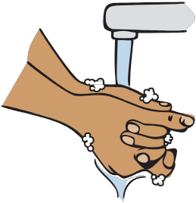

STEP 4
Put trash in double bags.
1
- Use 2 heavy plastic bags and seal them with tape.
- Throw bags out with the regular trash.

STEP 5
Wash up.

- Change your work clothes and shoes before you leave the work area.

- Shower and wash your hair.

- Wash your work clothes separately from other clothes

- Wash your hands before eating, drinking, or smoking.
10
10

Clean Up
Clean up at the end of each day is very important!
Wait at least 2 hours for dust to settle.

STEP 1
Pick up trash.

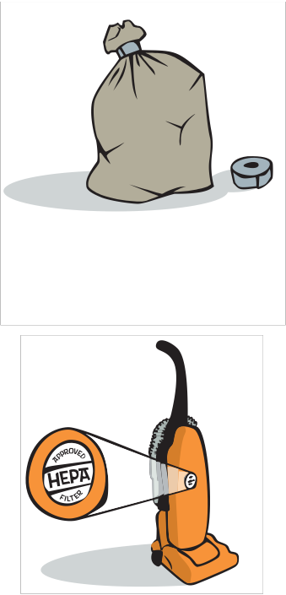

- First, pick up big pieces of trash and put them in a plastic trash bag. Seal with duct tape.

- Spray plastic sheeting with water. Fold or roll the plastic inward, trapping the dust inside. Put sheeting in a plastic bag. Seal with duct tape.

STEP 2
Use a vacuum with a HEPA filter.
        - Vacuum the room.

        - Do not use a household vacuum unless it has a HEPA filter. It will spread dust into the air.

        - Do not sweep.

STEP 3
Wash everything with all-purpose cleaner.
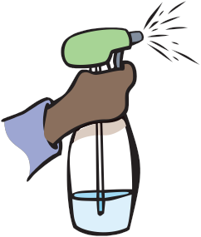

- Use disposable rags, sponges, or paper towels.

- Wet wash all surfaces. Start with the walls and wash from the top down.

- Use 2 buckets. Fill one with cleaner mixed with water. Fill the other one with clean rinse water. Change the water often.

- Wash all tools before taking them out of the work area.
9

Learn How to Renovate Safely

Follow the tips in this book to keep your family safe. Assume that all paint is lead paint unless your home was built after 1978. Even if you recently repainted your home, old layers of paint may still contain lead. If you are doing renovations or repair work on a rental property built before 1978, you need to be certified in lead safe work practices, also called the RRP Rule. For more information on RRP Call 617-626-6960 or visit www.mass.gov/lwd/labor-standards/lead-program/. If you hire a contractor, plumber, painter or electrician to do work on a pre-1978 home, they need to have RRP certification.

Deleading or Renovating?
Work done to remove or cover lead paint is called deleading. Deleading must be done by people who are trained and
authorized to do the work safely. If you need more information on deleading, call CLPPP at 1 (800) 532-9571.

This book tells you how to renovate safely. Renovation is work
done to repair or improve your home if it is built before 1978. Contractors must be RRP certified to do renovations in your home
if it is built before 1978.

Work that disturbs lead paint can be dangerous.
This includes:
- Painting: removing paint; sanding or scraping painted surfaces; painting outside surfaces

- Renovation/Demolition: tearing down walls or plaster; removing windows and woodwork

- Repairing: fixing plumbing or electrical systems; repairing heating or ventilation ducts
2

Before you begin...

Protect yourself when renovating

- Wear gloves and safety goggles.

- Do not eat, drink, chew gum or tobacco, or smoke in work areas.

- Do not touch your face, nose, or mouth when working.

Renovating safely will help protect yourself and your family from lead dust.

If you hire other people to do the work, they must be RRP certified by Labor and Workforce Department. www.mass.gov/LWD/labor-standards/lead- program
3
Working Safely Outside
3
Keep paint chips and dust out of soil, gardens and play areas!

Cover windows and doors with plastic.
- Close windows and doors so that dust cannot get inside.
- Cover them with plastic and seal the edges with tape.

Tape a drop cloth to the base of the building.
- It should extend 10 feet from the building.
- Hold it down with something heavy.

Cover gardens and play areas.
- Use a tarp or drop cloth. This will prevent lead from getting in the soil.
- Move or cover sandboxes, play equipment, and outdoor furniture so dust won’t be on them when you are done.

Keep lead dust from
leaving the work area
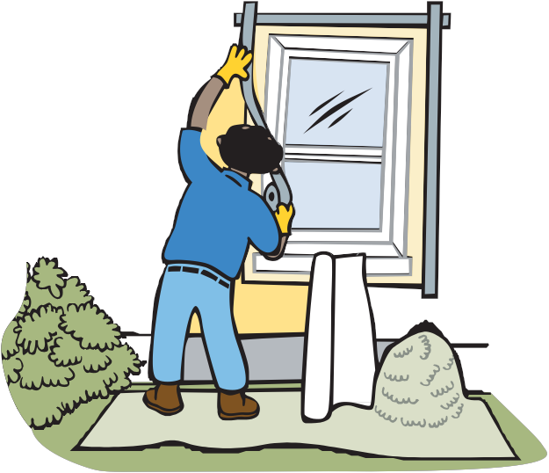

- Do not work on windy days.
- Remove work clothes and shoes before going inside.
- Do not use power sanders, heat guns, or torches. They create lots of dust or poisonous fumes.
8

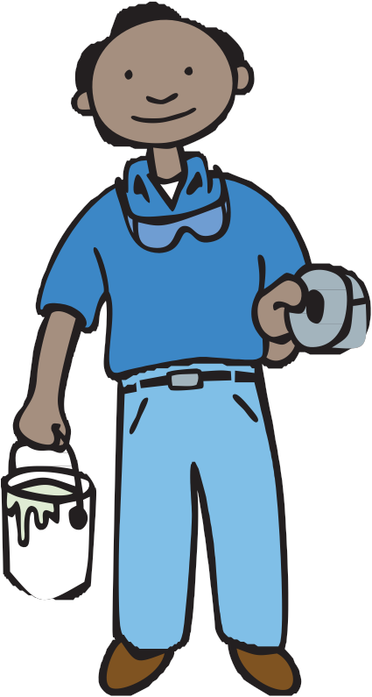

Remember
The purpose of renovating safely is to protect yourself and family from harmful lead dust!
You want to keep lead dust from escaping the
work area and getting into the house, including cracks, carpets and furniture.
Only people doing the work should be in the house.

- Keep children and pregnant or nursing women out of the work area until it has been cleaned up.

- Keep pets away from the work area, too.

- No one under 18 years old should work with lead paint.

- If possible, do the work when no one is living in the home.

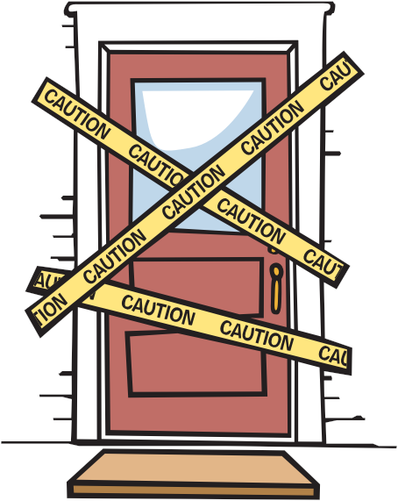

Work that disturbs lead paint can be dangerous.

This includes:
• Painting: removing paint; sanding or scraping painted surfaces; painting outside surfaces

• Renovation/Demolition: tearing down walls or plaster; removing windows and woodwork

• Repairing: fixing plumbing or electrical systems; repairing heating or ventilation ducts
4
7
Working Safely Inside
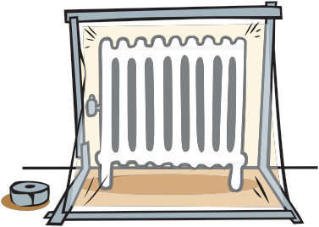

Don’t let harmful lead dust escape the work area!

Work in one room at a time.
- Do not walk in and out of the work area often. Have everything you need in the room before you start working.
- Place a damp floor mat outside the door to the work area. Wipe off dust from the bottom of your shoes when you leave the work area.

Seal off the room from the rest of the house.
- Close doors and windows and tape heavy plastic around them.
- Seal the edges with duct or masking tape.
- Be sure to leave an exit!
- Tape heavy plastic over heating vents.
- Shut down ventilation and heating systems.
Use heavy plastic sheeting that won’t rip easily (6 mil thick).

Cover floors and carpets with heavy plastic.
- Seal the edges with tape.
- Do not use a canvas tarp.

Protect all food, furniture, toys, and clothes.
- Remove them from the work area.

- Cover furniture that you cannot move with heavy plastic and seal tightly.
- Take down curtains.
Work Wet
5

Use a spray bottle filled with water to wet-mist painted areas.
This will reduce dust.
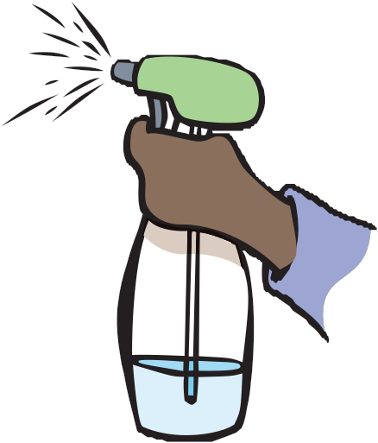

If you sand by hand, be sure to wet the area first.

Do Not Use:
- Electric sanders
- Heat guns
- Torches
- Paint strippers with methylene chloride

These methods create lots of dust or poisonous fumes.

If you are working outside, you can use a hose to mist surfaces (do not use on high pressure).
6

