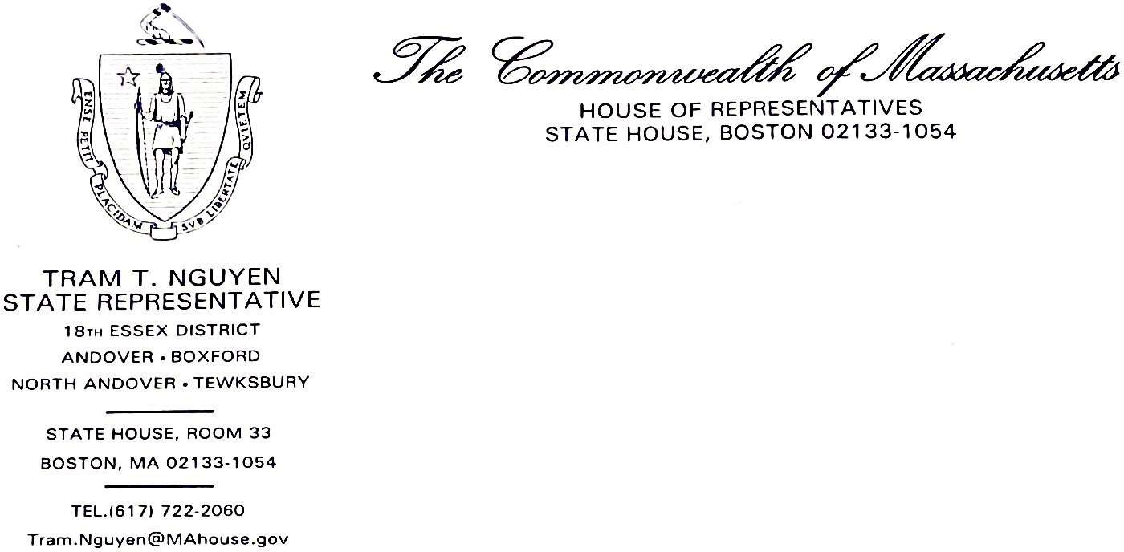

To: Chair Katherine Ginnis From: Rep. Tram Nguyen Date: October 14, 2021
RE: Legislative Update on FY22 Budget for the Community Behavioral Health Promotion and Prevention Commission

Key highlights from the FY22 Budget related to behavioral and mental health services

LINE ITEMS

Department of Mental Health

5042-5000: Child and Adolescent Mental Health Services
This line item is funded at $98.4 million for mental health care for children and adolescents, including community-based mental health services and evidence-based trauma treatments. It includes $3.9 million for the Massachusetts Child Psychiatry Access Program (MCPAP).
MCPAP makes child psychiatry consultations accessible to primary care providers—and, as a result, their patients—across the state and also includes mental health and substance use disorder support for pregnant and postpartum women.

This line item also allocates $150,000 to the Massachusetts Association for Mental Health to partner with the BIRCh (Behavioral Health Integrated Resources for Children) Center to develop a plan for establishment of a school based behavioral health technical assistance center. The technical center would be a home to support schools in a variety of ways to implement best practices in behavioral health promotion, prevention and intervention that are centered in evidence based research and would allow school professionals to share best practices with others across the state.

5046-0000: Adult Mental Health & Support Services
This line item is funded at $510 million for adult mental health services. It includes $9,000,000 for jail diversion and police efforts, of which $250,000 is directed towards expansion of safe haven housing for mentally ill adults who have been chronically homeless and are currently living in a shelter or on the streets in Boston.

5046-2000: Homelessness Support Services
This line item includes $24.1 million for programming for homeless individuals across the state, many of whom struggle with complex mental health and substance use needs.

5047-0001: Emergency Service Programs and Mental Health Care
This line item is funded at $22.2 million for emergency service programs (ESPs) and acute inpatient mental health care services. ESPs provide crisis response to DMH and non-DMH clients in the community, diverting people from the emergency department (ED) and providing specialized support.

5055-0000: Forensic Services
This line item contains $11.1 million for court clinics, psychiatric evaluations, and other costs associated with justice-involved persons with mental health needs.

5095-0015: Inpatient Facilities & Community Based Mental Health Services
This line item is funded at $255 million for the operation of hospital facilities and community- based mental health services. This includes inpatient facilities, which provide continuing care to patients who require long-term services typically not offered outside of DMH.

7004-9033: Rental Subsidy Program for DMH Clients *(DMH-related)
This line item is funded at $12.5 million for affordable housing vouchers for individuals with serious behavioral health conditions who are homeless, unstably housed, or ready to discharge from DMH inpatient units.

Department of Public Health 4510-0112: Postpartum Depression Programs
This line item is funded at $300,000. Funding is directed toward the Department of Public Health to conduct a postpartum depression programs at community health centers in the cities of Holyoke, Lynn, Worcester, Fall River, Salem, and in Jamaica Plain.

4512-0200: Bureau of Substance Addiction Services (BSAS)
This line item is funded at $175.5 million. Funding is directed towards the opening of 5 new recovery centers, 3 of which will, to the extent possible, serve gateway cities. It also includes

funding for the Massachusetts Access to Recovery (MA-ATR) program, which offers recovery support for individuals who have an opioid use disorder (OUD) or those who are at risk of developing one. It also allocates funds to additional family supportive housing programs (formerly called family sober living programs) across the state and for voluntary training and accreditation programs for owners and operators of alcohol and drug free housing. This line item further funds technical assistance and training to the services systems of medication management, medication-assisted treatment and treatment of co-occurring disorders at the same levels in FY21. It also provides funds to support municipalities utilizing grant funds from the Massachusetts Opioid Abuse Prevention Collaborative (MOAPC) grant program.

4512-0201: Substance use disorder step-down recovery services
This line item invests $4.5 million for substance use disorder step-down recovery services, known as level B beds and services as well as other critical recovery services with severely reduced capacity.

4512-0202: Jail Diversion Programs for Opiate Addiction
This line item invests $1.35 million in jail diversion programming. This funding will ensure that non-violent offenders primarily suffering from opiate addiction receive treatment rather than be incarcerated.

4512-0203: Young Adult Treatment Program and Early Intervention Services
This line item invests $1.44 million for intervention and care management for young adults dependent on or addicted to alcohol, controlled substances, or both.

4512-0204: First-Responder and Bystander Naloxone Distribution Programs
This line item includes $1.04 million for first-responder and bystander naloxone distribution programs, which help ensure life-saving access to this opioid overdose reversal drug. Funds will also maintain first-responder and bystander naloxone distribution grants in communities with high incidence of overdose.

4512-0205: Comprehensive prevention, intervention and recovery services
This line item is funded at $5.1 million for grants and contracts with substance use programs to provide comprehensive prevention, intervention and recovery services in localities across the Commonwealth.

4512-0206: Harm Reduction
This line item includes $6.4 million to coordinate a comprehensive statewide strategy to promote harm reduction efforts, which work to reduce negative consequences associated with drug use, at the statewide and community levels.

4513-1026: Suicide Prevention
This line item is funded at $7.05 million for statewide and community-based suicide prevention efforts. Programming provides support to community agencies, education and training for professionals and caregivers, and funds programs working with veterans and older adults.

4590-0930: Naloxone Bulk Purchasing Program
This line item provides $533,000 for municipalities purchasing naloxone through the bulk purchasing program.

Other Behavioral Health Investments Department of Elementary and Secondary Education

7061-9607: Recovery High Schools
This line item is funded at $2.7 million for the coverage of administrative, programmatic and operations costs of recovery high schools. Recovery high schools are public schools where students can both earn a high school diploma and also receive recovery support from alcohol and drug use. These programs provide our adolescents and young adults with opportunities to continue their education, while simultaneously receiving quality treatment for their mental health issues.

7061-9650: Supporting Healthy Alliances Reinforcing Education (SHARE)
This line item includes $2 million for the Supporting Healthy Alliances Reinforcing Education (SHARE) to provide student wellness grant programs to schools to coordinate with community- based resources, including social services, mental health, and behavioral health.

7061-0027: COVID-19-Related Funding for Public Schools and Districts
This line item makes available $15 million in one-time grants to public schools and districts in the Commonwealth for the cost of reimbursing added costs and other summer programming intended to remedy and reverse pandemic- and lockdown-related learning loss. This funding prioritizes grant applications that address the mental health issues facing students returning to in- person learning after remote or hybrid learning, on efforts to improve student socialization skills weakened by the isolation required by the public health emergency, and on ensuring access during said summer programming to social services, mental health, and behavioral health resources to address the potential trauma and other effects of the pandemic on students. This line item also requires DPH to report on grant implementation, including the effects such programs had on student mental and behavioral health.

Executive Office of Health and Human Services

1595-1071: Community Behavioral Health Promotion and Prevention Trust Fund
This line item directs $200,000 to fund the Community Behavioral Health Promotion and Prevention Trust Fund. The Trust Fund will support grants issued to community organizations to establish or support evidence-based and evidence-informed programs for children and young adults.

4000-0950: Children’s Behavioral Health Initiative
This line item provides $266.8 million for administrative and program expenses to provide comprehensive, community-based behavioral health services for children suffering from extreme emotional disturbances.

Judiciary 0321-2000: Mental Health Legal Advisors
This line item funds Mental Health Legal Advisors at $2.2 million which provides legal and policy support for those with mental health challenges.

0340-0203: Drug Diversion Programs
This line item funds $499,950 to the Massachusetts District Attorneys Association for drug diversion programs for young adult non-violent drug offenders.

Department of Correction (DOC) 8900-0003: Reform to Mental and Behavioral Health
This line item allocates $4.8 million to implement mandated reforms to mental and behavioral
health and residential treatment connected to the Department of Correction.

8910-1010: Forensic Mental Health Services
This line item allocates $1.2 million for the operation of a regional behavioral evaluation and stabilization unit to provide forensic mental health services within existing physical facilities for persons incarcerated in correctional facilities; provided, that the unit shall be located in Hampden county to serve the needs of those incarcerated in Berkshire, Franklin, Hampden, Hampshire and Worcester counties.

OUTSIDE SECTIONS

Section 16: Amends Section 2YYYY of chapter 29 of the General Laws, as amended by section 5 of chapter 31 of the acts of 2020 to allow the expense of, without further appropriation:

- up to $27 million in FY20, up to $53 million in FY21, and up to $60 million in FY22 to expand and support the residential treatment system to treat individuals with a substance use disorder or co-occurring mental health and substance use disorder;

- up to $11 million in FY20, up to $32 million in FY21, and up to $40 million in FY22 to expand and support access to medication assisted treatment;

- up to $8 million in FY20, and up to $15 million in FY21 and FY22 to expand and support access to recovery treatment support services; and

- up to $4 million in FY20, up to $10 million in FY21, and up to $15 million in FY22
to implement and support the American Society of Addiction Medicine assessment and care planning across substance use treatment providers.

Section 122: Directs DMH, in consultation with DPH and OPSS (public safety and security), to provide targeted outreach to frontline workers, including, but not limited to, healthcare workers and first responders and their families, to provide information about supports and other resources available to individuals experiencing trauma related to COVID-19.

Section 123: Directs DPH to conduct a study and report on the effects of COVID-19 on frontline healthcare workers, including, but not limited to, nurses, nurse practitioners, physician assistants, certified nurse aids, physicians and other healthcare providers in the commonwealth and their families. The study shall inform current and future practices for the wellbeing and maintenance of frontline healthcare workers. The department shall examine mental health effects, including, but not limited to: (i) trauma; (ii) stress related disorders; (iii) depression; (iv) anxiety; and (v) substance use disorders. The study and report shall include data on the role of the frontline healthcare worker and various demographic factors including, but not limited to: gender, race, ethnicity, geographic location and age. The study and report shall include data from frontline healthcare workers in various locations throughout the commonwealth and shall identify trends. The department shall submit a written report with the clerks of the house of representatives and the senate, the house and senate committees on ways and means and the joint committee on public health not later than September 1, 2022.

Section 127: Establishes a 17-member special commission to review and develop recommendations and best practices for local and regional public safety response to mental health emergencies, including, but not limited to, trainings, manner of deescalation, safety practices, personnel responding, including response in plain clothes or uniform and type of response. The commission shall submit a report of its review and recommendations, including draft legislation, by Sept. 1, 2022.

ADDITIONAL LINE ITEMS

3000-6075: Early Childhood Mental Health Consultation Services
This line item allocates $3 million for early childhood mental health consultation services in early education and care programs in the commonwealth.

4401-1003: Grant Program for High-Risk Young Parents
This line item provides $2.5 million in funds for a grant program to support economic mobility among high-risk young parents, targeted at young parents experiencing acute trauma, multiple systems involvement, mental health concerns, domestic violence, or abuse. The funds shall be utilized to increase parenting and life skills, housing stability, and self-sufficiency, and to build cognitive and behavioral skills through intensive case management and wraparound supports. Grants will be between $250,000 and $500,000 and include robust data collection requirements.

7100-0200: University of Massachusetts Operations
This line item allocates $571 million to fund University of Massachusetts Operations, of which no less than $4 million shall be expended by the university on student behavioral health services, including but not limited to, crisis services, therapy, the assessment of learning disorders, responses to sexual assault, substance abuse services, and assistance to students struggling with stress, anxiety or other mental health needs created or exacerbated by remote learning and the COVID-19 pandemic.

9110-1640: Geriatric Mental Health Program
This line item allocates $1.2 million for the geriatric mental health program, including outreach, counseling, resource management and system navigation for community-dwelling elders with mental health needs.

0950-0030: Commission on the Status of Grandparents Raising Grandchildren
This line item allocates $213,697 in funding for the commission on the status of grandparents raising grandchildren established under section 69 of chapter 3 of the General Laws. It also directs that $50,000 to be expended for a contract with the University of Massachusetts Medical School to conduct a study on opioid use in the Commonwealth specifically related to the impact

opioid use has had, and may continue to have, on grandparents and other relatives raising related children.

1599-0105: Medication-Assisted Treatment (MAT)
This line item allocates $15 million for costs associated with the delivery of medication-assisted treatment for opioid use disorder at county correctional facilities.

