

The Commonwealth of Massachusetts
Executive Office of Health and Human Services
Department of Youth Services
600 Washington Street, 4th floor
Boston, MA 02111

617-727-7575

FAX#: 617-727-0696
www.mass.gov

CHARLES D. BAKER

Governor

KARYN E. POLITO
Lieutenant Governor

MARYLOU SUDDERS
Secretary

PETER J. FORBES

Commissioner

Ordering Repealing DYS Policy

Pursuant to DYS Policy 01.01.03(a), Repeal of Policies, I, Peter Forbes, Commissioner for the Department of Youth Services (DYS), hereby repeal 01.01.02(b) Dissemination of Policies. This repeal is due to the content of this policy has been incorporated into the revised Policy Administration, Policy No. 01.01.01(c).

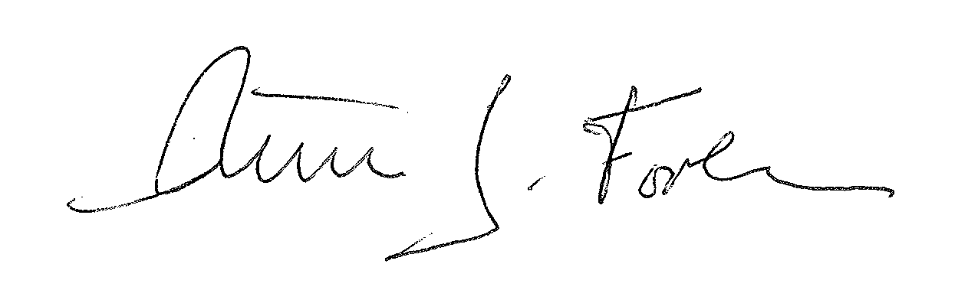
______________________________
Peter J. Forbes, Commissioner

______9/2/2015_________________
Date

