

The Commonwealth of Massachusetts
Executive Office of Health and Human Services
Department of Youth Services
600 Washington Street, 4th floor
Boston, MA 02111

617-727-7575

FAX#: 617-727-0696
www.mass.gov

CHARLES D. BAKER

Governor

KARYN E. POLITO
Lieutenant Governor

MARYLOU SUDDERS
Secretary

PETER J. FORBES

Commissioner

Ordering Repealing DYS Policies

Pursuant to DYS Policy 01.01.03, Repeal of Policies, I, Peter Forbes, Commissioner for the Department of Youth Services (DYS), hereby repeals the following DYS policies listed below. This repeal is due to the content of these policies are currently contained in DYS contracts with the specific contracted provider (s).

01.02.09(b) Foster Parent Payment
04.04.02 Foster Home Approval
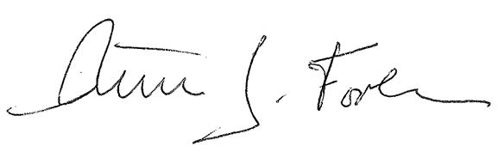
______________________________
Peter J. Forbes, Commissioner

_8/11/15_______________________
Date

