

The Commonwealth of Massachusetts
Executive Office of Health and Human Services
Department of Youth Services
600 Washington Street, 4th floor
Boston, MA 02111

DEVAL L. PATRICK

GOVERNOR

JOHN W. POLANOWICZ

SECRETARY

PETER J. FORBES

COMMISSIONER

617.727.7575

FAX#: 617.960.3298

Order Repealing DYS Policies

Pursuant to DYS Policy 01.01.03, Repeal of Policies, I, Peter Forbes, Commissioner for the Department of Youth Services (DYS), hereby repeal 01.03.02(b), Conflict of Interest.

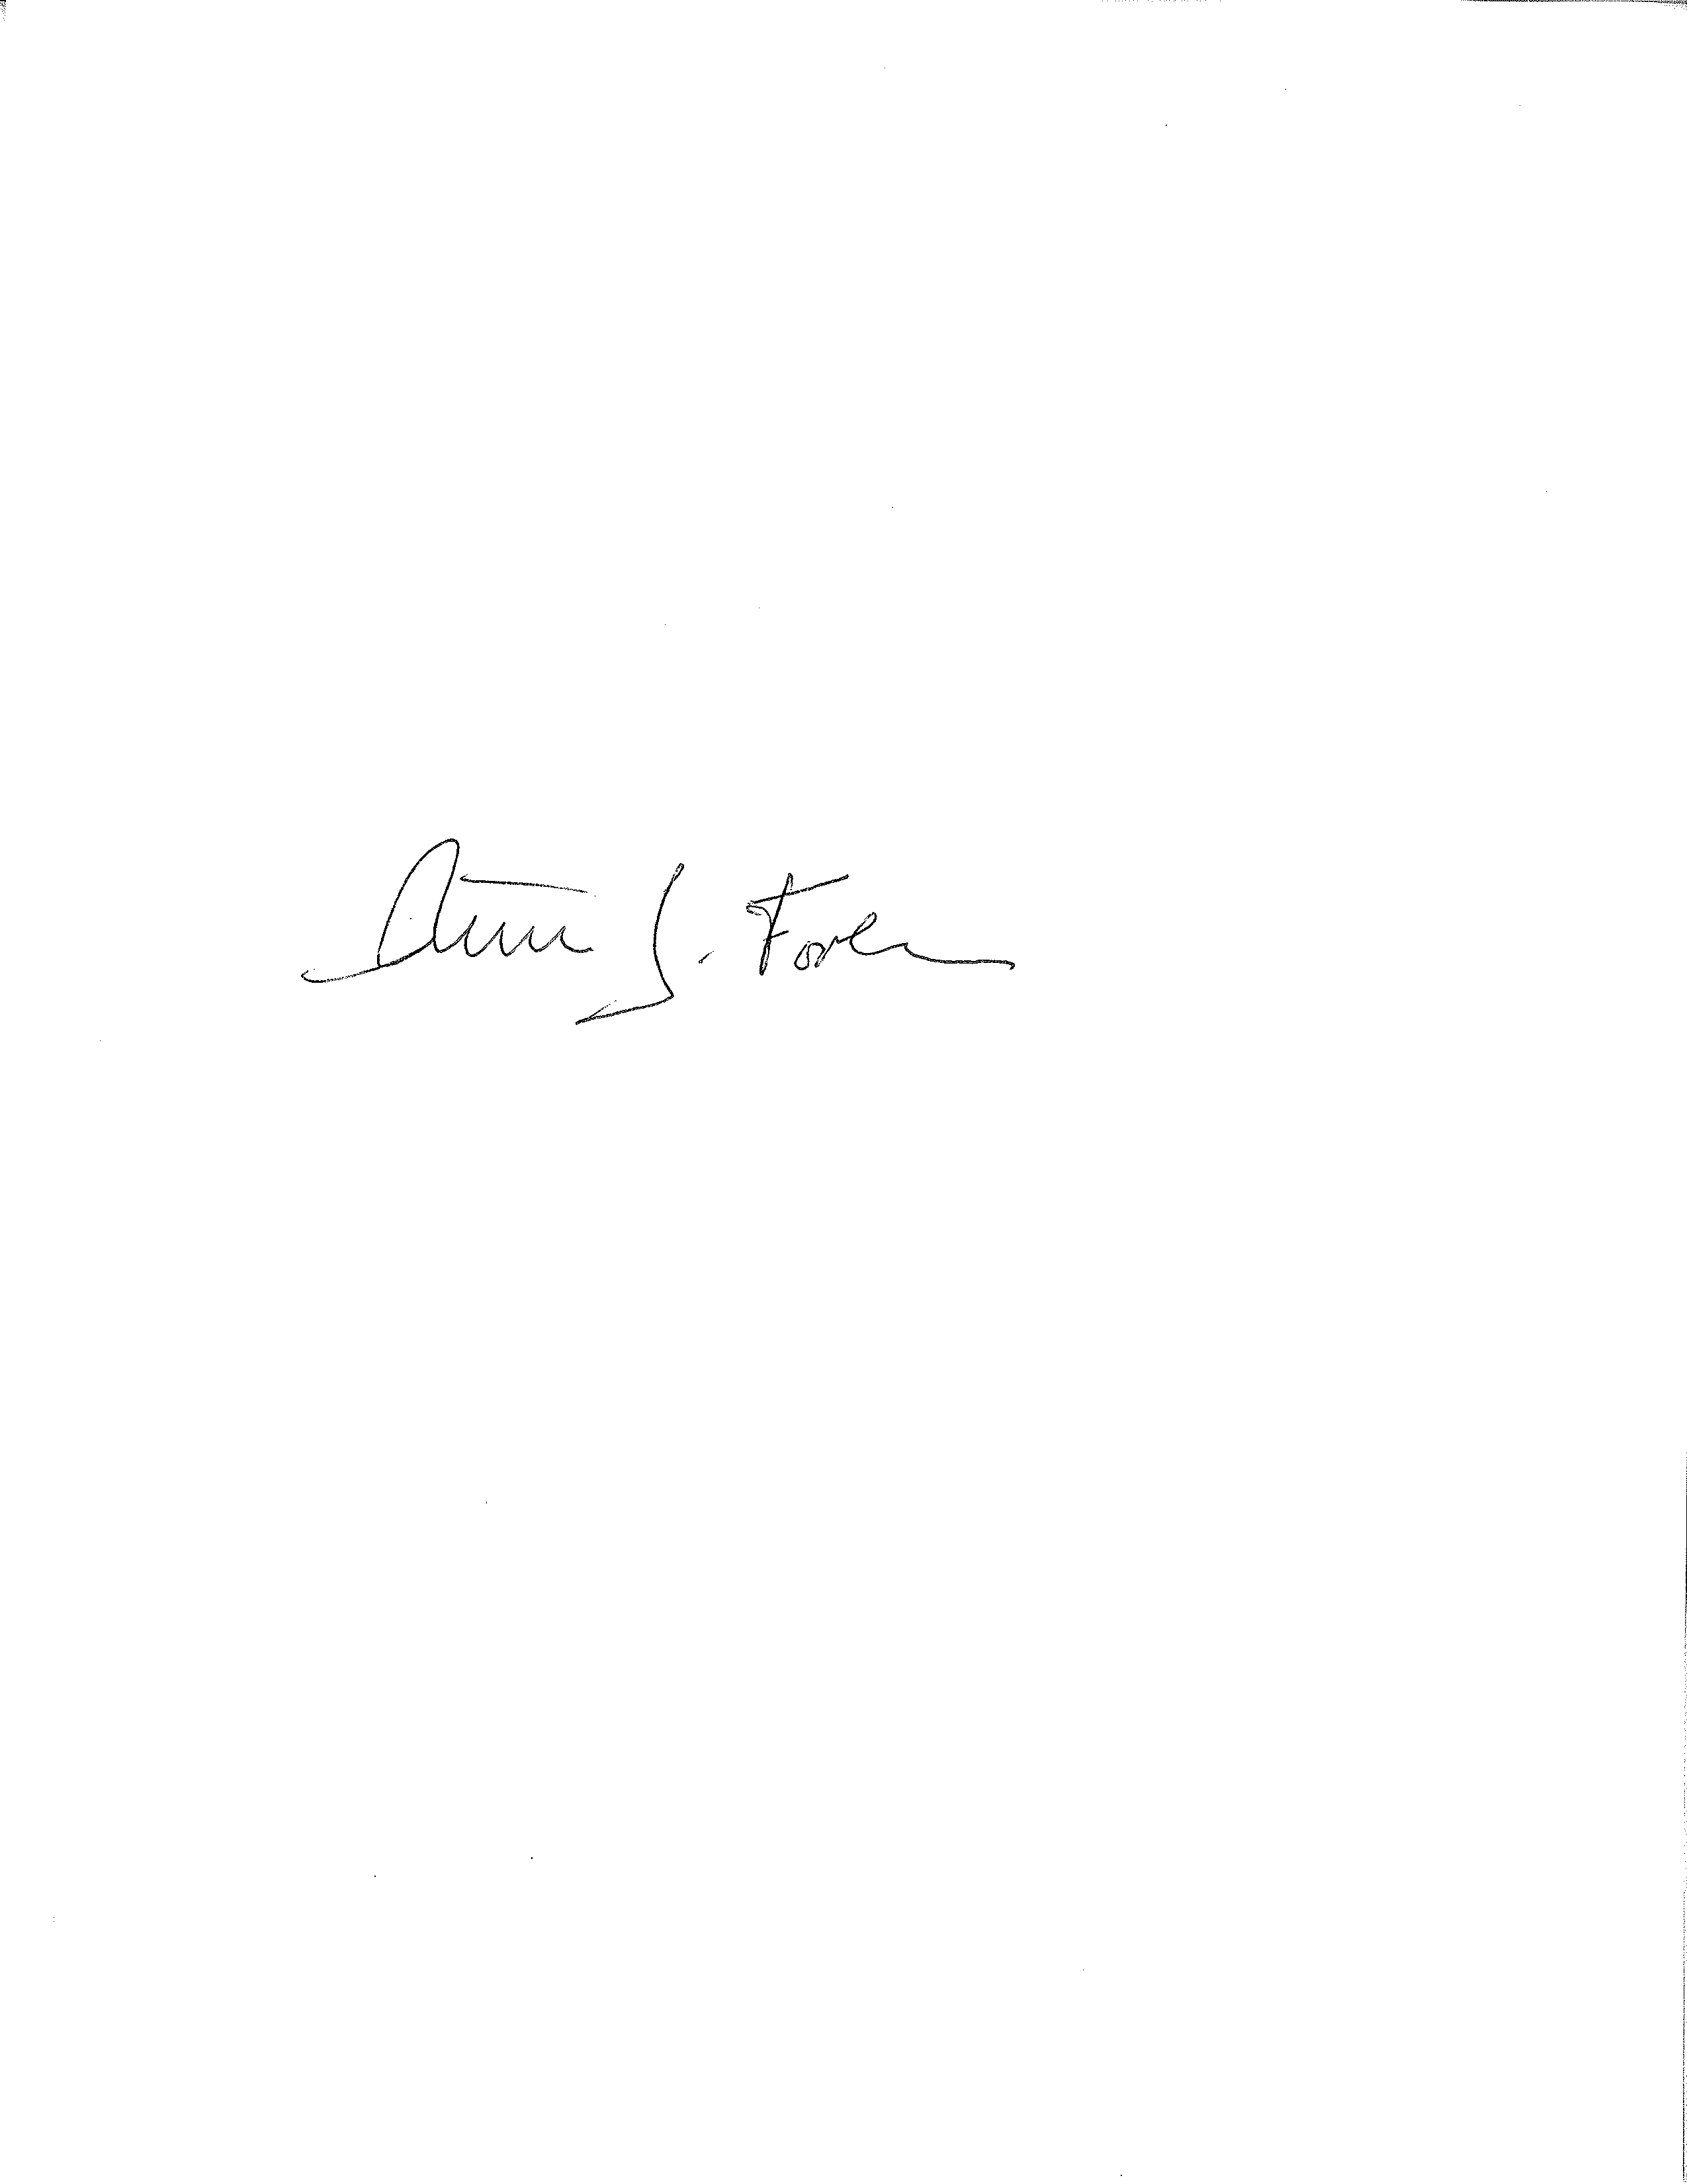
___________________________
Peter Forbes, Commissioner

9/8/2014
________________________________
Date

