The Commonwealth of Massachusetts
Executive Office of Health and Human Services
Department of Public Health
250 Washington Street, Boston, MA 02108-4619

CHARLES D. BAKER
Governor
KARYN E. POLITO
Lieutenant Governor

MARYLOU SUDDERS
Secretary
MARGRET R. COOKE
Commissioner

Tel: 617-624-6000
www.mass.gov/dph

September 15, 2022

Steven T. James
House Clerk
State House Room 145
Boston, MA 02133

Michael D. Hurley
Senate Clerk
State House Room 335
Boston, MA 02133

Dear Mr. Clerk:

Pursuant to section 26 of chapter 260 of the acts of 2020, please find the enclosed report from the Rare Disease Advisory Council.

Sincerely,

Margret Cooke, Commissioner
Department of Public Health

[intentionally blank]

2

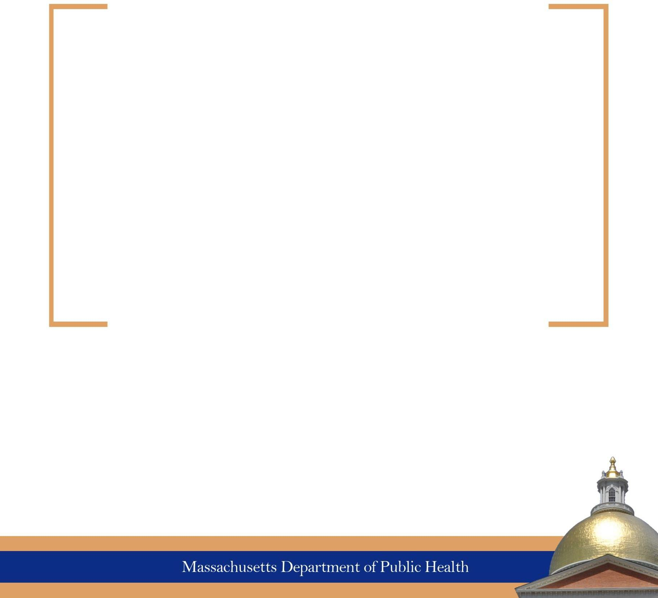

Report on Establishing a Rare Disease Advisory Council

September 15, 2022

Table of Contents
Overview and Summary of Legislative Charges 4
Overview 4
Summary of Legislative Charges 4
Membership 6
RDAC Meetings 7
September 16, 2021, Full Council Meeting 7
December 9, 2021, Full Council Meeting 7
March 28, 2022, Full Council Meeting 7
May 27, 2022, Steering Committee Meeting 8
July 14, 2022, Steering Committee Meeting 8
July 28, 2022, Full Council Meeting 8
Appointed Council Membership 9
Rare Disease Advisory Council Members 9

Overview

The Rare Disease Advisory Council was established as part of Senate Bill 2984, An Act promoting a resilient health care system that puts patients first. The legislature enacted the Bill in December of 2020, signed into law by Governor Charlie Baker on January 1, 2021. https://malegislature.gov/Laws/SessionLaws/Acts/2020/Chapter260
“Rare disease” is defined in the law as any disease that affects fewer than 200,000 people in the United States, has status as an orphan disease for research purposes, or is known to be substantially under-diagnosed and unrecognized as a result of a lack of adequate diagnostic and research information.
“Rare disease care” is defined in the law as the academic research of a rare disease or the medical treatment of individuals diagnosed with a rare disease.
The Rare Disease Advisory Council further referred to as RDAC, shall advise the Governor, the legislature, and the Department of Public Health on the incidence of rare diseases within the Commonwealth and the status of the rare disease community.

Summary of Legislative Charges
To achieve its purpose, the council’s legislative charges include:
- Coordinating the performance of the rare disease advisory council duties with those of other rare disease advisory bodies, community-based organizations, and other public and private organizations with the Commonwealth for the purpose of ensuring greater cooperation regarding the research, diagnosis, and treatment of rare diseases. This coordination may require:
  - Disseminating the outcomes of the advisory council’s research and identified best practices and policy recommendations
  - Utilizing common research collection and dissemination procedures
- Using existing publicly available records and information to undertake a statistical and qualitative examination of the prevalence and causes of rare diseases in order to develop a profile of the social and economic burden of rare diseases in the Commonwealth.
- Receive and consider reports and testimony from expert individuals, the Department of Public Health, community-based organizations, voluntary health organizations, healthcare providers, and other public and private organizations recognized as having expertise in rare disease care to learn about their contributions to rare disease care and the possibility to improve rare disease care in the Commonwealth.
- Develop methods to publicize the profile of the social and economic burden of rare diseases in the Commonwealth to ensure that the public and health care providers are sufficiently informed of the most effective strategies for recognizing and treating rare diseases.
- Determine the human impact and economic implications of early treatment of rare diseases versus delayed or inappropriate treatment of rare diseases as it pertains to the quality of care, the quality of patient’s and family’s lives, and the economic burdens, including insurance reimbursements, rehabilitation, hospitalization, and related services, on patients, families, and the Commonwealth.
- Evaluate the current system of rare disease treatment and available public resources to develop recommendations to increase rare disease survival rates, improve quality of life and prevent and control risks of co-morbidities for rare diseases based on the available evidence.
- Research and determine the most appropriate method for the Commonwealth to collect rare disease data, including a database of all rare diseases identified in the Commonwealth along with known best practices for the care of said diseases and such additional information concerning these cases as the advisory council deems necessary and appropriate to conduct thorough and complete epidemiological surveys of rare diseases, subject to all applicable privacy laws and protections.
- Examine the feasibility of developing a rare disease information and patient support network in the Commonwealth to aid in determining any genetic or environmental contributors to rare diseases.
- Develop and maintain a comprehensive rare disease plan for the Commonwealth utilizing any information and materials received or developed by the advisory council pursuant to the law, and shall include information specifically directed toward the general public, state and local officials, state agencies, private organizations, and associations, businesses, and industries.
The legislative language allows the advisory council to accept and solicit funds, including any gifts, donations, grants, bequests, or federal funds, for the purpose of carrying out the above charges.

Membership

Membership shall consist of 29 voting members, which shall consist of;

- the commissioner, or a designee, who shall serve as chair
- the executive director, or a designee, of the health policy commission
- 2 members of the senate or a designee
  - 1 of whom shall be appointed by the minority leader of the senate
- 2 members of the house of representatives or a designee
  - 1 of whom shall be appointed by the minority leader of the house
- 4 persons appointed by the senate president
  - 1 of whom shall be a pharmacist with experience with drugs used to treat rare diseases
  - 1 of whom shall be a geneticist licensed and practicing in the commonwealth
  - 1 of whom shall be a registered nurse or advanced practice registered nurse licensed and practicing in the commonwealth with experience treating rare diseases
- 4 persons appointed by the speaker of the house
  - 1 of whom shall be a representative of a health plan or accountable care organization certified by the health policy commission
  - 1 of whom shall be a genetic counselor with experience providing services to persons diagnosed with a rare disease
  - 1 of whom shall be a representative from a rehabilitation facility that provides rare disease care
- 15 persons to be appointed by the governor
  - 2 of whom shall be from academic research institutions that receive grant funding for rare diseases research
  - 2 of whom shall be physicians licensed and practicing in the commonwealth with experience researching, diagnosing, or treating rare diseases
  - 1 of whom shall be a hospital administrator, or a designee, from a hospital in the commonwealth that provides care to persons diagnosed with a rare disease
  - 1 of whom shall be a hospital administrator, or a designee, from a hospital in the commonwealth that provides care to persons diagnosed with a rare disease and in which the scope of service focuses on rare diseases of pediatric patients
  - 3 of whom shall be representatives of rare disease patient organizations that operate in the commonwealth
  - 2 of whom shall be representatives of the biotechnology and scientific community who are engaged in rare disease research, including, but not limited to, a medical researcher with experience conducting research on rare diseases
  - 1 of whom shall be a dietician licensed and practicing in the commonwealth with experience administering dietary therapies to those with rare diseases
  - 2 of whom shall be persons age 18 or older who have a rare disease
  - 1 of whom shall be a caregiver of a person with a rare disease

Each member of the council shall serve for a term of three years and shall serve until their successor(s) have been appointed. Members serve without compensation.

SECTION 72. The rare disease advisory council established by section 241 of chapter 111 of the General Laws shall provide a preliminary report to the governor, the department of public health and the clerks of the senate and house of representatives not later than 180 days after the effective date of this act. The preliminary report shall include, but not be limited to, an estimate of the financial, informational, and other resources needed to achieve the goals and duties of the advisory council.

RDAC Meetings
The work of the Council has begun, and below is a summary of meeting dates and the work completed. The council can't estimate the financial, informational, and resources needed to achieve the above charges.

September 16, 2021, Full Council Meeting
The Council held its first meeting on September 16th, 2021. The first meeting consisted of a review of the statutory authority and law regarding open meeting law, public records, and conflict of interest. Member introductions and future scheduling were also included in the first meeting.

December 9, 2021, Full Council Meeting
The second meeting included an informational presentation from the National Organization of Rare Disorders (NORD). The RDAC also voted to have a speaker impacted by a rare disease at the beginning of each full council meeting. This will support the council in staying grounded in its mission.
The council also voted to form a seven-member steering committee to guide the council’s work. This steering committee would consist of; the chair, Dr. Dylan Tierney, a person living with a rare disease, a caregiver or parent of a patient with a rare disease, a legislator, a hospital administrator, a clinician, and a researcher.

March 28, 2022, Full Council Meeting
The steering committee nominees were appointed:
Dr. Dylan Tierney – Chair
Michele Rhee – person living with a rare disease
Jenn McNary – a caregiver or parent
Representative Hannah Kane – legislator
Dr. Ryan Thompson – hospital administrator
Dr. David Miller – clinical
Dr. Jeff Livingstone – researcher

May 27, 2022, Steering Committee Meeting
The steering committee's first meeting was scheduled for May 27th, 2022. During this meeting, the committee received a presentation from Kevin Cranston, Assistant Commissioner and Director of the Bureau of Infectious Disease and Laboratory Sciences (BIDLS) at the Department of Public Health. Mr. Cranston discussed how BIDLS could support the work of the RDAC.
The committee discussed the scope of the RDAC and how the steering committee could help guide the council's work by setting agendas and helping to prioritize activities to meet the legislative charges. The committee discussed the expansive nature of the charges and that subcommittees may be a helpful way to meet the specific charges laid out in the legislation.

July 14, 2022, Steering Committee Meeting
The committee drafted a mission statement and suggested three additional subcommittees: Research, Advocacy, and Fundraising.

July 28, 2022, Full Council Meeting
The council voted on a mission statement for the RDAC.
“The Massachusetts Rare Disease Advisory Council’s mission is to provide guidance and recommendations on the rare disease incidence, the status, and the needs of the rare disease community to the governor, the legislature, and the department of public health with the goal of improving the lives of people impacted by a rare disease in the commonwealth.”
The council voted to approve the addition of three new subcommittees:
- Research
- Advocacy and Policy
- Fundraising
The MA RDAC and the Steering Committee have determined a meeting schedule. All meetings are open to the public, and additional information detailing the discussions held, including the minutes of the meetings as well as any meeting materials, can be found here on the MA RDAC webpage.

Appointed Council Membership

The Commissioner of Public Health appointed Dr. Dylan Tierney as chair of the council. Dr. Dylan B. Tierney is an infectious disease physician and the associate medical director for the Bureau of Infectious Disease and Laboratory Sciences at the Massachusetts Department of Public Health.

Rare Disease Advisory Council Members

Seat | Member | Appointed By
Commissioner, DPH or designee | Dylan Tierney, MD, MPH | Commissioner, DPH
Executive Director, Health Policy Commission, or designee | Celia Segel, MPP | Executive Director, Health Policy Commission
Senate Member 1 |  | Senate
Senate Member 2 (Minority Leader) | Senator Bruce Tarr (Ms. Tai Pasquini , MPA, PhD) | Senate Minority Leader
House Member 1 | Representative Jay Livingstone | House
House Member 2 (Minority  Leader) | Rep. Hannah Kane | House Minority Leader
Pharmacist – Experience with Rare Disease Drugs | Shivang Patel, Pharm.D. | Senate President
Geneticist | Diane Lucente, MS,  LCGC | Senate President
Nurse with Experience Treating Rare Disease | Lena Joseph, RN, CPN | Senate President
Senate President 4 | Michele Rhee, MBA, MPH | Senate President
Representative of a Health Plan | Michael Sherman, MD, MBA, MS | Speaker of the House
Genetic Counselor with Rare  Disease Experience | Asma Rashid, MS, CGC | Speaker of the House
Representative of a Rehab Facility | Ross Zafonte, DO | Speaker of the House
House Speaker 4 | Janis Creedon | Speaker of the House
Academic Research Institution 1 | Michael Green, MD, PhD | Governor
Academic Research Institution  2 | Andrew Dwyer, PhD, FNP-BC, FNAP, FAAN | Governor
Physician with Rare Disease Experience 1 | Andrew Lane, MD, PhD | Governor
Physician with Rare Disease  Experience 2 | David Miller, MD | Governor
Hospital Administrator 1 | Ryan Thompson, MD | Governor
Hospital Administrator 2 - Pediatric | Charlotte Boney, MD | Governor
Representative of Rare Disease  Organization 1 | Julie Gortze, RN | Governor
Representative of Rare Disease Organization 2 | Lisa Deck | Governor
Representative of Rare Disease  Organization 3 | Jenn McNary | Governor
Biotechnology and Scientific Community 1 | Jeff R. Livingstone, PhD | Governor
Biotechnology and Scientific Community 2 | Robert E. Schultz, MBA | Governor
Dietician -experience with Rare Disease | Ann Wessel, MS, RD, LDN | Governor
18 or older with Rare Disease 1 | Glenda Thomas | Governor
18 or older with Rare Disease 2 | Guadalupe Hayes-Mota, MBA, MS, MPA | Governor
Rare Disease Caregiver | Alexsandra Mahady | Governor

