Prevalence of Rare Diseases in Massachusetts
(Approved by the council on 9.21.23)

Executive Summary
Pursuant to the Massachusetts Rare Disease Advisory Council (RDAC) charter, we present this summary of the prevalence of rare diseases in Massachusetts. The purpose of this document is to provide the legislature with an estimate of the proportion of Massachusetts residents affected by a rare disease. To the best of our knowledge, no other RDAC in the country has prepared a similar report estimating rare disease prevalence within their state.
Despite the name, when taken together, rare diseases are not rare in society. Having a prevalence estimate is important so that the public and the legislators can have a sense of the magnitude of this problem and adequately prepare a response. Prevalence helps inform programs for family support, disease management, and diagnosis, facilitates access to care, guides policy decisions, helps in the allocation of healthcare resources, and informs clinical trial design.
We estimate that a minimum of 244,369 to 432,882 people in Massachusetts have a rare disease. However, rare disease patients are likely to be underdiagnosed and under-identified in healthcare systems, making it difficult to identify the true scope of their impact. Through policy and system changes, we can improve the lives of individuals and families living with rare diseases in Massachusetts.
Introduction
The members of the Massachusetts Rare Disease Advisory Council are pleased to present this summary of the prevalence of rare diseases in Massachusetts. The purpose of this document is to provide the legislature with an estimate of the proportion of Massachusetts residents affected by a rare disease. Having a prevalence estimate is important so that the public and the legislators can have a sense of the magnitude of this problem and adequately prepare a response. Through policy and system changes, we can improve the lives of individuals and families living with rare diseases in Massachusetts.
In the United States, a rare disease is defined as a condition having less than 200,000 cases. Rare diseases are medically diverse and can impact people across demographic characteristics. The exact number of people affected with rare diseases in Massachusetts is difficult to estimate for several reasons. The collective population of people with rare diseases represents a heterogeneous group of people affected by thousands if not tens of thousands, of rare diseases. Among these diseases, there may only be a few people affected in the Commonwealth for some of them. In aggregate, as we will summarize, there are many people affected by rare diseases.
We estimate that between 244,369 to 432,882 people (between 3,500 to 6,200 per 100,000 people) in the Commonwealth of Massachusetts have a rare disease.

Methods for Prevalence Estimates

Our findings are based on evidence-based prevalence data from Orphanet and are extrapolated from the total population reported in the 2022 Massachusetts census.¹ In the following sections, we provide our rationale for the assumption that rare disease prevalence in Massachusetts is similar to international data. If anything, this range is a conservative underestimate of the number of people in Massachusetts with a rare disease for at least several reasons. First, Orphanet does not include certain disease categories, such as rare cancers. Second, it does not fully account for underdiagnosis, misdiagnosis, and continual new disease discovery, which are all known challenges in rare disease identification. For these reasons, the National Organization of Rare Disorders (NORD) states that approximately 10% of people have a rare disease, which could raise the Massachusetts rare disease prevalence to close to 700,000 people.

To provide this estimate, we searched the peer-reviewed literature for national and global rare disease prevalence estimates. We relied on international data based on Orphanet, a portal for rare diseases that provides an inventory and classification of rare diseases. These Orphanet prevalence estimates are provided at a global or European level. Although there are likely to be differences in the population of MA and Europe, in terms of specific proportions of people from different ancestry backgrounds, the estimates are the most reliable systematic data points available.

A 2019 estimate using the Orphanet data estimated that 6.2% of the general population likely had a rare disease. ² A 2020 global estimate using the same data, but a different methodology found between 3.5-5.9% of the population was estimated to have a rare disease. ³ This did not include infectious diseases or rare cancers. The National Cancer Institute estimates that 27% of all cancers are rare.⁴ According to the American Cancer Society, over 1.9 million new cancer cases are expected to be diagnosed in the U.S. in 2023.⁵ Both of the estimates were considered conservative by the authors, and the true population living with a rare disease is likely much larger. Our reported estimates were calculated using the range 3.5-6.2% of the population.

The United States has no centralized infrastructure to identify and track rare disease patients systematically. It is estimated that less than 5% of rare diseases have a specific International Classification of Disease (ICD-10) code, the identifier used in medical health and billing systems.⁶ Some rare diseases are included in newborn screening panels, have dedicated registries, or are tracked by patient organizations or medical centers with expertise in the condition. These methods can be used to collect more reliable estimates of the actual number of patients within that condition. However, patients affected by rare diseases are geographically dispersed, and may not participate in voluntary systems or connect with medical experts who are collecting information on a particular disease.

One challenge of determining disease prevalence specific to Massachusetts is that there may not be state-specific data on each rare disorder. To address this, we compared prevalence data that are available at both the national and Massachusetts level for some of the more frequent rare diseases that are accurately counted, such as by newborn screening, registries, or other reporting mechanisms. As outlined in the Appendix (Table 1), we found several examples of rare diseases where the Massachusetts prevalence matched the national prevalence. Concordance between national and Massachusetts prevalence rates strengthens our confidence in the accuracy of our estimated prevalence of rare diseases within the Commonwealth of Massachusetts.

General Challenges and Limitations

There are many challenges that make it difficult to accurately estimate the prevalence of rare diseases. Individual rare diseases are often poorly understood, may not have clear diagnostic criteria, and are often difficult to diagnose, with many patients waiting years to get an accurate diagnosis. It is often recommended that people with a rare disease undergo genetic testing, but many rare diseases cannot be diagnosed by genetic testing, or such testing may not be covered by insurance making it difficult for families to access. It is essential to understand the needs of undiagnosed rare disease patients when making healthcare policy recommendations. However, this patient population is even more challenging to identify and understand. It is equally difficult to determine the total number of rare diseases. New diseases are constantly being identified due to scientific breakthroughs and new genetic discoveries. Even within more common diseases, rare variants or subtypes can be identified.

Special Considerations for Massachusetts

It is possible that there is a higher percentage of rare disease patients in Massachusetts due to the breadth and quality of our healthcare facilities. Some evidence suggests that patients will relocate to be closer to specialists or to access needed healthcare, this could include individuals from other parts of the country or international patients engaging in either medical tourism or clinical trial participation. Additionally, the pharmaceutical and biotechnology industry in MA increases the potential for innovative discoveries and partnerships within the state that present unique opportunities for families and patient organizations, which may mean there are more families identified and diagnosed from within the state or who choose to relocate.

Importance of Prevalence

Prevalence is critical to provide context for the scope of a health problem. Understanding the number of people who have a particular health condition can impact the following:

- Family support: Programs can be designed to meet the needs of individuals living with a particular health problem, including establishing virtual or local support groups.
- Disease management and diagnosis: Medical professionals may be more likely to pursue a diagnosis if they understand how likely they will encounter a particular disease. Some medical professionals may not even consider an extremely rare diagnosis. Understanding how people with that diagnosis are treated and their prognosis helps inform healthcare decisions.
- Access to care: If there is a clearly defined population with a documented set of needs, it is easier to make the case for access to crucial healthcare needs, such as medical equipment, healthcare supplies, and access to specialists such as therapists and home nursing aides.
- Policy decisions: Once a population is defined, policymakers may identify ways to support the community further, including new studies to generate additional knowledge, additional programs to support patients and families, changes in the healthcare financing or delivery system, and protections within the insurance system.
- Allocation of healthcare resources: Budget considerations can ensure enough resources are dedicated to funding programs that provide families, healthcare providers, and the community with the necessary resources.
- Clinical trial design: Knowing the number of potential participants can help regulatory agencies decide the type of trial they are willing to approve and the number of people who need to participate to be considered a meaningful sample. It also helps companies anticipate the number of people who would benefit from drug development and which conditions to pursue further research.

Conclusion

Rare disease patients are likely to be under-diagnosed and under-identified (or mis-identified) in healthcare systems making it difficult to identify the true scope of the public health impact of rare diseases on our healthcare system and the vast unmet need for rare disease patients and families. There is an indication that the prevalence of rare diseases is growing, which is likely attributed to better diagnostics, more effective treatments, greater awareness of rare diseases, and new disease discoveries. This underscores the growing importance of establishing the necessary infrastructure to support rare disease patients and families and the healthcare providers that treat them. As the RDAC, we look forward to working with the key decision makers and the rare disease community in Massachusetts to improve the lives of all of those impacted by rare diseases in the Commonwealth.

Contributions
- Lead Author: Tai LS Pasquini, MPA, PhD
- Contributing Authors: Andrew Dwyer, PhD; Andrew Lane, MD, PhD; Dylan Tierney, MPH
- Senior Author: David T. Miller, MD, PhD
Appendix
Figure 1: Comparison of Massachusetts Prevalence Estimates by Data Sources
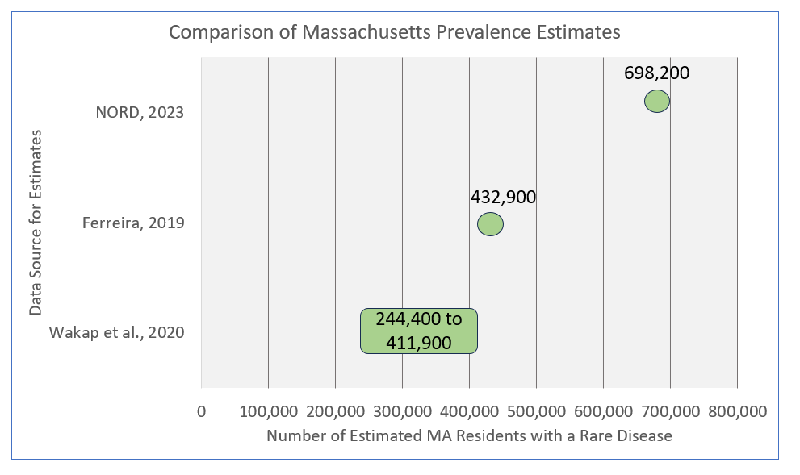
Table 1: Select MA Rare Disease Specific Prevalence Estimates Compared to State Projections
Disease | Estimated National Prevalence | Reported MA Prevalence | Comparison of Actual and Anticipated Prevalence
Spinal Muscular Atrophy (SMA) | 1 in 10,000 live births⁷  Estimated prevalence is between one and two per 100,000 people. | .44 in 10,000 live births  MA newborn screening study found 9 in 204,643 live births (January 2018-January 2021) ⁸ | Lower than expected
Sickle Cell Disease (SCD) | 45 in 100,000  138,923 patients (based on the birth cohort from 2005 to 2007)⁹ | 50 in 100,000  3,261 patients (based on the birth cohort from 2005 to 2007)⁹ | Higher than expected
Hemophilia | 1.6 to 23.3 per 100,000 males¹⁰ | 11.7 – 14.4 in 100,000 males¹⁰ | Overlap in the mid-range
Interpretation: Reliable Massachusetts state-specific rare disease estimates were difficult to identify for individual diagnoses. We found that for some diseases, MA data were reasonably close to national estimates. For others, there are challenges (as outlined above) in obtaining accurate direct counts or estimates. Nonetheless, on the whole, our working group felt that general population level estimates are adequate to project the total number of rare disease patients in MA.

Citations
- United States Census Bureau. Quick Facts. Washington, DC; July 1, 2022. Accessed July 15, 2023. https://www.census.gov/quickfacts/fact/table/MA/PST045222

- Ferreira CR. The burden of rare diseases. Am J Med Genet A. 2019;179(6):885-892. doi:10.1002/ajmg.a.61124

- Nguengang Wakap S, Lambert DM, Olry A, et al. Estimating cumulative point prevalence of rare diseases: analysis of the Orphanet database. Eur J Hum Genet EJHG. 2020;28(2):165-173. doi:10.1038/s41431-019-0508-0

- National Cancer Institute. About Rare Cancers. Washington, DC; February 27, 2019. Accessed February 22, 2023. https://www.cancer.gov/pediatric-adult-rare-tumor/rare-tumors/about-rare-cancers

- American Cancer Society. Cancer Facts & Figures 2023. Atlanta: American Cancer Society; 2023. https://www.cancer.org/research/cancer-facts-statistics/all-cancer-facts-figures/cancer-facts-figures-2023

- Aymé S, Bellet B, Rath A. Rare diseases in ICD11: making rare diseases visible in health information systems through appropriate coding. Orphanet J Rare Dis. 2015;10(1):35. doi:10.1186/s13023-015-0251-8

- Verhaart IEC, Robertson A, Wilson IJ, Aartsma-Rus A, Cameron S, Jones CC, Cook SF, Lochmüller H. Prevalence, incidence and carrier frequency of 5q-linked spinal muscular atrophy - a literature review. Orphanet J Rare Dis. 2017;12:124.

- Hale et al. (2021). Massachusetts’ Findings from Statewide Newborn Screening for Spinal Muscular Atrophy. Int J Neonatal Screen 7(2): 26.

- Hassell, K.L. Population Estimates of Sickle Cell Disease in the US. American Journal of Preventive Medicine, 2010. 38(4): p. S512-S521.

- Soucie JM, Miller CH, Dupervil B, Le B, Buckner TW. Occurrence rates of haemophilia among males in the United States based on surveillance conducted in specialized haemophilia treatment centres. Haemophilia. 2020 May;26(3):487-493. doi: 10.1111/hae.13998. Epub 2020 Apr 24. PMID: 32329553; PMCID: PMC8117262.

