Commonwealth of Massachusetts
Executive Office of Health and Human Services

Virtual Gateway



ESM Reports Guide
Winter 2008 R4v1

Table of Contents
Module 1: Getting Started 1
What is the Virtual Gateway? 1
What is the Virtual Gateway? 2
What is the Virtual Gateway? 3
System Requirements 3
Accessing the Virtual Gateway 4
Accessing the Virtual Gateway 5
Accessing Provider Services 6
Password Management 6
Password Management 7
Virtual Gateway Customer Service Information 8
Module 2: Introduction to EIM/ESM and EOM 9
What is EIM/ESM and EOM? 9
EIM Overview 10
ESM Overview 10
EOM Overview 10
Benefits of EIM/ESM and EOM 11
Module 3: EIM/ESM Navigation Basics 13
Introduction 13
Module Links 13
Additional Navigational Tools 14
Action Buttons 14
Page Characteristics 14
Page Characteristics 15
Module 4: Reporting 17
Key Terms 17
Accessing the Reporting Feature 17
Reports Catalog 18
Reports Catalog 19
Entering Report Criteria 20
Client Enrollment Status (DI) Sample Report 20
Client Enrollment Status (DI) Sample Report Results 21
Trouble -Shooting 22

Getting Started
Introduction | Enterprise Invoice Management/Enterprise System Management (EIM/ESM) is a web-based billing and service delivery reporting system for Purchase of Service (POS) providers and is one of the many services offered through the Virtual Gateway. Use of specific ESM report functionality is discussed in a later module.  This module discusses the following topics:  - What is the Virtual Gateway  - System Requirements  - Accessing the Virtual Gateway  - Accessing Provider Services (including EIM/ESM)  - Password Management  - Virtual Gateway Customer Service Information
What is the Virtual Gateway? | The Virtual Gateway is a single point on the internet for accessing programs and services offered by the Executive Office of Health and Human Services (EOHHS).  The goal of the Virtual Gateway is to streamline service access and coordinate service delivery. It serves three important groups:  - Internal Health and Human Services staff  - Service Provider staff  - Consumers  In addition to EIM/ESM, the Virtual Gateway also offers:  - Catalog of Services: An online catalog with descriptions of several of the most widely used programs in Health and Human Services.  - Screening & Referral: A short online survey for consumers and providers to determine potential eligibility for select EOHHS programs. Multiple services can be assessed at the same time.  - Common Intake: An online data collection tool for registered providers to create applications for multiple EOHHS programs on behalf of clients (login required).
What is the Virtual Gateway?  (continued) | - Transitional Assistance Gateway: An online inquiry tool for registered agencies to view secure case management information for various transitional assistance programs, including Food Stamps, financial assistance, and homeless services (login required).  - Provider Data Management: An online service that gives Purchase of Service (POS) providers a single place to view, upload and edit information commonly requested by Health and Human Services agencies. The service also provides EOHHS agencies with a single place to view provider information (login required).  - Service and Transition Planning: An online tool for registered EOHHS staff and providers to support collaborative treatment planning and referral services for certain children served by EOHHS (login required).  - IRIS Services for Deaf and Hard of Hearing Consumers: An online service for providers to request ASL interpreter or CART services on behalf of consumers; for ASL interpreters and CART reporters to post availability schedules, review and apply for open jobs (login required).  - Homeless Management Information Systems: The Homeless Management Information Systems (HMIS) perform data collection to capture information about citizens who experience being homeless over a period of time (login required).  - Mental Retardation Quality Management Reporting (HCSIS): A service for Purchase of Service providers, Department of Mental Retardation (DMR) staff, human rights coordinators, and others to file clinical information and reports on incidents, medication occurrences, restraints, and investigations for DMR clients (login required).  - Senior Information Management System (SIMS): An online data collection, case management, and reporting tool for Executive Office of Elderly Affairs (EOEA) agencies and providers. It enables users to track various programs for elders, including intake and referral, home care, nutrition, clinical assessments, and more (login required).
What is the Virtual Gateway?  (continued) | - Enterprise Invoice Management/Enterprise Service Management (EIM/ESM): Is a web-based billing and services reporting system for Purchase of Service (POS) providers. (login required).  - Enterprise Organization Management (EOM): Allows for administration of organization and staff information (login required).
System Requirements | System Requirements for EIM/ESM and the Virtual Gateway  All computers used to access the Virtual Gateway require Internet Explorer 6.0 or higher.  For the EIM/ESM application, the minimum system requirements are:  - Windows (98, 2000 or XP Business)  - Internet Explorer 6.0 or higher  - 800x600 screen resolution  - 300MHz CPU and 128MB RAM  Additionally, the preferred system features to enhance the performance of EIM/ESM are:  - Windows XP (Business Class)  - 1024x768 screen resolution  - 500MHz CPU and 256MB RAM  Acceptable Alternatives:  - Operating System  - Mac OS X  - Browsers:  - Safari (Mac)  - Firefox  - Netscape  Note: Testing on the EIM/ESM application has not been conducted on these alternative platforms therefore compatibility issues may result.  Tip: If a lower screen resolution is selected, then the user needs to select the “Smaller” text size.  - Select the View menu from the Internet Explorer browser.  - Select Text Size>>Smaller.
Accessing the Virtual Gateway | Access to EIM/ESM is through Virtual Gateway Provider Services. To Access Provider Services:  - Open an Internet Explorer session.  - Type the web address mass.gov/eohhs in your browser.  - Select  from ONLINE SERVICES box.  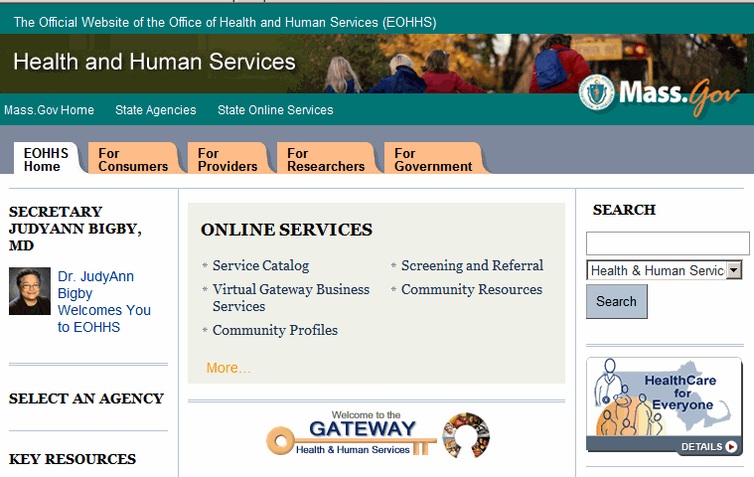  A Security Alert message appears.  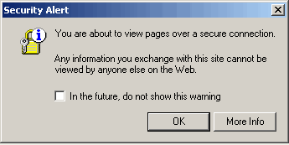  - Click OK.  Tip: Once you are in the Virtual Gateway, you must use the navigation tools that are part of the application not your internet browser’s Back and Forward () buttons.
Accessing the Virtual Gateway (continued) | You are directed to the Virtual Gateway Login page.  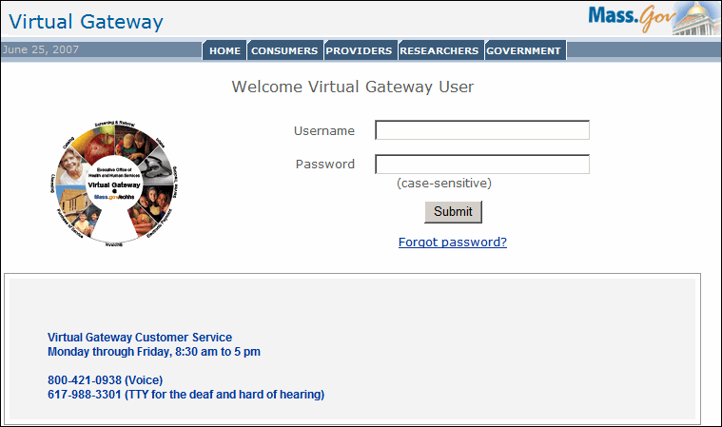  - Enter Username and Password.  - Click Submit.  The Virtual Gateway Business Services page displays.  Note: Security requires that each person have a Virtual Gateway username and password.
Accessing Provider Services | The Virtual Gateway Business Services page displays after you have successfully entered your username and password. You can select the service(s) you wish to access from this page. You can call the Virtual Gateway Customer Service if you need any assistance: 1-800-421-0938.  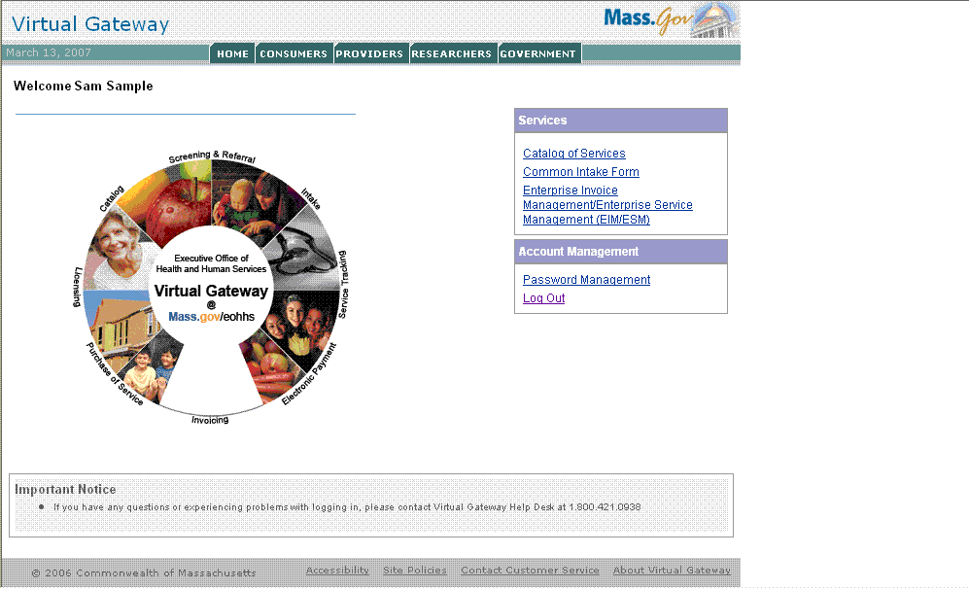  Note: Once you are logged in, you will have access to EIM/ESM.
Password Management | All users must change their password at first login.  After your initial login, you can change your password at any time by clicking on the Password Management link.  Password policy rules:  - The user will be assigned an ID and temporary password sent through e-mail by the Virtual Gateway Customer Service  - The password must contain between 8 and 12 characters and have at least 1 alpha and 1 numeric character  - Passwords are case-sensitive  - Users will be automatically logged out of the system after 30 minutes of inactivity  - EIM/ESM after 15 minutes of inactivity
Password Management  (continued) | 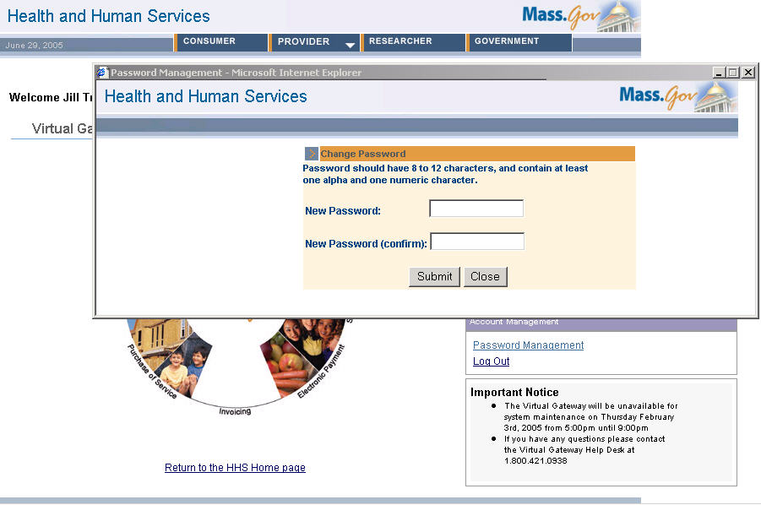  Important: You will need to disable any pop-up blocker in your browser to allow the change of password screen to appear. Contact your network administrator if you need assistance with this process.  Once you login, you can change your password.  To change your password:  - Access the Business Services page.  - Click the Password Management link.  The Change Password popup window appears.  - Type your new password twice.  - Click Submit.  - Click Close.

Virtual Gateway  Customer Service  Information | The Virtual Gateway Customer Service is available to assist with:  - General questions regarding the Virtual Gateway  - Technical questions or system issues  - Questions regarding how to use EIM/ESM  - Password resets  Please be prepared to provide the following:  - Name, organization, phone number, email address  - Module/page/field you were working on (if applicable)  - Description of the issue or error message  - Perceived criticality  You can reach the Virtual Gateway Customer Service at 1-(800)-421-0938 from 8:30 a.m. to 5 p.m. Please leave a voice mail if calling after hours.

Introduction to EIM/ESM and EOM
Introduction | The EIM/ESM service provides functionality for a variety of provider and agency users. These functions are presented as modules within EIM/ESM. Users have access to their required modules when logged into EIM/ESM. EOM service allows administrative staff to enter and update staff records.  The EIM/ESM and EOM service is available from 7 a.m. to 7 p.m.  This module discusses the following topics:  - What is EIM/ESM and EOM?  - EIM/ESM and EOM Overviews  - Benefits of EIM/ESM and EOM
What is EIM/ESM and  EOM? | Enterprise Invoice Management/Enterprise Service Management (EIM/ESM) is a web-based billing and service delivery reporting system for Purchase of Service (POS) providers.  Enterprise Invoice Management (EIM) is an EOHHS-wide invoicing application which coordinates billing and reporting across POS programs, agencies, and providers.  Enterprise Service Management (ESM) supports providers contracted through the Department of Public Health (DPH) with a client management and service tracking tool. ESM fully integrates and coordinates delivery and administration of care across DPH programs, bureaus, and providers.  Enterprise Organization Management (EOM) allows for administration of organization and staff information.  This guide focuses on reports functionality available in ESM. Additional information about EIM/ESM can be found under the Provider tab of the EOHHS web page: www.mass.gov/eohhs.
EIM Overview | EIM (Enterprise Invoice Management) integrates invoicing and payment across EOHHS agencies.  Invoices:  - Are generated and submitted by providers through EIM  - Are automatically adjudicated within EIM  - Adjudication results can be viewed in EIM  PRC (Payment Request for Commodity):  - Are generated within EIM  - Can be tracked through EIM
ESM Overview | ESM (Enterprise Service Management) enables provider organizations to maintain their client roster, program enrollments, service plans, case management plans, and encounter documentation.  Client Management:  - Provides program-specific electronic applications  - Maintains client information  - Determines eligibility  - Enrolls clients  - Offers configurable assessments  Service Management:  - Generates individual client service plans  - Offers configurable assessments  - Manages authorizations, when required  - Offers service planning and case management  Note: Initially, ESM will be deployed for DPH programs only.
EOM Overview | EOM (Enterprise Organization Management) enables provider and government organizations to maintain their related information such as addresses and identifiers.
Benefits of EIM/ESM and  EOM | How does the EIM/ESM service benefit providers?  - Simplifies reporting and invoicing for purchased services  - Enables providers to track invoices through the adjudication and payment process, providing information about status, adjustments, date of payment, etc.  - Provides unprecedented enterprise reporting capabilities to provider organizations as well as agencies  What are the benefits of EIM?  - Provides expedited payment  - Provides real-time payment processing  - Offers access to up-to-date financial data  What are the benefits of ESM?  - Provides access to dynamic data collection and reporting  - Provides online, client-based enrollment  - Enhances referral throughout treatment episode  What are the benefits of EOM?  - Offers visibility into the structure of organizations and the ability to create multiple levels (sub-organizations) when appropriate  - Provides online access for maintaining staff and their associations with one or more organizations

Notes:

EIM/ESM Navigation Basics
Introduction | Navigation is simple and consistent throughout each module in EIM/ESM. The topics in this module will help you:  - Understand the modular structure of EIM/ESM  - Navigate through each module  - Search for records  - Identify additional navigational tools
Module Links | When a user logs into EIM/ESM, the module links are immediately available at the top of the page.  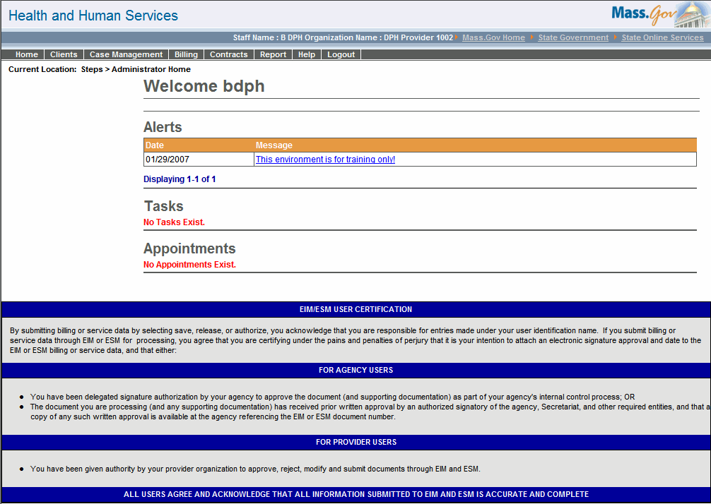  Each module link corresponds with a functional area: the Clients module provides access to eligibility and enrollment functions, the Report module provides access to reports, etc.  Clicking a module link navigates you to the corresponding features.

Additional Navigational Tools | You can use the following features to navigate through EIM/ESM.
Action Buttons | These buttons are used to inform the system to perform a function such as saving data, opening a new page, or performing a search.
Page Characteristics | The look and feel of EIM/ESM is intended to ensure the pages are user-friendly.  The following table contains page characteristics with a graphic example.

Required Fields  These fields must be entered before the system can perform an action such as save new data or perform a calculation. Required fields are identified on each page with a red asterisk (*) to the left of the field name. If required fields are not populated appropriately, an error message is presented to the user. | 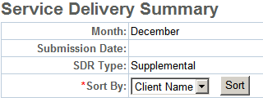
Optional Fields  These are fields where only policy and procedures dictate that the field needs to be populated. The system will allow these fields to remain empty. | 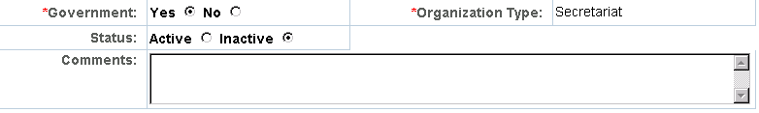

Page Characteristics
(continued)

Calendar Buttons  These buttons appear to the right of date fields. By clicking the calendar button the current month calendar opens. You can use your mouse to select days in the current month or navigate to other months or years. | 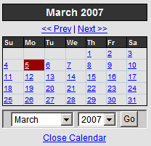
Radio Buttons
These buttons allow you to make a selection where you are limited to only one choice. Radio buttons can be selected using the mouse or the space bar.
Pick Lists  These fields allow you to click the arrow and select a single choice from an available list of previously entered options. Or you can type the first letter or number you are looking for and the system automatically reduces the list to the beginning letter or number you type. | 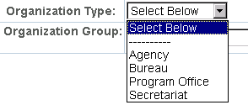

Notes:

Reporting
Introduction | Typically, reports are generated by an authorized user who chooses report content and format as part of submitting a reporting request.
Key Terms | The following terms will help in understanding how reports function:  - Service Management Reports:  Reports related to ESM functionality  - Report Selection Criteria:  Parameters/filters a provider enters when requesting a report  - Report Output Format:  Reports can be created as Excel or PDF files  - Report Frequency:  Reports in EIM/ESM are scheduled on-demand
Accessing the Reporting Feature | To access the reporting feature of EIM/ESM: Access the Reports module. A list of Service Management reports appear.  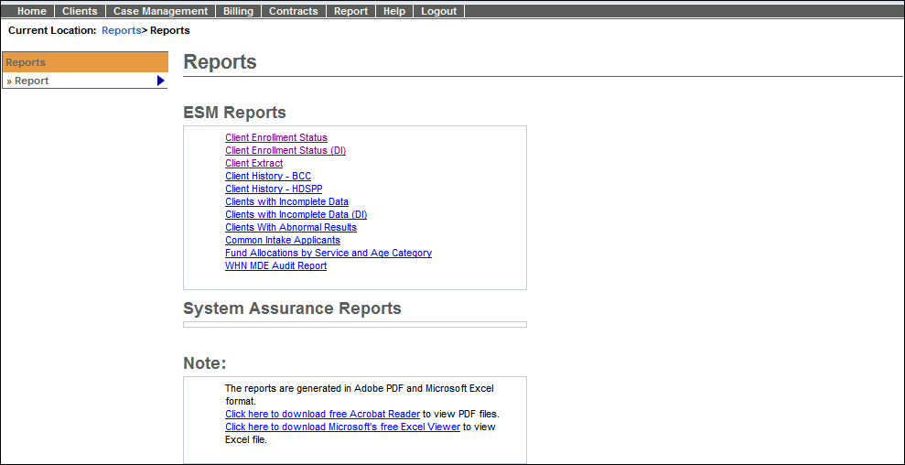  Note: Access to reports is based on user security roles. Your page may look slightly different.

Reports  Catalog | The table below lists the reports available in EIM/ESM. Depending on your user security role, not all reports listed here may be relevant to the program you are working with.

Report Name | Purpose
Aggregate Diagnosis Report (SBHC) | Provides a listing of the top 50 diagnoses made at a given site in a given period.
Aggregate Enrollment Status Report (SBHC) | Provides a copy of the new unique client enrollments per site per month for the selected year.
Aggregate Service Report (SBHC) | Provides a listing of the top 50 services delivered at a given site in a given period.
Client Extract Report | Provides contact and demographic information for a selected client population for the purpose of contacting the client.
Client Enrollment Status Report | Provides a list of clients enrolled within some specified timeframe. Can be used to identify clients that have been enrolled that have not received services, to confirm enrollments, to identify clients that have disenrolled and referred to another program (activity) and to assess organization capacity usage.
Client Enrollment Status Report - DI (BSAS) | Provides a list of clients enrolled within some specified timeframe. This version of the report without client identification information is to be used by BSAS agency users.
Clients with Abnormal Results | Identifies clients with abnormal test results that require monitoring or follow-up.
Client with Incomplete Data | Provides a list of active clients missing information. The purpose of this report is to provide a summary report of clients where data is missing such as missing Assessments (input parameters might include: Program/Activity and Assessment Name – multi-select).

Reports
Catalog
(continued)

Report Name | Purpose
Client With Incomplete Data - DI (BSAS) | Provides a list of active clients that are missing information.  This version of the report without client identification information is to be used by BSAS agency users.
Common Intake Applicant Report | Identifies clients that have been processed through common intake. Provides a list of applicants processed through common intake for a specific program.
Client History - BCC | Shows the full clinical history of services received and paid, funding sources, results, diagnosis, and treatment information for selected client/s. This report format will be used with site visit criteria to generate site visit client history as well.
Client History - HDSPP | Shows the full clinical history of services received and paid, funding sources, results, diagnosis, and treatment information for selected client/s. This report format will be used with Site visit criteria to generate site visit client history as well.
Diagnosis Report (SBHC) | Provides a copy of the enrolled individuals associated with a selected diagnosis.
Encounter Status Report (SBHC) | Provides a copy of the unique daily encounters per site for each month of the selected year.
Fund Allocations by Service and Age Category (Fund Allocation Report) | Analyzes fund allocations by service and age categories. The CDC requires monitoring performance against guidelines based on Age and Service Category.
Services Not Associated With a Claim or Have an Error | Provides a list of services that are in draft or ready state that have not been associated with a claim or services that have been rejected.

Entering Report Criteria | Criteria selection tailors report results. By entering criteria, a user can determine the details and grouping of the report data. Criteria include dates, activity, locations, and contract numbers.  To enter criteria and run a report:  - Access the Reports module.  A list of Service Management reports appear.  - Click the name of the individual report link.  A Report Criteria page appears.  Note: The Report Criteria page will differ depending upon the specific report being requested.  - Enter criteria.  - Select a Report Format (PDF is the default). Report criteria are not always printed on reports. Users may find it helpful to record criteria manually.  - Click .  The report opens in a new window.  - Click File from the menu at the top of the page, select Save As for Excel file or Save a Copy for PDF.  - Navigate to the desired location; enter a title in the File Name field and click .
Client Enrollment Status (DI) Sample Report | 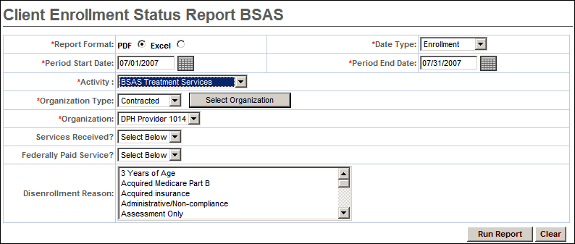

Client Enrollment Status (DI) Sample Report Results | 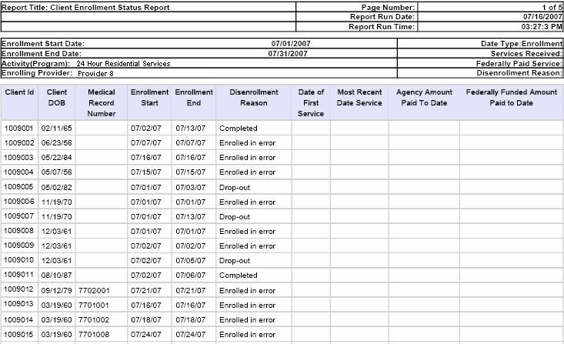

Trouble -Shooting | Listed below are some of the most commonly asked questions about running reports in EIM/ESM.

Problem | Possible solutions
Why am I not getting the results I expected? | - Double-check that criteria filters are correct  - Consider user security
Why doesn’t this match my legacy reports? | - Double-check that criteria filters are correct
Why does my computer stall when I try to run certain reports? | - Check your report parameters (dates, contract numbers etc). It may be the parameters you specified returned no results. Sometimes, when the system is trying to return an 'empty' report, it stalls. This does not happen every time when there are no results returned. If the system is unresponsive after five minutes, close any unresponsive windows.  - Reports do not run directly off the EIM/ESM service. They run from a separate database that is regularly refreshed with EIM/ESM information. The time delay for this replication is about 20 minutes, so if you just entered information into EIM/ESM, you would not be able to report on it until about 20 minutes later.
When I alert customer service about reports not running or taking too long to run, what information should I provide? | - Make a note of the report name and the date and time you attempted to run it.  - Provide the input parameters you used (contract number, vendor name, etc.) and how long you waited before the report timed out or you halted your efforts. If an error message appears on the screen, make a note of that as well.
Notes:

