Reports | Reports
Accessing a Report:  - Select the Reports module.  The Reports page appears with a list of Financial (EIM) and Service (ESM) Management reports.  Tip: Access to reports is based on user security roles. Your page may look slightly different.  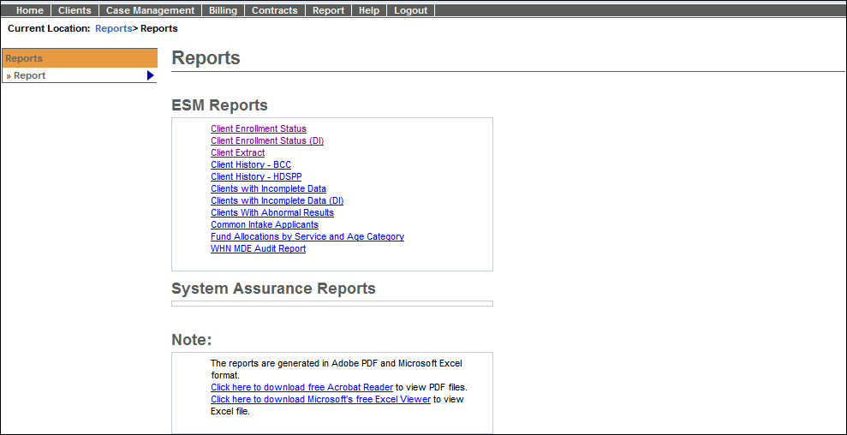  - Click the name of the individual report link.  A Report Criteria page appears. | Entering Report Parameters:  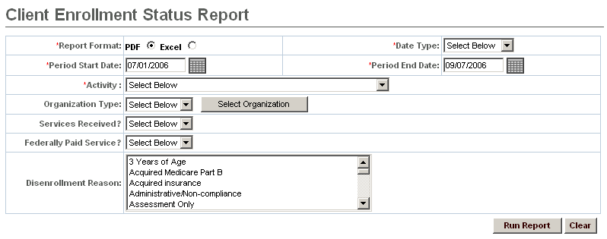  - Enter your report criteria. (Fields denoted with * are required.)  - Select a Report Format (PDF is the default). Report criteria are not always printed on reports. Users may find it helpful to record criteria manually.  - Click .  The report opens in a new window.  - Click File from the menu at the top of the page, select Save As for Excel file or Save a Copy for PDF.  - Navigate to the desired location; enter a title in the File Name field and click .  Tip: If you want to clear report criteria that you have entered, click .

Trouble-Shooting
Problem | Possible solutions
Why am I not getting the results I expected? | - Double-check that criteria filters are correct  - Consider user security
Why doesn’t this match my legacy reports? | - Double-check that criteria filters are correct
Why does my computer stall when I try to run certain reports? | - Check your report parameters (dates, contract numbers etc). It may be the parameters you specified returned no results. Sometimes, when the system is trying to return an 'empty' report, it stalls. This does not happen every time when there are no results returned. If the system is unresponsive after five minutes, close any unresponsive windows.  - Reports do not run directly off the EIM/ESM service. They run from a separate database that is regularly refreshed with EIM/ESM information. The time delay for this replication is about 20 minutes, so if you just entered information into EIM/ESM, you would not be able to report on it until about 20 minutes later.
When I alert customer service about reports not running or taking too long to run, what information should I provide? | - Make a note of the report name and the date and time you attempted to run it.  - Provide the input parameters you used (contract number, vendor name, etc.) and how long you waited before the report timed out or you halted your efforts. If an error message appears on the screen, make a note of that as well.
For system and access questions call:
Virtual Gateway Customer Service (www.Mass.Gov/vg) : 1-800-421-0938

For program policy or data forms questions call:
DPH Resource Center : 1-800-232-0093

