Table of Contents
Overview of the Report Module 1
Selecting Report and Entering Report Parameters 2
Search/Edit Schedule 3
Searching for and Viewing Scheduled Reports 5

Overview of the Report Module
EIM/ESM Reports allow users the …
Ability to process report requests in the background:
- EIM/ESM allows users the ability to run reports asynchronously, permitting access to other functionalities while the report generation process is in progress. The designated report results will no longer automatically display in a separate tab, and users can review the results for an extended period. Reports results will be stored on the system and purged periodically.
Ability to send out key reports as email attachment
- EIM/ESM allows users to send out EIM/ESM reports as an attachment to an individual or group of email addresses.
- The Report Parameter page for key reports has been enhanced to include the following new fields - Email Address (up to the maximum of 10 email addresses) and Run Report & Send Email. The ‘Run Report & Send Email’ feature will execute the report processing and send out the report (or a completion notification) as an email attachment to the specified recipients.
- In order to maintain a strict standard of confidentiality, reports containing client names will not be sent from EIM/ESM via email. Authorized users will have to log into the application to review the report content after which they will have the opportunity to download or securely store the information in accordance with their organization’s practices.
- In cases where the size of the email exceeds Commonwealth system limits, an email notification that the report is ready for viewing will be sent instead.
Ability to schedule key reports
- The EIM/ESM system will allow users to schedule select reports to be delivered at a later date/time.
- The Report page for key reports has been enhanced to include the following new button – Schedule Report. Users can schedule reports to be run Daily, Weekly By Day of Week or By Date of Month.
The features noted above only apply to the following EIM/ESM reports:
- HIPAA Claim Status Report
- Payment Detail by Client Report (including de-identified version)
- Payment Detail Report by Bed Days (including de-identified version)
- Client Enrollment Status (including de-identified version)
- Cost Reimbursement Invoice
- Cost Reimbursement Expenditure Analysis
- CIES Budgeting Report
- Payment Tracking Report
All the other EIM/ESM Reports will continue to function as they do currently.

Selecting Report and Entering Report Parameters
- Select the [Reports] module.
Figure 1: Image of the EIM/ESM Module bar.
- From the Reports page, select the applicable report from the list.
Tip: Access to reports is based on user security roles. Your page may look slightly different.
This job aid will walk users through how to run the Payment Tracking Report.
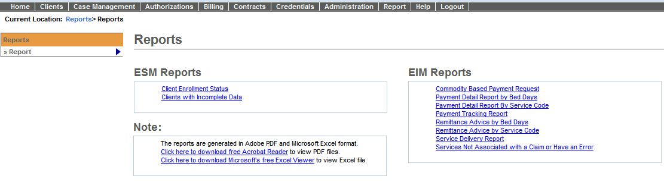
Figure 2: Image of the EIM/ESM Reports page.
- Using the Filter field, type in the entire or partial Contract Number. (See example in screen capture below.) You can search for a contract using the Filter field. The wildcard (%) symbol can also be used.
- Select the [Filter] button.
- Select the [*Contract Number] from the drop-down menu. (The Contract Number drop-down menu will only display contract numbers that meet the filtered criteria.)
- Optional field: Select the [Invoice/SDR Reference Number] from the drop-down menu. **
** Note: This field is optional and will only contain data if entered when the Invoice/SDR was in a Draft status in EIM.
- Select [*Report Format]. Defaults to PDF format.
- Optional field: If report results need to be emailed to recipients; select the Email Address field and type in the email addresses.
Note: Up to 10 email addresses can be added and each email address must be separated with a comma.
- Optional field: Report Comments can be added.
- Users now have options on how they can run certain reports in EIM/ESM:
- Run Report: A report can be run and viewed during logged in session.
- Run Report & Send Email: The selected report will be run and the results emailed to listed recipients. User can continue to use other functions of EIM/ESM while the report is being run and emailed.
- Schedule Report: EIM/ESM allows users to choose various patterns in which a report needs to be scheduled, in order to be delivered on a later date/time.
- The schedule type can be ‘Daily’, ‘Weekly – By Day of Week’ or ‘By Date of Month’.
Note: The Clear button clears all criteria on page.
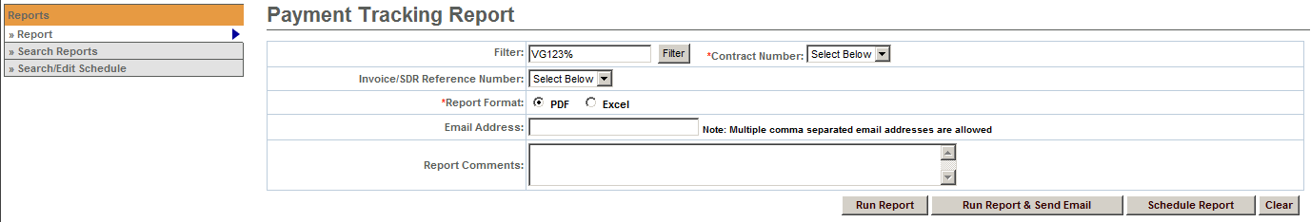
Figure 3: Example of Running a Report in EIM/ESM. This image is displaying the criteria needed to run the Payment Tracking Report.
If a user selects the option of Schedule Report, additional fields that must be completed in order for the selected report to run.
- Enter the Start Date or use the Calendar icon to select date.
- Enter the End Date or use the Calendar icon to select date.
- Select the Pattern: Daily, Weekly – By Day of Week, or By Date of Month.
- When Weekly – By Day of Week is selected as the Pattern, the user must specify the days of the week on which they want to schedule the report to run. This field is mandatory if the Pattern selected is ‘Weekly – By Day of Week’.
- When By Date of Month is selected as the Pattern, the user needs to select 29, 30 or 31 from ‘Date of Month’ dropdown menu. Note: EIM/ESM will consider the last day of the month, if a month does not have 29, 30 or 31 days. This field is mandatory if the Pattern selected is ‘By Date of Month’.
- Select the Save Schedule button.
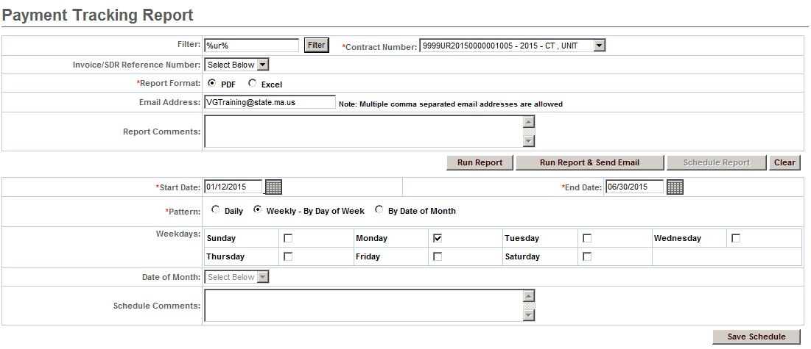
Figure 4: Example of Scheduling a Report to be run in EIM/ESM. This image is displaying the criteria needed to run the Payment Tracking Report.

Search/Edit Schedule
EIM/ESM offers users the ability to search, edit or delete existing schedules that were previously saved.
The ‘Search/Edit Schedule’ is located on the left navigation of all the screens within the Report module.
- Using the Filter field, type in the entire or partial Contract Number. (The wildcard (%) symbol can also be used.)
- Select the [Filter] button.
- Select the [Report Name] from the drop-down menu.
- Enter the [*Schedule Effective From].
- Enter the [*Schedule Effective To].
- Select the [Search Schedule] button.
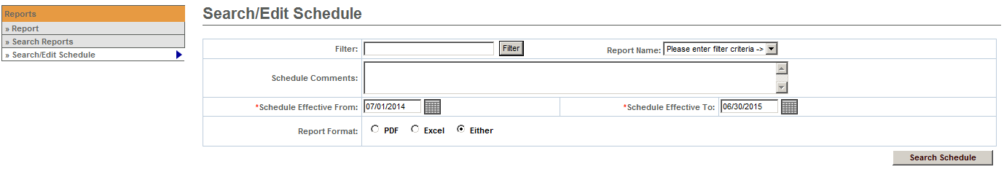
Figure 5: This is an image of the Search/Edit Schedule page.
To Edit an Existing Schedule
- From the Search Results, select the schedule that needs to be edited.
- Select the [Edit] button.
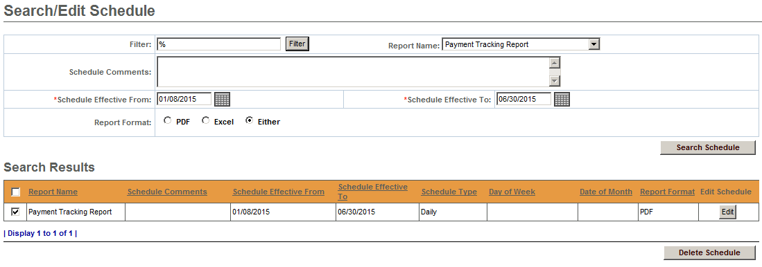
Figure 6: This is an image of the Search Results on the Search/Edit Schedule page.
- The system will display the current/existing schedule.
- The user should update the schedule as applicable
- Select the [Save Schedule] button.
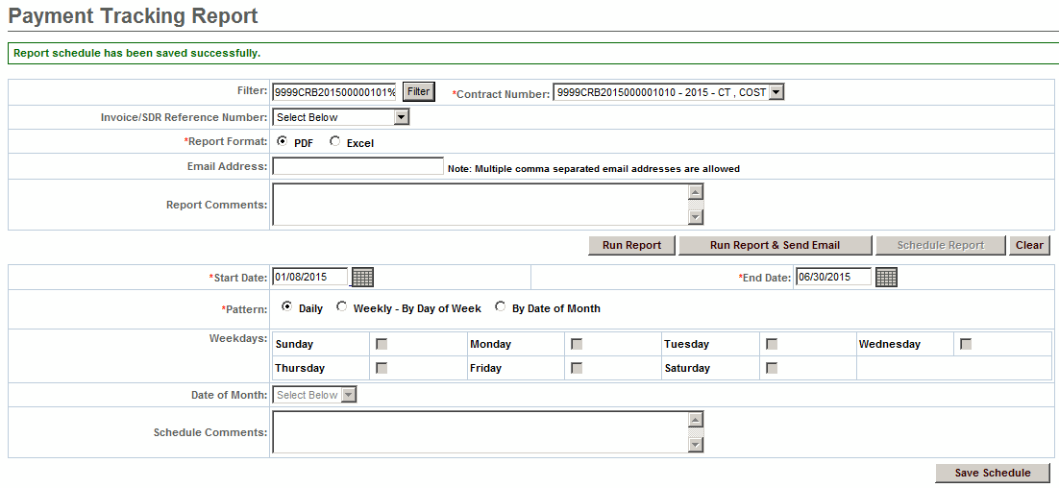
Figure 7: This is an image of the message displayed when you successfully schedule a report to be run at a late time: Report schedule has been saved successfully.
To Delete a Schedule
- From the Search Results, select the schedule that needs to be deleted.
- Select the [Delete Schedule] button.
The following message will appear: Are you sure you want to delete these records? Please click "Confirm Delete" to delete the record or "Cancel Delete" to cancel the operation.
- Select [Confirm Delete] or [Cancel Delete].
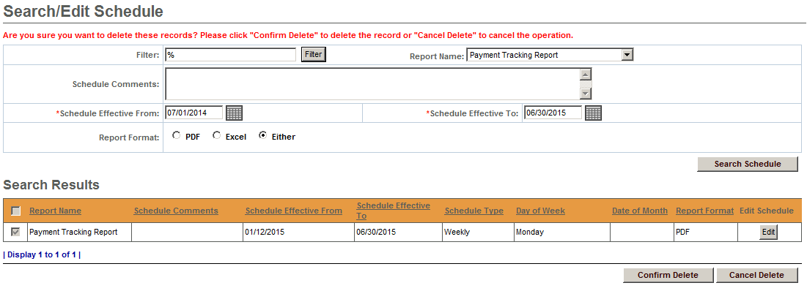
Figure 8: This is an image of the message that appears when you are deleting a schedule from the Search/Edit Schedule page: Are you sure you want to delete these records? Please click "Confirm Delete" to delete the record or "Cancel Delete" to cancel the operation.

Searching for and Viewing Scheduled Reports
Users can input parameters to search for requested reports to view the report status (Success, In progress or Error), to view the report itself or to delete a specific report. Users will have access to only the reports they requested for.
Searching for Scheduled Reports
- Select [Search Reports] link from the left navigation menu.
- Using the Filter field, type in the entire or partial Report Name. (The wildcard (%) symbol can also be used.)
- Select the [Filter] button.
- Select the [Report Name] from the drop-down menu.
- Optional field: Report Comments: The field allows a user to search for any generated Report based on the Report comment specified during generation of the Report (on the Report Parameter screen). There will be a limitation of 200 characters for this field.
Example: Payment Tracking Report for the contract “Contract2014” might have a Report comment as “PTRreportforContract2014 generated on 08012014”.
- The Status options are: Error, Success, In Progress.
- Enter in the [Report Generated Date From].
- Enter in the [Report Generated Date To].
- Select the [Report Format]. The options are “PDF”,”Excel” or “Either”. The default selection of this field is ‘Either’.
- Select the [Search Reports] button. Note: Only top 100 search results will be retrieved based on the search parameters.
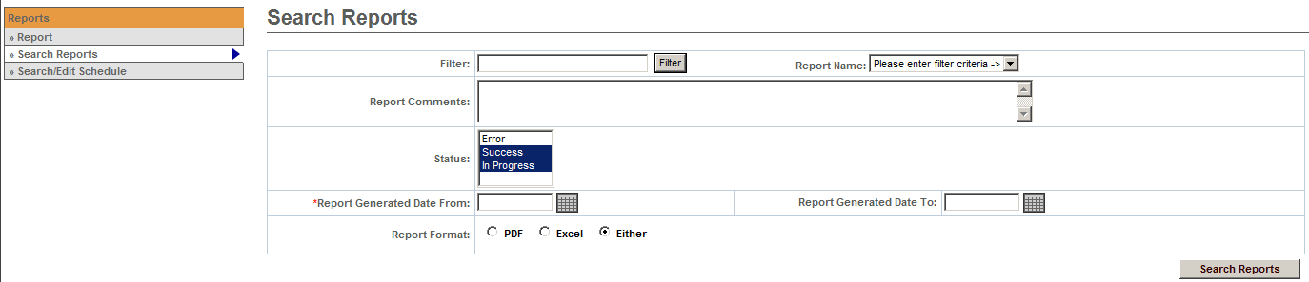
Figure 9: This is an image of the Search Reports page.
Viewing Results
The results, based off of the searched criteria, will display under the Search Results. Users can access the report data by either :
- Selecting the Checkbox next to the Report Name link
- Select the [View/Download Reports] button.
OR
- Selecting the [Report Name] link.
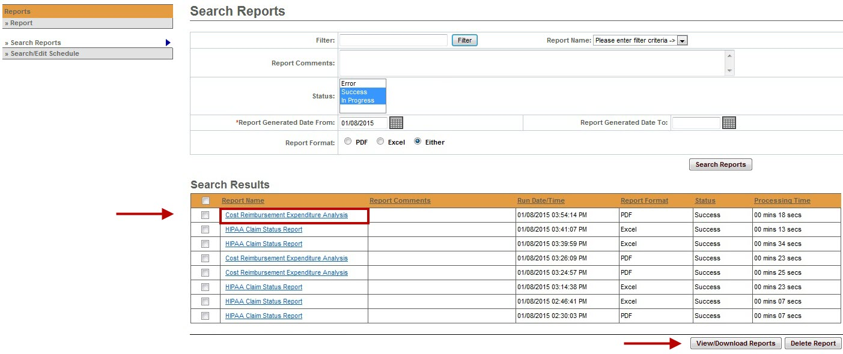
Figure 10: This is an example of the Search Reports page with Search Results displayed.
Delete Report
A report can also be deleted, if desired, by selecting the [Report Name] to be deleted and then selecting the [Delete Report] button.
Questions or need assistance? Call Virtual Gateway Customer Service
1-800-421-0938 (617-988-3301 - TTY for the deaf and hard of hearing)
8:30 am to 5:00 pm Monday through Friday

