April 6, 2020

Via E-Mail

Margo Michaels, MPH
Director, Determination of Need Program Department of Public Health
250 Washington Street
Boston, MA 02511

Re: Partners HealthCare System, Inc. –Notification to Open and License a Hospital Inpatient Bed Satellite Related to COVID-19

Dear Ms. Michaels:

Pursuant to the Order of the Commissioner of Public Health Regarding Determination of Need Approvals Related to COVID-19, issued on March 24, 2020, Spaulding Hospital for Continuing Medical Care Cambridge (“Hospital”) respectfully requests the Department of Public Health (“DPH”) to approve the Hospital to establish an inpatient satellite/campus at the Boston Convention and Exhibition Center located at 415 Summer Street, Boston MA 02210 (“BCEC”), to address the needs of the Commonwealth in response to the outbreak of COVID-19 (“Proposed Project”).

On March 10, 2020, Governor Baker declared a State of Emergency in response to an outbreak of the novel coronavirus 2019 (“COVID-19”). 1 As of April 3, 2020, Massachusetts has 10,402 COVID-19 Positive Patients.2 There have been 966 hospitalizations and 192 deaths due to the virus. The Commonwealth seeks to establish a field hospital to provide care related to COVID-19 to ensure there is available inpatient bed capacity in the Boston area due to the expected surge of cases in the coming weeks. As the Hospital has the ability and expertise to care for these patients, it seeks to establish a satellite of the Hospital consisting of up to 500 inpatient beds at the BCEC.

The cost associated with the Proposed Project is unknown at this time. The Applicant will provide this information when it becomes available.

By submitting this request, the Applicant hereby attests that the Proposed Project is intended for use in the management and treatment of the COVID-19 virus. In addition, please see Attachment A for an affidavit signed by the Applicant’s CEO.

1 Exec. Order No. 591: Declaration of a State of Emergency to Respond to COVID-19 (Mar. 10, 2020), https://www.mass.gov/executive-orders/no-591-declaration-of-a-state-of-emergency-to-respond-to-covid-19.
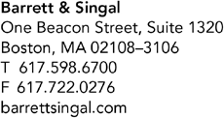2 COVID-19 Cases in Massachusetts, MASS.GOV, at https://www.mass.gov/doc/covid-19-cases-in-massachusetts-as-of- april-3-2020/download updated Mar. 4, 2020).

Margo Michaels, MPH
Director, Determination of Need Program Department of Public Health
April 6, 2020
Page 2

We thank you for your attention to this matter. Please contact me or Crystal Bloom, Esq. if you have any questions or require any additional information.
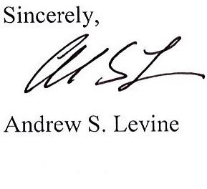
Enclosure

cc: Laura Peabody, Esq.
Rebecca Rodman, Esq.

Attachment A

Pursuant to the Order of the Commissioner of Public Health Regarding Determination of Need Approvals Related to COVID-19 , dated March 24, 2020, and the Memorandum from Margo Michaels, Director of the Determination of Need Program, dated March 24, 2020, providing guidance on requesting Determination of Need ("DoN") approval for projects related to COVID-19 during the State of Emergency, I, Maureen Banks, President of Spaulding Hospital for Continuing Medical Care Cambridge, hereby submits this notification under the pains and penalties of perjury.

Date:
/
<signature on file>

Maureen Banks, DNP, President
Spaulding Hospital for Continuing Medical Care Cambridge

