 | Massachusetts Department of Environmental Protection  Bureau of Resource Protection – Drinking Water Program  Request for a Waiver from the Requirement for a Chemical Analyzer  under the Chemical Safety Control Strategy for Critical Chemical Feed Systems  (In accordance with Chapter 111, Section 160, and Section 6.1.3.1 of the Chemical Safety Control Strategy for Critical Chemical Feed Systems, contained in Chapter 6 of the Guidelines and Policies for Public Water Systems)
 | PWS Information
Important: When filling out forms on the computer, use only the tab key to move your cursor - do not use the return key.  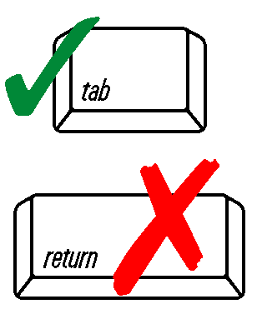 | City/Town
 | PWS Name |  | PWS ID #
 | PWS Classification
 | Type of Waiver Requested
 | Adequate Dilution – An analyzer may not be needed if it can be demonstrated that there is adequate dilution to insure that the PWS cannot overfeed a critical chemical at a dosage above the critical level. Examples of this condition include systems with the required electrical and flow based interlocks that discharge from small day tanks; that have large downstream storage tanks; or use dilute chemical mixtures.
 | Limited Chemical Feed Pump Capacity – An analyzer may not be needed if it can be demonstrated that the capacity of the chemical feed pump is not capable of feeding chemicals at a dose over the critical limits. An example of this condition is a chemical feed pump with the required electrical and flow-based interlocks that cannot pump at a dose over the specified limits under its maximum pumping capacity and lowest demand flow.
 | Limited Population Served – TNC, NTNC or VSS with the required electrical and flow based interlocks and that collect a grab sample at least once per day.
 | Required Documentation
Check appropriate box and attach the following documentation, if applicable:
(Note: Operations & Maintenance Plan required for all systems.)
 | An Operation and Maintenance Plan that mitigates the risk of an accidental overfeed by including the following:
 | - maintenance schedule that meets the manufacturer’s recommendations,
 | - sampling plan to measure at least once per day the chemical dose entering the system,
 | - description of the electrical and flow based interlocks, and
 | - description of testing procedures which includes monthly testing to verify that the interlocks work properly
 | Calculations that demonstrate the maximum dosage entering the distribution system cannot exceed the specified limits. (Note: This is not applicable for waivers requested based on limited population served.)
 | Certified Operator Certification
 | I certify under penalties of law that the required electrical and flow-based interlocks are installed and operational to prevent an overfeed of chemical to the drinking water system.
 | Name |  | Grade
 | Treatment License Grade | License Number
 | Signature of Certified Operator
 | Owner’s Certification
 | I certify under penalties of law that the information I have provided pursuant to this request is truthful and accurate.
 | Name |  | Date
 | Signature of Owner

