 | Massachusetts Department of Environmental Protection  Bureau of Resource Protection – Drinking Water Program  Request for Public Water System Authorization to Delegate, Sub-delegate, Contract, or Sub-contract Cross Connection Surveyors Responsibilities
 | Public water systems (PWS) requesting authorization to delegate, or sub-delegate, contract, or subcontract the review and approval of design data sheets and plans for proposed new installations of reduced pressure backflow preventers and double check valve assemblies must complete this form in its entirety to satisfy the requirements of 310 CMR 22.22(3)(q).
 | 1. Public Water System (PWS) Information
Important: When filling out forms on the computer, use only the tab key to move your cursor - do not use the return key.  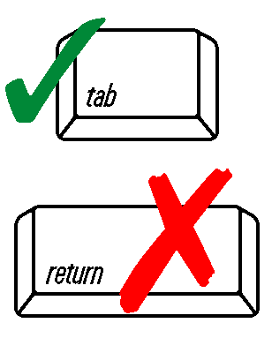 | PWS Name |  |  | PWS ID #
 | City/Town
 | The above named public water system requests the authorization to delegate, or sub-delegate, contract or subcontract the responsibilities for the review and approval of the design data sheet and plans for the installation of backflow prevention devices for the protection of cross connections. In approving any such contract arrangement, the Department requires that all recommendations or findings made by the contracted certified surveyor, when reviewing and approving data sheets and plans, be submitted on the public water system letterhead and signed by an authorized person of the public water system.
 | 2. Cross Connection Control Program Contracted Certified Surveyor
 | The services of the Massachusetts Certified Cross-connection Surveyor named below will be retained by the public water system to review and approve the design data sheet and plans for the installation of backflow prevention devices for the protection of cross connections as specified at 310 CMR 22.22(3)(q).
 | Certified Surveyor Name | Company Name
 | Street Address
 | City | State |  | Zip Code
 | Phone Number | Cell Phone Number
 | Email (optional) | Fax Number (if available)
 | MassDEP Surveyor Certificate Number | Expiration Date
 | Certification
 | I certify under penalties of law that this document and that the information contained herein is true, accurate and complete to the best of my knowledge and belief. The public water system understands that this completed form will be incorporated into its cross connection control program plan as previously approved by the Department.
 | PWS Owner Signature |  | Date
 | Print Name | Title
 | Phone # | Email
 | MassDEP Use Only:
 | Reviewed by: (Print Name) | Title
 | Received on (Date) | Approved on (Date)
 | Comments

