The Commonwealth of Massachusetts

executive office of energy & environmental Affairs

department of environmental protection

ONE HUNDRED CAMBRIDGE STREET, SUITE 900, BOSTON, MA 02114

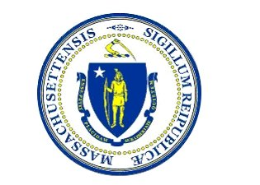

Request for Response (RFR)

SFY26 Natural Resource Area Nitrogen Sensitive Area (NRNSA)

Grant Program

Request for Responses

Agency Document Number: BWR-NSA-01

September 12, 2025

**This information is available in alternate format.**

**Please contact MassDEP at 617-292-5500  
TTY# MassRelay Service 1-800-439-2370  
MassDEP Website: www.mass.gov/dep**

SFY26 NRNSA GRANT RFR

# FY26 NRNSA GRANT

Grant Summary 1

1. GRANT OPPORTUNITY SUMMARY: 2

A. Proposals Sought 2

B. Overview and Goals 2

**C.** Disadvantaged Communities 3

D. Eligible Entities 4

E. Eligible Projects 4

F. Application Deadline 6

G. Page Limit 6

H. Funding Availability 6

I. Match and Other Funding Obligations 6

J. Pre-Application Meeting 6

K. Written Questions via the Grant Q&A Process 7

L. Amendment Deadline 7

M. Total Anticipated Duration of Grant(s) 7

N. Required Documentation 8

O. Applicable Procurement Law 8

2. INSTRUCTIONS FOR APPLICATION SUBMISSION: 8

A. Evaluation Criteria (general) 8

B. Application Completion and Submission Instructions 9

C. Additional Required Documentation: 10

3. ESTIMATED CALENDAR FOR GRANT APPLICATION/AWARD: 11

ATTACHMENT A A-1

ATTACHMENT B B-1

100 Cambridge Street Suite 900 Boston Massachusetts 02114 Telephone 617-292-5500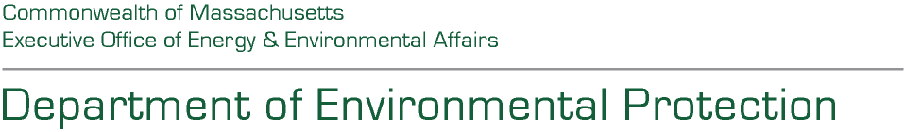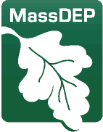

Maura T. Healey, Governor Kimberley Driscoll, Lieutenant Governor

Rebecca L. Tepper, Secretary Bonnie Heiple, Commissioner

SFY26 Natural Resource Area – Nitrogen Sensitive Area Grant Program

**Request for Responses**

# Grant Summary

**Total Funding Available:** Up to $830,000

**Estimated Grant Amounts:** $20,000 to $350,000 per applicant

**Pre-Application Meeting:** September 18, 2025 at 1:00 p.m.

**Responses Due:** October 14, 2025 by 5:00 p.m.

**Match Required:** No, but recommended

**Eligible Entities:** “Local Government Units” with an NRNSA designated watershed

**Sample Eligible Projects:** planning activities that contribute to, or come from, a Watershed Management Plan (WMP), a Comprehensive Wastewater Management Plan (CWMP), a Comprehensive Water Resource Management Plan (CWRMP), a Targeted Watershed Plan (TWMP), Watershed Permit application or De Minimis Load application.

**Note: “**Local Government Units” (LGU) are any town, city, district, county, commission, agency, authority, board or other instrumentality of the commonwealth or of any of its political subdivisions, including any Local Government Unit (314 CMR 21.02).

# GRANT OPPORTUNITY SUMMARY:

## Proposals Sought

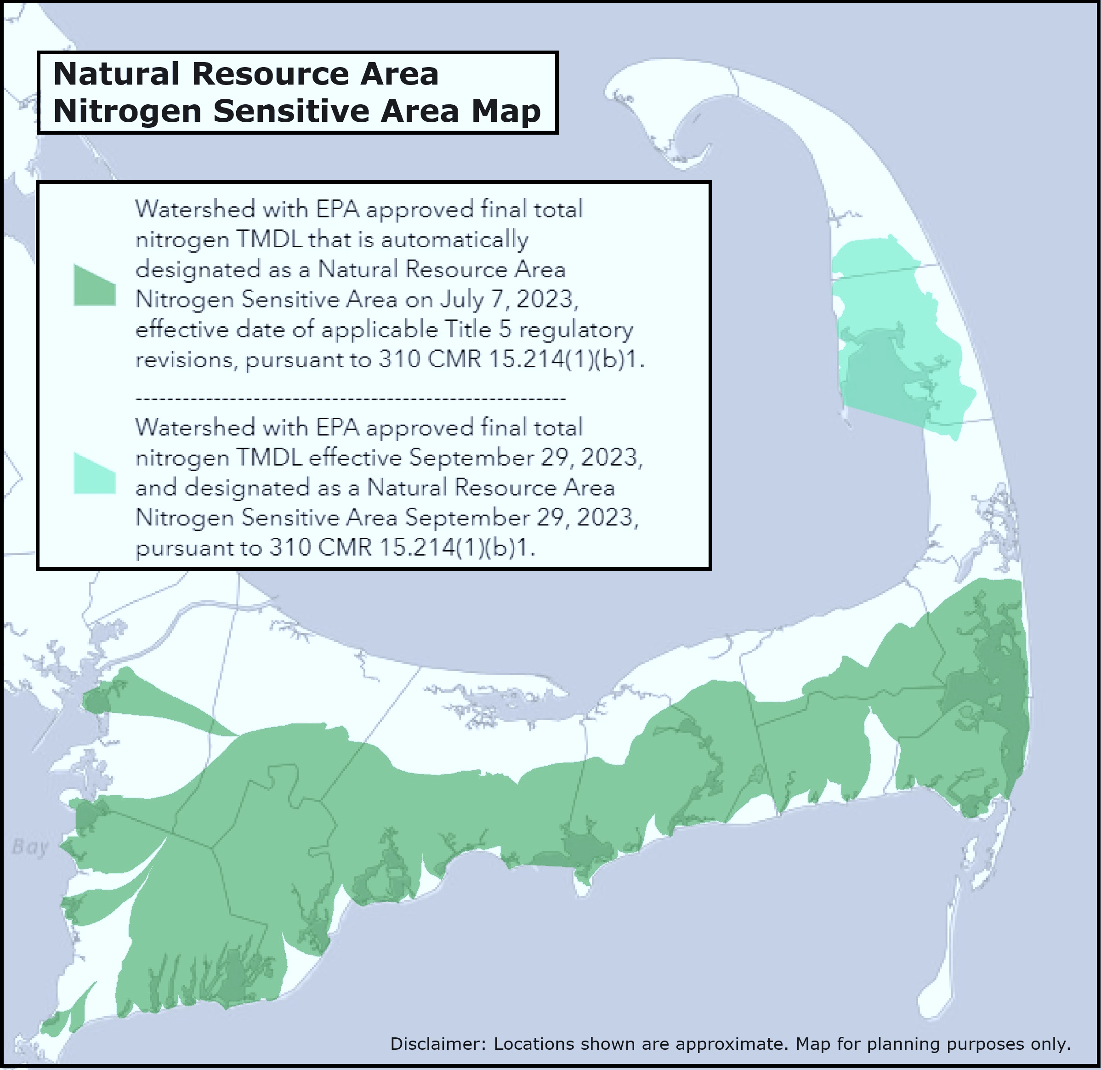The Massachusetts Department of Environmental Protection (MassDEP or the Department) seeks proposals from Massachusetts municipalities or other government entities that meet the definition of “Local Government Unit,” (LGU) as defined in 314 CMR 21.02, and have a watershed that has been designated as a “Nitrogen Sensitive Area” under 310 CMR 15.002, Title 5.

The purpose of this grant program is to assist municipalities to perform activities identified in this Request for Responses (RFR) which facilitate the completion of a Watershed Management Plan (WMP) for the purpose of completing: (1) a Watershed Permit application, or (2) De Minimis Load application; each of which address solutions to cultural eutrophication caused by nitrogen pollution from wastewater and other sources.

Only planning activities that contribute to, or come from a Watershed Management Plan, Watershed Permit application, or De Minimis Load application (as defined in 314 CMR 21.00) will be considered for funding. Through this grant program, MassDEP seeks to facilitate and advance LGUs’ application for a Watershed Permit or De Minimis Load application under 314 CMR 21.00 by offering funding for Eligible Projects to Eligible Entities, as further defined below.

Interested entities are encouraged to refer to the Watershed Permit Regulations online at:

<https://www.mass.gov/regulations/314-CMR-2100-watershed-permit-regulations>

The funding for this Grant Program is available only for work conducted during the Commonwealth of Massachusetts State Fiscal Year 2026 (SFY26) (July 1, 2025 - June 30, 2026). However, the work proposed to be funded may be part of a larger, ongoing project that exceeds Massachusetts State Fiscal Year 2026.

## Overview and Goals

A primary source of nitrogen contamination of coastal estuaries in Cape Cod isnitrogen loading from on-site septic systems. MassDEP, in conjunction with local Boards of Health, regulates these systems through its “Title 5” regulations, 310 CMR 15.000. On July 7, 2023, MassDEP promulgated revisions to these regulations. These regulations established new Natural Resource Area – Nitrogen Sensitive Areas (NRNSAs) to more effectively address nitrogen impacted estuaries in the Commonwealth so that the waterbodies will meet state Surface Water Quality Standards for nitrogen loads, as found and outlined in 314 CMR 4.00. Currently, 31 watersheds of Cape Cod have been designated as NRNSAs under Title 5.

The regulations also establish new requirements for these NRNSAs. These requirements are designed to more effectively address specific problems related to the impairment of coastal estuaries arising from high densities of septic systems. More specifically, the Title 5 revisions require that any system serving new construction incorporates Best Available Nitrogen Reducing Technology by July 8, 2025 (as extended by MassDEP), unless the LGU submits a Notice of Intent, a Watershed Permit application or a De Minimis Load application to stay this requirement. For existing systems, there is a 2-year Notice of Intent period, after which if no Notice of Intent (NOI), Watershed Permit, or De Minimis application is filed, any existing facility with a Title 5 system must incorporate Best Available Nitrogen Reducing Technology within five (5) years of the end of the NOI period. While the enhanced treatment requirements for septic systems will result in significant reductions in nitrogen pollution, they may not be the most effective and efficient way to restore the impacted estuaries and achieve established water quality goals.   
  
Therefore, MassDEP promulgated a second, concurrent regulatory revision formally establishing a “watershed permit process” under 314 CMR 21.00: Watershed Permit Regulations. A Watershed Permit, including the Pleasant Bay Watershed Permit that was issued in 2018, prior to the regulation, provides a 20-year timeframe to implement a more comprehensive solution to address nitrogen loading to one or more watersheds. As noted above, if LGUs file a Notice of Intent to obtain a Watershed Permit, file a Watershed Permit application, or file a De Minimis Load application within two years of the effective date of the NRNSA designation that covers an NRNSA (i.e., an area that would be subject to the updated Title 5 regulations), the above Title 5 NRNSA requirements will not become effective for that area. The watershed permit process requires LGUs to complete a Watershed Permit application as described by 314 CMR 21.03, or De Minimis Load application as described in 314 CMR 21.12. A Watershed Management Plan (WMP) is a required component of the Watershed Permit application and may be part of a De Minimis Load application. Other components of a watershed permit application may include a Comprehensive Wastewater Management Plan (CWMP), a Comprehensive Water Resource Management Plan (CWRMP), or a Targeted Watershed Management Plan (TWMP). Through this grant program, MassDEP seeks to facilitate and advance LGUs’ applications for Watershed Permits or De Minimis Load Exemption under 314 CMR 21.00 by offering funding for Eligible Projects to Eligible Entities as further defined below.

1. **Disadvantaged Communities**

MassDEP is committed to advancing Disadvantaged Communities through its public investments. To that end, preference will be given to projects that provide direct benefit to Disadvantaged Communities. Information on how communities are classified as Disadvantaged Communities and which communities they are can be found at [The Disadvantaged Community Loan Forgiveness Program | Mass.gov](https://www.mass.gov/info-details/the-disadvantaged-community-loan-forgiveness-program#disadvantaged-community-designation)

This Grant Opportunity will prioritize proposals that are located in, or directly benefit communities designated as a Disadvantaged Community, and that fall within one of three Affordability Tiers following a system first utilized by the Massachusetts Clean Water Trust and the State Revolving Fund. A “Disadvantaged Community” is a community that falls into one of the three tiers using an affordability calculation based on the State’s “**Adjusted Per Capita Income”** (*Per Capita Income * Employment Rate * Population Change (2020/2010)* = **APCI**). The State’s Adjusted Per Capita Income for the purposes of this RFR is **$53,549.85**, from FY25, the most recent year data is currently available.

**Tier 1:** Communities with APCI more than 80% but less than 100% of the State’s APCI.

**Tier 2:** Communities with APCI more than 60% but less than 80% of the State’s APCI.

**Tier 3:** Communities with APCI less than 60% of the State’s APCI.

The calculations may be viewed online here:

[FY25 Disadvantaged Communities Affordability Calculations I Mass.gov](https://www.mass.gov/doc/affordability-calculation-october-2024/download)

Eligible applicants, including partnerships and coalitions, shall identify the municipalities served by their entity or entities, as well as which municipalities within their service area(s) are designated as Tier 1, 2, or 3 Disadvantaged Communities. MassDEP will assign a composite ranking based on the ranking of all the communities located within the service areas of the applicant(s). If the composite ranking falls within the scope of the assistance tiers, the Applicant will be assigned a Tier 1, 2, or 3 ranking for scoring purposes of the RFR. A list of communities by Tier is available in **Appendix B** of this RFR.

## Eligible Entities

Eligible Entities are regional or local government units that:

1. meet the regulatory definition of "Local Government Unit" as defined in 314 CMR 21.02; and
2. are seeking a Watershed Permit to address nitrogen pollution in at least one (1) of the 31 Cape Cod watersheds designated as an NRNSA under Title 5. The NRNSA Address Lookup Map can be found at: [MassDEP NRNSA Map Viewer I Mass.gov](https://mass-eoeea.maps.arcgis.com/apps/webappviewer/index.html?id=96035fe034044e2596b49168b0e35d8e)

## Eligible Projects

Eligible projects will assist LGUs in completing Watershed Management Plans for the purpose of applying for a Watershed Permit, each of which address solutions to cultural eutrophication caused by nitrogen pollution from wastewater and other sources. Proposed projects must be in at least one (1) of the 31 Cape Cod watersheds designated as an NRNSA to be eligible. Interested applicants can use the MassDEP Designated Natural Resource Area – Nitrogen Sensitive Area Address Lookup Map to determine if their project is eligible. The NRNSA Address Lookup Map can be found at: [MassDEP NRNSA Address Lookup Map I Mass.gov](https://mass-eoeea.maps.arcgis.com/apps/webappviewer/index.html?id=96035fe034044e2596b49168b0e35d8e)

Only planning activities that contribute to, or come from, a Watershed Management Plan (WMP), a Comprehensive Wastewater Management Plan (CWMP), a Comprehensive Water Resource Management Plan (CWRMP), a Targeted Watershed Plan (TWMP), Watershed Permit application or De Minimis Load application (as defined in 314 CMR 21.00) will be considered for funding. Preference will be given to Eligible Projects that are in Disadvantaged Communities.  
  
*A Watershed Management Plan (WMP):*

1. is consistent with a 208 Plan, if such plan exists, as determined by the designated areawide planning agency under § 208 of the Clean Water Act, 33 U.S.C. § 1288;
2. includes or is supplemented with the information and documentation specified in 314 CMR 21.03(2), unless the Department determines otherwise;
3. is based on one or more Comprehensive Wastewater Management Plans (CWMPs), Comprehensive Water Resource Management Plans (CWRMPs), or Targeted Watershed Management Plans (TWMPs), as defined in 314 CMR 21.02, which may serve as the WMP if all requirements of this definition are met; and
4. provides a schedule and description of actions to achieve Necessary Nitrogen Load Reductions. Unless otherwise determined by the Department, the WMP may address pollutants other than nitrogen (314 CMR 21.02).

Both existing and proposed projects are eligible for this grant program, and funding will support work activities for the planning phase of Watershed Management Plans or a Watershed Permit, so long as the work funded by this program is conducted during FY2026 (i.e., July 1, 2025, through June 30, 2026). All applications must include a feasible timeline for completion of the proposed work (i.e., illustrating that the work being proposed for funding can be completed on or before the June 30, 2026, deadline). For proposed projects including work conducted before submission of the Grant Application, but on or after July 1, 2025, the Applicant must provide documentation, such as invoices, in the Grant Application.

Only planning activities that contribute to, or come from, a Watershed Management Plan (WMP), a Comprehensive Wastewater Management Plan (CWMP), a Comprehensive Water Resource Management Plan (CWRMP), a Targeted Watershed Plan (TWMP), Watershed Permit application or De Minimis Load application (as defined in 314 CMR 21.00) will be considered for funding. Examples of Eligible Projects include, but are not limited to:

* + - Planning activities necessary to complete a watershed permit application, as explained by 314 CMR 21.03(2), or De Minimis Load application, as explained by 314 CMR 21.12. Such activities include, but are not limited to:
      * Completing a Watershed Management Plan, CWMP, TWMP, or Scientific Evaluation;
      * Assessment of nitrogen loads; or
      * Modeling of nitrogen reduction scenarios.
    - Planning activities required by approved watershed permit. Such activities may include, but are not limited to:
      * Data analysis of ambient water quality monitoring results; or
      * Permeable reactive barrier design.
    - Review of ambient water quality monitoring, modeling, and/or other measures for the purpose of demonstrating de minimis load within a watershed or sub-watershed.

Construction or implementation projects are not eligible for SFY26 funding and will not be considered. Examples of projects that are not eligible for funding include, but are not limited to:

* + - Construction or implementation projects, including but not limited to:
      * Construction of approved sewering;
      * Upgrades to existing wastewater treatment facilities and/or septic systems; or
      * Installation of a permeable reactive barrier.
    - Continued operation or maintenance of wastewater treatment facilities or upgraded septic systems.

Ownership of all equipment or resources purchased pursuant to a grant award shall remain the property of the grantee.

## Application Deadline

Applications are due electronically by 5:00 P.M., E.S.T. on Monday, September 22, 2025.

## Page Limit

Grant Applications, including the budget sheet but excluding the cover sheet, must not exceed fifteen single-sided (15) pages in length (exclusive of attachments).The cover sheet (Attachment A) is at the end of this document is also available online at <https://www.mass.gov/info-details/grants-financial-assistance-watersheds-water-quality#natural-resource-nitrogen-sensitive-area-grant-program->

## Funding Availability

MassDEP anticipates that up to $830,000 in total funding may be available for projects through the Capital Fund for the SFY26 NRNSA Grant Program. Individual grant awards may range from $20,000 to $350,000 per applicant, although MassDEP reserves the right, in its discretion, to grant smaller or larger awards to proposals of exceptional merit. If additional funds become available during the period between the announcement of this grant opportunity and end of State Fiscal Year 2026, the Department reserves the right to allocate supplemental funds to this grant solicitation and/or initiate additional funding rounds.

Applicants may seek funding for Eligible Projects that will exceed the length of the grant award period (i.e., past June 30, 2026); however, only work that is proposed to be conducted during FY 26 (July 1, 2025- June 30, 2026), is eligible for funding. All funding for awards issued through this program are subject to the availability of appropriations or funding from other Department sources.

## Match and Other Funding Obligations

Applicants are not required to provide matching funds. However, applicants are encouraged to identify other known sources of funding for a proposed project on the Application Form, from both secured and anticipated sources, which may make the Application more competitive during review and evaluation by MassDEP.

In addition, Applicants are advised that grant awards involving capital funds are required to be disbursed on a cost reimbursement basis, meaning that grantees will be reimbursed for funds already expended. To receive reimbursement for funds expended, grantees must submit a written request for payment, along with invoices and purchase orders. Grantees must submit written requests for payment, and any corresponding supporting documentation, on or before June 30, 2026. Please see Section 1.N. for more information on required documents.

## Pre-Application Meeting

A Pre-Application Meeting using Zoom will be held on **Thursday, September 18, 2025 at 1:00 P.M. E.S.T.** The purpose of the meeting will be to provide information on the application process and the grant program. Please note that MassDEP cannot address the substance of any particular application. Questions answered during this meeting will be summarized and included in the written Q&A document. A recording of the meeting will be available online at the following link: [www.mass.gov/info-details/grants-financial-assistance-watersheds-water-quality#natural-resource-nitrogen-sensitive-area-grant-program-](http://www.mass.gov/info-details/grants-financial-assistance-watersheds-water-quality#natural-resource-nitrogen-sensitive-area-grant-program-)

To obtain the meeting link information or the Zoom link please contact Courtney Starling via email at [courtney.starling@mass.gov](mailto:courtney.starling@mass.gov) with “FY 2026 NRNSA Grant Application Meeting” in the email subject line.

## Written Questions via the Grant Q&A Process

As noted in the Estimated Grant Procurement Calendar, grant applicants may submit written questions, via e-mail, to Caroline Adamson at [caroline.p.adamson@mass.gov](mailto:caroline.p.adamson@mass.gov) on or before September 5, 2025 at 3:00 pm E.S.T. MassDEP will post official responses to questions regarding this grant RFR on or before September 15, 2025, at 5:00 pm E.S.T. It is the Applicant’s responsibility to verify receipt of questions with MassDEP.

MassDEP reserves the right to condense, summarize, or combine related questions and/or answers. Applicants are responsible for entering content suitable for public viewing since all the questions are accessible to the public. Applicants kindly shall not include any information that could be considered personal, security sensitive, inflammatory, incorrect, collusory, or otherwise objectionable.

The Q&A document for this Grant RFR will be available on COMMBUYS, as well as online at the following link: The Q&A document for this Grant RFR will be available online at the following link:  [www.mass.gov/info-details/grants-financial-assistance-watersheds-water-quality#natural-resource-nitrogen-sensitive-area-grant-program-](http://www.mass.gov/info-details/grants-financial-assistance-watersheds-water-quality#natural-resource-nitrogen-sensitive-area-grant-program-)

**All answers are final when posted. Any subsequent revisions to previously provided answers will be dated.**

## Amendment Deadline

MassDEP reserves the right to make amendments to the Grant RFR after initial publication prior to the Application Deadline in the Estimated Procurement Calendar. It is each Applicant’s responsibility to check for any amendments, addenda, or modifications to this Grant RFR, as well as any Q&A related to this RFR and any amendments thereto.

## Total Anticipated Duration of Grant(s)

The contract duration will be through June 30, 2026. MassDEP reserves the right to extend the contract duration solely for the purposes of performance completion consistent with the terms of the Grant Award contract.

## Required Documentation

Upon completion of the proposed work, and with submission of the final request for reimbursement, all Grant Awardees shall submit a one (1)-page Final Report summarizing their project tasks, including links or copies to the work product completed during the contract period.

MassDEP reserves the right to request additional materials, information, or other documentary evidence demonstrating completion of work and/or compliance with program requirements. MassDEP also reserves the right to withhold funding until receipt of satisfactory materials, information, or other documentary evidence demonstrating completion of work and/or compliance with program requirements.

## Applicable Procurement Law

Grants: MGL c. 7A, § 7; St. 1986 c. 206, § 17; 815 CMR 2.00.

# INSTRUCTIONS FOR APPLICATION SUBMISSION:

## Evaluation Criteria (general)

In order to be considered for a grant award,Applicants must submit a completed application that: includes all required supporting materials; consent to program terms and conditions; provides an affirmative commitment to completing the proposed work by June 30, 2026; and meets program eligibility requirements. A MassDEP review committee will evaluate proposed projects based upon the criteria listed below. The review committee reserves the right to reject any or all proposals.

**Evaluation Criteria Components:** The review committee will evaluate and score the grant applications from Eligible Entities (as previously defined in Section 1.D. of this Grant Opportunity) based upon the following criteria:

ATTACHMENTS DO NOT COUNT TOWARDS THE 15-PAGE LIMIT.

**Project Description (20 points)**

* Does the project description state how the proposed or existing project will contribute to or support the overall reduction of nitrogen loads so that the waterbodies will meet state Surface Water Quality Standards?
* If some or all of the proposed project includes a request for reimbursement for eligible costs incurred after July 1, 2025, and before submission of the Application, does the application included a description of the portion of the project that is partially or fully completed?
* Are all elements of the proposal eligible under the listed criteria for this grant program? Will any of the requested grant funding be used for any ineligible activities such as construction/implementation and/or continued operational/ maintenance costs, or for activities occurring outside of a designated NRNSA?

**Meet Regulatory Requirements (25 points)**

* Does the application demonstrate how the proposed project intends to contribute to the development of a Watershed Management Plan, Watershed Permit application, or De Minimis Load application under 314 CMR 21.00, De Minimis Load application and/or Title 5?
* How does the proposed project further the goal of the LGU in comprehensively addressing nitrogen impacts in the watershed?

**Financial Need (5 points)**

* How well does the application demonstrate the Eligible Entity’s need for financial assistance to support the Proposed or Existing Project?

**Project Budget and Timeline (20 points)**

* Does the application include a detailed project budget that includes cost and time estimates by project task and milestone?
* Does the proposed budget include matching or outside funds from the applicant? If so, what is the proposed percentage of the overall budget the applicant is proposing to provide?
* If the project includes a request for reimbursement for eligible costs incurred after July 1, 2025, and before submission of this Application, does the application include all documentation supporting the request for reimbursement for these project costs?
* Does the application demonstrate a realistic timeline to achieve the proposed work?

**Qualifications of Organization and Project Manager (10 points)**

* Does the application describe the qualifications of the Eligible Entity, their contractor(s), the project manager, and any other staffing assigned to carry out the proposed project?
* Does the Eligible Entity, and/or their contractor(s) have sufficient qualifications and project experience to perform the proposed project?

**Project Benefit (15 points)**

* How well does the proposed or existing project clearly achieve/meet the overview and goals of the Natural Resource Area – Nitrogen Sensitive Areas Grant Program and Title 5 Requirements?
* Will the project include any community engagement with local stakeholders such as the general public, local boards, committees, commissions, and other groups to inform them of project goals and outcomes?

**Disadvantaged Communities (5 points)**

* MassDEP will prioritize projects that are located in, or directly benefit, Disadvantaged Communities. Points will be awarded proportionately by tier (i.e. the highest number of points will be given to Applicants with projects in communities that have been designated Tier 3 Disadvantaged Communities). Please see Attachment B for a list of Disadvantaged Communities by Tier as determined by the Clean Water Trust for FY25.

## Application Completion and Submission Instructions

All Applicants must include the attached application form (Attachment A) in their application and submit the packet electronically, as a Microsoft Word or Adobe PDF file, **by 5:00 p.m. E.S.T., on Friday, October 14, 2025.**

Applications shall be submitted to Caroline Adamson, via email at: [Caroline.P.Adamson@mass.gov](mailto:Caroline.P.Adamson@mass.gov). Please include the Applicant name AND “NRNSA Grant Program” in the subject line. Attachment A, Section 1 and 2 are at the end of this document or available for download at: [Nitrogen Sensitive Areas Grant Program I Mass.gov](https://www.mass.gov/info-details/grants-financial-assistance-watersheds-water-quality#natural-resource-nitrogen-sensitive-area-grant-program-).

Applications received after the deadline will be automatically rejected. MassDEP reserves the right to reject nonresponsive proposals or request additional information, if needed.

## Additional Required Documentation:

If selected for a Grant Award, the Applicant will be required to submit the following forms to complete the Grant Award contracting process. Forms with an asterisk (*) need not be submitted, if they have been completed previously and are already on file with the Commonwealth:

* + Commonwealth Standard Contract Form, filled out and signed by the applicant. The Standard Contract Form is listed under Contracts on this website: [www.macomptroller.org/forms](http://www.macomptroller.org/forms)
  + Commonwealth Terms and Conditions. [www.macomptroller.org/forms](http://www.macomptroller.org/forms)

These Terms and Conditions are incorporated by reference into the Standard Contract Form, and do not need to be executed separately.

* + Commonwealth W‐9 tax information form filled out and signed by the applicant with DUNS number and Federal Tax ID(*). [www.macomptroller.org/forms](http://www.macomptroller.org/forms)
  + Completed Contractor Authorized Signatory Listing Form.

[www.macomptroller.org/forms](http://www.macomptroller.org/forms)

* + Electronic Funds Transfer (EFT) form(*).

<https://www.mass.gov/how-to/tips-for-completing-the-electronic-funds-transfer-eft-form>

* + Scope of Work

Applicants are encouraged to review these forms prior to submission of an application.

# ESTIMATED CALENDAR FOR GRANT APPLICATION/AWARD:

| **Event** | **Date** | **Time** |
| --- | --- | --- |
| **Notice of Grant Opportunity** (posted on COMMBUYS and MassDEP website) | Friday, September 12, 2025 |  |
| **Bid Release Date** (Posting Date) on MassDEP website | Friday, September 12, 2025 |  |
| **Pre-Application Meeting**  Via Zoom. To obtain dial-in information or the Zoom link please contact Courtney Starling via email at [courtney.starling@mass.gov](mailto:courtney.starling@mass.gov) with ‘FY 2026 NRNSA Grant Meeting’ in the email subject line. | Thursday, September 18, 2025 | **1 P.M.** |
| **Deadline for Submission of Questions to MassDEP**: Please submit questions to Caroline Adamson via email to: [caroline.p.adamson@mass.gov](mailto:caroline.p.adamson@mass.gov) | Friday, September 19, 2025 | **3 P.M.** |
| **Bid Amendment Deadline** | Friday, October 6, 2025 | **5 P.M.** |
| **Official Answers for Q&A** published on MassDEP website | Friday, October 6, 2025 | **5 P.M.** |
| **GRANT APPLICATION DEADLINE; ELECTRONIC SUBMISSION TO:** Please submit applications to Caroline Adamson via email to: [caroline.p.adamson@mass.gov](mailto:caroline.p.adamson@mass.gov) | Tuesday, October 14, 2025 | **5 P.M.** |
| Notification of Grant Award(s) (Estimated)  (POSTED ON COMMBUYS AND MASSDEP WEBSITE) | January 2026 |  |

# ATTACHMENT A

**Natural Resource Area – Nitrogen Sensitive Area**

**SFY2026 Grant Program Application**

**Overview:** The Massachusetts Department of Environmental Protection (MassDEP or the Department) seeks proposals from Massachusetts municipalities or other government entities that meet the definition of “Local Government Unit,” as defined in 314 CMR 21.02, and have a watershed that has been designated as a Natural Resource Area – Nitrogen Sensitive Area under 310 CMR 15.000, Title 5. The purpose of this grant program is to assist municipalities in a variety of activities which facilitate completion of a Watershed Management Plan (WMP) for the purpose of completing a Watershed Permit application or De Minimis Load application, each of which address solutions to cultural eutrophication caused by nitrogen pollution from wastewater and other sources. Only planning activities that contribute to or come from a Watershed Management Plan, Watershed Permit application, or De Minimis Load application (as defined in 314 CMR 21.00) will be considered for funding. For more information, please see the Notice of Grant Opportunity.

**Section 1: Applicant Information**

Applicant Name: __________________________________________________________________

Project Title: _____________________________________________________________________

Short description of the work (<5 sentences)

Requested Funds: ____________________________Matching Funds (optional): _________________

Municipal Contact Name: ______________________ Title: __________________________________

Address: ___________________________________________________________________________

Phone: _____________________ Email: _______________________________________________

Applicant Signature: __________________________________________________________________

*(Electronic or digital signatures are acceptable on this form)*

Consultant Contact Name: _______________________ Email: _____________________________

**By checking this box  the applicant confirms that they are authorized to submit this grant application on behalf of the specified Permittee listed above.**

**Section 2: Ability to Perform Proposed Project**

1. Ability to Use Funds: If awarded an NRNSA Grant, the awardee must be able to enter into a contract with MassDEP within 15-30 days of Grant Award.

**By checking this box**  the Applicant acknowledges and agrees that its entity is able to enter into the contract and perform the project and meet all requirements of this state grant.

**Section 3: Application Structure**

Please use the following format for your application. Applications longer than 15 single-sided pages exclusive of the cover and attachments will not be accepted.

**Project Description (20 Points):** Describethe Eligible Project and the proposed work to be covered by this funding. Include proposed project tasks, desired outcome(s) for the project, and how the Eligible Entity will be helped to meet the goals of the grant program and Title 5 requirements by the project. If all or some of the Eligible Project includes a request for reimbursement for eligible costs incurred after July 1, 2025, and before submission of the Application, please include a description of the project partially or fully completed.

**Meet Regulatory Requirements (25 Points):** Describe how the proposed project intends to contribute to the development of a Wastewater Management Plan and/or application for a Watershed Permit or De Minimis Load under 314 CMR 21.00?

**Project Budget and Timeline (15 Points):** Please fill out the budget table below for the proposed project (use as many rows as needed). If all or some of the proposed project includes a request for reimbursement for eligible costs incurred after July 1, 2025, and before submission of the Application, please attach documentation supporting these project costs.

***NSA Grant Budget Table***

| **Key Project Tasks/Milestone**  **(Responsible Party)** | **Estimated Cost** | **Estimated Match* (if applicable)** | **Known or Estimated Task Completion Date** |
| --- | --- | --- | --- |
| *Use as many lines as needed* |  |  |  |
|  |  |  |  |
|  |  |  |  |
| **Project Total:** |  |  |  |
| **Total Funding Requested:** |  |  |  |

**Source of Match*:** For any in-kind or monetary match, explain how extensive it is and how it will be made available to the project here.

**Financial Need (5 Points):** Describe the needfor financial assistance to implement the proposed project, including other anticipated or secured funding sources that will support portions of the project (if applicable).

**Project Benefit (15 Points):** How well does the proposed or existing project clearly achieve/meet the overview and goals of the Natural Resource Area – Nitrogen Sensitive Areas Grant Program and Title 5 Requirements? Does the applicant propose to engage a diverse range of stakeholders as part of their planning process?

**Qualifications of Organization and Project Manager (10 Points):** Describe the qualifications of the Eligible Entity and/or their contractor and the project manager relevant to carrying out the proposed project.

**Disadvantaged Community Status (5 Points):** Please identify all municipalities served by the Applicant; indicate which of those municipalities are designated as Tier 1, 2, or 3 Disadvantaged Communities.

# ATTACHMENT B

**Disadvantaged Communities by Tier**

## Tier 1:

Amesbury, Ayer, Barnstable, Berkley, Billerica, Bourne, Braintree, Brewster, Cummington, Deerfield, Dighton, Douglas, East Longmeadow, Eastham, Falmouth, Gloucester, Great Barrington, Groveland, Hampden, Harwich, Hopedale, Hudson, Hull, Kingston, Lakeville, Leyden, Lunenburg, Mashpee, Maynard, Medford, Merrimac, Millis, North Attleborough, Northampton, Northbridge, Norwood, Pembroke, Pepperell, Plainville, Plymouth, Plympton, Raynham, Rehoboth, Richmond, Rochester, Rutland, Seekonk, Southampton, Sterling, Stockbridge, Sturbridge, Tewksbury, Tyngsborough, Uxbridge, Waltham, West Bridgewater, West Tisbury, Westhampton, Westminster, Westport, Wilbraham, Winthrop, and Woburn

## Tier 2:

Abington, Acushnet, Agawam, Alford, Ashburnham, Ashby, Attleboro, Auburn, Avon, Becket, Belchertown, Bellingham, Blackstone, Blandford, Bridgewater, Brimfield, Carver, Charlton, Clinton, Conway, Dalton, Dartmouth, Dennis, Dracut, East Bridgewater, East Brookfield, Easthampton, Egremont, Fairhaven, Framingham, Freetown, Granby, Granville, Hadley, Halifax, Hanson, Hatfield, Haverhill, Hinsdale, Holbrook, Holland, Hubbardston, Huntington, Lancaster, Lee, Leicester, Leominster, Malden , Marlborough, Methuen, Middleborough, Milford, Millbury, Millville, Monson, Monterey, Montgomery, Mount Washington, New Ashford, New Braintree, New Marlborough, Northfield, Norton, Oakham, Otis, Oxford, Paxton, Peabody, Pelham, Petersham, Phillipston, Quincy, Randolph, Revere, Rockland, Rowe, Salem, Salisbury, Saugus, Sheffield, Shirley, Somerset, South Hadley, Southwick, Stoughton, Swansea, Townsend, West Boylston, West Brookfield, Weymouth, Whitman, Williamstown, Worthington, and Yarmouth

## Tier 3:

Adams, Amherst, Ashfield, Athol, Barre, Bernardston, Brockton, Brookfield, Buckland, Charlemont, Chelsea, Cheshire, Chester, Chesterfield, Chicopee, Clarksburg, Colrain, Dudley, Erving, Everett, Fall River, Fitchburg, Florida, Gardner, Gill, Goshen, Gosnold, Greenfield, Hancock, Hardwick, Hawley, Heath, Holyoke, Lanesborough, Lawrence, Lowell, Ludlow, Lynn, Middlefield, Monroe, Montague, New Bedford, New Salem, North Adams, North Brookfield, Oak Bluffs, Orange, Palmer, Peru, Pittsfield, Plainfield, Royalston, Russell, Sandisfield, Savoy, Shelburne, Shutesbury, Southbridge, Spencer, Springfield, Sunderland, Taunton, Templeton, Tisbury, Tolland, Tyringham, Wales, Ware, Wareham, Warren, Warwick, Webster, Wendell, West Springfield, Westfield, Whately, Williamsburg, Winchendon, Windsor, and Worcester

**Date Source:** <https://www.mass.gov/doc/affordability-calculation-october-2024/download>

**Note**: FY25 is the most current year for which data was available at the time of the publication of this RFR. New calculations are typically published in October.