Massachusetts Department of Environmental Protection
Request to Maintain Information Confidential
This form must accompany any request that information submitted to the Department of Environmental Protection be kept confidential and protected from public disclosure. Please refer
to the Guidance on Requests to Keep Trade Secret Information Confidential at http://mass.gov/dep/service/cbi.htm if you have questions on filling out this form.
 | A. Filer Information
Important: When filling out forms on the computer, use only the tab key to move your cursor - do not use the return key.  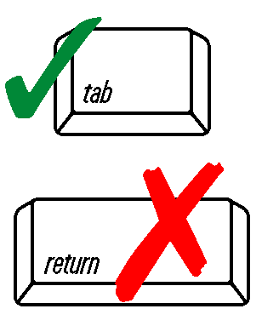 | 1.  Name of Organization or Person Filing
 | Name of Contact Person |  | Title
 | Street Address
 | City/Town |  | State | ZIP Code | Telephone Number
 | B. Reason for Making Submission
 | 2. Reporting Requirement Under Regulations or Order
 | Request for Department Review of Innovative Technology
 | Other:
 | Facility Contact Person: |  | Contact person's title
 | 3. Are you requesting that any of the information submitted with this cover sheet should be kept confidential and protected against public access as a:
 | Trade Secret
 | Other: | Describe
 | 4. Did you submit a sanitized copy (confidential information blanked out) of the information in addition to the confidential copy?
 | Yes No If no, please submit sanitized copy with this form.
 | 5. Please state the length of time you wish the information to remain confidential:
 | 6. If you are filing this form in response to a Notice from the Department that your earlier request for confidentiality was insufficiently substantiated, do you request : (check one box only )
 | (1) Reconsideration of the request based on the supplemental information filed with this form;
 | (2) Reconsideration of the request based on the information already submitted to the DEP; or
 | (3) Withdrawal of the request. Withdrawal will waive your request that the information filed be treated as confidential, and the information will be placed in files available for public review.
 | B. Reason for Making Submission (continued)
 | 7. If you are filing additional information to substantiate a confidentiality request for a trade secret, please check the box(es) below to indicate the type of information submitted.
 | The extent to which the trade secret is known by people outside the filer’s business;
 | The extent to which the trade secret is known to the filer's employees and business associates;
 | The extent of the security measures the filer has used to protect the trade secret;
 | The value of the trade secret to the filer and to the filer's competitors;
 | The amount of effort it took to develop the trade secret; and
 | The ease or difficulty for the trade secret to be acquired or duplicated.
 | 8. Have you made the same trade secret claim on previous submissions?
 | Yes No
 | C. Certification Statement
 | “I hereby certify that I have reviewed all the attached documents and that, to the best of my knowledge and belief, the submitted information is true, complete and accurate. I further certify that I am fully authorized to make this attestation on behalf of the filer. I am aware there are significant penalties for willful or intentional submission of false or incomplete information.”
 | Authorized Signature* |  | Print Name
 | Position/Title |  | Date
 | * If Corporation, President, Secretary, Treasurer or representative if authorized by a corporate vote. If Partnership, identify general or limited partnership status.

