In order to better meet federal and state requirements for a more rigorous Background Record Check (BRC) process, the Department of Early Education and Care (EEC) is implementing a new BRC system known as “BRC Navigator”. Starting in April 2019, Group and School Age (GSA) Child Care Programs will use a component of the BRC Navigator called the BRC Program Portal to run new BRCs on staff and update hiring decisions instead of the current BRC Manager system. EEC is asking GSA Child Care Programs to begin preparing now to complete the switchover to the new BRC Program Portal in April 2019.

**If you are a Licensed GSA Child Care Program, you will be eligible for an account on BRC Navigator - Program Portal if you meet the following criteria:**

1. You are listed as the Main Contact/Licensee in the LEAD (Licensing Education Analytic Database) system and have provided a valid email address in LEAD that is unique to your name and not shared by any other member of your program or agency.
2. You have completed and were approved for all EEC-required BRCs, including Criminal Offender Record Information (CORI), Sex Offender Record Information (SORI), Department of Children and Families (DCF), and a fingerprint check within the last 3 years and the BRC overall status is “*Suitable***”.**
3. If you are a GSA Child Care licensee and meet the above two requirements, you do not need to do anything at this time. EEC will provide you with an account via email in the near future. The invitation will be sent to the e-mail address listed under your name in LEAD, along with instructions on how to login and use the BRC Program Portal.

**If your BRC does not meet the criteria listed in “2” above, you will not receive an invitation to set up your user account for the BRC Program Portal for the following reasons:**

* Your last fingerprint scan date was over 3 years ago, your BRC needs to be renewed, please contact your EEC regional office to execute the transaction in LEAD to receive the link to the DocuSign Consent Form via e-mail.
* If you are a GSA Licensee who has had a BRC on/or after January 1, 2017 and the CORI, SORI, and DCF is completed, but you have never been fingerprinted, please re-print the fingerprint notification letter and set up an appointment to be fingerprinted. Instructions are included with the fingerprint notification letter.
* If you are a GSA Licensee who has had a BRC prior to January 1, 2017, and the CORI, SORI, and DCF was completed, but you have never been fingerprinted, you will need to contact your EEC Regional Office to execute the transaction in LEAD and receive the link to the DocuSign Consent Form via e-mail.
* If you are a GSA Licensee who just submitted a new BRC application, once it is completed and is approved for all EEC-required BRCs and the BRC overall status is “*Suitable”,* the BRC Program Portal will be updated and you will receive an invitation to set up a BRC Program Portal user account.
  + - Note: If your BRC application is under review and the EEC BRC Unit has requested additional documentation you must provide all requested documentation as soon as possible. You will not be able to access the BRC Program Portal until EEC completes your BRC review.

**If you are a GSA Child Care Licensee and are unsure of your BRC status, you can look this up in BRC Manager (instructions below) to review the BRC status of both you and your staff to ensure they meet suitability requirements.**

* **From the BRC Manager Homepage:** 
  + **Select “View Pending and Completed BRC Requests”.**

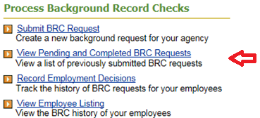

* **Go to the Background Checks Request Report page:** 
  + **Select “View Pending and Completed BRC Requests”.**

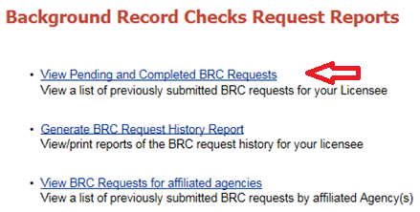

* **After you click on “View Pending and Completed BRC Requests”:** 
  + **Enter the first and last name of the applicant you wish to find and click “get results”.**

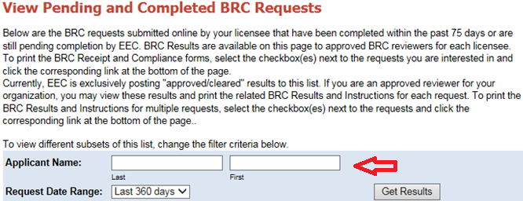

* **View applicant status:**
* **This is an example of a complete background record check**

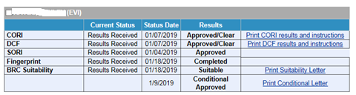

* **This is an example of a candidate with an incomplete background record check:**

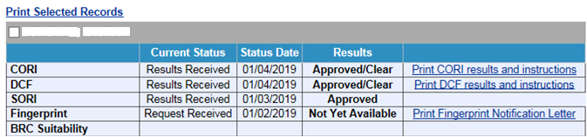

**If you’re BRC overall status is “Suitable” but you did not receive an invite for the BRC Program Portal, then you likely did not receive an invitation to set up your user account in BRC Program Portal for one of the following reasons:**

* + **You are the licensee and your role in LEAD does not designate you as the Main Contact/Licensee;**
  + **You do not have a valid email address in LEAD that is both unique to your name and not shared by any other member of** **your program or agency; or**
  + **Your name in LEAD does to match the information submitted for your last BRC.**
    - **Examples of this issue include:** 
      * **Your first name is legally “Elizabeth” and was submitted this way on your BRC consent form, but the LEAD Licensee/Main Contact has you listed with the nickname “Liz” for your first name;**
      * **There is more than one name in the LEAD Contact Role; or**
      * **The LEAD Contact Role First and Last Name are reversed.**

**To resolve any of the issues above, please submit a Help Desk ticket in the LEAD Portal:**

* + **Log into the LEAD Portal:**

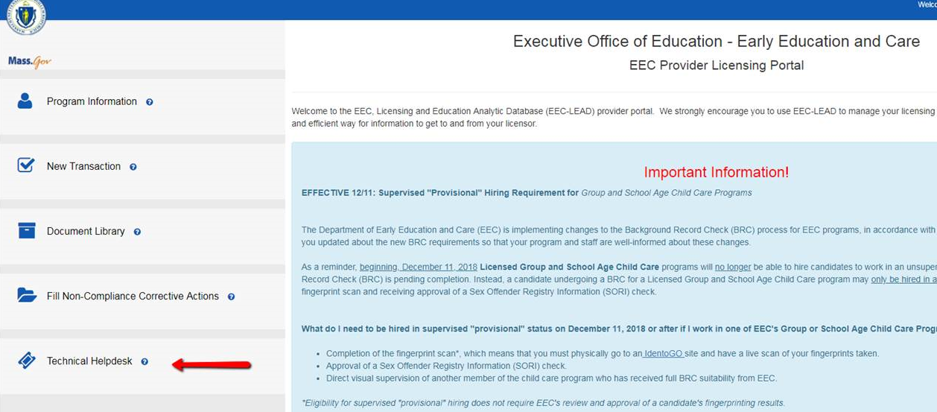

* + **When creating a new ticket, select “Profile Management”:**

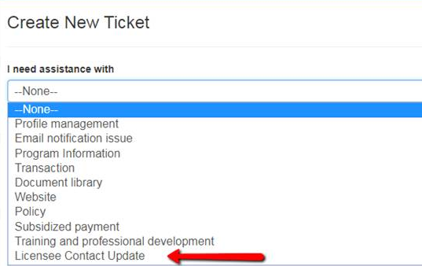

* + **On the subject line type:** 
    - * **“Access to New BRC Program Portal”**
  + **In the description section, provide the change to your LEAD Contact Role:** 
    - **For example:**
      * **Indicate you are requesting that your Contact Role in LEAD needs to be updated to “Licensee/Main Contact”;**
        + **Indicate that your first name or last name in LEAD is not your correct legal name. A change to your name may require you to submit a consent form via DocuSign.**
      * **Indicate that you need to update your e-mail address. Provide your new e-mail address, but remember that your e-mail must only be accessible to you and cannot be accessed by anyone else**.

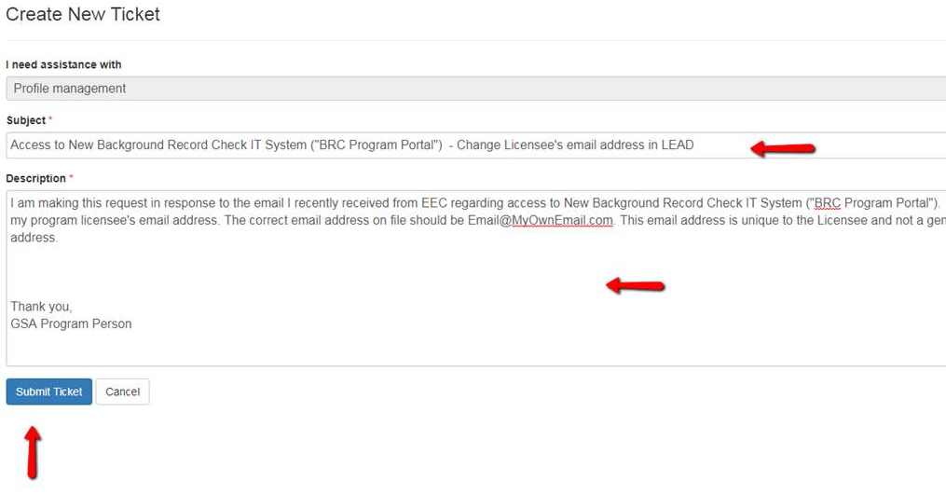

* + **Click “Submit Ticket”.**