RESEA CRYSTAL REPORTS AND DESCRIPTIONS
AS OF SEPTEMBER 2020
https://www.mass.gov/service-details/reports-by-category

Crystal Report Name | Description
RESEA Attains Scheduled to Return | RESEA participants who attained their RESEA Review and are scheduled for a future goal or event.
RESEA Attended CCS - No Initial RESEA - C | RESEA participants who attended a CCS but have not completed an Initial RESEA Review.
RESEA Entered Employment Outreach | List of RESEA participants who do not have a job recorded in MOSES
RESEA DNR After Attainment | RESEA participants who attained their RESEA but did not report to a scheduled event or goal.
RESEA Enrollments Outreach F | Purpose: For outreach to RESEA enrollments who have not completed their RESEA Review.  Report Detail: The report is grouped by the enrolling office. The report lists the individuals contact information and information on the CCS and RESEA Review. If either the CCS Event or RESEA Review Goal exists, the report will show where and when they attended or if they failed to attend the CCS and where they are scheduled for their RESEA Review, the attainment status of the review and the target date.
RESEA Mail Email Export 60 Dayers G | Purpose: To outreach to RESEA claimants who were enrolled in the RESEA program this past Saturday and who attended a CCS in prior 60 days of enrollment (waived from CCS).  These claimants received a notification letter from DUA informing them of their requirements. Career Center staff may want to contact these individuals to inform them that they have been selected to participate in the RESEA program and that they must complete a RESEA Review within 5 weeks of enrollment.
RESEA Potential Attainments C | Shows participants who attained all the required goals but the RESEA Review goal is still pending.
RESEA Rainbow Report v18 | Purpose: To manage RESEA Review Goals to avoid UI Sanctions.  Selection: RESEA participants whose RESEA Review Deadline is in the future.  Highlights (RESEA Rainbow Report):  Pink: Warning - RESEA Review Goal is Pending, UI Sanction this Friday. Goal Status should be updated by COB on Friday.  Yellow: RESEA Review Goal is Pending with a Target Date in the Past. Goal Status should be updated in MOSES.  Green: Attended CCS but no RESEA Review Goal Target Date. Goal Target Date should be updated in MOSES.  Blue: Waived from CCS (60 Dayers) but no RESEA Review Goal Target Date. Goal Target Date should be updated when RESEA Review is scheduled.  Red Text: RESEA Review Target Date is Scheduled After the Deadline. To avoid sanction you should re-schedule the RESEA Review.
RESEA RTW Avg Wks | RESEA participants who were enrolled in the past three (3) calendar years who have a job recorded in MOSES and the job start date is within one (1) year from the date of enrollment. The report displays the average number of weeks from the enrollment date to the job start date by calendar year and enrolling MassHire Career Center.
RESEA Sanctions - Attainments F | RESEA participants who were sanctioned or attained after sanction in the date range selected.
Some RESEA Crystal Report Examples

New
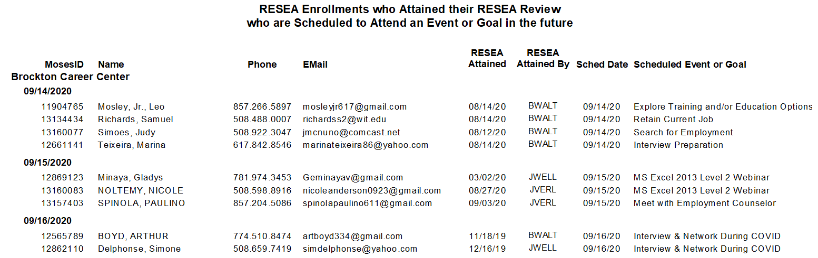

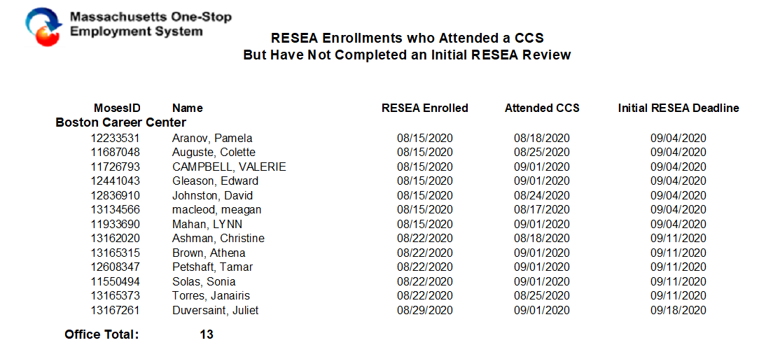

New
RESEA Attainments who did not report to a scheduled event or goal

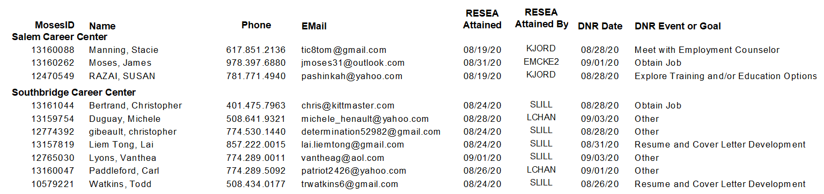
New
