DPH PANDAS/PANS Advisory Council
RESEARCH WORKGROUP MEETING

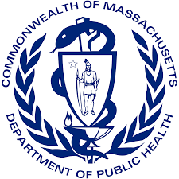

August 31, 2022

MINUTES
ATTENDEES: Blake Poggi, Dr. Mark Pasternack, Jennifer Vitelli & Dr. Kyle Williams
LOCATION: VIRTUAL

- Meeting called to order
  - Dr. Williams made a motion to call the meeting to order at 12:35 p.m.
  - Ms. Poggi seconded the motion
  - all were in favor of the motion
- Open Roll Call & VOTE: Minutes (6.28.22)
  - Dr. Pasternack made motion to accept the minutes of the June 28, 2022 meeting
  - Ms. Vitelli seconded the motion
  - all were in favor of the motion & minutes were accepted without revisions
- REVIEW: Categorized Baseline Environmental Scan on Research
  - the workgroup reviewed the research gathered thus far on PANDAS/PANS research.
  - Dr. Williams will classify the database as “basic science; translational, or clinical in nature.
  - This will be presented at next workgroup meeting
- Adjournment
  - Ms. Poggi made a motion to adjourn at 1:15 p.m.
  - Dr. Pasternack seconded the motion
  - minutes were accepted without revisions

