MINUTES
DPH PANDAS/PANS Advisory Council
RESEARCH WORKGROUP MEETING

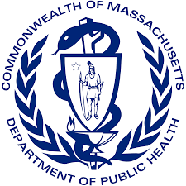
Wednesday, March 1, 2023

ATTENDEES: Blake Poggi, Dr. Mark Pasternack, Jennifer Vitelli & Dr. Kyle Williams
LOCATION: VIRTUAL

MINUTES
- Meeting called to order
  - 1:04 p.m.
- Open Roll Call
  - Blake Poggi, Kyle Williams & Jennifer Vitelli were present
- VOTE: Minutes (2.8.22)
  - Ms. Poggi made a motion to accept the minutes
  - Dr. Williams seconded the motion
  - all were in favor of the motion
- Baseline Environmental Scan on Research
  - Ms. Poggi provided Dr. Williams with additional research to be added to the baseline scan
  - Dr. Williams will finalize the scan (categorizing)
- Gaps in Research
  - Members decided to hold off on discussing the gaps until after the full council meeting on March 8th and will focus on that work between March and May’s full council meeting
- PREPARE: presentation on Baseline Environmental Scan on Research for next full council meeting (March 2023)
  - Dr. Williams will present findings for the March 8th meeting
- Adjournment
  - Ms. Vitelli made a motion to call the meeting to a close at 1:11 p.m.
  - Dr. Williams seconded the motion
  - all were in favor of the motion

