

CCFA TROUBLESHOOTING: I forgot my password!



- CCFA allows users to manage initiate changing their
passwords

- Select the Forgot Password link under the Sign in button

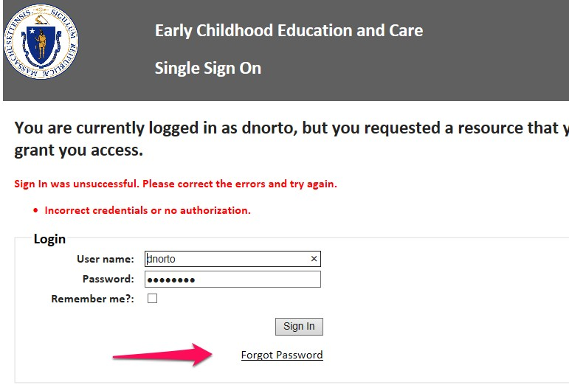
2

  - Enter your username

  - Select the request Password Reset button
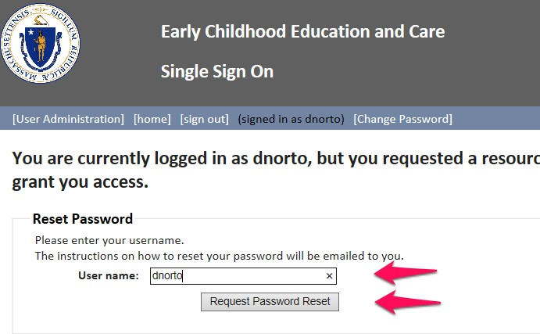– CCFA will send an email to the email address used to create the account

3

- Enter your
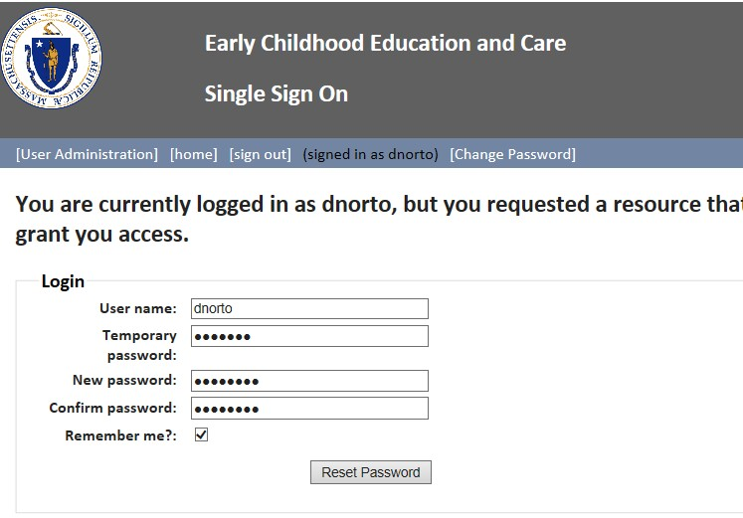username

- the temporary password provided in the CCFA email

- Create a new password

- Confirm the new password

- Check remember me?

- Select the request Password Reset button

Once completed CCFA will require you to login using your new credentials

4

  - Check our website for updates and available recordings www.mass.gov/eec/ccfa/training

  - Please email your questions to CCFATraining@massmail.state.ma.us

5

