Residential Care Home

Billing Guide for the UB-04

Executive Office of Health and Human Services
MassHealth
January 2014

BG-UB-04-CL-RCH (01/14)

Table of Contents
Introduction 1
General Instructions for Submitting Paper Claims 1
Entering Information on the UB-04 Claim Form 1
Time Limitations on the Submission of Claims 1
General Instructions for Submitting Paper Claims (cont.) 2
Electronic Claims 2
Where to Send Paper Claim Forms 2
Further Assistance 2
How to Complete the UB-04 Claim Form 3

Introduction
Residential care homes choosing to submit their claims on paper must use the UB-04 claim form to submit their claims. This document provides detailed instructions for completing the paper UB-04 claim form.

Residential care home services are not covered by MassHealth. However, the Commonwealth of Massachusetts uses the MassHealth claims payment system to process claims on behalf of the Department of Transitional Assistance (DTA) for payment of residential care home services provided to residents receiving DTA assistance. For administrative purposes, MassHealth issues a 10-character identification number/service location code that permits residential care homes to submit claims through the MassHealth claims payment system.

For information about submitting claims electronically, see the 837I Companion Guide for Residential Care Homes.

For information about the resulting remittance advice, see the MassHealth Residential Care Home Guide to the Remittance Advice for Paper Claims and Equivalents at www.mass.gov/masshealth. Go to MassHealth Regulations and Other Publications. Click on Provider Library and then on MassHealth Billing Guides for Paper Claim Submitters.

Please Note: Effective January 1, 2012, MassHealth adopted an all-electronic claims submission policy to achieve greater efficiency. All claims must be submitted electronically, unless the provider has received an approved electronic claim submission waiver. Ninety-day waiver requests and final deadline appeals may be submitted either electronically via the Provider Online Service Center (POSC) or on paper.
Please see All Provider Bulletin 217, dated September 2011, and All Provider Bulletin 223, dated February 2012, for more information about MassHealth’s paper claims waiver policy. For information on how to submit 90-day waiver requests and final deadline appeals electronically, please also see All Provider Bulletin 220 and All Provider Bulletin 221, both dated December 2011, and All Provider Bulletin 226, dated June 2012.

General Instructions for Submitting Paper Claims

Entering Information on the UB-04 Claim Form

- Complete a separate claim form for each resident receiving DTA assistance.
- Type or print all applicable information (as stated in the instructions) on the claim form, using black ink only. Be sure all entries are complete, accurate, and legible.
- For each claim line, enter all required information as applicable, repeating if necessary. Do not use ditto marks or words such as “same as above.”
- When a required entry is a date, enter the date in MMDDYY or MMDDYYYY format.

Time Limitations on the Submission of Claims

Claims must be received within 90 days from the through date entered in Field 6 (Statement Covers Period) of the UB-04 claim form.

General Instructions for Submitting Paper Claims (cont.)

Electronic Claims

To submit electronic claims, refer to the 837I Companion Guide for Residential Care Homes or contact the Electronic Data Interchange (EDI) Department at 1-800-841-2900, Option 1, Option 8, then Option 3.

Please Note: When submitting electronic files to MassHealth, be sure to review this UB-04 billing guide, the 837I Companion Guide, and our Billing Tips flyers to determine the appropriate requirements for submitting electronic files to MassHealth. These documents can be found on the MassHealth web site at www.mass.gov/masshealth.

Where to Send Paper Claim Forms

Paper claims should be submitted to the following address.

MassHealth
Attn: Original Paper Claim Submissions
P.O. Box 9152
Canton, MA 02021

Keep a copy of the submitted claim for your records. Please note that MassHealth does not accept mail with postage due.

Further Assistance

If, after reviewing the following field-by-field instructions, you need additional assistance to complete the UB-04 claim form, please contact MassHealth Customer Service at 1-800-841-2900.

How to Complete the UB-04 Claim Form
A sample of the front of the UB-04 claim form is shown below. A sample of the back of the form is on the next page. Following this sample are instructions for completing each field on the UB-04 claim form. Refer to the National Uniform Claim Committee (NUBC) instruction manual available at www.nubc.org.
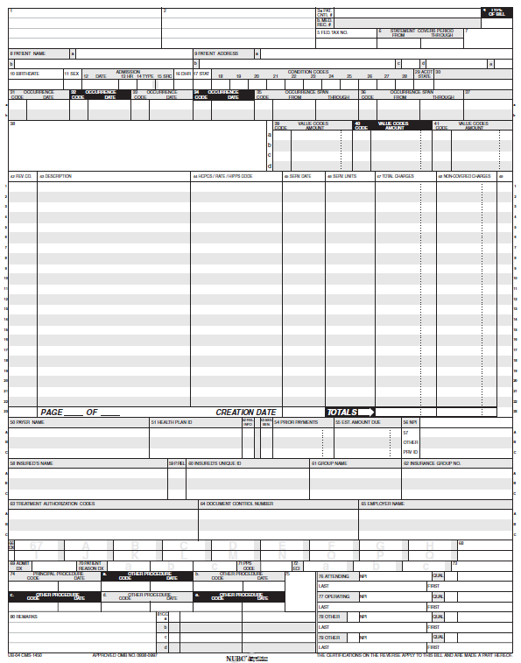

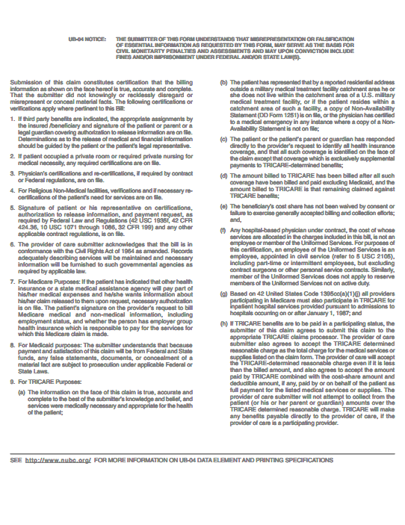

Field No. | Field Name | Description
1 | (Unnamed) | Enter the residential care home’s name, doing business as (DBA) address, city, state, zip code, and telephone number.  Please Note: The Billing Provider Address must be a street address. Do not use P.O. boxes or lock boxes.
2 | (Unnamed) | Not required
3a | Pat Cntl # | Enter the resident control number, if it is assigned by the residential care home. If one is not assigned, enter the resident’s last name.
3b | Med. Rec. # | Not required
4 | Type of Bill | Residential care homes should use type of bill (TOB) 021x. Please refer to the list below.  0210 Nonpayment/Zero  0211 Admit through Discharge Claim  0212 Interim-First Claim  0213 Interim-Continuing Claim  0214 Interim-Last Claim  0215 Late Charges Only  0217 Replacement  0218 Void
5 | Fed. Tax No. | Enter the residential care home’s federal tax ID number.
6 | Statement Covers Period From/Through | Enter the beginning and ending dates of the period included on this bill in MMDDYYYY format. Do not bill for more than one calendar month on a claim.
7 | (Unnamed) | Not used
8a | Patient Name | Not required
8b | Patient Name | Enter the name of the resident in the following order: last name, first name, middle initial.
9a | Patient Address | Enter the street address of the residential care home.
9b | Patient Address | Enter the city of the residential care home.
9c | Patient Address | Enter the state of the residential care home.
9d | Patient Address | Enter the zip code of the residential care home.
9e | Patient Address | Not required
10 | Birthdate | Enter the resident’s date of birth in MMDDYYYY format.
11 | Sex | Enter an “M” or “F” to indicate the resident’s gender.
12 | Admission Date | Enter the date of the resident’s initial admission to the residential care home or the date of the most recent readmission following a three-day hospital stay.
13 | Admission Hr | Not required
14 | Admission Type | Not required
15 | Admission Src | Enter a code indicating the point of origin (source) for this admission or visit. Refer to the NUBC Instruction Manual for code values.
16 | DHR | Not required
17 | Stat | Enter the code indicating the disposition or discharge status of the resident at the end of the period covered on this bill, as reported in Field 6, Statement Covers Period.  Refer to the NUBC Instruction Manual for code values.
18-28 | Condition Codes | Not required
29 | ACDT State | Not required
30 | (Unnamed) | Not required
31-34 | Occurrence Code/Date | Not required
35-36 | Occurrence Span  Code  From  Through | If applicable, enter the occurrence span code from the list below, for any medical leave of absence (MLOA) days or nonmedical leave of absence (NMLOA) days along with the associated dates of leave.  71 Prior stay dates - MLOA  74 First/last visit dates - NMLOA
37 | (Unnamed) | Not used
38 | (Unnamed) | Not required
39-41 | Value Codes  Code  Amount | Enter value code 24 (Medicaid rate code) along with the total charges amount of the claim. (Note: The actual payer is DTA, but the Commonwealth uses the MassHealth claims payment system to process claims on behalf of DTA.)  Enter value code 80 for covered days and the number of covered days.  If a resident has a resident liability amount, on a separate line, enter value code FC and the resident liability amount.
42 (Lines 1-22) | Rev Cd | Enter the applicable revenue code(s) as described below.  - Enter revenue code 100 for room and board days for residential care homes.  - Enter revenue code 183 for nonmedical-leave-of-absence (NMLOA) days.  - Enter revenue code 185 for medical-leave-of-absence (MLOA) days.  If a resident has MLOA days or NMLOA days in the statement billed period, bill the revenue code and the number of room-and-board days (excluding MLOA and NMLOA days) on the first line with the number of room and board days in Field 46. Then, enter the revenue code for the MLOA days or NMLOA days on a different line with the appropriate revenue code and number of days in Field 46. The total number of room-and-board days and MLOA or NMLOA days should equal the number of covered days. When billing only for leave-of-absence days, do not include revenue code 100 for room-and-board days.
42 (Line 23) | Rev Cd | Enter revenue code 0001.
43 (Lines 1-22) | Description | Enter the appropriate description of the revenue code.
43 (Line 23) | Page__of __ | Only single-page UB-04 claims are accepted. This should always be Page 1 of 1.
44 (Lines 1-22) | HCPCS/ Rates/HIPPS Code | Not required
45 (Lines 1-22) | Serv. Date | Not required
45 (Line 23) | Creation Date | Enter the date the claim form was submitted for reimbursement. This date cannot be earlier than the dates listed in field 6 of the UB-04.  This is a required field.
46 (Lines 1-22) | Serv. Units | For each claim line, enter the total number of covered accommodation days defined by revenue code requirements.
47 (Lines 1-22) | Total Charges | For each claim line, enter the total charges that apply to the revenue codes entered in lines 1-22 in field 42.  Do not deduct the resident’s resident-liability amount from the total charge of the claim.
47 (Line 23) | Total Charges (Totals) | Enter the total of all entries in this column on the bottom line.  This is a required field.
48 (Lines 1-22) | Non-Covered Charges | Not required
48 (Line 23) | Non-Covered Charges (Totals) | Not required
49 (Lines 1-23) | (Unnamed) | Not used
50A-C | Payer Name | Enter “MassHealth.” (Note: The actual payer is DTA, but the Commonwealth uses the MassHealth claims payment system to process claims on behalf of DTA.)
51A-C | Health Plan ID | Not required
52A-C | Rel Info | If applicable, enter the appropriate code for release of information. Refer to the NUBC Instruction Manual for code values.
53A-C | Asg. Ben. | Not required
54A-C | Prior Payments | Not required
55A-C | Est. Amount Due | Enter the amount estimated by the residential care home to be due from the indicated payer (estimated responsibility minus prior payments).
56 | NPI | Enter the residential care home’s 10-digit national provider identifier (NPI) if applicable. Residential care homes should enter the NPI only if they have an NPI on file with the MassHealth claims payment system. Otherwise, they must leave it blank.
57A-C | Other  Prv ID | If you do not have an NPI, enter your 10-character MassHealth provider ID and service location.
58A-C | Insured’s Name | Enter the name of the resident.
59A-C | P. Rel | Enter “self.”
60A-C | Insured’s Unique ID | Enter the resident’s 12-character MassHealth ID. (Note: The actual payer is DTA, but the Commonwealth uses the MassHealth claims payment system to process claims on behalf of DTA.)
61A-C | Group Name | Not required
62A-C | Insurance Group No. | Not required
63A-C | Treatment Authorization Codes | Not required
64A | Document Control Number (Line A only) | For Adjustments:  When requesting an adjustment to paid claims, and the frequency code on the Type of Bill is “7” (Replacement of Prior Claim), enter an “A” followed by the 13-character internal control number (ICN) assigned to the paid claim. The ICN appears on the remittance advice on which the original claim was paid. When submitting an adjustment, include all lines that were on the original claim. Correct the line that needs to be adjusted.  For Resubmittals:  When resubmitting a denied claim, enter an “R” followed by the 13-character ICN assigned to the denied claim. The ICN appears on the remittance advice on which the original claim was denied.
64B-C | Document Control Number | Not required
65 | Employer Name | Not required
66 | DX | Enter the qualifier that denotes the version of International Classification of Diseases (ICD) reported.
67 | (Unnamed) | Enter the ICD-CM diagnosis codes describing the principal diagnosis. Refer to the NUBC Instruction Manual for code values.
67(A-Q) | (Unnamed) | Enter the ICD-CM diagnosis codes corresponding to all conditions that coexist at the time of admission, that develop subsequently, or that affect the treatment received or the length of stay. Refer to the NUBC Instruction Manual for code values.
68 | (Unnamed) | Not used
69 | Admit DX | Not required
70(a-c) | Patient Reason DX | Not required
71 | PPS Code | Not required
72(a-c) | ECI | Not required
73 | (Unnamed) | Not used
74 | Principal Procedure  Code  Date | Not required
74 (a-e) | Other Procedure  Code  Date | Not required
75 | (Unnamed) | Not used
76 | Attending  NPI  Qual  Last  First | Enter the name and NPI of the physician who is primarily responsible for the care of the resident reported in this claim.
77 | Operating  NPI  Qual  Last  First | Not required
78-79 | Other  NPI  Qual  Last  First | Not required
80 | Remarks | Not required
81 (a-d) | CC | Not required

