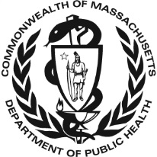
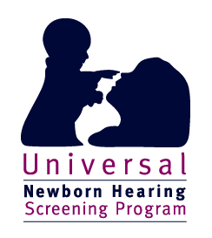
Resources in Massachusetts for hearing aids
Resources in
Massachusetts
for hearing aids

Massachusetts has an insurance mandate for hearing aids for children under the age of 21. Learn about the law and what it covers. Discuss your individual benefits with your employer. In addition, the Massachusetts Department of Public Health has a hearing aid program for infants and children that is based on financial need. More information can be found at: www.mass.gov/dph/newbornhearingscreening or by calling 800-882-1435. In addition, some individual audiological centers offer loaner hearing aids for their patients and access manufacturers’ programs as well.

Audiological Centers in Massachusetts with Loaner Banks

Audiology and Hearing Solutions, Inc., Audiology contact: Melonie Marple
drmarple@audiologyhearing.net

Baystate Medical Center, Audiology contact: Jeanne Coburn
Jeanne.Coburn@baystatehealth.org

Berkshire Medical Center, Audiology contact: Annie Lee
Alee4@bhs1.org

Boston Children’s Hospital, Audiology contact: Heather Saczynski
heather.saczynski@childrens.harvard.edu

Massachusetts Eye and Ear Infirmary, Audiology contact: Cheryl Glovsky
cheryl_glovsky@meei.harvard.edu

Tufts Medical Center, Audiology contact: Alison Packer
Alison.packer@tuftsmedicine.org

UMass Memorial Medical Center, Audiology contact: Kristen O’Conner
Kristen.oconner@umassmemorial.org

If your family’s audiology center is not on this list, you should still ask about financial assistance or other resources for hearing aids.

