**Massachusetts Department of Public Health | Bureau of Environmental Health**

Response to Community Concerns about

the Incidence of Brain Cancer near the former National Fireworks Site in Hanover

BACKGROUND

The former National Fireworks site encompasses about 240 acres in the Towns of Hanover and Hanson. It was first used to manufacture fireworks and pyrotechnics starting in 1907. It was then used for research and development and the manufacturing, storage, and testing of munitions for the U.S. Department of Defense during World War II until it closed around 1970. The site is currently owned by more than 40 different public and private entities. Much of the southern portion is managed by the Hanover Conservation Commission for conservation and recreation.

Past activities at the site resulted in the release of military munitions and various contaminants, primarily mercury and lead. Remediation is ongoing with oversight by the Massachusetts Department of Environmental Protection (MassDEP).

WHY IS THE MASSACHUSETTS DEPARTMENT OF PUBLIC HEALTH (DPH) EVALUATING HEALTH INFORMATION?

At the request of MassDEP, the Massachusetts Department of Public Health (DPH) spoke with officials from the Town of Hanover in June 2019 to learn about concerns raised by a resident of a possible elevation in brain cancer incidence near the former National Fireworks site.

DPH routinely conducts health data reviews across the state to respond to questions from residents and local health departments. To address concerns, DPH will review relevant health data collected by DPH.

WHAT TYPE OF HEALTH INFORMATION WILL DPH REVIEW?

DPH routinely collects health data across the state to monitor health and disease patterns in our communities. DPH will use data collected by the Massachusetts Cancer Registry to evaluate the pattern of brain and other nervous system cancers in the area surrounding the former National Fireworks site over a 30-year time period.

WHERE IS THE DPH EVALUATION AREA?

For health data reviews, DPH uses U.S. Census Bureau census tracts. Census tracts are small areas for which reliable disease rates can be calculated. DPH will focus on 8 census tracts that encompass the area within 2 miles of the former National Fireworks site. These census tracts are located in Hanover, Hanson, Pembroke, Rockland, and Whitman. See the map below.

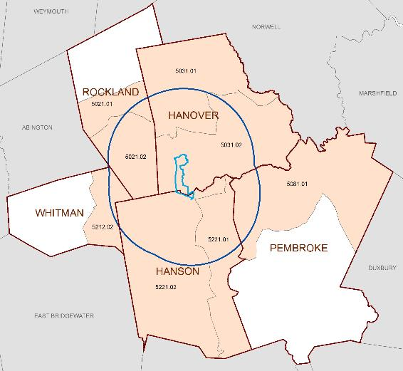

WHAT WILL THE RESULTS TELL US?

Diseases occur in the general population at a certain frequency and with certain characteristics. DPH will look to see if the pattern of this type of cancer appears unusual.

If the pattern appears unusual, DPH will provide additional support to residents and work with MassDEP on any follow-up actions.

Background information about cancer and the type of information DPH considers during routine screening-level reviews is available at <http://www.mass.gov/eohhs/gov/departments/dph/programs/environmental-health/cancer-in-ma-info-sheet.html>.

HOW WILL THE RESULTS BE SHARED?

DPH will share the findings in writing with the health agents in the towns of Hanover, Hanson, Pembroke, Rockland, and Whitman. The findings will also be available to the public on the DPH website. DPH staff will be available to answer questions from residents.

No personal health information will be shared, only summary information for the 8 census tracts in this screening-level review.

WHERE CAN I GET MORE INFORMATION?

For questions about health concerns or this review of health data contact:

Massachusetts Department of Public Health

Bureau of Environmental Health

Phone: 617-624-5757

[www.mass.gov/dph/environmental_health](http://www.mass.gov/dph/environmental_health)

If you are experiencing symptoms or have medical care questions, DPH always recommends consulting with your health care provider.

For questions about the ongoing remediation at the former National Fireworks site:

Massachusetts Department of Environmental Protection

Southeast Regional Office

Deborah Marshall-Hewlitt

Phone: 508-946-2888



Massachusetts Department of Public Health

Bureau of Environmental Health

250 Washington Street, 7th Floor

Boston, MA 02108

Phone: 617-624-5757 | Fax: 617-624-5777 | TTY: 617-624-5286

[www.mass.gov/dph/environmental_health](http://www.mass.gov/dph/environmental_health)

September 2019