APPLICANT QUESTIONS
Responses should be sent to DoN staff at DPH.DON@State.MA.US
While you may submit each answer as available, please
- List question number and question for each answer you provide
- Submit responses as a separate word document, using the above application title and number as a running header and page numbers in the footer
- When providing the answer to the final question, submit all questions and answers in one final document
- Whenever possible, include a table with the response
- Responses must be available in PDF and source document (Excel preferred for data and Word for narrative).

Factor 1a: Patient Panel Need
- Provide the APM contract percentage for Heywood Hospital and Athol Hospital using the table provided below for the most recent year available. Provide a year for the data.
APM Contract
percentages (for any system-affiliated Primary Care Physicians)
- ACO and APM Contracts
- Non-ACO and Non-APM Contracts

Heywood Healthcare is currently a partner in the ACO led by UMass Memorial Health. However, Heywood is currently not enrolled in any national Alternative Payment Model Programs.

- The regulation defines Patient Panel as “The total of the individual patients regardless of payer, including those patients seen within an emergency department(s) if applicable, seen over the course of the most recent complete 36-month period by the Applicant or Holder.”
  - Do the data provided for Heywood and Athol Hospitals represent the most recent complete 36-month period (FY2018-FY2020)? If not, please explain what years are represented and how you decided to utilize those years.
Yes, the data represented FY18-FY20
  - When combining the Patient Panel data from the Heywood Hospital and Athol Hospital for FY2018 to FY2020, will some patients be counted more than once?
Yes, if the Patient Panel data was combined for Athol and Heywood, there may be patients counted more than once.

- The application includes a breakdown of the Heywood Hospital and Athol Hospital Patient Panels by race/ethnicity. To better understand the race/ethnicity of the Patient Panel, briefly describe how race/ethnicity data are collected.
  - Is race/ethnicity self-reported?
Yes, race/ethnicity is self-reported.
  - Is the category Hispanic captured in the collection of ethnicity data? Provide the percent of Heywood Hospital and Athol Hospital patients identifying as Hispanic for FY2020.
Yes, the category Hispanic is captured in the collection of ethnicity data. The percentage of Hispanic patients for FY2020 is 3% for Heywood and 2% for Athol.

- The change in service form provides existing and proposed volume.
Existing Volume | Proposed Volume
5,400 | 6,480

In order to understand the impact of the Proposed Project on surgical volume:
  - Provide a year for the existing data and a year for the proposed volume.
The existing volume reported on the change in service form is from CY2019. (Data for CY2020 was skewed due to the mandatory weeks-long closure of the operating room for elective cases.)

  - By what year do you expect to reach the proposed volume?
2029
  - Where do you anticipate new patient volume will originate (within the Patient Panel, or new patients)?
As has happened recently when new service lines were added (e.g., bariatric surgery, anterior hip arthroplasty and ERCP), we anticipate that new case volume will come both from within the existing patient panel and from new patients who would otherwise have gone to a tertiary facility to receive needed procedural care.
- The Application states that Heywood will be increasing the number of operating rooms from four to six through the Proposed Project (pg.3).
  - How did you calculate the number of ORs needed to address Patient Panel need for surgical services? Include data, source and methodology used.
In 1961, the current surgical suite opened with six operating rooms. As equipment needs evolved over the ensuing decades, two of those six rooms had to be repurposed due to their small size: at only 200sf, OR 6 became a storage closet and at 283sf, OR 5 became a minor procedure room. Presently, we continue to use ORs 1 through 4, but they are all undersized by modern standards and only one of these rooms can safely and efficiently accommodate anesthesia, radiology, and special surgical equipment (such as the Hana table) at the same time. With the recent growth in case volume and in the variety of surgical procedures offered at Heywood, the challenges that derive from the small size of the operating rooms have become increasingly impactful.

- The application states that with only twelve admission bays in the Surgical Day Care Unit and eight in the PACU, patient care bottlenecks are all too common (pg.7).
  - How did you calculate the number of pre/post procedure bays needed to address Patient Panel need? Include data, source, and methodology used.
Perioperative Services currently has 20 combined pre/post rooms that support seven procedural rooms: four ORs, two endoscopy rooms and one pain procedure room. Even with this ratio of 2.9 pre/post rooms per procedural room (a ratio that far exceeds the FGI guideline of at least two combined pre/post rooms per OR), patient care bottlenecks are nonetheless relatively common. When this happens, it is typically the result of one or more PACU bays being tied up by patients who, though fully recovered, have to “board” in PACU until an inpatient bed becomes available. With a schedule that is typically comprised of a large volume of relatively quick procedures and a recovery room that has only eight bays in it, it does not take much for a patient care bottleneck to develop. It is for these reasons that a ratio of three combined pre/post procedure rooms per OR has been included in the plans for the new operating suite.

- The application states that case volume of surgical procedures grew 20% from 2016 to 2018 and that this increase in case volume brought Perioperative Services to peak capacity and maximal utilization (pg.5).
  - In order to demonstrate an increasing need for surgical services based on case volume, provide the number of patients receiving services and case volume for 2016, 2017, and 2018.
 | Individual Patients | Case Volume
2016 | 3,506 | 4,469
2017 | 3,624 | 4,709
2018 | 4,187 | 5,486
Total | 9,627* | 14,664
* 9,627 is the total number of individual (unique) patients who had one or more surgical procedure(s) completed at Heywood Hospital between January 1, 2016 and December 31, 2018.
  - Provide data to demonstrate maximum utilization of Perioperative services during this period.
To appreciate why the existing perioperative infrastructure is running at peak capacity and maximum utilization with the current demand for surgical services, consideration must be given to a multitude of factors:

- OR Size:
Two of the existing “six” ORs are only 200ft² and 283ft² and, as such, are no longer used as ORs. Ranging in size from 347ft² to 392ft², three of the remaining four ORs are too small to accommodate cases that require large equipment, such as the Hana table that is needed for anterior approach total hip arthroplasty cases. The existing perioperative suite has one operating room that can accommodate such cases, but at only 429ft², the footprint of this “large” OR is still one-third smaller than the 600sf that is currently recommended for cases requiring specialized equipment. In recent years, the operational challenges that derive from the small size of the existing ORs have been further exacerbated by service line expansions that have brought new procedures to Heywood Hospital, but that require large and bulky equipment, such as a bariatric surgery program and the endoscopic retrograde cholangiopancreatography (ERCP) service.

- Case Mix:
Across all of Perioperative Services, the average case length is only 47 minutes (patient in-room to patient out-of-room). With a large volume of short cases that have rapid turnarounds, it is not uncommon for patient care bottlenecks to occur during check-in in Surgical Day Care and/or during recovery in the Post-Anesthesia Care Unit.

- Daily Schedule:
As can be seen from the following chart, there has been significant growth in the average number of scheduled cases per day in Perioperative Services:
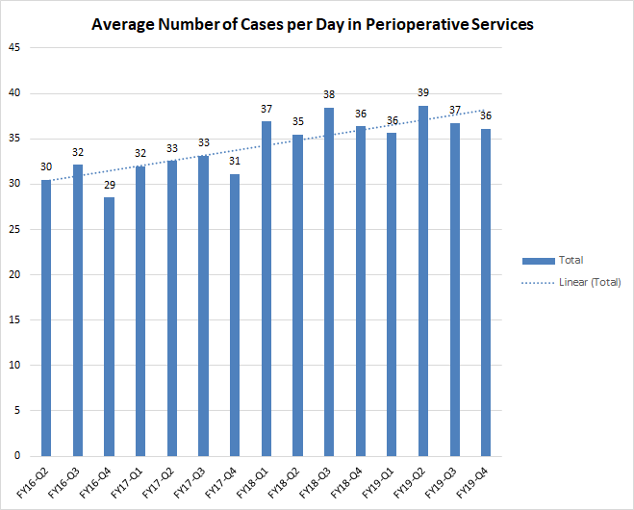

- OR Utilization:
In 2016, the operating room was staffed with three teams during the day (07:00 - 15:30) and one on-call team that was available after 15:30. Under this model, overall OR utilization during elective surgery hours was 79% in 2016, 84% in 2017 and, had the staffing model not changed, would have been 98% in 2018.* In order to achieve a more sustainable utilization level, the Perioperative Leadership team began experimenting with alternative staffing arrangements in 2018. Several configurations were trialed, including extended elective operating hours (07:00 - 17:00) and/or the addition of a fourth team to enable all four ORs to be used simultaneously. While these new staffing models did allow for some decompression of surgical cases and more sustainable levels of overall utilization (ranging from 62% to 90%, depending on the time period and staffing arrangement being trialed at the time), their ultimate impact was limited by two new challenges that presented after they were rolled out: 1. Case scheduling limitations imposed by the small size of the ORs (as detailed above) which frequently compromised the productivity of the fourth team; 2. Reluctance on the part of patients and surgeons alike to start elective surgery late in the afternoon.
*Calculated as follows: [(Total case minutes) + (Turnover time))] / [(Total staffed minutes)]

- Call Team Usage:
Use of the on-call team results in increased costs and, with limited personnel available during on-call hours, has the potential to make complicated cases and/or patients particularly challenging. Unfortunately, due to the aforementioned reasons, the on-call team has been used with increasing frequency in recent years in order to finish scheduled cases and/or accommodate urgent/emergent add-on cases.
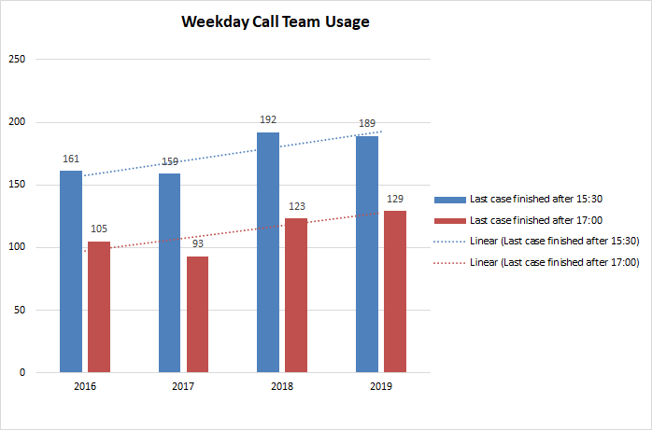

- The application states that the Applicant decided against the alternative to construct an ambulatory surgery center (ASC) because it would not address the needs of inpatients and emergency room surgical patients (pg.20).
  - In order to understand Patient Panel need for surgical services by patient status, provide a breakdown of 2019 Heywood OR volume by inpatient, outpatient, and emergency status.

Heywood OR
(5,430)
Inpatient | 13% (698)
Outpatient | 79% (4,273)
Emergency | 9% (459)
Total | 100%
Note: Of the 459 emergency cases, 79% (363 cases) were for inpatients and 21% (96 cases) were for outpatients.
- The application states the Proposed Project includes an increase in the number of the ORs from 4 to 6, which will reduce waiting times for procedures and increase the overall surgical volume (pg.15).
  - In order to understand Patient Panel need for surgical services, provide average wait times (with date) for procedures.

Surgical Specialty | Averaged Wait for Elective Procedure (in weeks)
Local/Minor procedures | 1-2 weeks
General Surgery | 3 weeks
Bariatric Surgery | 4 weeks
Orthopedic | 16-20 weeks
Interventional Pain | 2 weeks
GYN | 5 weeks
Urology | 2 weeks
Gastroenterology | 6 weeks

Factor 1b: Public Health Value
- The application describes wide-ranging disparities in income and poverty rates across the Service Area as well as health status and access problems across the Heywood Hospital Service area (pg.5). The application also states in response to the COVID1-19 pandemic, Heywood is focusing on the following areas: 1. Data for identifying and addressing health disparities 2. Equitable distribution of health care resources 3. Telehealth as a tool for expanding equitable access to care 4. Health care workforce diversity 5. Social determinants of health and root causes of health inequities (pgs.8-9).
  - How does the Proposed Project plan to leverage existing/new initiatives to identify and address healthcare disparities at Heywood Hospital and/or larger community related to the Proposed Project?
Healthcare disparities are identified and addressed through the triennial Community Health Needs Assessment(CHNA). The CHNA is a comprehensive qualitative and quantitative assessment tool which presents issues related to the health, wellbeing and related factors that impact the health of those living in Heywood Healthcare’s catchment area. This study is a collaborative effort conducted by Heywood Healthcare’s Heywood Hospital and Athol Hospital; the Montachusett Regional Planning Commission; UMASS Memorial Health Alliance Clinton Hospital; The CHNA 9 Group; and John Snow, Inc.

Various other organizations and individuals also contribute to this effort, including community-based organizations and health service partners, as well as advocacy efforts from hospitals, health centers, rehabilitation centers, primary care physician and specialty networks, public health networks and local schools.

Based on study findings and identification of prevalent health needs, a Community Health Improvement Plan or CHIP is formulated, with initiatives carried out over the next three years. Heywood Healthcare works closely with community partners and the CHNA9, to address regional disparities.
Heywood Hospital will use regional health disparity information to inform outreach initiatives to ensure access for those needing surgical care.

Factor 1e Community Engagement
- In order to better understand the Applicant’s community engagement process during the development of the Proposed Project please complete the following table:
Event/Meeting | Date Completed | Attendance (if applicable)
Patient Family Advisory Council | 09/22/2020
Patient Family Advisory Council | 10/20/2020
Community Based Advisory Committee | 05/24/2021
Surgical Pavilion – Neighborhood Session | 06/16/2021
Community Based Advisory Committee | 06/21/2021
Surgical Pavilion Community Reception | 07/27/2021

  - Briefly explain how the PFAC and Multicultural Committee engaged for the purposes of the Proposed Project are representative of the Patient Panel (e.g., demographics—age, race/ethnicity, gender/gender identity, veterans status, disability status)?
Refer to the attached Demographic Sheet for PFAC Heywood.
The Multicultural Task Force has evolved this year into Heywood's DEI Diversity, Equity and Inclusion Committee. Through this evolution, we have membership not only from the various hospital departments but have added previous patients, families, community agencies attempting to secure representation from all groups within our catchment area. Membership includes but not limited to: Representation from the following: Ahmadiyya Muslim Community, Care Central VNA,City of Gardner, Community Health Center,Congressman McGovern’s Office, Congresswoman Trahan’s office, GAIT-Gardner Area Interagency Team, Gardner CAC, Disability Commission Heywood Healthcare-Athol & Heywood Hospital-FS,HMG,HR,MCS,Pt Reg,PD,RS,SS,Telehealth Program, Genesis Healthcare, Heywood-Wakefield Commons, Leominster Haitian American Community Center, LUK ,Massachusetts Department of Mental Health, MOC-Making Opportunity Count, Montachusett Suicide Prevention Task Force, North Central Mass Minority Coalition, Open Sky, Patient Family Advisory Committee, Spanish American Center , Three Pyramids Inc, United Hmong of Massachusetts, Wachusett Medical Reserve, Wachusett Rehab & Nursing Center. Attendees are also representative of the LGBTQI+, veterans, disabiled, elderly, youth etc.
Our Multicultural Service Department conducts an annual Language Needs Assessment (LNA) and works with the committee in development of strategies to best meet the needs of these populations. We serve on various Boards, committees and subgroups. Currently our HR Department is working on additional educational opportunities identified by staff on working with DEI initiatives.
This committee is also part of the Montachusett Suicide Prevention Task Force. This Task Force is a member of the Mass Coalition for Suicide Prevention and it focuses on reducing suicide in our region.

Factor 1f. Competition
- The application states as more patients are able to receive procedural care at Heywood Hospital, fewer referrals to higher-cost tertiary centers will need to be made (pg.6).
  - To better understand the impact of the Proposed Project on access to care in a lower cost setting, provide the number of patient referrals to higher-cost tertiary centers, if possible.
Surgical Cases Performed at Other Healthcare Facilities
(see attached PDF for details)
FY2017 | FY2018 | FY2019
2,309 | 2,053 | 2,016

Factor 2 Delivery System Transformation
- The application states that patients will be provided with linkages to address identified social determinants, and assigned a community health worker to assist with unanticipated challenges (pg.16).
- In order to better understand the impact of the Proposed Project on Delivery System Transformation, provide a brief description of the social determinants of health (SDoH) screening process, including when and how patients are screened, screening domains, and the referral and tracking process for positive screens related to SDoH.

Patients are screened in various ways to identify potential needs upon entry to the hospital. Please refer to the attached policies from the Department of Social Services. Transportation is also considered a social determent in this rural area. Department of social services works closely with the local community agencies to secure transportation for those in need. For those patients who are not financially able to secure legal services for guardianships, the hospital covers the cost and secures an appropriate discharge plan.
- Is Heywood Healthcare affiliated with any accountable care organization (ACO)? If so, provide the name and number of member patients.
The name of ACO is UMass Memorial Accountable Care, Inc. Total number of member patients is 45,580. Total number of Heywood member patients is 5,096.

