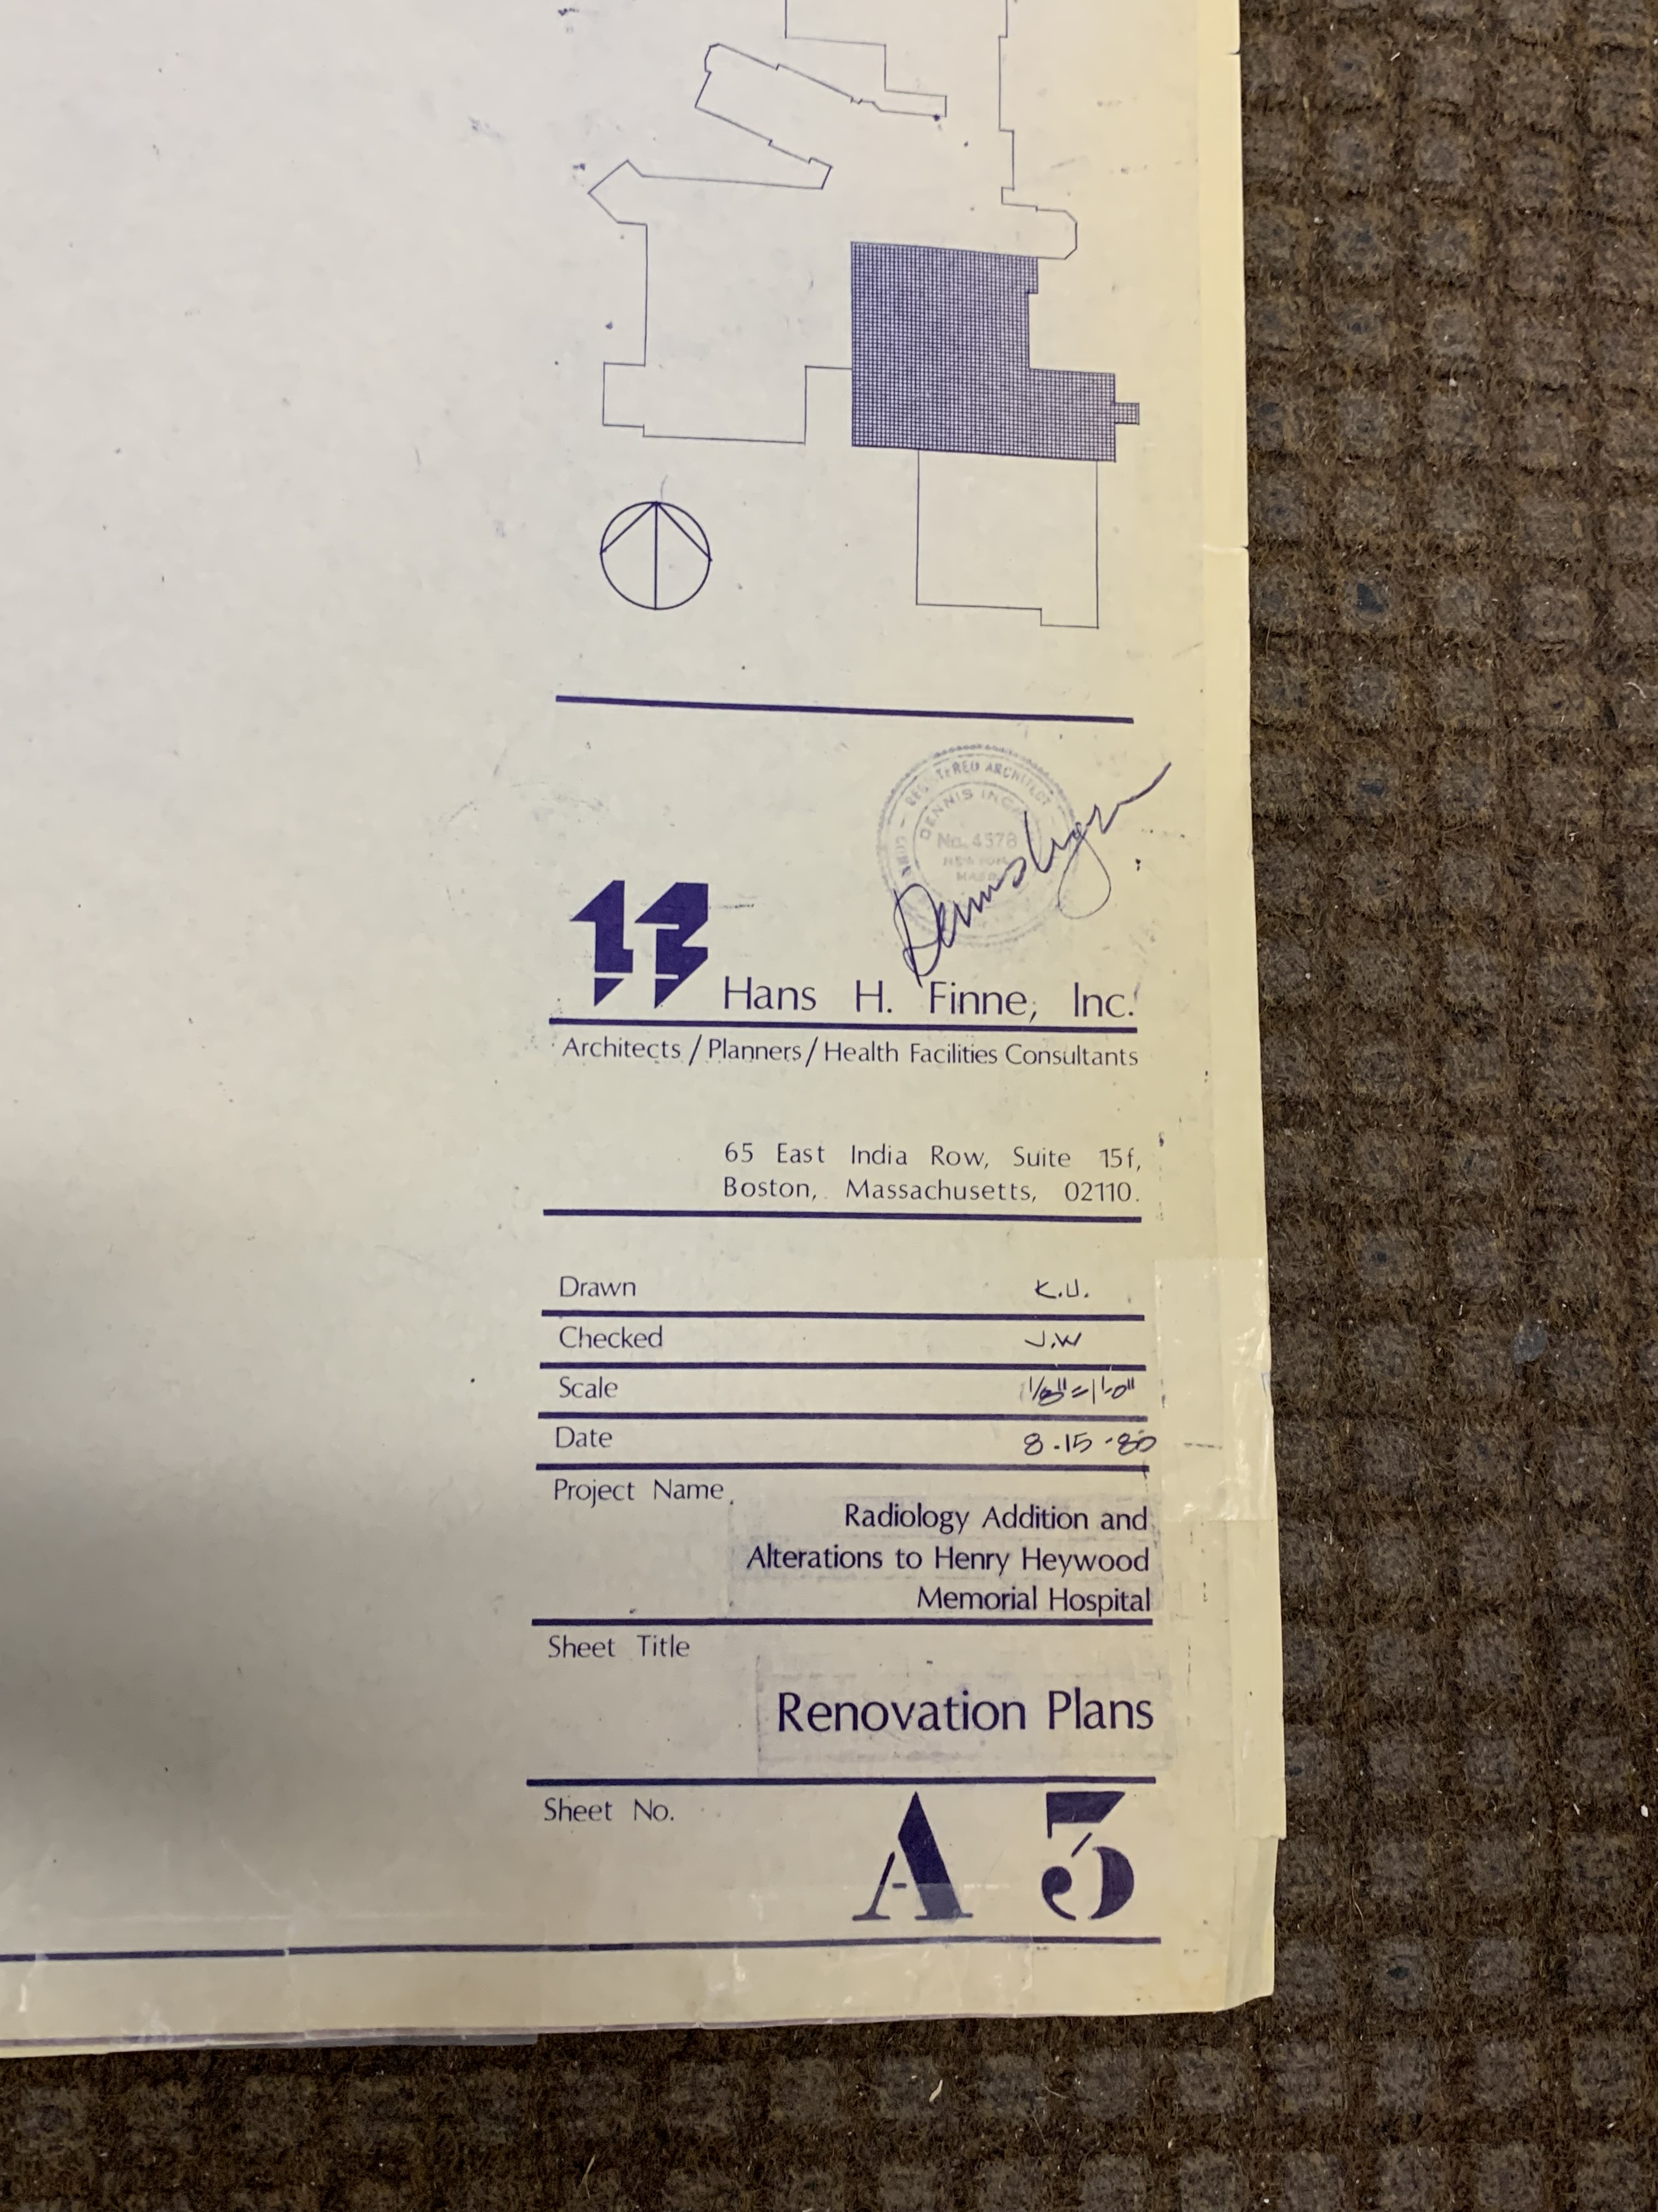
Figure 1 Attached are the pictures of designs for the radiology addition in 1980, which show the existing at that time ORs. According to our director of facilities, OR 6 was converted to storage and OR 5 was converted to a minor procedure room between 2000-2004.
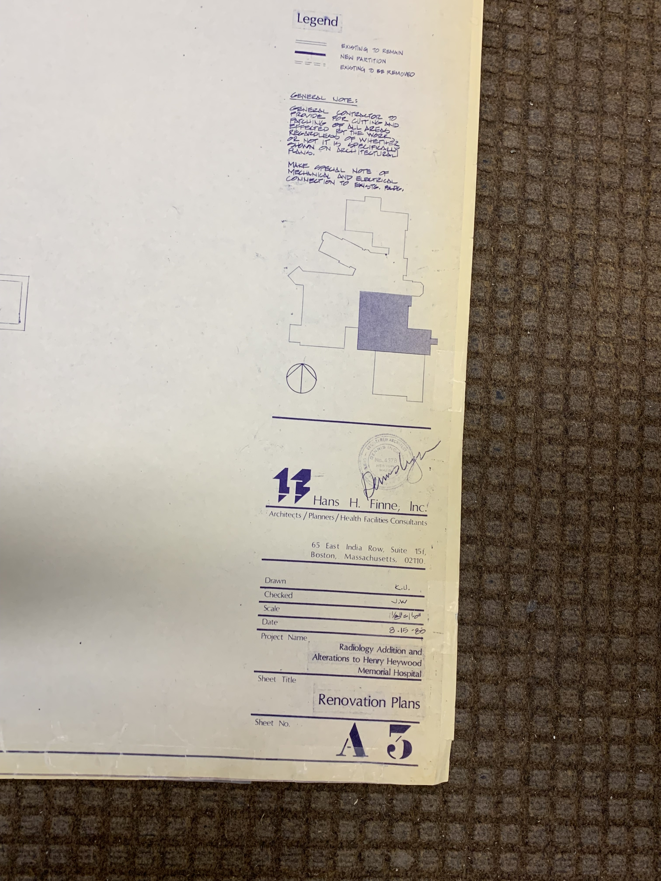
Figure 2 Attached are the pictures of designs for the radiology addition in 1980, which show the existing at that time ORs. According to our director of facilities, OR 6 was converted to storage and OR 5 was converted to a minor procedure room between 2000-2004.
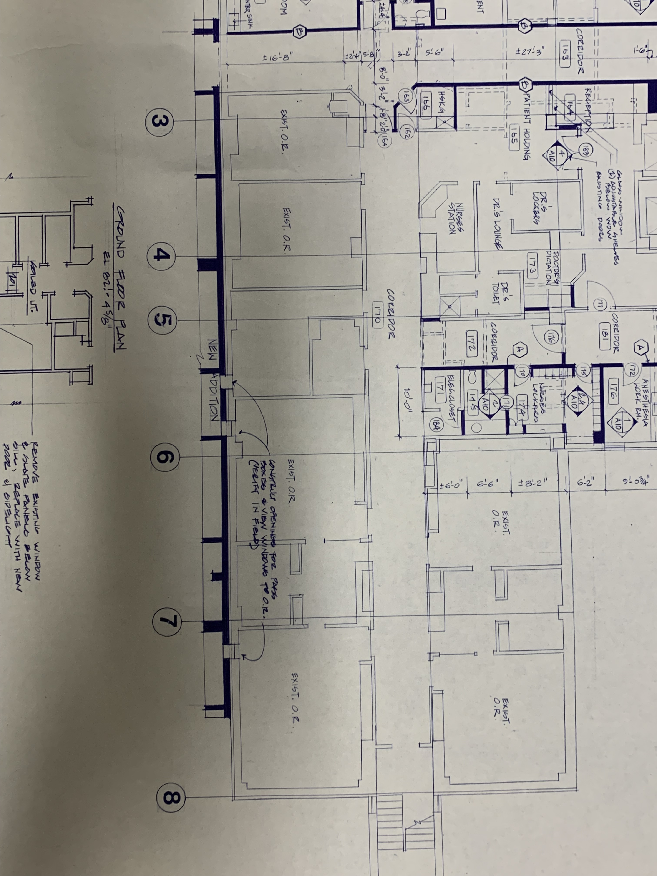
Figure 3 Attached are the pictures of designs for the radiology addition in 1980, which show the existing at that time ORs. According to our director of facilities, OR 6 was converted to storage and OR 5 was converted to a minor procedure room between 2000-2004.
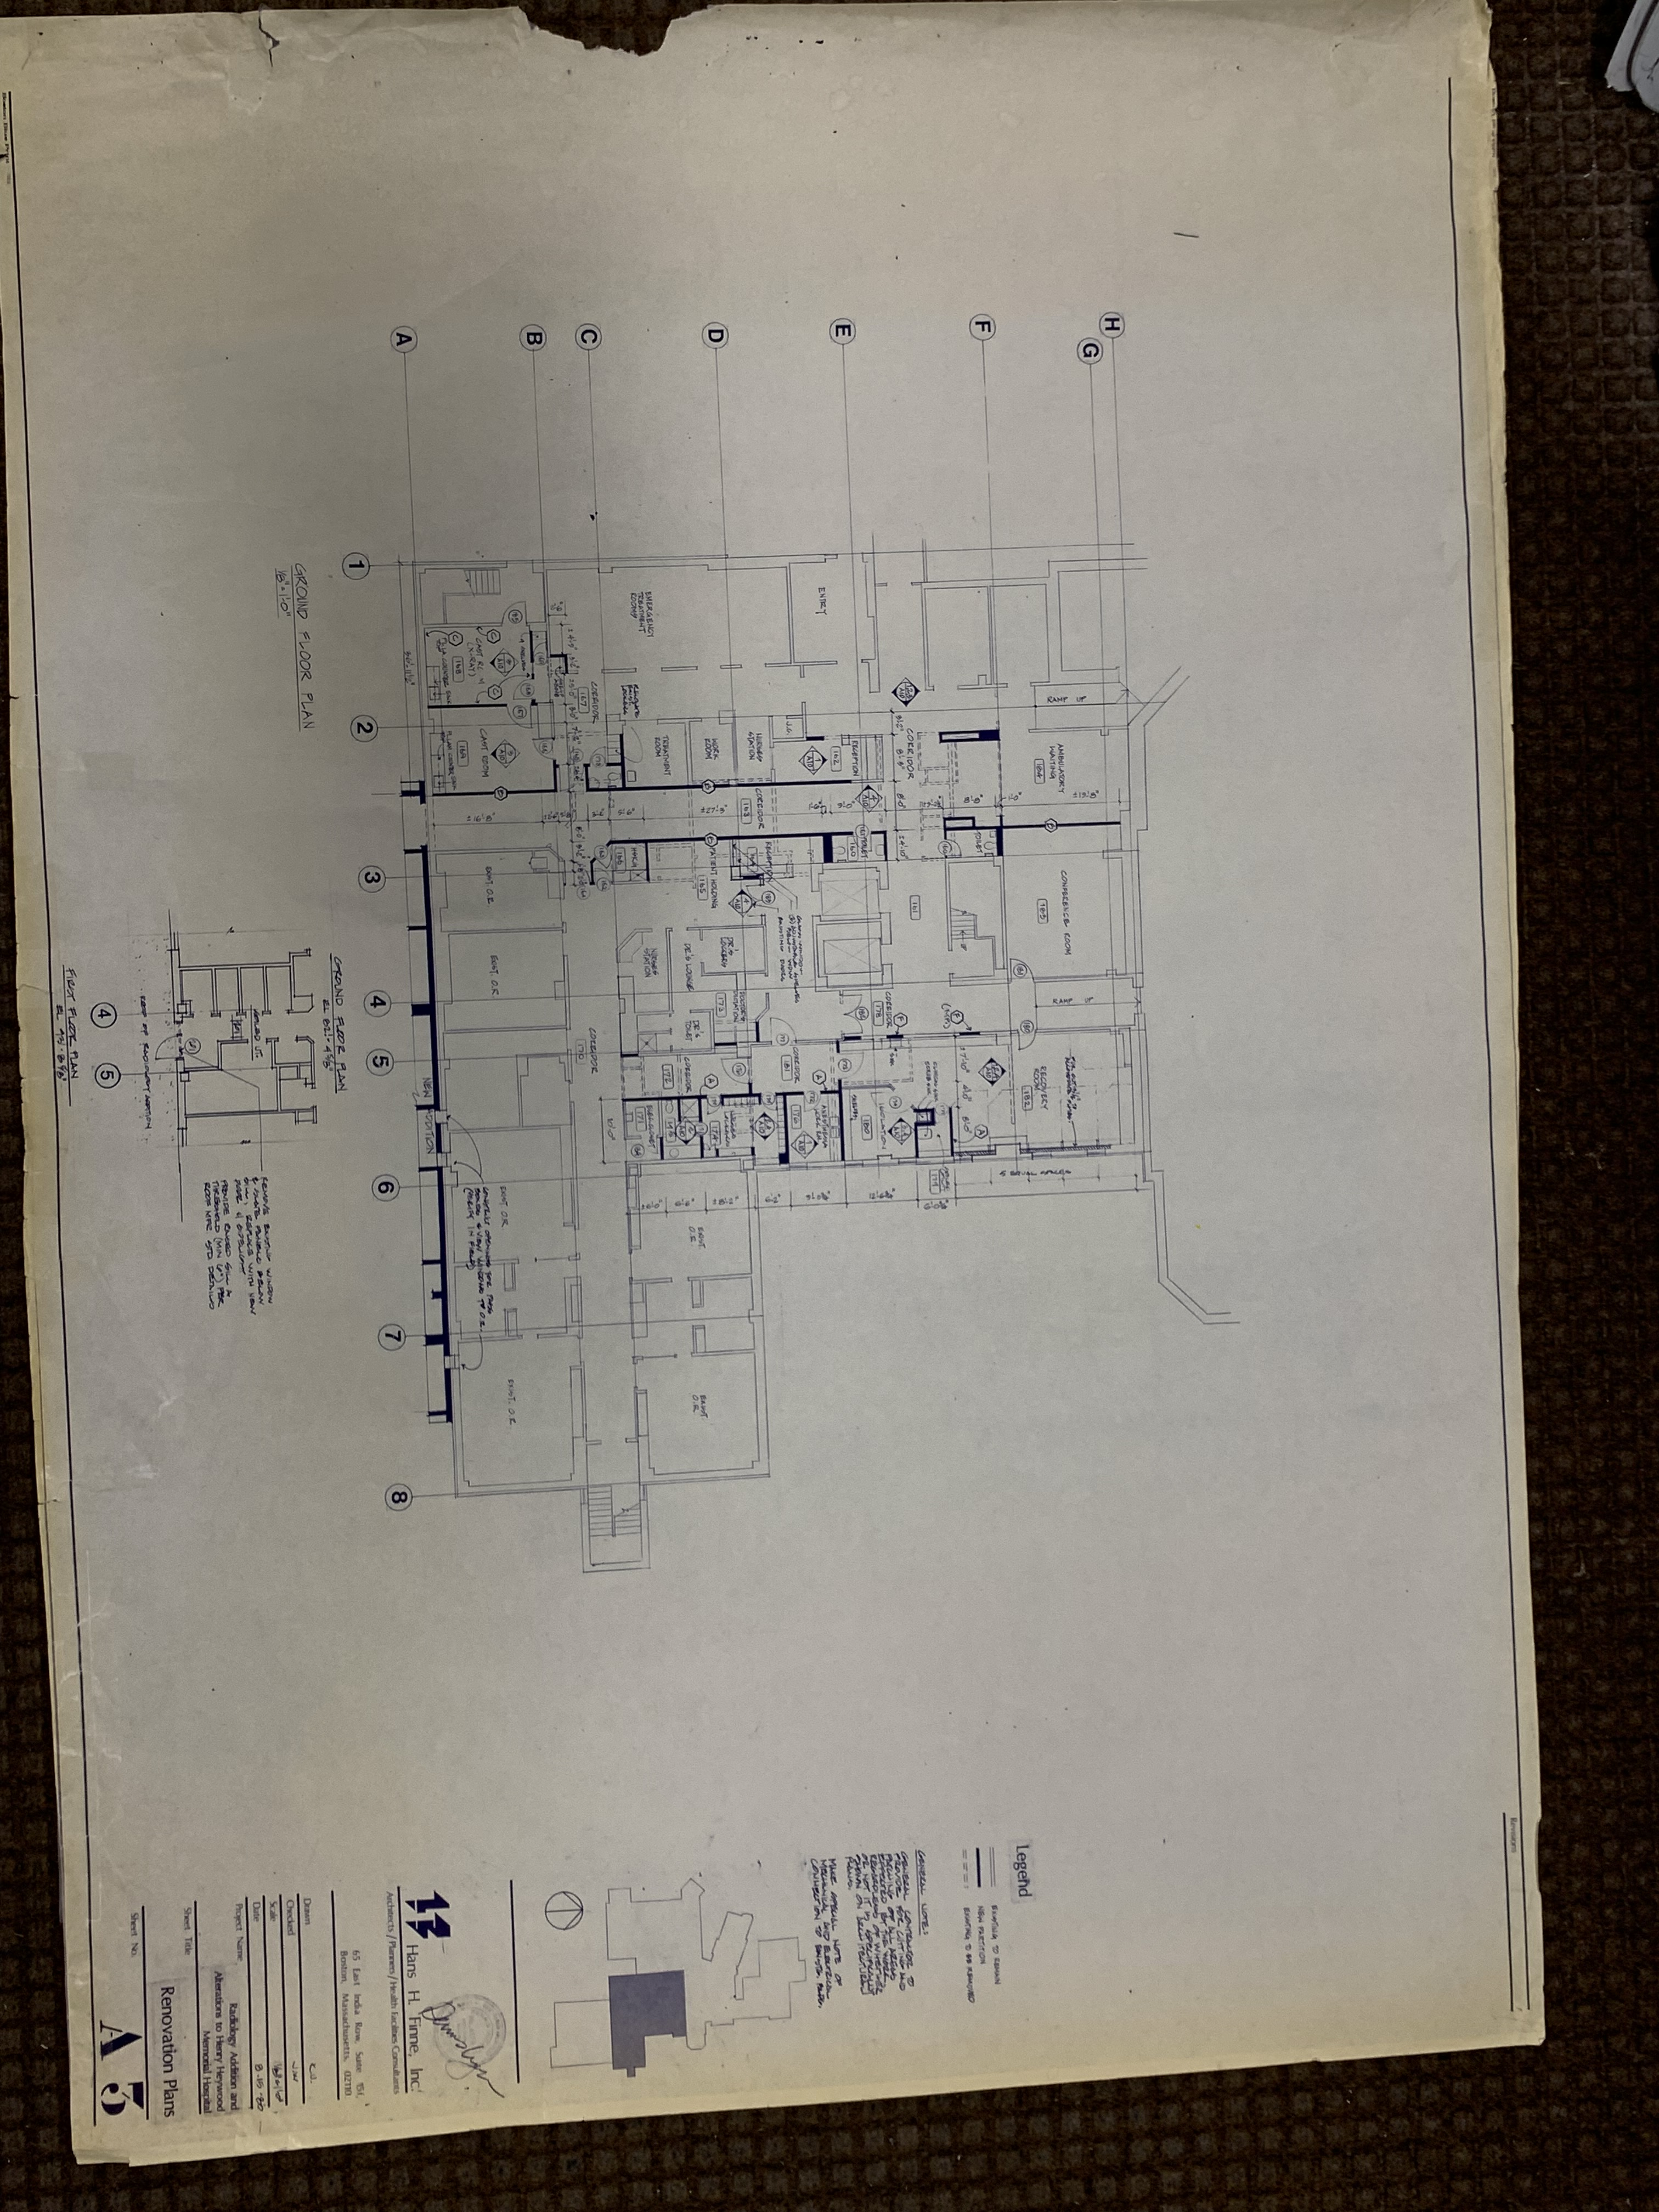
Figure 4 Attached are the pictures of designs for the radiology addition in 1980, which show the existing at that time ORs. According to our director of facilities, OR 6 was converted to storage and OR 5 was converted to a minor procedure room between 2000-2004.

