

Winchester Hospital Endoscopy Center Expansion- Determination of Need

Winchester Hospital CBAC Special Meeting
October 7, 2025 Catharine Robertson,
Vice President, Ambulatory Services,
Winchester Hospital
LeighAnne Taylor,
Manager, Community Benefits and Community
Relations, Winchester Hospital


Agenda

- Overview: Current State and Future Goal

- Proposed Expansion Plan
- Timing

- Project Questions
- CBAC role in MA Department of Public Health Determination of Need process



Overview: Current State and Future Goal

WH Gastrointestinal Service Line

Supporting our Community

Why is this an initiative?
  - Access across the network
  - BILH Performance Network (BILHPN) Affiliated Practices – up to 12
month wait times

Goal: Reduce wait times for cancer screening colonoscopy
  - Create access through physician capacity and physical capacity at the Winchester Hospital Endoscopy Center at 10P Commerce Way, Woburn, MA
  - Physician capacity has been built
  - Winchester is budgeted for 11,500 cases in FY2026 with a max capacity of 12,000
  - This expansion will allow capacity to increase to 19,000

Winchester Hospital GI Service Line

Strategic Expansion Plan

- Winchester Hospital continues to outpace budget YOY in OP GI procedures at the 10P Endoscopy Center.
 | Actual | Budget | Variance | % Budget | Prior Year | % PY
FY 2024 | 8,387 | 6,632 | 1,755 | 126% | 6,295 | 133%
YTD April 2025 | 6,002 | 4,309 | 1,693 | 139% | 4,440 | 135%
- The current center, leased through Cummings Properties, is in need of renovation to keep up with the growing demand for GI services.
- Winchester works with three practice groups Winchester
Gastroenterology, DHA, and Atrius at this location.
- Winchester has partnered with BILHMG to hire an additional provider for Win GI starting in FY2026, increasing the practice to 2.0 FTE physicians and 4.0 FTE total providers.
- Market data continues to show growth in the OP GI sector directing Winchester to look for an opportunity to expand services.

Proposed Expansion Plan & Timing

Winchester Hospital Endoscopy Center

Current vs. Future State

  - Renovation of existing space and
approximately 7500 sq. ft. addition
  - Expansion plan increases procedure rooms from 5 to 8
  - Increases pre-op and post-op spaces from 15 to 22
  - Increases scope processing capabilities
  - Relocates Winchester GI office to the new Center, enhancing provider efficiency
  - Potential 50% increase in scheduling capacity

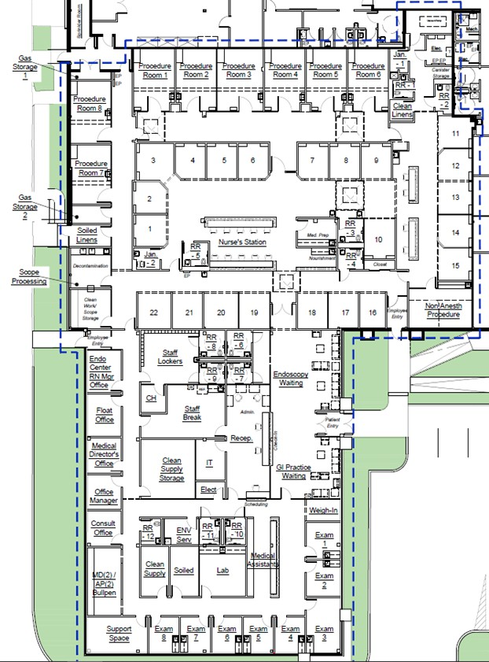

Winchester Hospital FY26-27

Strategic Initiatives – GI Expansion - Timeline

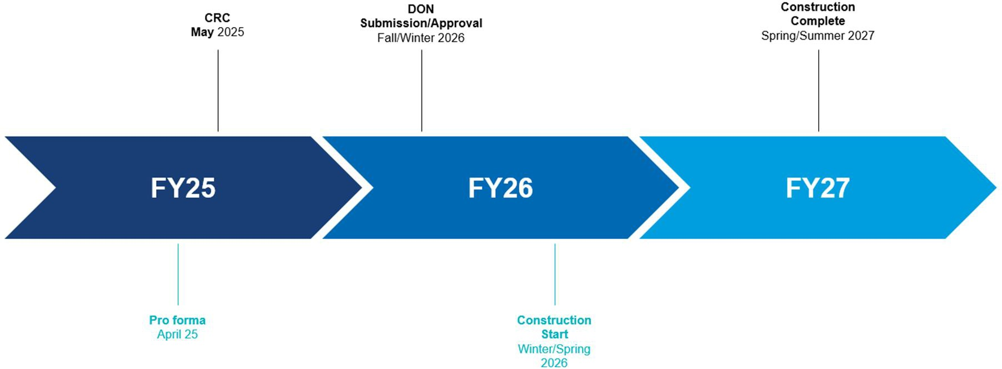

Project Questions

Endoscopy Expansion Determination of Need

Background

  - A Massachusetts Determination of Need (DoN) is a state-mandated regulatory program that requires healthcare facilities to get approval from the Massachusetts Department of Public Health (DPH) for significant capital projects, substantial changes to services, or other major changes that could affect the state's healthcare system.

  - The DoN program aims to promote population health, encourage competition, ensure equitable resource access, and advance cost containment and transformation goals for the healthcare delivery system.

  - Community-Based Health Initiatives (CHI): DoN holders are typically required to spend a specific amount on primary and preventive healthcare services for underserved populations as part of their approved plan

Winchester Hospital CBAC role

Community Health Investment timeline

  - The CBAC role in the DoN process includes:
    - Advisory role in the Community Health Investment (CHI) process
    - Voice of the community in attesting to Winchester Hospital’s
commitment to community engagement and collaboration

Community Health Investment (CHI) timeline:
    - December CBAC meeting: discuss health priority area of focus
based on the 2025 Community Health Needs Assessment
    - March CBAC meeting (or special meeting dependent on MA DPH filing timeline): confirm identified community partner and evidence-based program to receive CHI funding
    - 3 months post-DoN approval from MA DPH – Disbursement of CHI
funds into the community

Winchester Hospital CBAC role

Next steps

- CBAC members to complete Community Engagement Partner
Assessment form via the state website by October 14, 2025.
link: https://www.mass.gov/forms/community-engagement-partner-assessment

- Attend December and March CBAC meetings to advise and support the next steps of the CHI process

Determination of Need and Community Health Investment Questions

Appendix

Winchester Hospital Endoscopy Center

Proposed Expansion Timeline

Winchester Hospital Endoscopy Center

Proposed Floor Plan

