Safety Tips for Pool Owners

Swimming is a fun activity and a great way to keep cool during the hot summer months, but it’s important to know how to stay safe in and around water. If you own a pool, you have the power to make sure your family and the kids in your neighborhood are safe.

Drowning is swift and silent—there may be little splashing or cries for help. It can take as few as 20 seconds to sink below the water and only minutes to drown, but you make sure the kids in your neighborhood are safe by following these tips.

- Install a 4 foot high fence around your pool that separates it from everything around it, even from your house.

- Make sure the fence is made in a way that a child cannot climb. For example, chain link fences are easy for most young children to climb.

- Use gate that closes and latches by itself whenever it is opened, and make sure it is on the inside the gate, out of reach of small children.

- Make your pool drains safe. To keep kids from getting pulled into the pool drain and trapped there, you can install special drain covers or something called a “safety vacuum release system” (SVRS).

- Teach everyone in your house how to dial 911 in an emergency.

- Learn how to do CPR on a child. CPR classes are offered by the Red Cross, local hospitals, and many other organizations.


Here are some other helpful Web sites:
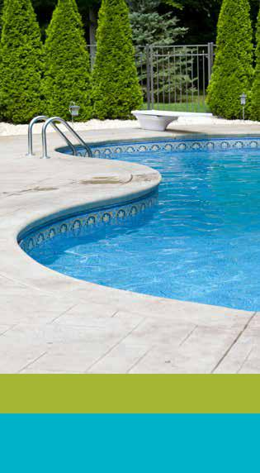
www.cpsc.gov/cpscpub/pubs/chdrown

www.liveandlearn.com/pools

www.poolsafely.gov

The Massachusetts Injury Prevention & Control Program Visit our website www.mass.gov/dph/swimsafety for more information, or call us at 617-624-6060.

AUG 2016

