November 1, 2022

Chair Michael Rodrigues

Senate Committee on Ways and Means

24 Beacon Street

Room 212 – State House

Boston, MA 02133

Chair Aaron Michlewitz

House Committee on Ways and Means

24 Beacon Street

Room 243 – State House

Boston, MA 02133

Governor Charles D. Baker

24 Beacon Street

Room 280 – State House

Boston, MA 02133

Senator Julian Cyr, Chair

Joint Committee on Mental Health, Substance Use and Recovery

24 Beacon Street

Room 301-E – State House

Boston, MA 02133

Representative Adrian Madaro, Chair

Joint Committee on Mental Health, Substance Use and Recovery

24 Beacon Street

Room 33 – State House

Boston, MA 02133

Senator Cindy F. Friedman, Senate Chair

Joint Committee on Health Care Financing

24 Beacon St.

Room 313

Boston, MA 02133

John J. Lawn, House Chair

Joint Committee on Health Care Financing

24 Beacon St.

Room 236

Boston, MA 02133

Secretary Terrence Reidy

Executive Office of Public Safety and Security

1 Ashburton Place, Suite 2133

Boston, MA 02108

Secretary Marylou Sudders

Executive Office of Health and Human Services

1 Ashburton Place, 11th Fl.

Boston, MA 02108

Dear Senate Clerk Hurley and House Clerk James, Governor Baker, Chairs Cyr and Madaro, and Secretaries Reidy and Sudders:

We write as the co-chairs and legislative members of the Restoration Center Commission (“Commission”) established under *An Act Relative to Criminal Justice Reform*, Chapter 69 of the Acts of 2018 (“Act”), as amended by Section 142 of Chapter 126 of the Acts of 2022. The Act directs the Commission to provide an annual report to the legislature by November 1.

The attached Year Four Findings and Recommendations were compiled by Commonwealth Medicine of UMass Chan Medical School on behalf of the Commission and detail the Commission’s activities from May 2021 through April 2022, including the following:

* Commission meetings, administration, and activities in Year Four,
* The final Restoration Center pilot program service model, and
* Findings and recommendations for future years.

During the period May through October 2022, the Commission met once and completed the following activities.

* Secured an additional $1.65 million for the development of a Restoration Center; the funds were made available from the federal FY 2022 Congressional Directive Spending Projects through Funding Opportunity No. FG-22-099.
* Posted a Request for Proposals (RFP) to procure a Restoration Center vendor, held a bidders’ conference for prospective bidders, responded to questions from prospective bidders, and developed a process for reviewing proposals. No proposals were submitted in response to the RFP.
* Posted a Request for Information (RFI) to learn what vendors saw as the barriers that prevented them from submitting a proposal in response to the RFP, analyzed the two responses to the RFI, and developed a plan for modifying the RFP required scope of services.

We look forward to reporting to you a year from now on the successes and lessons learned in implementing the Middlesex County Restoration Center pilot.

Sincerely,

Co-Chair, Sheriff Peter J. Koutoujian Co-Chair, President and CEO Danna Mauch, PhD

Middlesex County Massachusetts Association for Mental Health

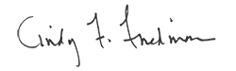 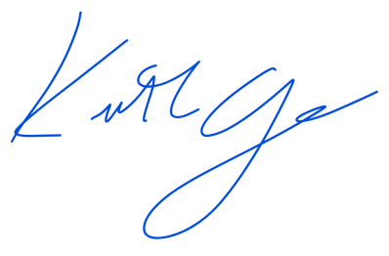

Senator Cindy F. Friedman Representative Kenneth Gordon

cc: Senate President Karen Spilka

House Speaker Ronald Mariano