**Middlesex County Restoration Center**

**Monday, December 11, 2018**

**Restoration Center**

**Bexar County, Texas**

**Notes**

Attendees: Co-Chair Danna Mauch, Senator Cindy Friedman; Representative Kenneth Gordon; Scott Taberner, MassHealth; Kati Mapa, National Alliance on Mental Illness; Mandy Gilman, Association for Behavioral Healthcare; Marisa Hebble, MA Trial Courts; Rebecca Tsopelas, Arlington Police Department; David Ryan, Middlesex Sheriff’s Office; Catia Sharp, Middlesex Sheriff’s Office.

9:00AM TOUR & OVERVIEW OF BEXAR COUNTY RESTORATION CENTER[1]

*David Pan, ACSW, LCSW, Community Initiatives Liaison*

*Marisol Lucio, External Relations*

**Texas behavioral health system**

* Texas Health and Human Services contracts with 37 local mental health authorities (LMHA’s) and two local behavioral health authorities (LBHA’s). In large urban counties like Bexar, these coincide with county boundaries.[2]
  + LMHA’s provide the following basic services at a minimum:[3]
    - *Case management*: services that help an adult, child or adolescent, or caregiver gain and coordinate access to needed care and services – primarily site-based.
    - *Pharmacological management*: services to treat the signs and symptoms of mental illness through use and management of psychoactive drugs – provided by a physician or other prescribing professional.
    - *Counseling (Cognitive Behavioral Therapy (CBT))*: services to reduce symptoms of mental illness and increase ability to perform activities of daily living, including individual, family, and group CBT and recovery or treatment planning to improve recovery and resiliency.
    - *Counseling (Cognitive Processing Therapy (CPT))*: services to reduce or remove symptoms of post-traumatic stress disorder in adults, including military veterans – services include individual CPT and recovery or treatment planning to improve recovery and resiliency.
    - *Medication training and support*: services to provide information about medications and their possible side effects.
    - *Psychosocial rehabilitative services*: services to help a person develop and maintain relationships, occupational or educational achievement, independent living skills, and housing – services include social, educational, vocational, behavioral, and cognitive interventions provided by a person’s treatment team.
    - *Skills training and development*: training to help a person with serious symptoms of mental illness get and improve skills to successfully participate in the community.
    - *Crisis services*: vary by LMHA.[4]
* The Bexar County LMHA is the Center for Health Care Services (CHCS[5]), sponsored by the county hospital.[6] More on CHCS below.
* Community Centers are quasi-governmental organizations sponsored by government agencies like counties, hospitals, etc. and contract with the state to develop and provide services.
  + Must provide certain services, including crisis services, crisis hotline, and crisis response (which, at the Restoration Center in Bexar County, is a 24/7 mobile crisis team)

**Center for Health Care Services (CHCS)**[7]**[8]** runs the Restoration Center

* 501(c)3 nonprofit
* Funding (over 100 sources): $1.2 million in 2003 (2016 funding below[9])
  + 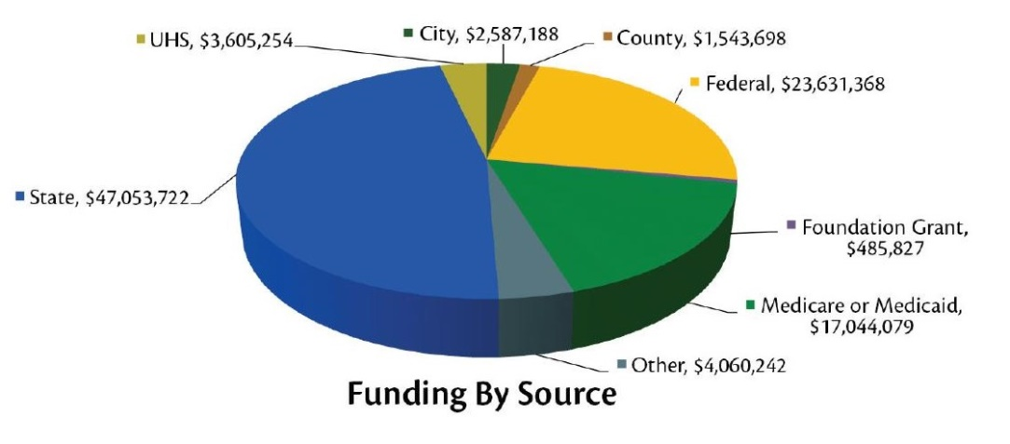State govern
  + State government
    - Medicaid billing
    - Health and Human Services (through LMHA status)
  + Federal government – Medicare billing
  + Bexar County
  + Private insurance billing
* Services:
  + Not a lot of private providers in SA
  + 12 locations [10]
    - *4 outpatient clinics* serving ~6,500 people
      * One focusing on specialty programs
      * One focusing on high utilizer programs (including Assertive Community Treatment (ACT))
      * Use the Adult Needs and Strengths Assessment (ANSA)[11] to determine appropriate level of care
    - *Clinic at The Courtyard* at Haven for Hope
    - 2 *HIV* clinics
    - Calidad *day-hab and employment*
    - *Children’s* behavioral health campus and 3 satellite offices
    - Josephine Recovery Center – crisis follow-up/relapse prevention, *case management*, medication management
    - *Court-based forensic unit* – jail-based criminal justice residential treatment, competency evaluation and restoration, jail diversion and trauma recovery
    - *Long-term care services* site
* Outcomes: 2016 8-year cost savings analysis estimated $96,740,479 in total cost savings over 7 years, with $14,898,162 in 2016 alone[12]

**The Bexar County Restoration Center**

* Target population
  + A study of who was in county jail found that low-level offenders with mental illness and substance use disorder (MI/SUD) are those who are friendly faces (requesting copy)
  + ~2,000 individuals served per month
    - ~80% uninsured (compared to ~20% uninsured rate for Bexar County as a whole)
    - Diverted ~600 people last year from jail for mental health, ~60-70 for SUD (diversion is both pre- and post-arrest)
    - Most from Bexar – some officers come from other counties
* Services
  + **Coordination** between all of the below services (like notifying your CHCS outpatient provider when you arrive at crisis stabilization, for example)
  + **Medical clearance[13]** – Minor Medical Clinic
    - Provide minor medical clearance for crisis and detox programs, with immediate access for law enforcement
    - At first, they had RN’s doing it, but they were rejecting a lot of people because they couldn’t treat the chronic medical conditions people were showing up with, even though those conditions were non-acute (hypertension, diabetes, etc.)
    - So now they use EMT’s to do medical clearance because the EMT’s use an ED level of care for their determination – they send people to the ED if needed, but this only happens about 1-2 times per week out of 500 total clients per week
  + **Crisis stabilization**
    - *Target population*: Both voluntary (walk-ins”) and involuntary (police dropoff)
      * By law, involuntary “emergency detention” has to be seen within 12 hours by a psychiatrist
      * Used to be 50/50 voluntary/involuntary; now 80-90% involuntary
    - *Services*: 16-bed clinic with 24-hour assessment and intervention services, crisis resolution, extended observation, and coordination into alternative care[14]
      * Goal is to be seen by LMHP within 15 minutes
      * Medical clearance by PA
      * Crisis warm line
      * 2 telemedicine rooms
      * 1 full-time prescriber
    - *Length of stay*: up to 48 hours
    - *Capacity*: serves ~200-300 per month
    - *Staffing*:[15]
      * Psychiatrist and/or psychiatric nurse practitioner
      * Licensed clinical social workers and licensed professional counselors
      * RNs and LVNs trained in MH psychiatric care
    - *Security*: locked unit; no restraints or seclusion
    - *Aftercare*: 1/3 inpatient; 1/3 outpatient; 1/3 street
  + **Mobile crisis outreach team**
    - *Services*: crisis workers go out into the community to provide face-to-face assessments for service
      * Transportation to Restoration Center (eg, from hospital) – hospital has a direct line
    - *Security*: caged cars
  + **Mental health services** (we did not tour these – they are at locations other than the Restoration Center)
    - **Assertive Community Treatment (ACT)** – intensive case management for individuals with symptoms of severe and persistent mental illness (SPMI) resulting in frequent hospitalizations.
    - **Money follows the person** – assists people discharged from care facilities transition to independence in the community through finding nursing care if needed, housing, coordination of Medicaid and STAR+PLUS services, and other community resources.
    - **Employment connections** – anyone enrolled in any CHCS programs can get help with resumes, interviewing skills, and applying for jobs.
    - **Integrated care program** – holistic medical, psychiatric and recovery services that empower patients to make positive life changes, including medical treatment by psychiatric and primary care staff, health and wellness coaching and support, therapy, skills development, and comprehensive coordination with community resources
    - **High utilizer/integrated care program** – dedicated team of behavioral health and primary care physicians providing comprehensive integrated health care for people living with serious mental illness and with an extensive history of emergency department utilization and/or inpatient hospitalizations
  + **Treatment for Substance Use Disorders** (SUD)[16]

*Laura Artzberger, Clinical Practitioner*

* + - **Outpatient SUD treatment** – includes opioid medication-assisted treatment (MAT) (methadone and suboxone)
      * *Target population*: specifically targeting indigent population
        + A lot 2nd/3rd generation opioid use

90% heroin (fentanyl is just starting)

Transportation corridor for heroin between Mexico and US markets, making it cheap and readily available

Multi-drug use: a lot of benzos, starting to see more meth

* + - * + Huge co-morbidity rates
      * *Services*: harm reduction model
        + Unlike many other programs, this is 7 days a week because it is specifically targeting the indigent population
        + **Opioid Addiction Treatment (OATS) MAT** program – largest publically funded MAT clinic in Texas

2% buprenorphine, 98% methadone

Provide prescribed opioid replacement medications off-site at select locations for those in the program – Haven for Hope, at residences in the community

Do 10-day methadone detox for all opioid users at the jail as well

Require lab work prior to induction on MAT (TB, etc.) – so you sometimes lose people while waiting for the lab results, because it is usually not the same day

Lots of private clinics exist for methadone

* + - * + Recently got supported employment grant from the state

Study (requesting copy) ~70% of opioid addicts have a criminal record that prevents employment, but only ~2% of programs have supported employment

* + - * + Some urine testing
      * *Length of stay*: no limit
      * *Capacity*: average 450-500 patients; licensed for up to 800 (640 patients on the list currently)
      * *Staffing*: licensed chemical dependency clinicians (LCDC’s)
      * *Funding*:
        + Accept insurance
        + Some state money for the uninsured
        + Hospital contract
    - **Mommies program** – specialized intensive outpatient (IOP) substance abuse treatment
      * *Target population*: 60 women who are pregnant, parenting, or working to get custody per year
      * *Services*:
        + Therapy/skills: women are required to go to sessions at least 3 times per week (can be group, individual (SUD and/or MI-focused), family and couples counseling on the topics of parenting, seeking safety, relapse prevention, life skills)
        + Pre-natal care: pre-natal 16 week course, focused on neo-natal abstinence syndrome and how to treat the baby – they bring in child protective services to run a session as well
        + Benefits specialist
        + MAT – provide methadone at the jail for pregnant moms
        + Program will go to court with them for custody
      * *Staffing*: require a higher level of licensure for the clinicians in this program than traditional outpatient
      * *Funding*: partnership between CHCS, University Health System, and Texas Department of State Health Services
      * **NAS Residential Treatment Program** – specialized residential treatment program for Mommies
    - **Co-Occurring Psychiatric Substance Abuse Disorder (COPSD) program** – specialized outpatienttreatment for those with co-occurring disorders
      * *Target population*: co-occurring disorders
      * *Services*: case management and counseling
      * *Staffing*: Licensed Chemical Dependency Counselors (LCDC’s)
    - **Residential Detoxification** (Detox) (also above)
      * *Target population*: those detoxing from any substance (heroin, alcohol, methamphetamine, stimulants, benzodiazepines/sedatives, etc.)
        + ~3% of patients come directly from sobering center

You have to be sober enough by BAC to sign yourself in, so some people have to go to the sobering center and wait to sign into detox

* + - * *Services*: 28 beds of medical oversight and recovery support
        + They bring in people who have graduated to the 4-month residential program to talk to detox residents to encourage them (kind of a peer support)
      * *Length of stay*: 5-7 days average (but allow for longer depending on need)
      * *Aftercare*: 50% “graduate” to another program
        + Long-term residential treatment (also on-site)
        + Salvation Army referral
        + 120 day program at Haven for Hope (Haven for Hope then steps you up to a rental unit with supported employment if possible)
        + Can induct onto MAT in their outpatient program
    - **Ambulatory Detoxification** (aka outpatient detox)
      * *Target population*: those with more moderate symptoms of withdrawal who need less structure to stay sober who are concurrently enrolled in a substance use treatment program
      * *Services*: daily medical supervision
      * *Staffing*: licensed counselor, nurse and physician
    - **Adult Outpatient Substance Use Treatment** – this is intensive outpatient treatment (IOP)
      * *Goals*: Coordinates with specialty courts to reduce recidivism in the criminal justice system
    - Substance Abuse Public **Sobering Unit**
      * *Target population*: this is considered a jail diversion program – a treatment alternative to arrest for public intoxicants.
      * *Services*: 24/7 unit with mats for sleeping
        + Harm reduction model based on the Seattle model
        + Medically safe environment using motivational interviewing techniques to engage individuals and offer direct access to treatment

Negotiate with people to keep them at the sobering center instead of going to lockup

* + - * + Process: first de-escalate the person, then transition to trying to get them into longer-term services

The idea is to get people into longer-term treatment through behavior modification, which is a long process

It is also about behavior modification of the officers themselves to take people to the sobering center instead of police lockup

* + - * + Medical clearance, including SUD history and drugs of choice, blood pressure
      * *Length of stay*: up to 12 hours
      * *Capacity*: ~500 walk-ins per month (all voluntary, though many are transported by police)
      * *Staffing*: 2 people at all times, 24/7
      * *Security*: Used to have an officer and a metal detector for security, but that was slowing down the process and the officers were intervening and kicking people out of the sobering center who could have been served well there, so they got rid of the metal detector and on-site officer
      * *Aftercare*: Some go to detox (across the hall)
      * *Goals*: jail diversion
      * *Barriers*:
        + Not enough next steps (available beds) – when the person is ready, they have a narrow window to get the person into a bed before the person gets frustrated and gives up
        + Staff burnout (it is difficult to work with this population and takes a lot of patience)
      * *What works*?
        + Treating people with honesty and respect
  + **Housing and residential treatment services[17]**
    - **In-House Wellness Program (IHWP)** – services for individuals at Haven for Hope
    - **Project for Assistance in Transition from Homelessness (PATH)** – chronic homelessness street outreach team
    - **Shelter Plus Care/SNAPs** – CHCS provides mental health treatment, psychosocial rehabilitation, case management, and skills training to individuals in shelter
      * *Aftercare*: Homeless Set-Aside Voucher Program (below)
    - **In-House Recovery Program (IHRP)** – 3-4 month sober living dormitory run 24 hours a day by peer support workers
    - **Homeless Set-Aside Voucher Program** – the San Antonio Housing Authority sets aside Section 8 vouchers for chronically homeless individuals actively receiving outpatient treatment at CHCS
    - **Male Safe Haven** – helps people experiencing chronic homelessness get off the street and engage in psychiatric services and find housing
    - **DSHS Supportive Housing** – up to 12 months
    - **Tenant-Based Rental Assistance** – 2-year rental assistance by application for individuals receiving treatment in CHCS programs and in need
* Question about the challenges facing the Restoration Center
  + Staff turnover: RN starting salary at the Restoration Center is $62,500 vs at a hospital $75,000-80,000
* Question about what are the core services needed for a Restoration Center
  + The ability to move people easily between services:
    - Co-occurring MI/SUD
    - Basic needs
    - Co-located primary care clinic
    - Integration of physical and behavioral health care
  + Warm handoff to other services – single accountable individual responsible for getting a person to the next step (like in ACT, FACT)
  + First episode rapid response, especially for adolescents
  + Safe, affordable, stable housing
  + Political leadership and engagement

**Inpatient care in Bexar County**

* Typical inpatient stay is 7-14 days
* 8 state hospitals in Texas
  + 3 of these are forensic
  + 80 state-funded civil beds in the 55 county area around San Antonio

|  |  |  |  |  |  |  |  |  |  |
| --- | --- | --- | --- | --- | --- | --- | --- | --- | --- |
|  | **Crisis Stabilization** | **Mobile Crisis** | **Outpatient SUD** | **Mommies** | **COPSD** | **Residential detox** | **Ambulatory detox** | **Intensive Out-patient** | **Sobering Center** |
| **Target pop-ulation** | 80-90% involuntary (police dropoff), rest voluntary |  | Indigent SUD population | Moms who are pregnant, parenting, or working to get custody | Co-occurring MI/SUD |  | Those with less severe symptoms than residential detox |  | All voluntary (some with police transport) |
| **Services** |  |  | Harm reduction model  7 days/week  Includes MAT program | Therapy, skills training (parenting etc.), specialized pre-natal care, MAT, benefits counseling | Case management, outpatient counseling | 28 beds  Medical oversight of detox symptoms |  |  | 24/7 harm reduction model |
| **Length of stay** | 48 hours |  |  | 16 weeks |  | 5-7 day avg. |  |  | 12 hours |
| **Capacity** | 200-300/month |  | Avg. 450-500 patients at a time | 60/year |  |  |  |  | 500/month |
| **Staffing** | Psychiatrist and/or psych NP; licensed clinical social workers; RNs |  | LCDC’s |  | LCDC’s |  | LCDC, nurse, physician |  | 2 at all times |
| **Funding** |  |  | Insurance billing plus state money for uninsured populations | Partnership with University hospital and state |  |  |  |  |  |
| **Security** | Locked unit, but no restraints or seclusion | Caged cars |  |  |  |  |  |  |  |
| **Aftercare** | 1/3 inpatient  1/3 outpatient  1/3 street |  |  |  |  | 50% go on to another program (residential, outpatient, etc.) |  |  | Some to detox |
| **Goals** |  |  |  |  |  |  |  | Criminal justice diversion |  |

**Regional behavioral health triage and coordination**

* The Southwest Texas Regional Advisory Council (STRAC)[18] is a regional trauma response coordination system in a 22 county area from San Antonio to the Mexican border. STRAC routes helicopters and other first response to hospitals for trauma emergencies like heart attacks, strokes, etc.
* Through Bexar County Mental Health Consortium work (see below), it became clear that first responders did not have a good system for triaging behavioral health incidents and finding the right level of care for individuals in emergency situations. Specifically, the creation of the CIT team in the San Antonio Police Department in turn significantly increased the volume of patients being diverted to hospital emergency rooms instead of jail. As hospital emergency departments became overwhelmed with this new volume of patients, the Consortium was able to make the case for a regionalized triage system that would allow first responders to transport individuals directly to inpatient beds. Hospitals agreed to finance the use of the STRAC infrastructure to triage and place individuals in appropriate care settings to allow first responders to quickly and efficiently transport individuals from the street to a bed.
  + The Southwest Texas Crisis Collaborative (STCC)[19] was created under the umbrella of STRAC, focused on ending ineffective utilization of services for the safety net population at the intersection of mental illness, homelessness, and high utilization in Southwest Texas. They are developing a comprehensive, integrated crisis system across all major public payors, hospital providers, philanthropy, public safety (fire/EMS and law enforcement), and behavioral health providers. This includes the online cloud-based platform TAVConnect (a product of TAVHealth[20]), designed to address a patient’s social determinants of health. The platform is deployed by STCC, with portals provided to behavioral health providers including hospitals, outpatient care, law enforcement, EMS, the San Antonio Fire Department, and other community-based organizations). The platform is intended to contain a treatment plan for complex crisis patients that can be accessed and edited by multiple treatment providers. Images below come from the STCC website.[21]

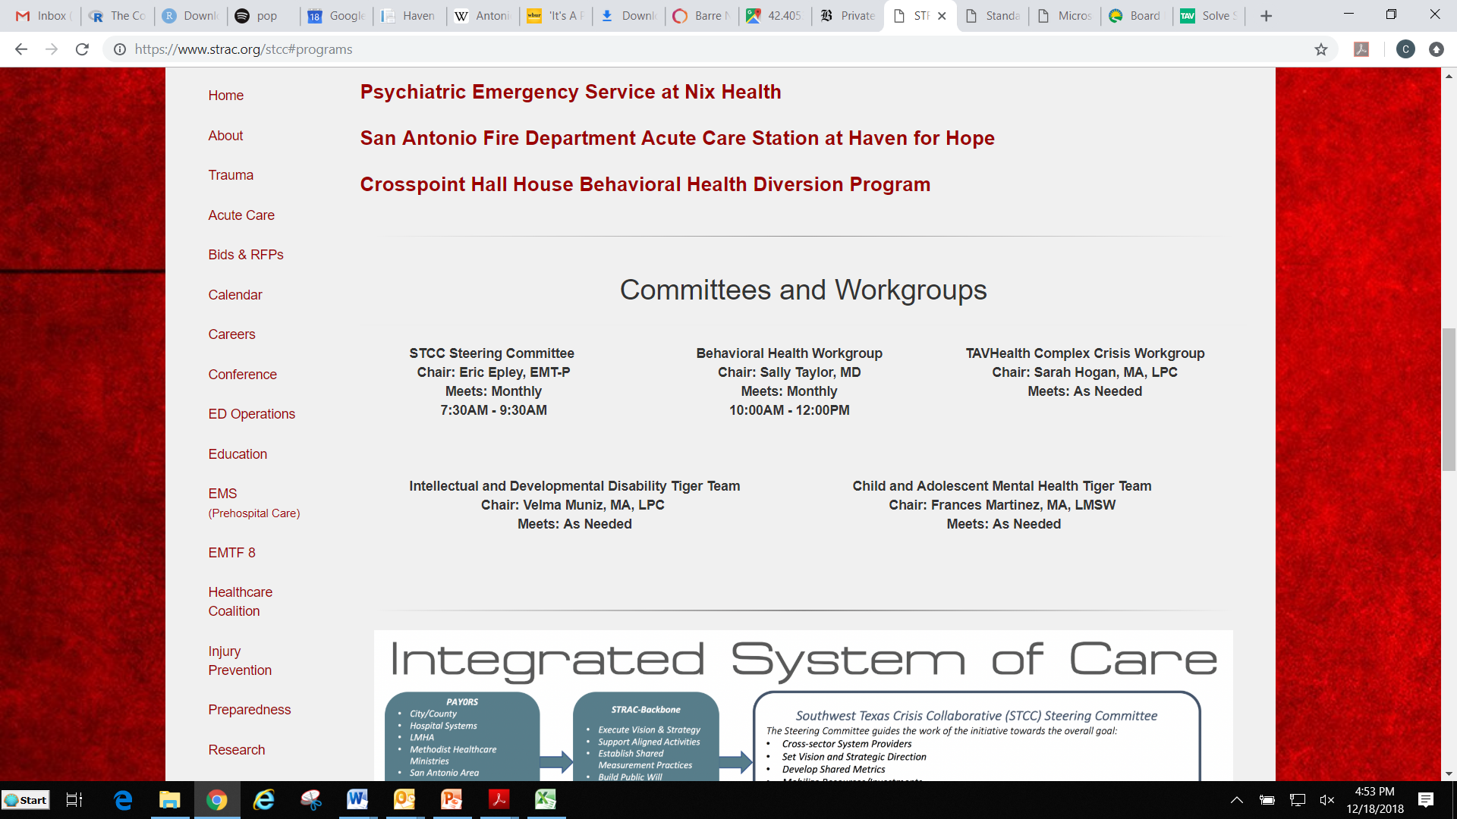

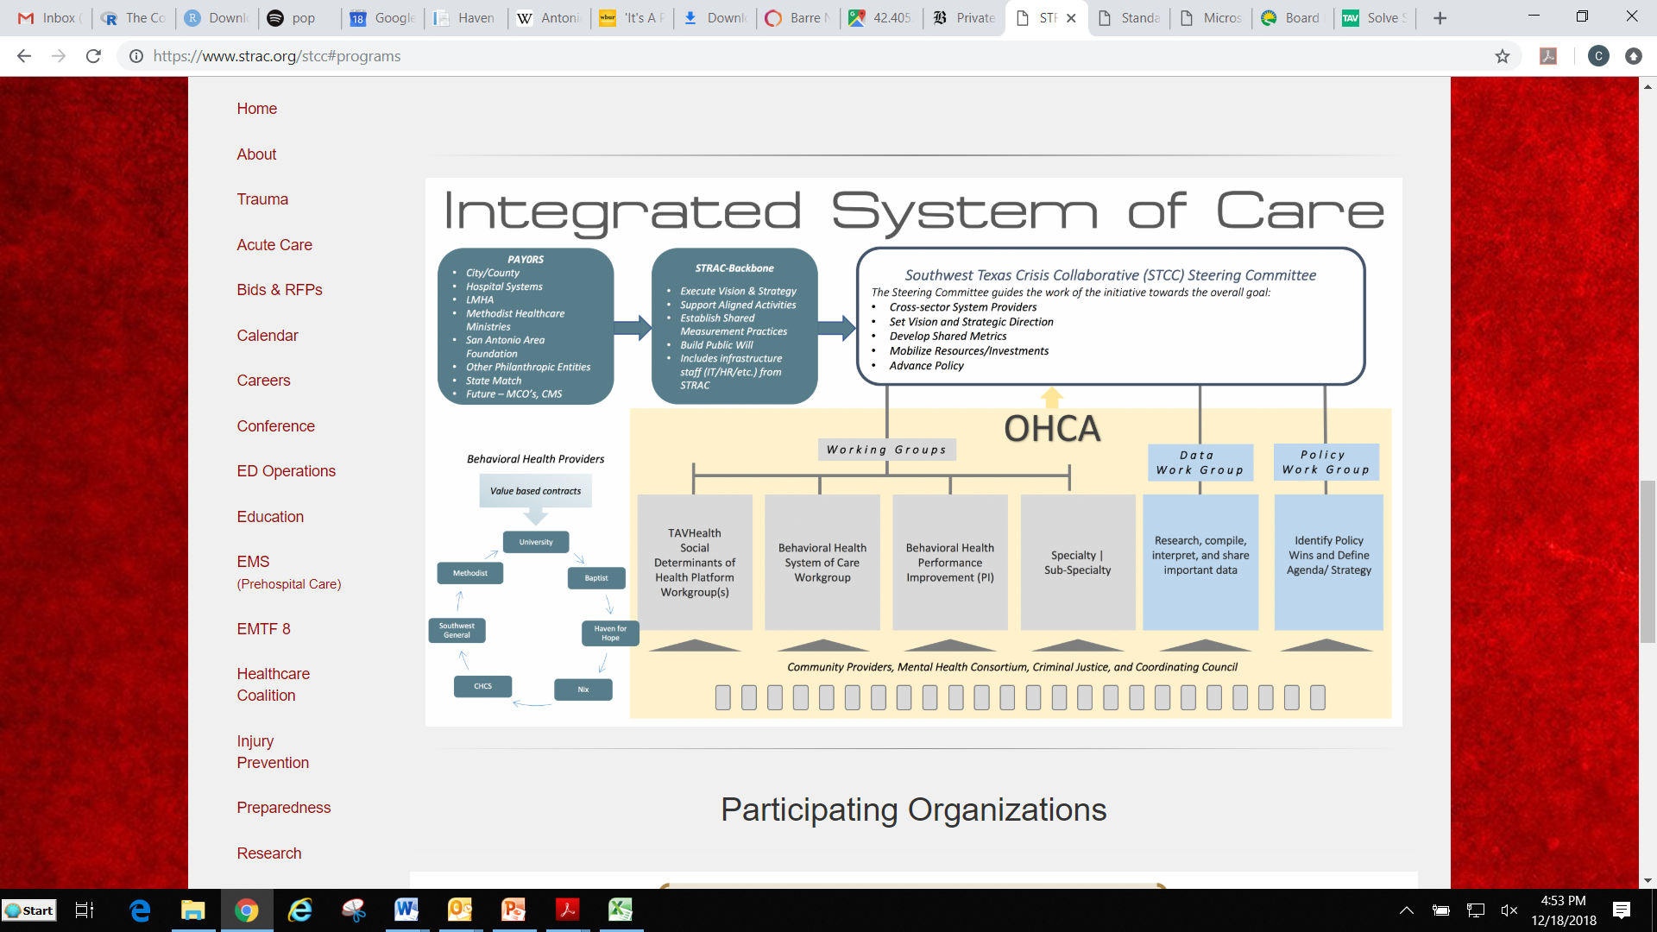

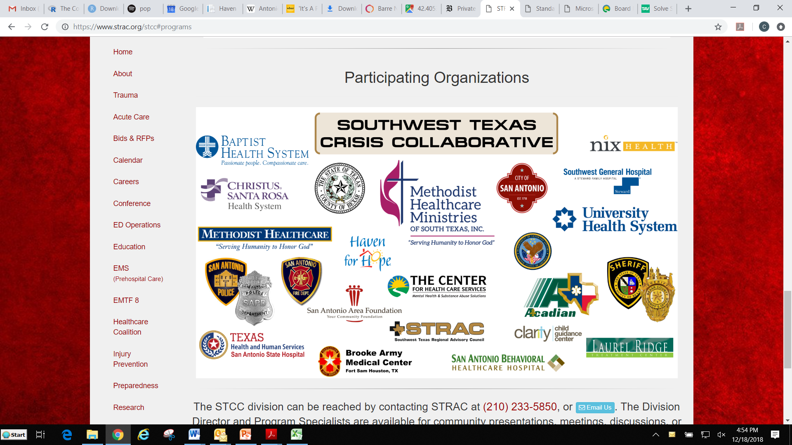

**Certified Community Behavioral Health Clinics (CCBHC’s)**[22] were created by Section 223 of the 2014 Protecting Access to Medicare Act[23] to integrate physical and behavioral health care. Core standards for CCBHC’s include:[24]

* Staffing with diverse disciplinary backgrounds who are culturally and linguistically trained to serve the needs of the clinic’s patient population.
* Availability and accessibility of services, including crisis management services that are available 24/7, the use of a sliding scale for payment, and no rejection of services or limiting services on the basis of a patient’s ability to pay or place of residence.
* Care coordination, including coordination across all care settings and ensuring seamless transitions for patients across the full spectrum of health services, including acute, chronic, and behavioral health needs, including partnerships or formal contracts with:
  + Federally-qualified health centers (FQHC’s), rural health clinics;
  + Inpatient psychiatric facilities and substance use detoxification, post-detoxification step-down services, and residential programs;
  + Other community or regional services, supports, and providers like schools, child welfare agencies, juvenile and criminal justice entities, and other social and human services;
  + Department of Veteran’s Affairs (VA) medical centers, independent outpatient clinics, and drop-in centers; and
  + Inpatient acute care hospitals and hospital outpatient clinics.
* Provision in a manner reflecting person-centered care of the following services directly or through formal relationships with other providers:
  + Crisis mental health services, including 24-hour mobile crisis teams, emergency crisis intervention services, and crisis stabilization.
  + Screening, assessment, and diagnosis, including risk assessment.
  + Patient-centered treatment planning or similar processes, including risk assessment and crisis planning.
  + Outpatient mental health and substance use services.
  + Targeted case management.
  + Psychiatric rehabilitation services.
  + Peer support and counselor services and family supports.
  + Intensive, community-based mental health care for members of the armed forces or veterans consistent with the minimum clinical mental health guidelines promulgated by the Veterans Health Administration.
* Quality and other reporting on encounter data, clinical outcomes data, and quality data.
* Organizational authority, governance and accreditation.
* BHN is becoming one

10:45AM SAN ANTONIO POLICE DEPARTMENT MENTAL HEALTH UNIT

*Ernest Stevens, SAPD Mental Health Unit Officer*

*Joe Smarro, SAPD Mental Health Unit Officer*

* **Overview** of the San Antonio Police Department (SAPD) Mental Health Unit
  + 11 officers (plain clothes and driving unmarked vehicles) and two mental health workers (primarily do case management as opposed to crisis co-response)
  + “Assign themselves” cases from the CAD system
    - Created three new problem codes at the call center, with enhanced call scripts for 911 operators
      * “MH in progress” (priority – suicide attempt in progress, etc.)
      * “MH disturbance” – non-emergency mh call
      * “MH routine” – hospitals or facilities calling for sectioning papers, which can only be completed by police
    - Instead of flagging individuals (“friendly faces”), they flag locations and mental health workers follow up on these locations
    - The officers noted a special case where they got a referral from the police department’s communications department due to a disturbing Facebook post asking “Am I the next Parkland shooter?” They went to the house, seized an AR-15, and assigned the person to a caseload with the MH workers who follow-up in regular intervals with a subset of people who need more attention
  + Do a full needs assessment to determine the most appropriate location for care based on funding, continuity of care, etc. using the mental health workers
  + Try to avoid making arrests to maintain integrity with the people they work with.
  + Changed the vocabulary to “patient” from “perpetrator.”
  + Use Restoration Center as much as possible for people in crisis.
* Each officer described **how they became interested** in being assigned to the mental health team
  + Ernest Stevens was a long-time officer on the force (~27 years). He said that it used to be easier to arrest a person with mental illness than to do anything else for them. When Leon Evans became director of CHCS, he started a small Crisis Intervention Team (CIT)[25][26] training program based on the Memphis model[27]. Ernest’s partner persuaded him to attend the first CIT training because they would get the weekend off. Ernest remembered thinking to himself that he “hated these calls – why would I go to this training” to interact more often with these people? In the training, a mom talked about her schizophrenic son. She said “One day one of you officers will respond to my house and will probably shoot my son. It’s ok, I want you to go home to your family.” That struck a chord with him, and he subsequently got onto the NAMI board. When the Police Chief started a Mental Health Unit, initially to run CIT trainings for the whole force, Ernest and his partner volunteered to be first officers on the unit.
  + Joe Smarro is a marine veteran with PTSD and who has exhibited mental health symptoms from young age. Joe wants to help people because he can relate to them. Joe wants the SAPD to be “pro-sumer” – placing the rights of the individual at the center.
* **CIT Training**: SAPD does 40-hour CIT training for every officer – this occurs in the academy for new officers or in-service for all existing officers.
* **Mental health evaluations**: In response to the Sandra Bland case,[28] the SAPD decided to require that everyone gets a mental health brief screening in police lockup (requesting copy)
* Involuntary holds (called “**emergency detention**” in Texas):
  + Must be suicidal or homicidal
  + 48 hour hold, after which time the hospital can issue and order of protective custody if the individual needs to stay longer
  + MH team rarely uses handcuffs for involuntary holds (they say they can avoid handcuffs because they ride in pairs, as opposed to the rest of SAPD who ride individually).
  + Any officer can do an emergency detention, not just the MH team.
  + It is always police who do transportation for an emergency detention.
  + Before creating the MH unit, the SAPD was doing ~200 involuntary commitments per month; now, they do ~1100/month as an alternative to arrest.
    - The officers feel that this increase in emergency detention as an alternative to arrest has led to behavioral health providers treating officers and patients increasingly poorly because now the ED was become overcrowded with these difficult cases
    - This is what led to creating the “navigator program” (what the officers call the STCC, described above) to divert people straight to inpatient treatment or the Restoration Center instead of the ED
    - Part of the problem was that some hospitals don’t do psychiatric inpatient care – now, the navigator system only takes people to hospitals with psychiatric inpatient beds
      * In response to a question about **medical clearance** at psychiatric hospitals being a barrier to direct admission, the officers cited EMTALA[29] (see below). They also said FD/EMT do medical clearance in the field.
    - The officers argue that the hospitals pay for this system because they are getting new clients (note that Gilbert Gonzales has a different perspective on why hospitals are paying for this system, described above)

The Emergency Medical Treatment and Active Labor Act (**EMTALA**) was passed by the US Congress in 1986 to ensure patient access to emergency medical care and prevent the practice of patient dumping, in which uninsured patients were transferred from private to public hospitals without consideration for their medical condition or stability for the transfer. Under EMTALA, licensed hospitals that participate in the Medicare program have an obligation to perform an “appropriate” medical screening examination (MSE) to determine whether the individual has an emergency medical condition (EMC), which means “a medical condition manifesting itself by acute symptoms of sufficient severity such that the absence of immediate medical attention could reasonably be expected to result in (i) placing the health of the individual (or unborn child) in serious jeopardy; (ii) serious impairment to bodily functions; or (iii) serious dysfunction of any bodily organ or part. If an EMC exists, the hospital must either stabilize the condition or transfer the patient to another hospital with the appropriate capabilities.

Which hospitals are covered by EMTALA has been fraught with debate. Regulations by CMS and some court rulings have held that the definition of hospital is broad, including parts of hospitals, urgent care facilities, outpatient surgery centers, psychiatric facilities, and ambulances/EMS.

What constitutes an “appropriate” MSE has also been open to debate, given that neither EMTALA nor the CMS regulations defined it. The best description is that appropriate MSE means an ongoing process that ends when an EMC has been ruled out or stabilized, regardless of how long it takes.19

* In response to a question about the “police ratio” (in Massachusetts, there is a required number of officers on the street at any given time, preventing officers from doing hospital transports), the officers noted that the MH unit is outside normal officer count (but also there is no ratio in Texas).
* **Barriers**:
  + Siloed facilities
    - STCC data sharing program TavConnect (see above) has helped with this – electronic notification system where officer enters where the person is being taken and it notifies their doctors, law enforcement, etc. – consent is required
  + CIT training or other mental health training should be required for all law enforcement officers because many of the people who grumble about CIT end up being very good at it, and you would miss those people if you didn’t require CIT training. Also, the academy should include 3 weeks of communication and de-escalation skills because officers need to spend much more time in the field doing de-escalation than some of the other areas of focus in academy like weapons training.
  + Hospitals releasing individuals that police thought they were helping is frustrating. Police see the need, try to resolve by transporting the person to the ED, then see the person back in the community. This is because providers put up barriers to care through exclusion criteria. There is a lack of funding, lack of insurance, hospitals are unwelcoming to unfunded people.
  + Special populations: geriatric psych/dementia; very pregnant with SUD; intellectual and developmental disabilities (IDD) (autism, etc.)

11:15AM OVERVIEW OF JAIL DIVERSION PROGRAM

*Gilbert Gonzales, Bexar County Director of Mental Health Services*

**Bexar County Department of Behavioral and Mental Health**

* Created in 2014
* Mission statement[30]
  + Act as advocate, expert, and clearinghouse on community mental health issues and programs
  + Lead in planning, coordinating, advocating, and organizing community behavioral health stakeholders in activities to continuously improve the availability of services in Bexar County
* Purpose[31]
  + Identify gaps: identify overlap and system needs to best serve the mental health community
  + Increase capacity: identify resources that can be leveraged and identify new funding sreams to increase service capacity for persons in need
  + Identify and recommend best use of County dollars: identify emerging best practices and monitor costs specific to the provision of treatment for persons suffering from mental illness
* Goals and objectives[32]
  + Provide a systematic process to continuously assess the needs for mental health services in the community and prioritize the best investment of funds to meet those needs.
  + Create a seamless system of care and safety net services for the mentally ill by improving services at multiple points of entry to care, and coordinating programs, providers and services.
  + Lead mental health stakeholders in pursuing strategies supporting the improved system of care
  + Continue the work of the Bexar County Mental Health Consortium of implementing a strategic plan
  + Establish a partnership with CHCS to ensure that gaps, needs, and services identified by the community are formalized and incorporated into their service delivery plan
  + Negotiate contracts for mental health services while tracking performance measures, program compliance, and effectiveness
* Current actions
  + Reduce the number of people with mental illness from inappropriate incarceration[33]
  + Convene the **Bexar County Mental Health Consortium** and Legislative Symposium[34]
  + Promote methods that encourage the reduction of the stigma of mental illness[35]
  + Encourage, expand, and support effective mental health treatment services[36]
  + Dedicated mental health department within Judicial Services department of the county[37]
  + Smart Justice Central Magistration – screen 100% of individuals, perform clinical assessments, create treatment plans, integrate pre-trial, clinical and public defender services in team presentation to judge[38]
    - Licensed clinical assessors on site 7 days a week
    - Access to state MH database
    - Use Best Practice Brief Jail MH Screen (requesting copy)
    - MH attorney training
  + Criminal Justice Coordinating Council – joint between city and county[39]
* Publish a resource guide[40] (another is put out by the Bexar County Commissioners Court Mental Health Consortium[41])
* Bexar County Mental Health Systems Cost Assessment[42] produced in 2016 – established priorities for the behavioral health system in Bexar County

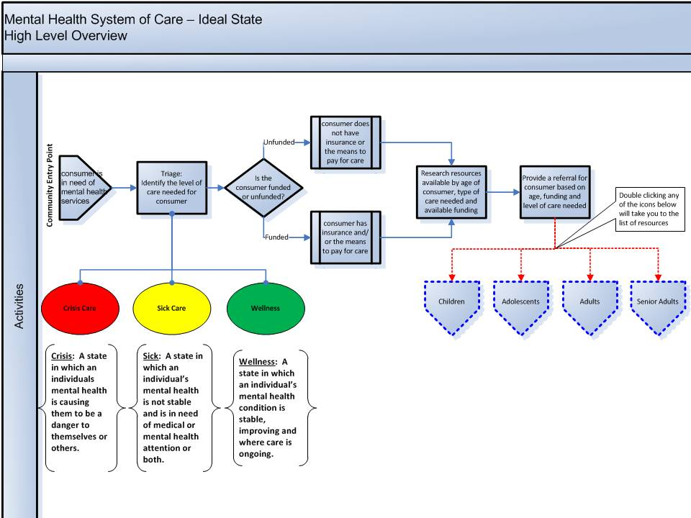

**Bexar County Smart Justice Initiative**

* Development of jail diversion programming has been very officer-driven
  + First, Leon Evans created the CIT program. Now, the SAPD has trained all officers on the force with no additional line item for the county (leveraged nonprofits, interfaith community, etc.)
  + Then, once trained, officers demanded 24/7 psychiatric and SUD evaluation capacity
  + Then, asked for sobering center
  + Then, asked for detox center
  + Then, asked for medical clearance
  + The Department of Behavioral and Mental Health has had an ongoing dialogue with the police to address the obstacles
  + It costs $2,295 per arrest event (magistrate, jail, police, etc.)
    - Only $350 per event at Restoration Center
* 4 mental health questions are now asked by all law enforcement[43]
* Monthly meetings (Community Medical Directors Meeting[44])
  + How to divert more effectively
  + How to increase access to care
  + Addressing gaps in the continuity of care
* First thing they did was a gaps analysis and a cost analysis (using ICD-9, ICD-10 data from hospitals) (requesting copy)
  + Found $1.2 billion in uncompensated care – this finding got hospitals to fund law enforcement navigators program
  + How did they get hospital data? Because of overcrowding at ERs – used 3rd party to get the data from the hospitals through a BAA
* Have kept jail population constant over life of project, despite 50% population growth in Bexar County

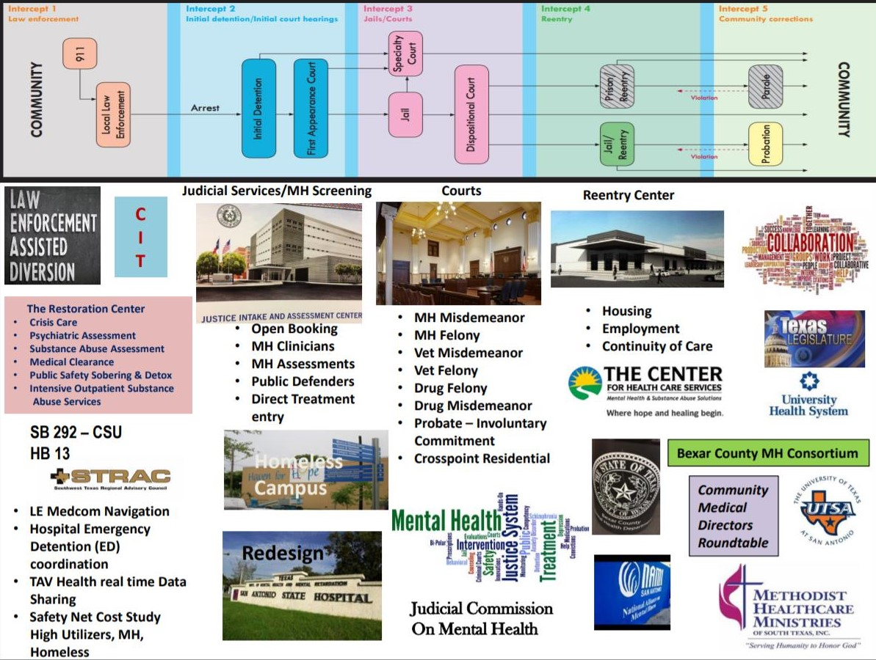

11:45AM TESTIMONIAL AND OVERVIEW OF PEER SUPPORTS

*Cynthia Dandridge, Outpatient Counselor for Intensive Outpatient Program*

Testimonial to her pathway through CHCS services:

Residential detox 🡺 intensive outpatient treatment (IOP) 🡺 residential treatment at Haven for Hope 🡺 associate’s degree at a local community college 🡺 employment as a counselor/peer support worker at CHCS’s IOP

* Keys to her success:
  + Transformational services resource center at Haven for Hope (employment, college, etc.) provided linkage to resources when she was ready
  + Faith center
  + 12-step program
  + Integrated MI and SUD treatment
  + IHRP (described above) at Haven for Hope 90-day residential intensive outpatient program – supportive, sober living environment run by peers
    - Taught her how to find out who she wanted to be, learn how to live

12:30PM TOUR HAVEN FOR HOPE

*Art Vela, Director of Life Safety*

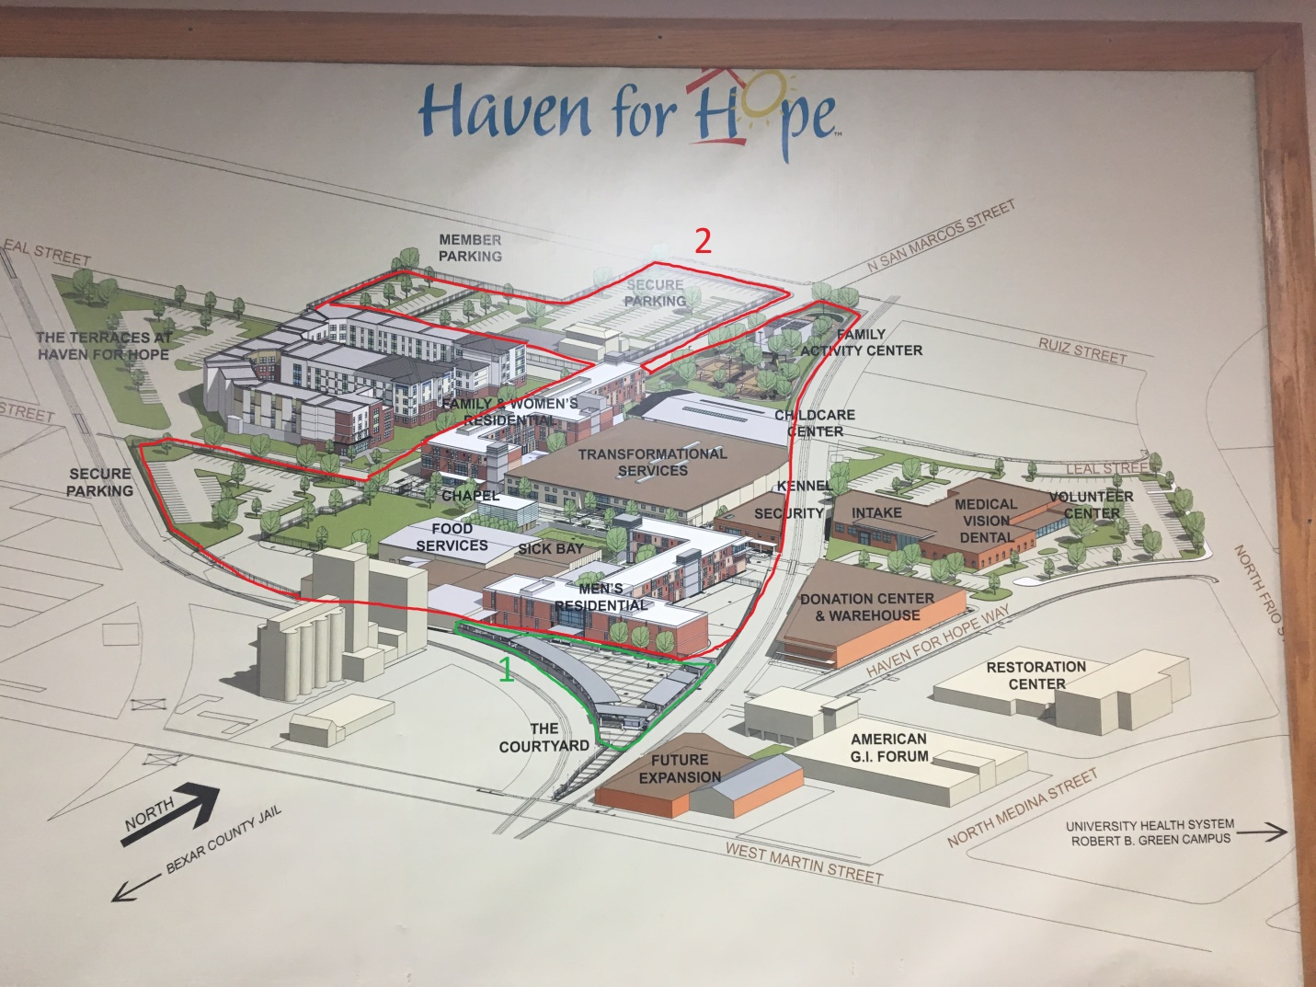

**General Information**

* “Faith-inspired”
* Target population: chronically homeless single adults and families at all stages of readiness for treatment
* Services:
  + CHCS runs mental health and addiction services on-site, and some individuals cross the street for additional services
  + The Terraces at Haven for Hope: 140 apartments
    - 50% of residents come directly from the Transformational Campus
    - 50% of residents come directly from the community
  + Intake: screen for homelessness during weekday business hours using a Triage Form (requesting copy)
    - If you are at risk of homelessness but not yet homeless, they will provide resources to keep you housed (for example, emergency rent assistance or other eviction prevention programs)
    - If you are already homeless:
      * And you are (i) a resident of Bexar County for at least 9 months, (ii) willing to be sober during your stay, and (iii) are not a sex offender, you can be housed in Transformational campus
  + **(1)** **The Courtyard**
    - *Target population*: any homeless individuals (includes sex offenders, non-sober people)
      * They do review criminal record and look at people with violent felonies to make sure they are safe to house on-site
    - *Services*: mats on the ground (except with inclement weather, when they move them inside the cafeteria)
      * Showers, bathrooms, laundry
      * 3 hot meals a day
      * CHCS treatment (as long as they can pass transformation checkpoint – requirements below)
      * Checking people for responsiveness all the time
      * Respite bay – actual beds for older people, those who work nights and sleep days
      * Med room – has to have their name on the prescription; tech will pick up prescriptions for them
      * ID recovery services with Department of Public Safety – get state ID in 2 days
      * Clothing vouchers
      * Bus passes
      * TB checks 2x/week on site
      * Carry narcan
    - *Length of stay*: indefinite
    - *Capacity*: Averages 675 people, but has had up to 850 people
    - *Security*: no weapons or drugs on premises, but no sobriety requirement
      * Checkpoint with metal detector, search items
      * 34 armed security guards
      * No breathalyzer
    - *Aftercare*: goal is for them to move into temporary or permanent housing
    - *Goals*: harm reduction
  + **(2) Transformational Campus**
    - *Target population*: homeless individuals who are sober and are not sex offenders (since there are children on campus) who have been Bexar County residents for at least 9 months (might wait in the Courtyard to become resident)
    - *Services*:
      * Mostly dorm-style housing, but families get rooms; special dorm for LGBTQ community
      * CHCS treatment
      * Gym, kennel (residents have to walk and feed the animals), mail room
      * YMCA provides free daycare for all residents; also provides daycare to outside community members on sliding fee scale based on income
        + By federal law, schools have to bus kids to their old school if parents choose – they are the first pick-up to prevent stigma
      * Free tutoring and intervention services for kids
      * Transformational resources center – individual office spaces for community-based service providers of a variety of programs
    - *Length of stay*: average 4-9 months
    - *Capacity*: 825 beds, indoors
    - *Security*: security checkpoint with breathalyzer, metal detector
      * Need badge to access – some badges are flagged for special security protocols
      * Can surrender contraband at checkpoint with no penalty to gain access
      * If you don’t surrender contraband, they will call police
      * All residents sign liability waivers
    - *Aftercare*: permanent housing solution, employment
  + Street outreach team: partners with SAPD Hope Team (reach out at homeless encampments to encourage people to come to Haven)
  + Dental and vision clinics run by nonprofits are located on-site, with entrances outside of the Transformational Campus security
    - Open to residents and broader community
    - For uninsured
  + Vocational programs – free to residents, open to broader community as well
    - 25-week dental assistant training program
    - Culinary arts program
* Capacity: 1,700 residents (including 300 children)
* Staffing: ~500 staff and partner entity staff
* Funding: annual budget: $180 million
  + Federal , state, county, local, United Way, private donations (original seed funder is local billionaire)
* San Antonio Point In Time Count (PIT) 2017:[45] 2,743 homeless, with 1,102 unsheltered homeless, 1,030 in emergency shelter and 611 in transitional housing

2:45 PM COMMISSION DISCUSSION

The Commission was unable to hold a full Commission meeting, but had a brief discussion at the end of the tour.

* Marisa: we can’t have one big center in Middlesex County because people aren’t going to drive from Arlington to Tewksbury, for example
* Catia: but the BHN and SA Restoration Center show it isn’t about spending a bunch of new money on new services – it’s about co-location of services
* Scott: not even about co-location; about knitting together disparate providers and services (coordination > co-location)
* Senator Friedman: need a clear and accurate listing of DMH services – is it forming a cohesive continuum (money for jail diversion, forensic, ACCS, etc.)
* Catia: Medicaid working group is identifying relevant axes for mapping the system for the gaps analysis – the system map should definitely include funding/oversight systems/agencies
* Mandy: not necessarily about a Restoration Center – what are the needs of the system?

1. Virtual tour can be found at: <https://www.youtube.com/watch?v=FD_wv49tO1Q>
2. https://hhs.texas.gov/services/mental-health-substance-use/mental-health-substance-use-resources/find-your-local-mental-health-or-behavioral-health-authority
3. https://hhs.texas.gov/services/mental-health-substance-use/adult-mental-health
4. https://hhs.texas.gov/services/mental-health-substance-use/mental-health-crisis-services
5. https://chcsbc.org/
6. https://chcsbc.org/board-of-trustees/sponsoring-agencies-funders/
7. https://chcsbc.org/
8. YouTube Channel can be found here: <https://www.youtube.com/channel/UCNEtcFN3gw7kyoY5FVjpEXA>
9. From document “CHCS Impact Brochure F 101416”
10. https://chcsbc.org/locations/
11. https://praedfoundation.org/tools/the-adult-needs-and-strengths-assessment-ansa/
12. See document “2016 Success Results Cost Avoidance Report 8 years 04-26-16”
13. https://chcsbc.org/get-help/treatment-for-substance-use-disorders/
14. https://chcsbc.org/get-help/crisis-care-services/
15. IBID
16. https://chcsbc.org/get-help/treatment-for-substance-use-disorders/
17. https://chcsbc.org/get-help/transformational-services-homelessness/
18. https://www.strac.org/
19. https://www.strac.org/stcc
20. https://www.tavhealth.com/
21. https://www.strac.org/stcc
22. https://www.samhsa.gov/section-223/certification-resource-guides/ccbhc-eligibility
23. https://www.congress.gov/bill/113th-congress/house-bill/4302
24. https://www.samhsa.gov/sites/default/files/programs_campaigns/ccbhc-criteria.pdf
25. https://www.ncbi.nlm.nih.gov/pmc/articles/PMC3769782/
26. https://www.nami.org/get-involved/law-enforcement-and-mental-health
27. http://www.cit.memphis.edu/aboutCIT.php
28. https://en.wikipedia.org/wiki/Death_of_Sandra_Bland
29. https://www.ncbi.nlm.nih.gov/pmc/articles/PMC1305897/
30. https://www.bexar.org/192/Department-of-Behavioral-and-Mental-Heal
31. IBID
32. IBID
33. IBID
34. IBID
35. IBID
36. IBID
37. From document “2017-07-08 Update MH Department overview”
38. IBID
39. IBID
40. https://www.bexar.org/DocumentCenter/View/10419/2018-Resource-Guide-for-Bexar-County?bidId=
41. https://www.bexar.org/DocumentCenter/View/484/Bexar-County-Directory-of-Mental-Health-Resources?bidId=
42. https://www.bexar.org/DocumentCenter/View/15898/Bexar-County-Mental-Health-Systems-Cost-Assessment
43. From document “2017-07-08 Update MH Department overview”
44. Gilbert told us to go to bexar.org/msd for more information, but this site does not exist
45. https://www.hudexchange.info/resource/reportmanagement/published/CoC_PopSub_CoC_TX-500-2017_TX_2017.pdf