The Middlesex Sheriff's Office Logo
 Flag of the Commonwealth of Massachusetts


**Middlesex County Restoration Center**

**Thursday, December 17, 2020**

**10:00 – 11:30 am**

**Zoom**

**MINUTES**

Attendees: Sheriff Peter J. Koutoujian, co-chair; Danna Mauch, Massachusetts Association for Mental Health, co-chair; Judge Minehan; Chief Robert Bongiorno, Bedford Police Department; Nancy Connolly, Department of Mental Health; Deirdre Calvert, Bureau of Substance Addiction Services; Scott Taberner, MassHealth; Marisa Hebble, MA Trial Court; Dave Ryan, MSO; Catia Sharp, MAMH; June Binney, member of the public; Richard Sheola, member of the public; Danielle Allen, member of the public.

10:00 AM: WELCOME AND INTRODUCTION

Sheriff Koutoujian called the meeting to order.

10:05 AM: LEGISLATIVE AND BUDGET UPDATE

Representative Gordon could not attend the meeting.

Senator Friedman noted that the final SFY2021 budget passed, and included $250,000 for the Restoration Center Commission.

10:10 AM: APPROVING THE MINUTES FROM THE LAST MEETING

Sheriff Koutoujian motioned to approve the minutes from the last meeting. The vote was unanimous in favor of approving the minutes.

10:15 AM: MEDIA UPDATE

Sheriff Koutoujian shared that he, Danna, and Senator Friedman had a meeting with the Globe Editorial Board to talk about the Restoration Center work. The Board was very interested in the topic and asked for the Commission to keep them appraised of any current events that would be supported by a timely article in the future.

10:20 AM: UPDATE ON SEQUENTIAL INTERCEPT MAPPING

Marisa Hebble provided a presentation updating the Commission on the status of the Massachusetts Community Justice Project using a powerpoint presentation. There have been 29 workshops to date, encompassing 155 cities, towns and neighborhoods. Below are some interesting cross-workshop conclusions from the data:

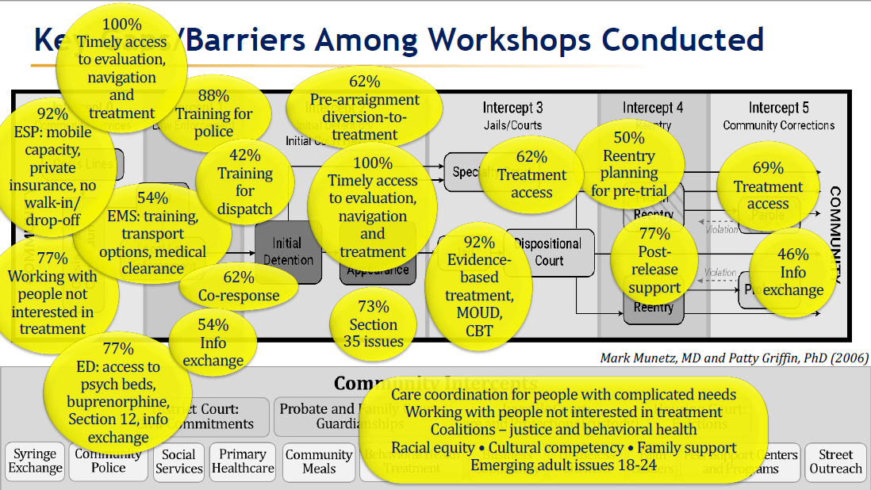

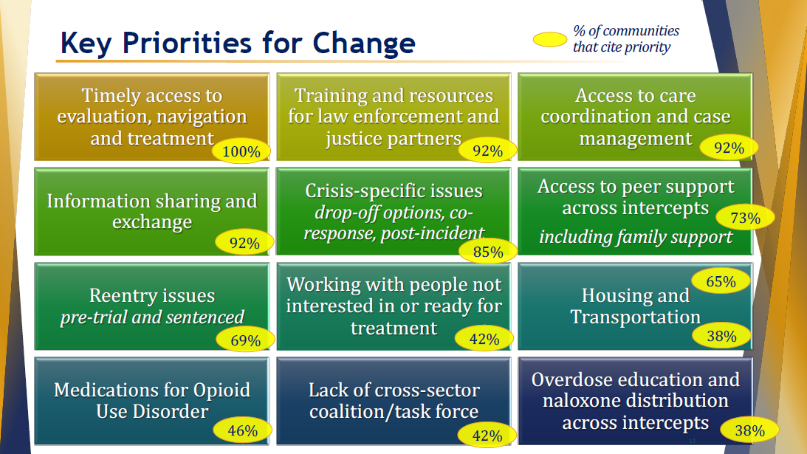

The primary challenge that communities cited post-workshop is finding champions to move key outcomes of the workshops forward.

Looking ahead, the Trial Court is currently planning three workshops tailored to specific target populations: child welfare, commercial sexual exploitation, and perinatal. Marisa also noted additional interesting work being done at the Trial Court, including the in-development Supreme Judicial Court Standards on Substance Use and Mental Health, which will be issued this spring; and Project NORTH (Navigation Outreach Recovery Treatment and Hope) to provide recovery support navigation, transportation, sober housing support, and virtual support.

Senator Friedman noted that this work is very important and is very informative to the work of the Commission.

Danielle Allen, community member, asked whether the Restoration Center Commission has been looking into the use of the Police-Assisted Addiction and Recovery Initiative (PAARI) and whether the Center will work with such programs.

Danna Mauch responded that the Commission is aware of PAARI programs and documented the police departments in Middlesex County who participate in its Year One Findings and Recommendations report. She noted the importance of such programs to divert individuals with substance use conditions away from police involvement and jail.

10:50 AM: MASSACHUSETTS 1115 WAIVER UPDATE

Scott Taberner provided more detail on the Massachusetts 1115 waiver update, including the choice to maximize the number of prisoners who might benefit from scaling back the Medicaid Inmate Exclusion Policy (MIEP).

11:15 AM: BRIEF PLAN FOR FY21

Sheriff Koutoujian asked Catia Sharp to briefly review the work plan for FY21, now that the state budget has been signed.

Catia Sharp reviewed the following components of the FY21 work plan, to be completed by a contracted provider entity:

* Selecting a site and capital planning
* Developing a hiring plan to ramp up services in FY22
* Work with DMH, DPH, and MassHealth to nail down licensure and leverage existing funding streams like respite and CSS, including taking into account 1115 waiver renewal development and EOHHS Roadmap to Reform
* Search for non-state sources of funds, including federal funds and private charitable sources
* Develop any subcontractors or contractual relationships with other providers, including other ESPs and outpatient providers, as needed
* Develop transportation services
* Work with Restoration Center Commission staff to identify a FY22 launch plan with an expected $250,000 budget
* Refine the budget produced in Year 2 taking into account the above listed work

11:25 AM: NEXT STEPS AND CLOSING

Danna Mauch thanked everyone for another very productive meeting.

Sheriff Koutoujian adjourned the meeting.