April 13, 2021

Michael Hurley, Senate Clerk

Office of the Clerk of the Senate

24 Beacon Street

Room 335 – State House

Boston, MA 02133

Steven T. James, House Clerk

Office of the Clerk of the House

24 Beacon Street

Room 145 – State House

Boston, MA 02133

Governor Charles D. Baker

24 Beacon Street

Room 280 – State House

Boston, MA 02133

Senator Julian Cyr, Chair

Joint Committee on Mental Health, Substance Use and Recovery

24 Beacon Street

Room 301-E – State House

Boston, MA 02133

Representative Adrian Madaro, Chair

Joint Committee on Mental Health, Substance Use and Recovery

23 Beacon Street

Room 33 – State House

Boston, MA 02133

Secretary Thomas Turco

Executive Office of Public Safety and Security

1 Ashburton Place, Suite 2133

Boston, MA 02108

Secretary Marylou Sudders

Executive Office of Health and Human Services

1 Ashburton Place, 11th Fl.

Boston, MA 02108

Dear Senate Clerk Hurley and House Clerk James, Governor Baker, Chairs Cyr and Madaro, and Secretaries Turco and Sudders:

We write as the co-chairs and legislative members of the Restoration Center Commission (“Commission”) established under *An Act Relative to Criminal Justice Reform*, Chapter 69 of the Acts of 2018 (“Act”). The Act directs the Commission in its third year to “develop a restoration center and secure funding for a subsequent 2-year period.” The Act further directs the Commission to provide an annual report to the legislature, including “a list of services and programs, populations served and financial information” by April 13.

The Commission has met seven times since delivering its last report on April 13, 2020. All agendas, minutes and documents used in those meetings are enclosed in this Findings and Recommendations Package as Appendix A.

Year three of the Commission’s work occurred against the backdrop of two defining historical events of significant relevance to the work of the Commission: the COVID-19 pandemic and a reckoning on racial justice and policing driven by the death of George Floyd.

In addition to a review of findings over its first three years of work, this report includes a recommendation to the legislature to fund implementation of a Restoration Center in Middlesex County at $1.85 million in the State Fiscal Year (SFY) 2022 budget in EOHHS line item #4000-0300.

**Commission Mandate and Work to Date**

An Act relative to criminal justice reform tasked the Commission with planning and implementing “a county restoration center and program to divert persons suffering from mental illness or substance use disorder who interact with law enforcement or the court system during a pre-arrest investigation of the pre-adjudication process form lock-up facilities and hospital emergency departments to appropriate treatment.”

The Commission consists of:

* Co-chair Sheriff Peter J. Koutoujian, Middlesex Sheriff’s Office
* Co-chair Danna Mauch, PhD, President and CEO of the Massachusetts Association for Mental Health
* Senator Cindy Friedman
* Representative Kenneth Gordon
* Lydia Conley, CEO of the Association for Behavioral Healthcare
* Chief Justice Paula Carey, Massachusetts Trial Court
* Chief Robert Bongiorno, Bedford Police Department
* Judge Rosemary Minehan (retired)
* Scott Taberner, Executive Office for Health and Human Services
* Nancy Connolly, Department of Mental Health
* Deirdre Calvert, Bureau of Substance Addiction Services
* Eliza Williamson, National Alliance on Mental Illness of Massachusetts
* Steven Mastandrea, Probation Department

The Commission was tasked with developing and implementing “a 3-year plan to build a restoration center in the former county of Middlesex. In the first year, the commission shall: (i) perform an examination of state and national best practices including, but not limited to, the Bexar County model, which has received national recognition from the federal Substance Abuse and Mental Health Services Administration for its success in diverting individuals with behavioral health issues away from the criminal justice system and into appropriate treatment; and (ii) review the current capacity of mental health providers within the former county of Middlesex to provide behavioral health services to individuals suffering from mental illness or substance use disorders who interact with law enforcement or the court system and the barriers they face to accessing treatment.” The Commission’s Year One Findings and Recommendations, submitted to you in 2019 and accessible at the following web address: https://www.mamh.org/library/middlesex-county-restoration-center-commission-year-one-findings-and-recommendations, laid out such a review of the gaps in services and examination of national best practices.

“In the second year, the commission shall develop a jail diversion program and an initial pilot focused on providing integrated community-based services from a centralized location and perform an analysis of potential costs and cost savings.” Such a model program is laid out in the Commission’s Year Two Findings and Recommendations, submitted to you in 2020 and accessible at the following web address: <https://www.mamh.org/library/middlesex-county-restoration-center-commission-year-two-findings-and-recommendations>.

In its first year, the Commission found that many people in behavioral health (mental health and substance use) crisis often end up arrested or boarding in emergency departments (EDs) waiting for hospital beds. Nearly 50% of those incarcerated or detained in the Middlesex Jail & House of Correction have a mental health condition, 80% of whom have a co-occurring substance use condition, and 75% have substance use condition.[1] There is a 68% three-year recidivism rate among individuals with co-occurring mental health and substance use conditions.[2] The Commission also found that, though individuals with a behavioral health diagnosis only accounted for 14% of ED visits in 2015, they accounted for 71% of all ED visits that “boarded” (spent extra time in the ED without treatment while waiting for an inpatient bed).[3] ED boarding increased from 17% of all ED visits in 2011 to 23% in 2015, driven largely by psychiatric boarding.[4] In its second year, the Commission sought to investigate specifically how individuals in a behavioral health crisis experience the 911 emergency response system and end up arrested or in the ED. The Commission surveyed police departments in Middlesex County, finding that anecdotally, up to 75% of police officer time is spent on calls for service relating to behavioral health conditions, even though only about 2-6% of 911 calls are coded as behavioral health in two departments that track such call codes: Bedford and Arlington.[5]

In its first year, the Commission also catalogued several ongoing efforts to divert these individuals from arrest, including:

* Crisis Intervention Teams (CIT) of police officers trained in mental health de-escalation. Police departments in Massachusetts can apply for officer training through the Jail Diversion Program at the Massachusetts Department of Mental Health.
* Crisis co-responders, who are trained behavioral health professionals who can respond to 911 emergency calls alongside or instead of police officers. Police departments in Massachusetts can apply for grant funding to support a co-responder through the Jail Diversion Program at the Massachusetts Department of Mental Health.
* The Living Room, a peer-run location where individuals can go or be dropped off by police to receive behavioral health and social services and supports. There are currently two Living Room models in Massachusetts, neither of which is in Middlesex County.
* Reentry programming like the Worcester Initiative for Supported Reentry (WISR), which helps individuals with behavioral health conditions reenter their community from prison successfully and helps to reduce the 68% recidivism rate cited above by connecting people to behavioral health and social services like housing.

The Commission continues to monitor developments in diversionary services, including a current MassHealth procurement using the WISR model to provide reentry services statewide, as well as the Executive Office of Health and Human Services’ ongoing work to redesign the behavioral healthcare delivery system in their Roadmap to Reform. The Commission found in its first year that these available programs and services are starting to create a comprehensive continuum of behavioral healthcare that can prevent crisis episodes or divert individuals from arrest or ED when crisis episodes do happen. However, the Commission found a gap in timely access to urgent and crisis care in a physical location in Middlesex County that could support Crisis Intervention Teams and co-responders in their efforts. The Commission therefore designed a model Restoration Center that would complement these existing programs and fill in the gaps identified in the continuum of care.

**COVID-19**

The widespread shutdown of our service economy is expected to cause lasting damage to many people’s livelihoods. A wave of evictions is expected, which makes access to affordable housing all the more important in an already high-cost state. The pandemic is also devastating the mental wellbeing of Commonwealth residents. In June 2020, the Massachusetts Association for Mental Health published a report on expected increases in “deaths of despair” (suicide and overdose) related to the pandemic and related economic recession, attached to this letter as Appendix B. MAMH projected that the recession generated by social distancing efforts could increase deaths of despair between 12% and 60% in Massachusetts, while also increasing the number of people with a substance use condition in the state by 15,000 to 55,000 individuals. Statistics are starting to reflect that reality. The U.S. Centers for Disease Control and Prevention reported 81,000 drug fatalities from June 2019 through May 2020, the largest number ever recorded for a 12-month period.[6] In Massachusetts, overdose-related mortality rates rose 2.2% over the first nine months of 2020.[7] Suicide deaths reported through May of 2020 are thought not to have increased relative to expectation,[8] but this metric may lag behind the beginning of the shutdown.

These trends are concerning for the Commission and create even more urgency to the task of redirecting individuals and families in crisis to the care and supports they need in a timely manner. The need for a Restoration Center has become even more clear as the number of new crisis cases emerged in the pandemic crowding our hospital emergency departments (EDs) and the rates of infection rose in congregate care settings, challenging us all to examine the risk of jail confinement for people with complex health conditions.

Many of the members of our Commission were on the front lines throughout the pandemic delivering critical health services to residents of the Commonwealth; re-imagining service delivery with low physical proximity; dramatically reducing the number of individuals held in jail and prison due to the incredible risk of a pandemic spreading in those environments; and so much more. There was also incredible uncertainty around the State Fiscal Year 2021 budget, which ultimately was delayed by 6 months. We took some time over the summer for our members to do their critical work, and to await guidance on the resources we would have at our disposal for Year Three work. The Commission’s funding for Year Three activities was delayed, and as a result, the utilization of those funds has also been delayed as we will report below.

Upon our return to regular Commission meetings (now virtual) in September 2020, the Commission dove into learning as much as possible from the first six months of the pandemic. The rapid adoption of telehealth has been an advancement in healthcare delivery that has increased access to healthcare for many groups who have long suffered access gaps and provides guidance to the Commission for improving access to a Restoration Center to those very same groups.

The Association for Behavioral Healthcare, whose members continued to deliver critical mental health and substance use services throughout the pandemic, provided the Commission with the results of a survey of its members around the rollout of telehealth. Between March 1 and May 31 of 2020, 31% of ABH member organizations provided telehealth care to 56,571 individuals. 36% of individuals were served telephonically; 19% were served via videoconferencing; and 45% of individuals’ telehealth services were unspecified in responses to the survey. Telehealth contributed to a 26% reduction in “no-show” visits among surveyed members, a dramatic improvement in utilization of behavioral healthcare. Average wait times for behavioral healthcare visits were reduced by 36% to 22 days; wait times even more dramatically reduced by 53% for clients whose primary language is other than English, from 43 to 20 days. This indicates that telehealth hugely improves access to needed behavioral healthcare services for individuals who typically struggle with access due to barriers like language, transportation, and delays in availability of care.

The Commission learned during its discussion of telehealth that:

* Advancements in access to Medications for Assisted Treatment (MAT), which is an evidence-based model of treatment for opioid use disorder, have greatly expanded and improved treatment of individuals with such conditions during COVID-19.
  + A federal waiver during COVID-19 allows buprenorphine to be prescribed by telephone, which is greatly expanding access to this lifesaving opioid use disorder medication.
  + A separate federal waiver is allowing providers to send multiple days’ worth of methadone home with individuals with prescriptions. The Bureau of Substance Abuse Services providers were up to 52% of patients receiving such access.
* While telehealth has successfully expanded access to needed care to many individuals who have not been well served in the past, it may not be well-suited to settings in the criminal legal system where court clinic assessments may be used to commit people to care against their will.
* Telephonic telehealth may be less ideal than video-based telehealth from a clinical perspective, although it can be easier to access for those without internet, computers, tablets or other devices with video capability.

These lessons learned can be incorporated into Restoration Center planning and implementation to help expand access to critical behavioral health crisis and urgent services.

**A National Conversation on Policing**

We are also in the midst of a national conversation on policing, which led to a significant piece of policing legislation in the Commonwealth. This national conversation shines a light squarely on the historical under-investment in behavioral healthcare and social services that the Commission has sought to rectify. One specific case that has been highlighted in the news has been that of Daniel Prude, a Black man in the middle of a behavioral health crisis in Rochester, New York, who died after his brother called 911. Had a Restoration Center been available, timely assessment and crisis care might have been provided instead.

The Commission has long sought alternatives to law enforcement interventions for the significant number of calls for service related to behavioral health and social service needs. The disparities among people of color and people with behavioral health conditions in institutionalization rates and outcomes in both the criminal legal system and the behavioral health system are high and inextricably intertwined, necessitating services that address both histories of behavioral health stigmatization as well as racial and ethnic trauma. The Commission now seeks to launch a pilot Restoration Center in Middlesex County that could begin to provide sound public health alternatives to a police based response to social service and behavioral health needs.

**Findings from Year Three**

With the delay in the state budget during Year Three of the Commission’s work, we cannot provide a significant update at this time on our progress piloting a Restoration Center in Middlesex County, but we can provide a plan for accomplishing this task.

In our first annual Findings and Recommendations, the Commission established a framework for strategically assessing the needs of Middlesex County and creating a service model, at right. The Commission can now fill in more of our strategic planning framework with learning over the course of three years.

Defining the Problem

In our Year One Findings and Recommendations, the Commission defined the problem as follows:

*Individuals living with mental illness and/or substance use disorder too often interact with law enforcement and the court system or are incarcerated or hospitalized.*

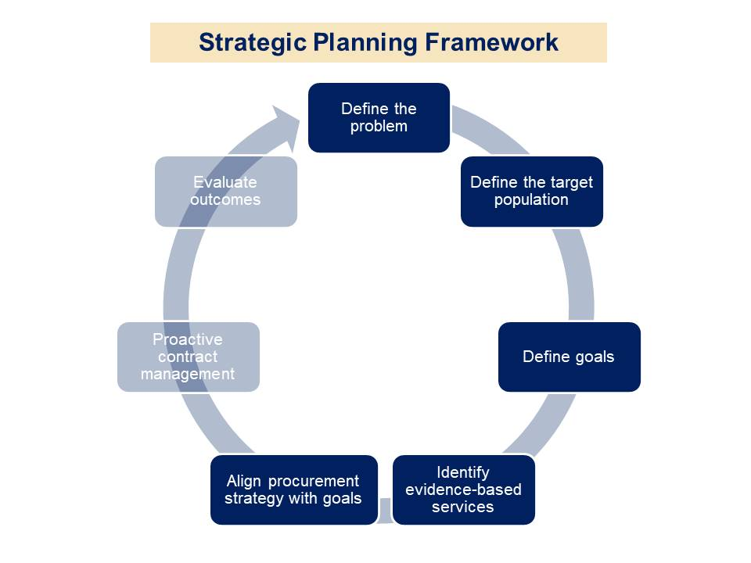In our Year One Findings and Recommendations, the Commission documented how 911 emergency calls typically result in a law enforcement response because dispatch protocols do not seek to distinguish behavioral health calls nor do cities and towns have sufficient resources like behavioral health co-responders to send out on such calls. When law enforcement responds to these calls, they only have the options to arrest the individual, bring them to the emergency department, or leave the individual in the community without needed behavioral health resources.

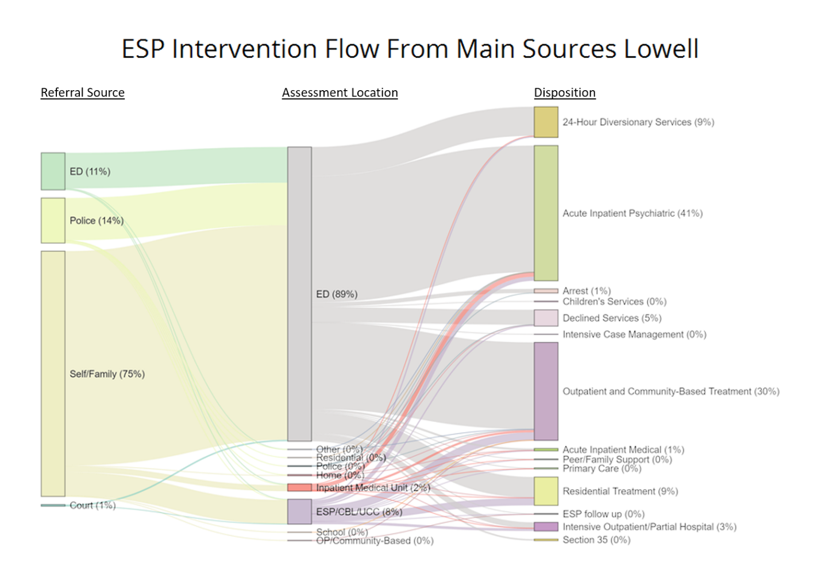The Commission’s Year One Findings and Recommendations further described the problem of emergency department (ED) boarding, outlining studies by the Health Policy Center (HPC) showing increasing rates of ED boarding driven primarily by behavioral health emergencies and crises.

In its Year Two Findings and Recommendations, the Commission further described the process by which individuals are driven to use EDs for behavioral health crises that could be better served in less restrictive settings. The Commission found that behavioral health crisis assessments continue to happen primarily in Emergency Departments, driving traffic toward this unnecessary institutional setting. To illustrate this point, we highlight a chart that was included in our Year Two Findings and Recommendations below. Data provided to the Commission by the Massachusetts Behavioral Heath Partnership (MBHP) is shown depicting the initial referral source to an Emergency Service Provider (ESP), the location of the assessment performed by the ESP, and where the individual ultimately ended up after the assessment. As shown, 75% of referrals were made to an ESP by an individual in crisis or their family members. While it is not known where each of those individuals was at the time of the referral, it is likely that these individuals are primarily at home or in other locations in the community at the time of the referral. Despite the high proportion of calls made to the ESP for an assessment being made from home or community-based locations, 89% of all crisis assessments performed by the ESP were done in an Emergency Department. This is despite the fact that less than half (42%) of the people assessed ended up in hospital-based care. Most people ended up in crisis stabilization units, outpatient treatment referrals, residential treatment, and other community-based settings.

The Commission seeks to divert individuals from Emergency Departments for a number of reasons that have been stated in prior reports: the rising and costly problem of ED boarding; the traumatic experience of the individual in institutional settings; the high cost of hospital levels of care; etc. This problem is complicated to resolve because of several specific problems embedded into the existing system of care, which implementation of a Restoration Center will need to resolve:

* Lack of reimbursement for nursing staffing at crisis facilities to ensure that medical clearance can happen without a visit to the ED;
* Current crisis services are available only to people with certain types of insurance or DMH clients;
* Sober support does not exist;
* Dedicated transportation options do not exist;
* A relentless focus on crisis services being more easily accessible than the emergency department does not exist.

Target Population

In its Year One Findings and Recommendations, the Commission defined the target population as:

*Individuals who are involved with the criminal justice system through, at a minimum, interaction with law enforcement or the court system, or those who are at high risk of becoming involved with the criminal justice system as a result of their behavioral health status.*

In its Year Two Findings and Recommendations, the Commission began to document the size and scope of this target population in three potential geographical sub-regions of Middlesex County: the Greater Lowell area, Southeast Middlesex County, and MetroWest. Advocates estimated the following numbers of target population members in each sub-region.

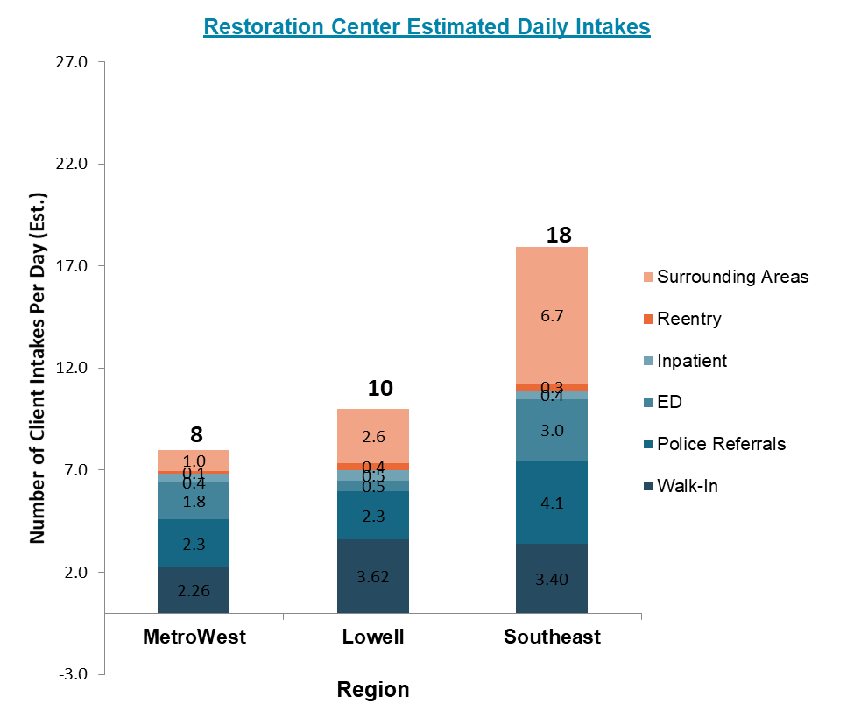

Goals

In its Year One Findings and Recommendations, the Commission identified the following goals for a Restoration Center:

* Reduce arrest for individuals with behavioral health conditions;
* Reduce emergency department visits for individuals with behavioral health conditions;
* Reduce ED boarding of individuals with behavioral health conditions;
* Increase use of community-based behavioral health care;
* Increase use of services supporting social determinants of health in the community;
* Strengthen police co-responder program and Crisis Intervention Training;
* Reduce arraignment of individuals with behavioral health conditions and forensic commitments;
* Reduce recidivism; and
* Reduce involuntary treatment petitions (§12, 35, and 15(b)).

Service Model

In order to launch a pilot Restoration Center, the Commission in Year Three is working with the Executive Office for Health and Human Services (EOHHS), which is the recipient of Restoration Center funding for SFY 2021, to launch a Request for Responses to procure a provider to pilot the Restoration Center services in Middlesex County.

The Commission formed a Subcommittee on Procurement to develop recommendations to EOHHS for a proposed scope of work and evaluation criteria, providing EOHHS with information and materials from the previous two years of Commission work. The recommendations are summarized below and incorporate the recommended service components outlined in the Year Two Findings and Recommendations.

* **Targeted geographies and physical infrastructure**
  + The Commission will seek to procure services that are focused on one of the three target geographies identified by Advocates in the Commission’s Year Two Findings and Recommendations listed below. The Commission seeks to ensure that the target geography selected prioritizes serving an underserved area with high unmet need.
    - Greater Lowell area
    - Southeast Middlesex area
    - MetroWest area
  + The Commission seeks to procure services delivered in a location with easy access to multiple sources of transportation, including public transportation, making the Restoration Center easily accessible to the public.
  + The Commission seeks a Restoration Center plan which minimizes the potential trauma or re-traumatization of any needed security components, for example by ensuring security personnel are not uniformed.
* **Target population**
  + The Restoration Center will serve individuals at risk of institutionalization. Institutionalization may include arrest and subsequent incarceration; hospitalization that is voluntary; hospitalization that is involuntary; and the use of hospital emergency departments. Individuals with previous histories of arrest or involvement with the criminal justice system and individuals with histories of hospitalization can be assumed to be at risk for institutionalization due to the high frequency of recidivism among those groups.
  + The Restoration Center Commission seeks a provider entity with extensive experience serving such populations with complex needs, including:
    - Those with co-occurring substance use and mental health conditions;
    - Those with significant hospitalization and/or emergency department utilization history;
    - People with significant arrest and/or detention histories;
    - Those who have been involved in the criminal legal system;
    - Those who have been unhoused or unstably housed;
    - Those with trauma histories;
    - Those with co-occurring behavioral health and medical comorbidities;
    - Those who struggle with related social determinants of health.
* **Services**
  + As described in more detail in the Commission’s Year Two Findings and Recommendations, the services the Commission seeks to include in a Restoration Center in Middlesex County include:
    - Triage and assessment to identify the needs of the individual.
    - Medical screening to ensure that the individual can be safely served at a Restoration Center and does not require emergency medical care.
    - Community crisis stabilization (10 beds), a level of care that is currently provided by the Emergency Service Providers who contract with MassHealth insurers and in some cases commercial insurers to provide up to 24 hour bed space for individuals in psychiatric crisis.
    - A sober support unit (10 beds), which will be a new level of care in Massachusetts consisting of bed space for up to 24 hours for individuals who have consumed drugs or alcohol and require medical and substance use supports. Peer supporters and/or recovery coaches are a key component that would help individuals to seek and access longer term substance use and recovery services like Acute Treatment Services/detox or residential treatment.
    - Respite (10 beds), a level of care that is currently provided by the Department of Mental Health (DMH) primarily to DMH clients which provides short-term (several days up to two weeks) stays at this sub-acute level of care to monitor the individual’s behavioral health, medications, and help to plan for the next level of care.
    - Reentry services and supports to individuals returning to the community from incarceration or detention to help them navigate housing resources, healthcare and behavioral healthcare services, and other related needs for success in the community.
    - Housing specialist/navigation services that can help individuals who are unhoused or unstably housed to find critical housing resources, because individuals who are unhoused cannot be expected to maintain engagement with adequate behavioral healthcare supports.
    - Medication-Assisted Treatment induction.
    - A multi-service center bringing in a range of services that would be helpful to members of the target population, which may include but is not limited to: food assistance providers or navigators, cash assistance providers or navigators, legal services providers or navigation, elder services providers or navigators, family support navigation, etc. Addressing the social determinants of health, which are social services needed to help support an individual’s health and wellbeing, is a critical element of maintaining stability in treatment and reducing future behavioral health crisis events for individuals and families.
    - Peer support staffing, because peer support workers have been found to be a critical element of engaging people who have historically not engaged in treatment. People do not engage in treatment for a myriad of reasons, but the treatment system can often feel oppressive, lacking individual choice, and can be scary and traumatic. Peer support workers often have experienced these challenges themselves and can help individuals to feel more empowered in their own treatment.
    - Documented relationships with providers of other related services to ensure continuity of care and follow-up supports after crisis to ensure that future behavioral health crisis episodes do not occur. Such after care support may include but are not limited to detoxification/ATS, co-response, mobile crisis response, Community Stabilization and Support, The Living Room, and CSP/CSPECH/CSP-JI, residential treatment services, etc.
    - 24/7/365 availability.
* **Bidder Qualifications, Licensure, and Regulatory Considerations**
  + The Commission seeks to engage a provider with a substance use clinic license and a mental health clinic license, in appreciation of the fact that many of the individuals served will likely have co-occurring conditions.
  + Preferred additional provider qualifications include being a designated Emergency Services Provider, being a CSP-JI provider, and having an ATS and/or E-ATS license.
  + The Commission seeks to engage a provider with extensive relationships with related providers of behavioral healthcare services and related social determinants of health to ensure continuity of care for served individuals that will help them maintain wellness and prevent future behavioral health crises.
* **Transportation**
  + The Restoration Center will accept:
    - Walk-in clients
    - Police drop-off
    - Ambulance transports
  + The Commission seeks to ensure access to all potential clients to the Restoration Center by also including in-house transportation services to pick up individuals in crisis who require Restoration Center services but have no other method of transportation, or who might be better served by Restoration Center transportation than by the potentially traumatic experience of being transported in a police cruiser or in an ambulance. Restoration Center-provided transportation would also ensure that individuals leaving the Restoration Center and moving on to other levels of care are able to quickly and easily access those levels of care, especially in cases like detox/ATS where time is of the essence. This can also reduce the potential impact of a Restoration Center on a host community’s fire department-based Emergency Medical Services.
* **Key Considerations**
  + A “no wrong door” policy will be critical for a Restoration Center to effectively divert individuals from institutionalization. Such a policy would mean that no person is turned away from the Restoration Center because of their insurance provider, their lack of health insurance, or their status as a client of the Department of Mental Health. All those in behavioral health crisis or at-risk of institutionalization should be served without question at the Restoration Center.
  + Racial and ethnic equity is a key consideration in the Commission’s goal of reducing institutionalization rates among individuals with behavioral health conditions, because of the disparity in such outcomes along racial and ethnic lines. The Commission seeks services that are linguistically responsive and culturally competent to a range of individuals and backgrounds.
  + A practice of treating law enforcement as a “preferred customer” is needed to reduce arrest and institutionalization. This will mean active outreach to police departments in Middlesex County to educate them on the Restoration Center and how it can be used to avoid arrest; an intense focus on making the Restoration Center the easiest way for police officers to handle 911 calls that are behavioral health and social service needs-related; and providing a consultation and triage phone line to police officers so that they can call and seek guidance on an individual they are interacting with in the moment.

Many, but not all, of the components of a Restoration Center outlined above exist in the current healthcare continuum in Massachusetts. A Restoration Center will therefore be able to draw on existing funding streams to account for nearly half of the needed funding to deliver this proposed suite of services. However, there is a need for additional funding to close gaps in what currently exists in order to more effectively divert people from institutionalization.

Below is a table describing the access gaps in the current behavioral health system, and how the Restoration Center Commission specifically intends to resolve those gaps.

|  |  |
| --- | --- |
| **Restoration Center** | **Current System** |
| Triage/assessment in a comfortable living room environment | Assessment is typically provided in ED settings (see below for discussion). |
| Medical clearance at the crisis center | Happens only in the ED. |
| Community Crisis Stabilization beds available to anyone regardless of insurance status or type (“no wrong door”) | CCS is available at ESP locations to MassHealth members and those with commercial insurance which has negotiated with the particular ESP to cover CCS. |
| Sober support unit | Does not currently exist (though the plan is to use an ATS license to provide up to 24-hour sober support, allowing individuals to be transitioned to longer-term ATS care if they so choose). |
| Respite with “no wrong door” | DMH respite for DMH clients at a limited number of locations, not always co-located with CCS or ATS. |
| Dedicated transportation to Restoration Center | ESP mobile crisis teams cannot transport to CCS; ambulance cannot transport to non-hospital settings; police often transport in official vehicles to the Living Room. |
| Peer support staffing | Only in Living Room models. |
| Multi-service center including housing and reentry supports | Does not currently exist. |
| MAT | Currently provided in disparate outpatient provider settings bifurcated by drug. |
| Relentless focus on emergency services providers like law enforcement as critical customers | Law enforcement views co-responders and the Living Room as critical partners/supports, but other diversionary services like ESP mobile crisis intervention are not timely enough to support the emergency response needed. |

The Commission hopes to launch a pilot of these services in SFY 2022.

Ownership/Contracting Structure

Contracting of a provider to begin implementation planning will be performed by EOHHS through the funding awarded by the legislature in the SFY2021 budget. As outlined below, the Commission seeks funding in the SFY2022 budget to implement Restoration Center services through that contracted provider entity.

As described above, the Commission seeks a provider entity which has a mental health clinic and substance use clinic license, and which holds formal and informal relationships with providers of related services like detoxification/ATS, ESP, reentry navigation, supports for social determinants of health, and more.

**Legislative Recommendations for Year Four**

In Year Four of the Commission (state fiscal year 2022), the Commission hopes to build on this procurement to launch pilot services for a Restoration Center in Middlesex County. The Commission seeks $1.85 million in funding in EOHHS line item #4000-0300 to launch these services. This amount would allow for a ramp-up period of six months during which time a provider entity could find and renovate a physical location, hire staff, and prepare for the launch of services. Starting halfway through the fiscal year, six months of services would cost $1.65 million, leveraging $1.3 million in existing resources as described above. As shown in the budget summary at right, which was originally included in the Commission’s Year Two Findings and Recommendations, the $1.65 million represents half of the $3.28 million annual variance between the cost of operating a Restoration Center and the billing that could occur using existing programs in the Commonwealth. An additional $250,000 would continue to support the Commission’s work of managing a provider contract, conducting evaluation of results from a Restoration Center, monitoring rollout, educating local communities about how to utilize a Restoration Center, and other pilot activities.

Included below is more detail on the components of the budget, reiterated from the Commission’s Year Two Findings and Recommendations.

Required Fixed Costs of a Restoration Center

Minimum Required Staffing for a Restoration Center

Variable Staffing Costs for a 30-bed Restoration Center

**Conclusion**

The Middlesex County Restoration Center Commission has now spent three years investigating the reasons why people with behavioral health conditions interact with police and are arrested, hospitalized, or brought to the emergency department unnecessarily. The Commission engaged with a broad range of justice and behavioral health stakeholders and leaders, analyzed public policies and program solutions in Massachusetts and around the US, and developed a solution to this challenge in the form of a Restoration Center for Middlesex County. In this particularly challenging year, the problems that the Commission seeks to address have become more prominent in the public view than ever before. The Commission hopes that in this time of significant need, the Massachusetts legislature will draw on the extensive research and meticulous policy development work of the Commission and fund the full implementation of a Restoration Center in Middlesex County at $1.85 million.

We look forward to reporting to you a year from now on the successes and lessons learned in implementing the Middlesex County Restoration Center pilot.

Sincerely,

 

Co-Chair, Sheriff Peter J. Koutoujian Co-Chair, President and CEO Danna Mauch, PhD

Middlesex County Massachusetts Association for Mental Health

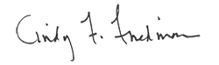 

Senator Cindy F. Friedman Representative Kenneth Gordon

cc: Senate President Karen Spilka

House Speaker Ronald Mariano

1. Middlesex County Restoration Center Commission (2019). Year One Findings and Recommendations. Accessible at https://www.mamh.org/library/middlesex-county-restoration-center-commission-year-one-findings-and-recommendations.
2. IBID.
3. IBID.
4. IBID.
5. Middlesex County Restoration Center Commission (2020). Year Two Findings and Recommendations. Accessible at https://www.mamh.org/library/middlesex-county-restoration-center-commission-year-two-findings-and-recommendations.
6. <https://www.cdc.gov/media/releases/2020/p1218-overdose-deaths-covid-19.html>
7. <https://www.wbur.org/commonhealth/2020/11/18/coronavirus-opioid-overdoses-death-data>
8. <https://jamanetwork.com/journals/jamanetworkopen/fullarticle/2775359>